Jackson Walston
Reflective Blogpost 1

What I’ve Learned About Queer History

What’s up guys! My name is Jackson Walston; a student at Longwood University. One class I’m taking this semester is all about Queer Virginia. I was super excited for this class because it's about something near and dear to my heart, the LGBT+ community. As a member of the community I was familiar with certain issues, like unequal rights, but I wanted to learn more. Being a business major, we focus more on the economy and banking; so I have not had much exposure to queer history in my classes before.

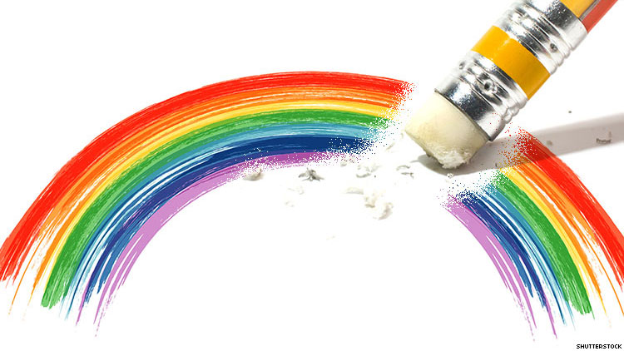

One of the big issues we have learned about so far is Queer Erasure, which refers to queer identities and history being intentionally left out of history as a whole. I never knew this existed before. When LGBT+ people are included in history it provides representation to today’s youth, helps normalize the being LGBT+, and fights the myth that being gay, trans, etc. is a new thing.

It is policy makers who can create legislation to mandate the inclusion of queer history. It is textbook publishers who need to be including this part of history. It is teachers who can tell the next generation what really happened. And it is you who can advocate for the inclusion of queer history.

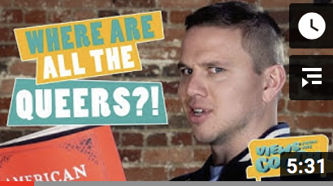

We watched a YouTube video for class called “LGBTQ History: Why Queer Erasure Sucks” by Robbie Couch. This video really stood out to me because it emphasized how this is actually happening. People like Charley Parkhurst, Jane Adams, and Beyard Rustin are included in history but the fact that they were queer is left out. We cannot allow this to continue, we must work to change things.

https://www.advocate.com/media/2019/9/18/report-lgbtq-media-coverage-vanished-after-trumps-election
https://www.youtube.com/watch?v=IA2exwahsJQ&t=5s

