Jackson Walston

Two-Way ANOVA: Number of Facebook Friends

For my paper on Two-Way ANOVA I decided to look at how many Facebook friends people have. I needed some factors to analyze and see how they affect number of friends. For my factors I chose sex (male or female) and involvment in greek life (yes, no, or planning to). After choosing these I submitted them to my professor, Dr. Emerson-Stonnell. She then provided me with a simple random sample containing data for my area of interest. I used this data to run a Two-Way ANOVA test to see how sex and greek life affect the number of Facebook friends people have.

The first step of my procedure was to establish the null and alternative hypotheses. An interesting aspect of the Two-Way ANOVA test is that it actually runs multiple One-Way ANOVAs. It is because of this that I had three sets of hypotheses. The first null hypothesis says that mean number of Facebook friends for all males equals the mean number number of Facebook friends for all females. The alternative hypothesis says that the mean number of Facebook friends for all males does not equal the mean number of Facebook friends for all females. The second null hypothesis is that the mean number of Facebook friends for all people belonging to a greek house equals the mean number of Facebook friends for all people not belonging to a greek house equals the mean number of Facebook friends for all people who plan to join a greek house. The last null hypothesis is that there is no interaction among the factors. The last alternative hypothesis says that there is interaction among the factors.

The next step in the test is to make sure that the conditions for the Two-Way ANOVA are met. The data given to me by Dr. Emerson-Stonnell was a simple random sample. This was good because it helped in avoiding bias. I had to assume that the simple random sample represented the entire population and that the data was collected from independent samples. This could be a problem going forward. The next condition I needed to test was the factors. To proceed safely with the test the factors’ population standard deviations needed to be equal and the data needed to be normally distributed. To check the standard deviation I used SPSS to find the sample standard deviations for sex and greek life. These numbers can be seen in Figure 2 and Figure 4 respectively. Next for each factor I took the larger standard deviation and divided it by the smaller. For sex I got 1.3230 and for greek life I got 1.1610. Both of these numbers are under 2 which means that it is safe to assume that the population standard deviations are equal. To check to see if the data is normally distributed I used SPSS to create a boxplot for each factor in order to sere if the data was normally distributed. When looking at the boxplots for sex, Figure 3, I noticed that the appears to be a skew for males. This was a potential problem moving forward. When looking at the boxplots for greek life, Figure 5, I noticed several things. There was an outlier for planning to join, people already in greek life was strongly skewed, and planning to join was skewed as well. These were potential problems moving forward. The last condition is to see if there is a potential interaction between sex and greek life. To check this, I created a line graph, Figure 6. The line graph showed that there was potential interaction among the variables.

The last step of the process was to actually run the test using SPSS. Before doing this I established a significance level of .01. After doing this I ran the test. The test gave me the data in Figure 7. I got three f-statistics of .515 (Sex), 3.924 (Greek Life), and 3.382 (Interaction). These numbers are relatively low, indicating that the means are not significantly different. I also got three p-values .480 (Sex), .033 (Greek Life), and .078 (Interaction). None of these numbers are under the significance level of .01, therefore there is not significant evidence to support the alternative hypotheses. To check and make sure this is true I ran a bonferroni test. The data from the bonferroni test is given in Figure 8. As you can see all of the significance levels are below that of the one I set. This support my conclusion in favor of supporting the null hypotheses.

The Two-Way ANOVA and bonferroni test leads me to believe that all the null hypotheses are true at the .01 significance level. This means that the means for sex and the means for greek life were equal and that there was no interaction among the factors. This could be true, but it could also be false. There were several problems that could have affected the credibility of this test. These problems include issues with the simple random sample, skewed data, and outliers. Despite these I personally (and subjectively) believe that the null hypotheses are true. Objectively the null hypotheses are true according to the test, but there were problems.
Appendix

Figure 1

Sex | facebook_friends | Greek_house
Male | 278 | No, but planning to
Female | 300 | No, but planning to
Female | 256 | No, but planning to
Female | 760 | No, but planning to
Female | 83 | No, but planning to
Male | 0 | No, but planning to
Female | 902 | Yes
Male | 0 | No, but planning to
Female | 436 | Yes
Female | 535 | Yes
Male | 194 | No
Male | 806 | No
Male | 425 | No
Male | 144 | No, but planning to
Male | 134 | No
Male | 212 | No
Male | 504 | No
Male | 987 | No
Male | 495 | No
Male | 678 | No
Female | 393 | No
Female | 467 | No, but planning to
Male | 600 | No
Female | 618 | No
Female | 425 | No
Female | 442 | Yes
Female | 760 | Yes
Female | 328 | No
Female | 224 | No
Male | 237 | No, but planning to

Figure 2

 | Standard Deviation
Male | 294.768
Female | 222.811

Figure 3

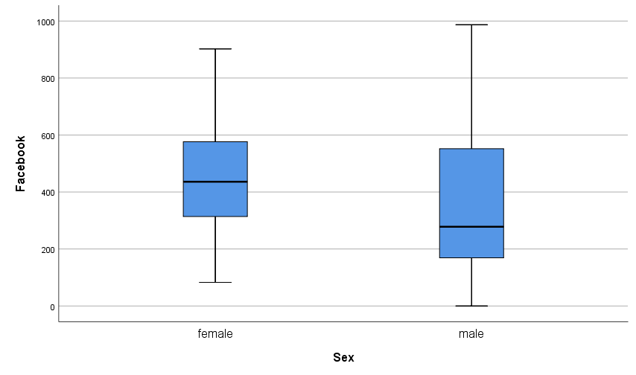

Figure 4

 | Standard Deviation
Yes | 207.222
No | 240.577
Plan to Join | 229.671

Figure 5

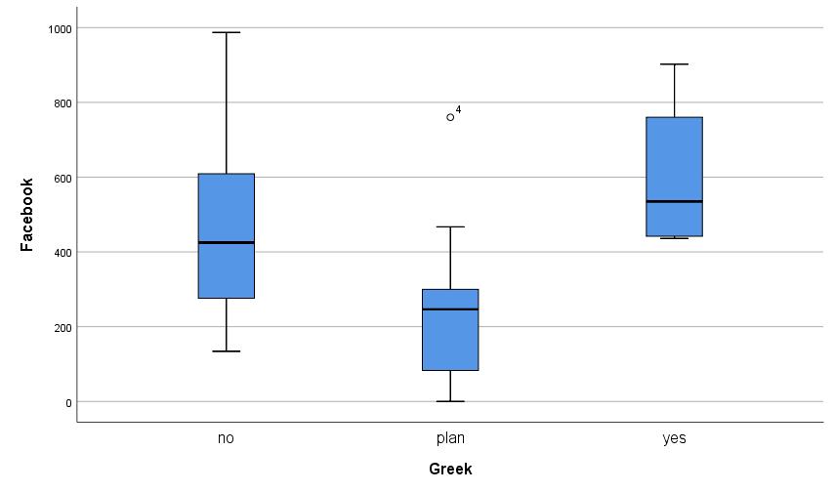
Figure 6

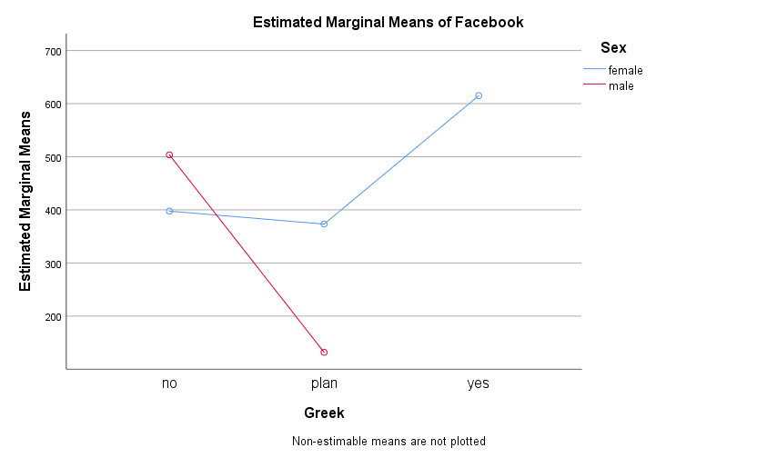

Figure 7

 | F-Statistic | P-Value
Sex | .515 | .480
Greek House | 3.924 | .033
Interaction | 3.382 | .078

Figure 8

 |  | Sig. | Lower Bound | Upper Bound
No | Plan To Join | .083 | -83.26 | 514.66
 | Yes | .659 | -524.95 | 231.35
Plan To Join | No | .083 | -514.66 | 83.26
 | Yes | .021 | -763.59 | 38.59
Yes | No | .659 | -231.35 | 524.95
 | Plan To Join | .021 | -38.59 | 763.59

