Breen Horner
Longwood University
SOCL 345
Dr. Pederson
November 20, 2023

Quantitative Findings
The dependent variable is highest level of education within each guardian that chose to complete the survey. This was asked with the options of some high school, high school diploma or ged, trade or vocational school, some college, associate’s degree, bachelor’s degree, and graduate’s degree or more. The independent variable is family involvement in fun time activities. Some participants decided not to participate in the survey or to do so.
The mean score of family involvement was a 7.2, the median was a 7, the mode was a 10, and the standard deviation was a score of 2.6. This shows the variety of answers and involvement.
Table 1.
Shows the descriptive numbers of family involvement
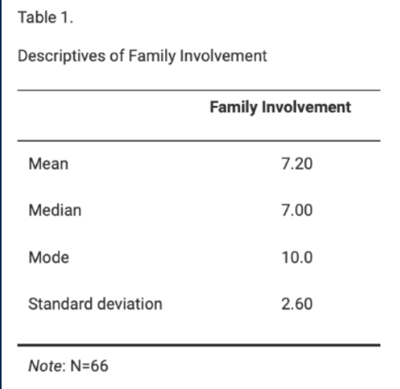
Table 1 shows the mean, median, mode, and standard deviation of the scores between 2019, 2022, and 2023. This table shows the most often score of involvement in the surveys was a 10.
Table 2.
Average involvement score by highest level of education received.
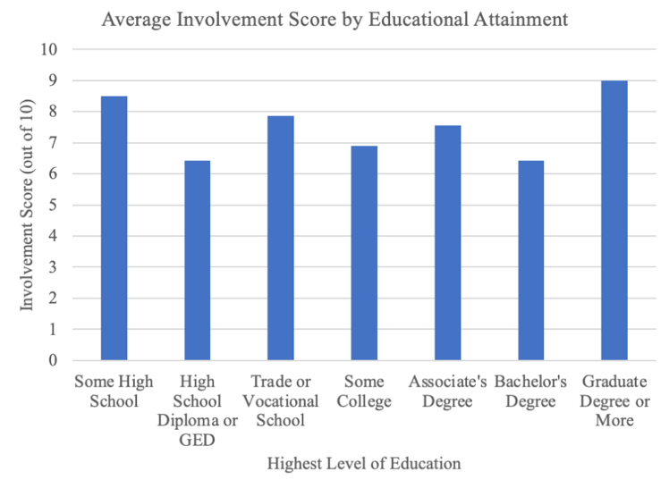
Table 2 shows that “Some High School and “Graduate degree or more” were the highest rated on the surveys. The lowest rated on the surveys was “HS diploma or GED” and “Bachelor’s degree”.
With the lack of data from 2023 surveys, this changed our data and showed a combined scores of all three years. There were a variety of answers and scores with the received data and this allowed for more skewed data.

