Carcinogens in the Environment: Extrinsic Factors and Breast Cancer Risk

Abstract
Breast cancer is one of the most common heterogeneous diseases in women around the world. It can be caused by many different intrinsic factors, including genes, race, and age at first menstruation. Although scientists once believed these factors were the most important in determining the likelihood of developing said disease, it is now becoming increasingly popular to discuss the extrinsic factors that can cause the disease. Many of these factors pertain to chemicals in the environment that can cause cancer, also known as carcinogens. When reviewing other papers, I was able to conclude that extrinsic factors contribute more to breast cancer risk and rates when compared to intrinsic factors.

Introduction
Breast cancer is a heterogeneous disease that is made up of an increasing number of biological subtypes (Carey et al. 2006). It is the most common form of cancer among women in developed and undeveloped countries and is one of the most common causes of cancer death in women worldwide (Coyle 2004 and Key et al. 2019). There are many different types of breast cancer, including Angiosarcoma, Invasive lobular carcinoma, and Inflammatory breast cancer (Breast Cancer 2019). Symptoms of breast cancer include a lump in the breast, change in size or appearance of a breast, or pitting of the skin over the breast.
Incidence rates vary from country to country, with America’s incidence rate being 86.3
per 100,000 women. These rates are steadily rising among each country. Carey et al. (2006) showed that exposure to chemicals that were identified as mammary carcinogens, or potential mammary carcinogens, is widespread. 73 of the potential mammary carcinogens that were tested by Brody et al. were found in consumer products and were present in contaminants of food (2007).
Diagnosing breast cancer has become increasingly easier over the last few decades. Mammograms are one of the most common ways to diagnose breast cancer, since most women who reach a certain age are encouraged to receive these tests yearly. Although mammograms are an effective tool for detecting breast cancer, they still have their faults. These tests sometimes show false-negative results, which can result from cancers that are not visible or are only visible in retrospect (Huynh et al. 1998). Scientists are trying to reduce the risk of the error by optimizing radiographic technique, but they also are working on other ways to diagnose the disease. Other tests to diagnose breast cancer include, but are not limited to, Raman spectroscopy, investigating body volume, and the Support Vector Machine (Haka et al 2005, Weibrecht et al. 2010, and Liu et al. 2003).
In this paper, I will be reviewing breast cancer rates in relation to intrinsic factors and extrinsic factors. Ultimately, I concluded that extrinsic factors, such as chemical exposure, will be the most influential in breast cancer risk. Although my conclusion is supported by several papers, research still needs to be done to determine how many of these chemicals released into the world each year are carcinogenic, how many women are exposed annually, and how these chemicals affect breast cancer growth and development.

Intrinsic and Extrinsic Factors
Intrinsic
There are many different risk factors for developing breast cancer that are intrinsic. Having a child at an older age, genetics, consuming alcohol, and obesity are all factors that can increase breast cancer risk (Breast Cancer 2019).
Scientists and doctors used to believe that intrinsic factors were more important for breast cancer susceptibility and diagnoses. Germline mutations in the BRCA1 gene have been identified in 60-80% of women with a family history of both breast and ovarian cancer, and in 15-20% of women who only have a family history of only breast cancer (Nathanson et al. 2001). Some scientists feel as if these numbers are overestimates due to their high numbers (Evans et al. 2008). Genetic testing is now available for women to know if they are carriers of the genes, but it has become a controversy among scientists and doctors (Evans et al. 2008). Many individuals are against testing because many women who have the gene will never develop the disease. Now, scientists and researchers believe that the BRCA1, BRCA2, and a few other rare gene variants account for only 15-20% of breast cancer in families and only less than 5% overall (Nathanson et al. 2001).
Race is also an intrinsic factor that elevates the occurrence of breast cancer in women. When comparing Caucasian and African American women, Caucasian women showed an increased level of breast cancer rates, while African American women showed higher mortality rates (Kaminska et al. 2015). These rates could be due to a number of factors, including availability of breast cancer screenings. Hunt et al. (2014) took samples of the fifty largest cities and ultimately determined that the Black woman: White woman cancer risk ratio is still increasing, meaning that Black women are becoming increasingly likely to develop breast cancer when compared to White women (Hunt et al. 2014). It is also worth mentioning that there is a lower incidence of breast cancer rates among Hispanic women, but they are diagnosed at much younger ages.
Natural hormonal changes that take place in the time of maturation can directly influence the risk of breast cancer in adult life (Kaminska et al. 2015). A few studies have shown that there is an increase in breast cancer risk for an individual who started menstruating at a younger age (Hsieh et al. 1990). These rates could potentially be due to the individual’s lengthened exposure to estrogen activity. It was shown that even delaying menstruation by two years can reduce the individual’s likelihood of developing breast cancer by as much as 10% (Hsieh et al. 1990).

Extrinsic
Extrinsic factors that can cause breast cancer are now well-discussed among the scientific community. Living Downstream goes into vivid detail about the harmful chemicals surrounding individuals (Sandra Steingraber). These chemicals are not regulated enough by the FDA, causing humans to not understand how much they are actually being impacted by said chemicals (Steingraber). Many of these chemicals are more prevalent in developed countries where there is more use of these chemicals. This increases the likelihood of developing many types of cancer (Steingraber).

Environmental Chemicals
Cadmium
Cadmium is a carcinogenic pollutant that has been shown to be associated with breast cancer risk (Gallagher et al. 2010). Found in many manures and pesticides, it has the ability to accumulate in the body as a person gets older. McElroy et al. (2006) found in a population-based study that women in Wisconsin in the highest quartile of urinary cadmium were twice as vulnerable to developing breast cancer when compared to those who were in the lowest quartile. Cadmium is looked at as a potential breast cancer risk factor due to its ability to transform estrogen receptor negative breast cancer cells into basal-like breast cancer phenotype (Benbrahim-Tallaa et al. 2009). Gallagher et al. 2010 found that there was an increase in breast cancer risk with an increase of cadmium in the body.

Tobacco Smoke
Tobacco smoke and its role in breast cancer development is not as clear as with other cancers. When researching the over 60 known chemicals that are in tobacco smoke, scientists found that many of those chemicals were known to cause mammary tumors in many laboratory animals (Hecht 2002). Many of the chemicals in cigarette smoke are not known as strong carcinogens, but it is possible that their diol epoxide metabolites could have an impact on human breast cancer. Scientists are finding more information that tobacco smoke from active smokers or even from secondhand smoking can cause breast cancer, because the levels of breast cancer rates are increasing as well as the number of women who smoke or are around individuals who smoke (Johnson et al. 2010).

Organochlorine
Organochlorines are synthetic chemicals that were released into the environment through their use as industrial products and pesticides (Calle et al. 2002). These chemicals act as estrogen agonists or antagonists which allowed scientists to hypothesize that they could play a role in breast cancer risk. Wolff et al. (1993) looked at organochlorines and their effect on breast cancer (Wolff et al. 1993). Their hypothesis that organochlorines are contributors to breast cancer stemmed from the fact that these chemicals were known animal carcinogens and labeled as possible human carcinogens. They found that individuals who were diagnosed with breast cancer had higher levels of DDT, a pesticide that contains organochlorines, when compared to their control (Wolff et al. 1993). In a 2002 study, scientists were able to prove that there was substantial evidence that there was a possible association between organochlorines and risk of breast cancer (Calle et al. 2002).

Conclusion
Although intrinsic factors are important in determining breast cancer risk, extrinsic factors ultimately contribute more (Wu et al. 2016). Wu et al. 2016 was able to conclude that cancer risk was heavily influenced by extrinsic factors. Intrinsic factors were only found to contribute to less than 10-30% of lifetime cancer risk and cancer development (Wu et al. 2016). Figure 1 shows the cancers that are impacted by intrinsic and extrinsic factors, but it shows that the extrinsic factors play a more important role in risk. I was able to conclude that extrinsic factors are more significant when determining how likely an individual is going to develop breast cancer. Further research needs to be done to understand whether or not certain cancers were developed intrinsically or extrinsically, and to determine what can be done to prevent such chemicals from reaching individuals.

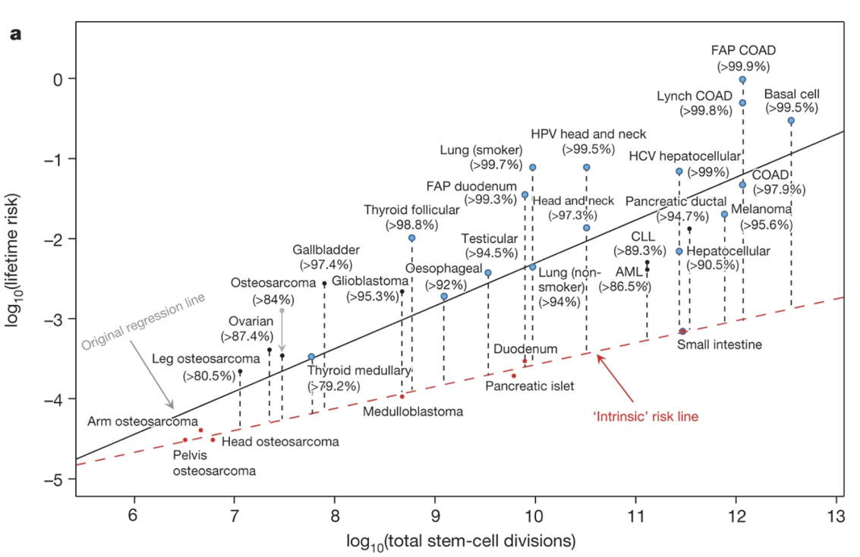
Figure 1. Estimations on total tissue stem-cell divisions. The red dots show cancers and were used to make the “intrinsic” risk linear regression line. The blue dots show cancers that have known extrinsic risks and the numbers in parentheses show the estimated percentages of cancer risks that are due to factors that are not intrinsic. (Figure from Wu et al. 2016)
References:
Benbrahim-Tallaa, L., Tokar, E. J., Diwan, B. A., Dill, A. L., Coppin, J.-F., & Waalkes, M. P. (2009). Cadmium malignantly transforms normal human breast epithelial cells into a basal-like phenotype. Environmental Health Perspectives, 111 (12): 1847–1852.

Breast Cancer. (2019). Mayo Clinic, Mayo Foundation for Medical Education and Research, [11/22]. www.mayoclinic.org/diseases-conditions/breast-cancer/symptoms-causes/syc-20352470.
Brody, J. G., Rudel, R. A., Michels, K. B., Moysich, K. B., Bernstein, L., Attfield, K. R., & Gray, S. (2007). Environmental pollutants, diet, physical activity, body size, and breast cancer: Where do we stand in research to identify opportunities for prevention? Cancer, 109(S12): 2627–2634.
Calle, E. E., Frumkin, H., Henley, S. J., Savitz, D. A., & Thun, M. J. (2002). Organochlorines and breast cancer risk. CA: A Cancer Journal for Clinicians, 52(5): 301–309.
Carey, L. A., Perou, C. M., Livasy, C. A., Dressler, L. G., Cowan, D., Conway, K., … Millikan, R. C. (2006). Race, breast cancer subtypes, and survival in the Carolina Breast Cancer Study. JAMA: The Journal of the American Medical Association, 295(21): 2492–2502.
Coyle, Y. M. (2004). The effect of environment on breast cancer risk. Breast Cancer Research and Treatment, 84(3), 273–288.
Evans, D. G., Shenton, A., Woodward, E., Lalloo, F., Howell, A., & Maher, E. R. (2008). Penetrance estimates for BRCA1 and BRCA2 based on genetic testing in a Clinical Cancer Genetics service setting: risks of breast/ovarian cancer quoted should reflect the cancer burden in the family. BMC Cancer, (8): 155.
Gallagher, C. M., Chen, J. J., & Kovach, J. S. (2010). Environmental cadmium and breast cancer risk. Aging, 2(11): 804–814.
Haka, A. S., Volynskaya, Z., Gardecki, J. A., Nazemi, J., Shenk, R., Wang, N., … Feld, M. S. (2009). Diagnosing breast cancer using Raman spectroscopy: prospective analysis. Journal of Biomedical Optics, 14(5): 054023.
Hecht, S. S. (2002). Tobacco smoke carcinogens and breast cancer. Environmental and Molecular Mutagenesis, 39(2–3): 119–126.
Hsieh, C. C., Trichopoulos, D., Katsouyanni, K., & Yuasa, S. (1990). Age at menarche, age at menopause, height and obesity as risk factors for breast cancer: associations and interactions in an international case-control study. International Journal of Cancer. Journal International Du Cancer, 46(5): 796–800.
Hunt, B. R., Whitman, S., & Hurlbert, M. S. (2014). Increasing Black:White disparities in breast cancer mortality in the 50 largest cities in the United States. Cancer Epidemiology, 38(2): 118–123.
Huynh, P. T., Jarolimek, A. M., & Daye, S. (1998). The false-negative mammogram. Radiographics: A Review Publication of the Radiological Society of North America, Inc, 18(5): 1137–1154, 1243–1244.
Johnson, K. C., Miller, A. B., Collishaw, N. E., Palmer, J. R., Hammond, S. K., Salmon, A. G., … Turcotte, F. (2011). Active smoking and secondhand smoke increase breast cancer risk: the report of the Canadian Expert Panel on Tobacco Smoke and Breast Cancer Risk (2009). Tobacco Control, 20(1): e2.
Kamińska, M., Ciszewski, T., Łopacka-Szatan, K., Miotła, P., & Starosławska, E. (2015). Breast cancer risk factors. Przeglad Menopauzalny, 14(3): 196–202.
Key, T. J., Balkwill, A., Bradbury, K. E., Reeves, G. K., Kuan, A. S., Simpson, R. F., … Beral, V. (2019). Foods, macronutrients and breast cancer risk in postmenopausal women: a large UK cohort. International Journal of Epidemiology, 48(2): 489–500.
Liu, H. X., Zhang, R. S., Luan, F., Yao, X. J., Liu, M. C., Hu, Z. D., & Fan, B. T. (2003). Diagnosing breast cancer based on support vector machines. ChemInform, 34(34).
McElroy, J. A., Shafer, M. M., Trentham-Dietz, A., Hampton, J. M., & Newcomb, P. A. (2006). Cadmium exposure and breast cancer risk. Journal of the National Cancer Institute, 98(12): 869–873.
Nathanson, K. L., Wooster, R., & Weber, B. L. (2001). Breast cancer genetics: what we know and what we need. Nature Medicine, 7(5): 552–556.
Parkin, D. M., Pisani, P., & Ferlay, J. (1999). Estimates of the worldwide incidence of 25 major cancers in 1990. International Journal of Cancer. Journal International Du Cancer, 80(6): 827–841.
Steingraber, S. (2010). Living Downstream. London, England: Da Capo Press.

Weibrecht, Martin, and Joerg Bredno. 2010. System and method for diagnosing breast cancer. U.S. Patent and Trademark Office.
Wolff, M. S., Toniolo, P. G., Lee, E. W., Rivera, M., & Dubin, N. (1993). Blood levels of organochlorine residues and risk of breast cancer. Journal of the National Cancer Institute, 85(8): 648–652.
Wu, S., Powers, S., Zhu, W., & Hannun, Y. A. (2016). Substantial contribution of extrinsic risk factors to cancer development. Nature, 529(7584): 43–47.

