Societal Standards Challenge Reputations in the Music Video “Look What You Made Me Do”
Laurel Thoreson
Longwood University
Dr. Elif Guler
10/19/2017

Introduction:
A commonly used phrase in show business is “there is no such thing as bad publicity.” People, especially celebrities and other prominent figures, often want to have their names circulating in the media. They do so in order to remain active and engaged members of society, regardless of what is being said about them is incriminating or positive. In the music video “Look What You Made Me Do,” by Taylor Swift, various rhetorical devices are used to convey messages to the public. Rhetoric is defined by the textbook as “the use of symbolic action by human beings to share ideas, enabling them to work together to make decisions about matters of common concern and to construct social reality,” (Palczewski, Ice, & Fritch, 2016). The rhetor or “the person, group, or social institution that uses symbolic action,” (Palczewski, et. al., 2016), is Taylor Swift, and is the singer, songwriter, and protagonist in the music video. The overarching message that Swift is attempting to convey to her audience is that although the media has given her a certain reputation, they do not accurately define her as a person, and that the public should not always trust the media. A reputation is a socially constructed definition or set of beliefs that a person has holds to be true about another person. Through the use of metaphors, logical fallacies, symbolism, visual and body rhetoric and Aristotelean appeals, Swift is able to create a music video both capable of persuading her audience and entertaining them.
The music video titled “Look What You Made Me Do,” is an approximately four-minute-long video staring pop singer, Taylor Swift. The video begins in a graveyard in front of the tombstone of Taylor Swift and she crawls out of the ground as an undead version of herself. In the following scene, Swift is in a bathtub, dressed lavishly and a surrounded by precious gems and jewelry. In the following scene she is on a throne dressed in red with snakes serving her. In the next clip, Swift is driving a yellow, luxury sports vehicle and crashes it head on into a light pole and the paparazzi is going wild, photographing her and the ruins of the car. Swift appears in what resembles a bird cage, she is wearing an orange jumpsuit and swinging from a trestle with security guards standing around the perimeter of the outside of the cage. In the next scene, Swift is shown in a bank vault wearing a cat mask, swinging a nun chuck. After the bank heist, she rides away with a motorcycle gang and is portrayed as a dictator of sorts with minions who are all dressed like her. She then walks through a room and has men dancing around her, she briefly appears in a plane hangar and proceeds to use a chainsaw to take the wing off one of the planes that she has defaced. Wearing a bodysuit that says “Rep,” short for reputation, Swift appears at the top of a pile of people, past characters she has played in music videos. She is standing above them to show that she is a new person and carries a new reputation and she wants to leave the past in the past. The following scene is a dance montage with Swift and the men from one of the other scenes. The video finishes with all of the past character’s she has portrayed in previous videos, lined up in the plane hangar, bowing and talking amongst each other. Figure I shows Swift’s previous characters she has played in music videos.
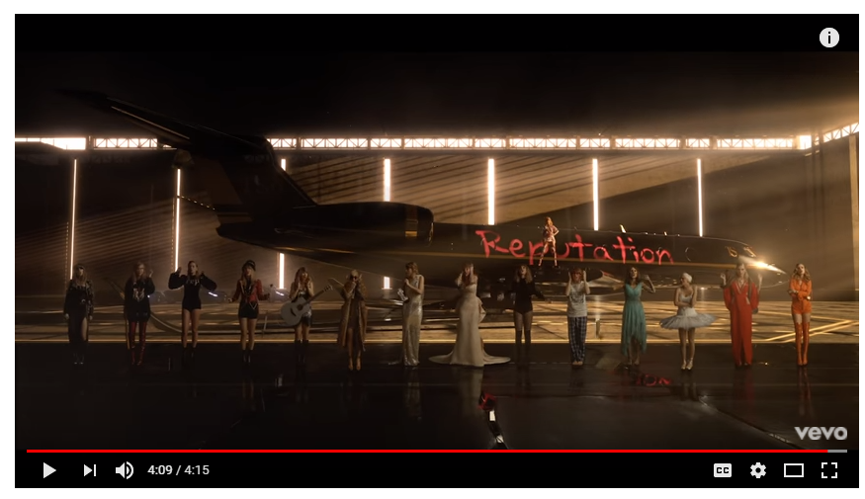 Figure I
Method:
In the music video “Look What You Made Me Do,” by Taylor Swift, introduces the concept of ethos. The Greek philosopher, Aristotle devised appeals to persuade his audience. Ethos is one of the Aristotelian appeals that is “in the character of the speaker,” (Palczewski, 2016). In the video, Swift, the protagonist is portraying a character and in this case, several different characters with unique identities and personalities. One overarching personality trait between her characters is their spontaneity and confidence in themselves. Her characters demand attention and are authority figures with power. An example of this is when she portrayed herself as a dictator to women who resembled her and were dressed identically to her. When analyzing texts and other rhetorical artifacts it is important to use Aristotelian appeals, because they can explain why and how rhetors can effectively persuade their audience.
Another Aristotelian appeal is pathos. Pathos is the appeal to emotion. Swift utilizes ethos in the video in several different ways. Some of the emotions produced in the content… The video begins in a graveyard and the tombstone reads “Here lies Taylor Swift’s Reputation.” One of the primary emotions that Swift has is anger and she wants to seek revenge. As audience members, we can see through her physical expressions and actions that she is unhappy, especially with her facial expressions. The song was made in response to emotions, Swift, the rhetor, herself was feeling. The song’s lyrics are full of angst, and feelings of holding a grudge not just against one person who has done something to upset her, but to the media who encourages others to form false opinions about her.
The third and final appeal by Aristotle is called Logos. Logos is “relies on argument itself, by showing or seeming to show something,” (Palczewski, 2016). Logos uses logical argument to persuade audience members to believe something or think a certain way. Logos is present throughout the video and aids significantly in establishing the persuasion theory as well as rhetorical aspects. The lyrics are probably the most intentional and logical forms of rhetoric and persuasion in this piece. Swift does not try to conceal the fact that the song is a response to a series of situations in her life. The lyrics help to inform the audience about why they should feel the same way as Swift or side with her opinions. The three appeals work separately and together efficiently to help the audience gain insight about why certain decisions were made and the impact of those decisions.
Analysis:
Metaphors play a huge role in the development of the video and the rhetoric. A metaphor is “a figure of speech in which two dissimilar things are said to be similar, offering a new perspective on a known issue,” (Palczewski, 2016). Taylor Swift is a pop music artist, singer-songwriter, actress amongst other things. Swift, a prominent figure in pop culture has been away from social media for a few months and had not produced any new music for over two years. When someone steps out of the spotlight people begin to talk and spread rumors and people were saying she was done with music/ dead. Swift fights the backlash and rumors of the public and media in her new music video for a single off her album “Look What You Made Me Do,” (Taylor Swift Vevo, YouTube, 2017). In one of the scenes of the video, Taylor is portrayed as a zombie/ or the undead and the line of the song goes: “Honey, I rise up from the dead I do it all the time…” Taylor Swift uses metaphor to show that she is always able to make a comeback and as soon as people begin to think she has become irrelevant as an artist, she releases music and whether it is well received or not by the public and media, it gets people to talk about her. Through the metaphor she also is able to discuss the concept of her new identity and she references the “old her” as dead. “The old Taylor can’t come to the phone right now. Why? Because she’s dead.”
Swift began her career as a country artist and transitioned into the top 50/ pop music scene. Her new music has darker elements, electronic beats and has drastically changed over the year since she first made an appearance in the music scene over ten years ago. Swift’s public image has been less than perfect and she has been involved in different controversies involving other big-name celebrities. The most notable controversial interactions have been made between Swift and hip-hop recording artist, Kanye West. Taylor Swift uses her lyrics as her main form of rhetoric in the music video. In the first stanza of her song the lyrics “I don't like your little games/ Don't like your tilted stage /The role you made me play/ Of the fool, no, I don't like you…” It is believed by multiple sources that she is discussing her relationship with hip-hop artist Kanye West. Swift and West have had public issues in the past and most recently a wax figure of Swift was featured in West’s music video for his song “Famous.” The lyrics are most likely a response to the “games” that Kanye West has publicly “played” on Swift. Swift is able to persuade her audience into siding with her in the situation and although it is only presumed that the song is about Kanye West, viewers are able to determine whom they agree with. Swift uses her rhetoric to address situations and events without directly naming the people involved. For example, she mentions that she does not like the tilted stage. West has been noted to perform on a floating stage of sorts, elevated above his audience and tilted. Swift uses symbolism in this lyric because the stage symbolizes West and she is essentially saying she does not like him. In Figure II, West is shown on the “tilted stage” tha Swift references in the song.
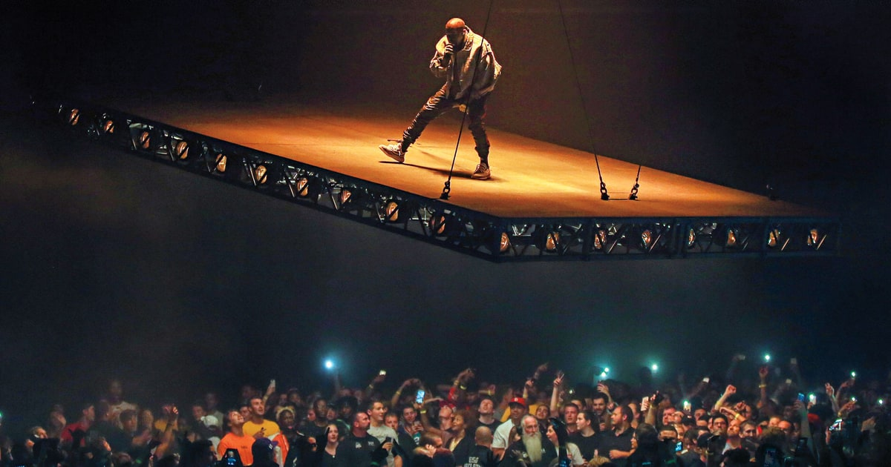 Figure II

Symbolism, in the form of a metaphor, is also found in the scene in which Swift is swinging in a birdcage, wearing orange, surrounded by security guards. This most likely represents her feeling trapped or imprisoned, yet she is high above the other people in the scene, which may represent her power and authority. A snake is a symbol that plays a large role in the video and has a larger meaning. Weeks before the release of the video, Swift removed all of the photographs from her social media account, Instagram and began posting short clips of a snake. Snakes make appearances in the video on a few occasions. One, being a ring she wears and the other, being the scene in which snakes are serving her tea as she sits on a throne. The snakes definitely play a role in this piece, and it is most likely fear. Snakes are capable of instilling fear in people, and Swift wants to be a force to be reckoned with, not necessarily someone that people especially the media will fear, but someone, that they will not threaten. In Figure III Swift appears in the birdcage on a swing.
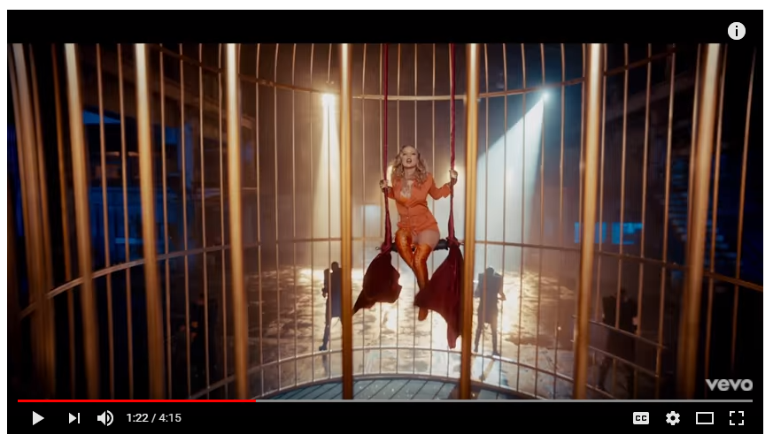 Figure III
The types of prominent rhetoric in this music video include body and visual rhetoric. Body rhetoric is “rhetoric that foreground the body as part of the symbolic act,” (Palczewski, 2016). The way that Swift is able to move creates a story and message of its own. One of the ways she incorporates visual and body rhetoric is through dancing and her other physical actions. In one of the scenes she is able to pick up two motorcycles, one in each hand, almost effortlessly, this shows her power. In another scene, Swift is the frontwoman of a dance formation. She confidently leads the troupe of dancers in strong, impactful motions that capture the audiences’ attention. She places her hands on her hips and makes wide stances, which is done so, to show power and dominance. All of the moves and motions she completes in the video, show her as someone with an abundance of energy and stamina. In most of the scenes, Swift is featured sitting or standing on something. She appears on something raised above people, such as platform, plane hangar, or throne, and is able to look down on people and physically have power over them. In Figure IV, Swift is shown with her dancers, in a powerful stance during their dance sequence.
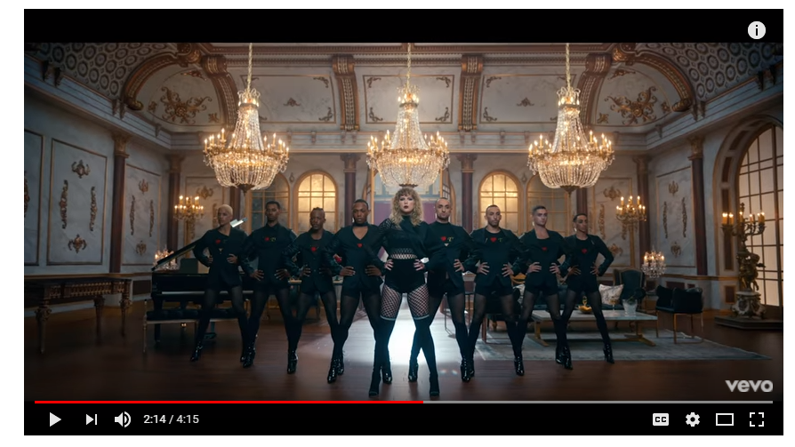 Figure IV
Visual rhetoric plays heavily into the video in the forms of costumes, and sets. Character are obvious storytelling component. The use of elaborate sets, and pieces to establish an over the top, ostentatious piece help create the atmosphere suitable for conveying the message and persuading viewers in the manner Swift finds best. In one of the scenes, Swift is sitting in a bathtub full of gems and jewels. This is an example of visual rhetoric, because the audience sees the jewels and are able to form an opinion about Swift or even the character she is portraying or playing. Visual rhetoric tells a story and helps people understand something about a situation or event without the use of words. The costumes worn by Swift are forms of visual rhetoric. She wears a lot of black and red. Both colors carry symbolic meanings, red, is known as a power color, whereas black is commonly connected with death, fear, and mystery. In Figure V, Swift appears in red, on a throne to assert her power, confidence and authority.
Figure V
Equally important, is the concept of logical fallacies. A logical fallacy is an error in reasoning (Shulman, 1951). The concept of logical fallacies is discussed in a short story by Max Shulman called “Love is a Fallacy.” The story focuses on the protagonist and his attempt to make the woman of his dreams more intelligent by teaching her the concept of fallacies. One logical fallacy that is prevalent in the music video is called hasty generalization. Hasty generalization is statement made without sufficient evidence or proof. For example, the video in its entirety is a response to the hasty generalizations that the media has contrived about Swift over the years. One particular generalization that has been made against her, is that she is a pushover. Swift has let people take advantage of her, for example during the 2009 VMA’s, Swift won the award for best music video and Kanye West jumped on stage and took the microphone from Swift, during her acceptance speech and spoke about why Beyoncé should have won instead. Since then, Swift had been seen as weak.
Ultimately, Swift believes that she is the one in charge of her own reputation. That she has the ability to establish herself as a person, the way that she wants to be perceived. From this music video the audience is able to gain insight to the person Swift thinks she is and the type of lifestyle she hopes to be representative of. A reputation is something contracted by society for the consumption of society and she thinks that people are able to make their own reputation and tell the stories they want to tell. This is a bold move on Swift’s part, because it establishes her as someone who does not care much for the media and is strong and confident in who she is as a person. The media seems to impact so much of what people in the public eye do and do not do. While some celebrities choose to not let some of parts of their private lives’ get into the public eye via media intervention, Swift is not shy and does not fear the attention. While, she acknowledges the dangers associated with the media and how easily stories can be misconstrued, she ultimately makes the chose to be a public figure and she knows how to take criticism as it comes.
Conclusion:
To conclude, this particular rhetorical artifact is able to inform and persuade the audience. The information that is conveys to the audience is that there are societal standards and people develop reputations, but the media does not always do a sufficient job at showing the truth. Swift is able to approach certain topics through the use of rhetoric. The music video is laden with examples of rhetoric and utilizes the appeals of Aristotle in order to persuade the audience to think along the ways that Swift intends. She wants her audience to have an opinion about her as well as develop opinions about the other people she talks about in the song. Everything that Swift did, whether it be in her lyrics or the way that the music video was set up, had a purpose and a deeper meaning.
Through Swift’s use of symbolism and metaphors she was able to subliminally persuade her audience into feeling a certain way about a situation, topic, person or collective group of people. To respond to the backlash, she decided to produce this song and then the music video which aided her audience additionally in distinguishing and interpreting the meanings associated with it. Swift worked hard to establish a reputation as a well-known and respected musical artist and yet her image has managed to be tarnished by the rumors and lies cultivated by the media. Taylor Swift does not let the media determine the way her life goes, she uses the media to her advantage to show that she is a strong and confident woman, who is incredibly capable and not willing to back down.

References

Shulman, M. (1951). Love is a Fallacy. Retrieved October 19, 2017
Swift, T. (2017, August 27). Retrieved October 19, 2017, from https://www.youtube.com/watch?v=3tmd-ClpJxA
Kayne West image courtesy of Google Images. Retrieved October 19, 2017

