Dear parents,

I hear you are considering a $75,000, 30-year mortgage to purchase your new home. I read that your current bank offers a rate of 7.54% compounded monthly, and a competitor is offering 6.87% compounded monthly. I am writing to you to tell you that, after doing many calculations and research, you should switch banks in order to save thousands of dollars. Here’s why:

I used the amortization of debt formula to find what your payments would be worth with each bank. With your current bank, you would pay $526.47 for 360 months (every month for thirty years). If you were to switch banks, you would pay $492.45 for 360 months. The difference here does not seem astronomical, but over the course of 30 years it makes a difference. I then used the interest formula to find the total interest with your current bank, and then repeated it to find the total interest you would pay if you switched banks. For your current bank, you would pay $189,527.99 in total; if you subtract the amount of your mortgage ($75,000) from the total, you will see you are paying $114,527.99 in interest alone. Looking at the competing bank, you will pay $177,280.58 in total. After subtracting your mortgage payment ($75,000), we see your total interest alone at $102, 280.58. To see the difference between the two, I subtracted:

$114,527.99 - $102, 280.58 to get your total savings of $12,246.42 (if you switch banks).

As you can see, you will save over $12,000 in thirty years by switching to the competing bank. I know this switch will not be easy since you all have been loyal customers to this bank for many years, but I want you to see that it is so much more financially smart to switch banks and save money, or even invest and make some money on the amount you save! Looking at the continuous interest formula, if you were to invest the saved amount of $12,246.42 into an account that offered 8% interest compounded continuously for 10 years, you would end up having $27,254.91 in that account! That means you would make $15,008.49 off that money, instead of losing $12,246.42 with the other account. I really hope you take my input into consideration and make financially intelligent decisions! 😊

From, Seraphina Marino

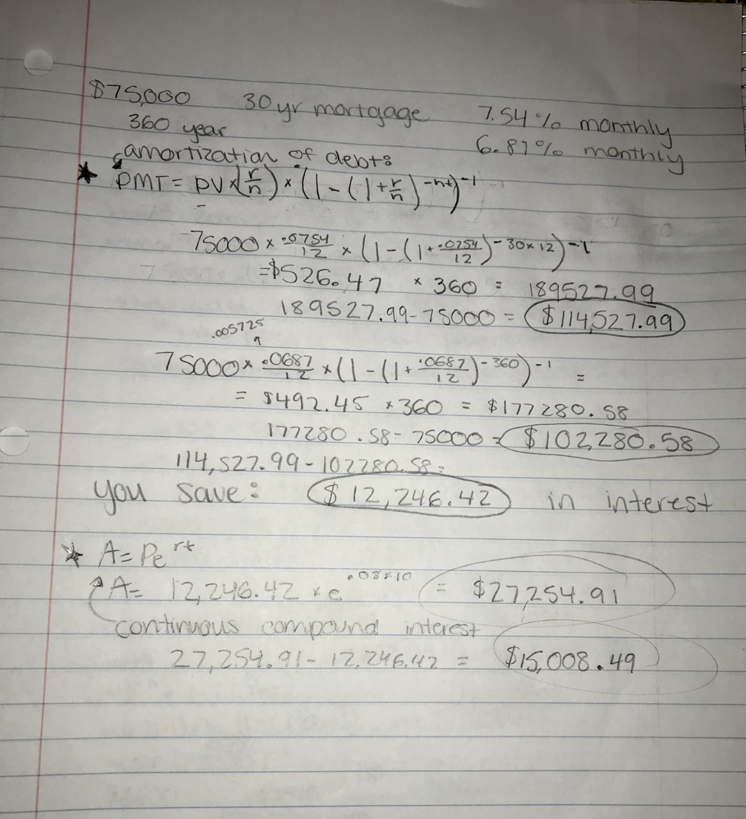Appendix: