Covid-19 emerged from the wildlife trade market and stricter regulations are needed.

Ally Salomon

Introduction

Zoonotic diseases are diseases that emerge from animals and can be harmful to human health. Many zoonotic diseases have emerged from wildlife trade markets, which are breeding grounds for harmful diseases. There have been many zoonotic diseases that have emerged from wildlife trade markets such as swine flu, Ebola, HIV, SARS and more specifically COVID-19. It is believed COVID-19 emerged from the Wuhan wet market in China due to unsanitary conditions and practices with live animals such as bats (Aguirre AA, Catherina R, Frye H, Shelley L., 2020).
Due to unsanitary conditions and practices in the wildlife trade markets and wet markets, zoonotic diseases have emerged and negatively impacted human health. In many wildlife trade markets and wet markets, the meats, produce, and wild animals are stored in open-air environments in close proximity of each other, which makes it easy for harmful pathogens to spread (Aguirre AA, Catherina R, Frye H, Shelley L., 2020). These markets also have little to no health safety precautions or sanitation measures to ensure public health, and therefore zoonotic diseases emerge that spread from the animals to the humans.
Many of the animals in the wildlife trade and wet markets are often from remote places and therefore might carry diseases that humans have never come in contact with (Aguirre AA, Catherina R, Frye H, Shelley L., 2020). During transportation, diverse groups of wild animals are crammed into small cages from all over southeastern and eastern Asia and transported over large distances. This long trip causes the wild animals to become stressed, which causes them to shed infective stages of pathogens from existing infections. Due to this, the wild animals become vulnerable to new infections that may in return eventually spread to humans (Perveen N, Muzaffar SB, Al-Deeb MA, 2020). Also, during transportation, these wild animals may come in contact with bats which are believed to be carriers of coronaviruses that can spread to humans (Perveen N, Muzaffar SB, Al-Deeb MA, 2020) (Figure 1). This contact may cause the wild animal to contract a zoonotic disease, which later may spread throughout the wildlife trade market (Figure 1). With many opportunities for a zoonotic disease to spread to humans, it is said that the wildlife trade and wet markets played a significant role in the emergence of COVID-19.
Many zoonotic diseases have emerged from the wildlife trade and wet markets such as HIV and SARS. The HIV pandemic emerged from the hunting and butchering of primates in the wildlife trade market, which led to 35 million deaths worldwide (Halbwax M., 2020). Today, HIV is still prevalent and around 37 million people live with HIV, which has been predicted to increase in the coming years. The HIV pandemic still affects people today and still isn’t fully contained due to wildlife trade markets still being open (Córdoba-Aguilar A, Ibarra-Cerdeña CN, Castro-Arellano I, Suzan G., 2020).
Another zoonotic disease that emerged from the wildlife trade market was SARS-CoV-1. This zoonotic disease first emerged in 2002-2003 due to the international trade of civets and bats (Halbwax M., 2020) (Figure 2). SARS-CoV-1 has been found to be easily transmissible to 10 mammalian species, which makes it able to easily spread to humans or other animals present in the wildlife trade market (Perveen N, Muzaffar SB, Al-Deeb MA, 2020). Also, SARS-CoV-1 was not controlled sufficiently due to lack of international efforts which ultimately led to severe consequences on human health and other wild animals. Ultimately, China has been responsible for two coronaviruses and needs stricter regulations to prevent another one (Figure 2).
China has begun making stricter regulations on the wildlife trade and wet markets and in some cases began banning this practice. In 2020, China released a revision of the Wildlife Protection Law to reduce and or ban the consumption of wildlife to prevent future zoonotic outbreaks like COVID-19 (Huang Q, Wang F, Yang H, Valitutto M, Songer M., 2021). Although the government is having trouble reducing the use of traditional medicine, strengthening habitat and ecosystem conservation, committing to long term WPL enforcement, and promoting community education and institutional reforms (Huang Q, Wang F, Yang H, Valitutto M, Songer M., 2021). With this, the Chinese government is determined to prevent future zoonotic disease outbreaks despite the difficulties by creating stricter legislation on wildlife consumption.

China has begun creating stricter regulation on wildlife trade and consumption to prevent future pandemics. This allows other countries to follow in their footsteps and create stricter regulations on wildlife trade and consumption to prevent the occurrence of another zoonotic disease. Stricter regulations are needed in Indonesia because the island of Sulawesi is an important site for wildlife trade and its local fauna is being exploited for meat markets, and therefore contributes to the occurrence of zoonotic diseases (Latinne A, Saputro S, Kalengkongan J, Kowel CL, Gaghiwu L, Ransaleleh TA, Nangoy MJ, Wahyuni I, Kusumaningrum T, Safari D, 2020) (Figure 2). With stricter regulations in countries such as Indonesia that are important sites for wildlife trade and consumption, future pandemics like COVID-19 can be prevented. COVID-19 emerged from the wildlife trade in China, and stricter regulations need to be expanded into Indonesia to prevent future pandemics.

Methods
Stricter regulations on wildlife trade and consumption in Indonesia is needed to prevent future pandemics like COVID-19. To expand stricter regulations on wildlife trade and consumption into Indonesia we must inform and persuade the local representatives and government officials to make a change in the wildlife trade markets. To persuade the local representatives and government officials, Statistics from other Asian countries such as China on wildlife trade and its effects on human health will be used, and petitions will be formed to promote stricter regulations to prevent future pandemics.
Also, involving conservation organizations such as World Resources Institute Indonesia (WRI) to inform the government on the long-standing issue with wildlife trade and consumption through collected data and surveys from wildlife trade markets in Indonesia to provide a compelling argument for stricter regulations. Also, regular updates from CITES on protected species and international treaties will promote stricter regulations and persuade the government to be aware of the issue and be able to make a change for public health.

Implications of Research
COVID-19 emerged from the Wuhan wet market in China, and stricter regulations are needed to prevent future pandemics. The call for stricter regulations needs to be expanded into other countries such as Indonesia to prevent future zoonotic disease outbreaks such as HIV, SARS, and COVID-19. With minimizing the contact between humans and wild animals, future zoonotic disease outbreaks will be limited (Huang Q, Wang F, Yang H, Valitutto M, Songer M., 2021). Stricter regulations on wildlife trade and consumption will also cause less human suffering, disruption of economies, and destabilization of societies (Huang Q, Wang F, Yang H, Valitutto M, Songer M., 2021).
Wildlife trade and consumption is a huge issue that negatively affects human health with 60% of emerging infectious diseases in people coming from animals and 70% of which are from wild animals (Huang Q, Wang F, Yang H, Valitutto M, Songer M., 2021). With this, stricter regulations need to expanded past China to prevent future zoonotic disease outbreaks. Also, protecting natural environments from further devastation will help limit human and wild animal contact, and therefore lower the risk of another zoonotic disease outbreak (Córdoba-Aguilar A, Ibarra-Cerdeña CN, Castro-Arellano I, Suzan G., 2020). By taking care of the environment, zoonotic diseases like HIV, SARS, and COVID-19 wouldn’t be as prevalent in our society today.
COVID-19 was caused by the consumption of wild animals for food and the unsanitary conditions in the wildlife trade market. Many residents in rural areas that handle wild animals or live in close contact with wild animals are at higher risk of contracting a zoonotic disease (Córdoba-Aguilar A, Ibarra-Cerdeña CN, Castro-Arellano I, Suzan G., 2020). This makes zoonotic diseases easily transferred to other people when residents from rural areas engage in the wildlife trade market. With stricter regulations on the handling of wild animals and exploitation of the environment, the spread of zoonotic diseases would be limited. If the COVID-19 pandemic has taught anything it is that we are too close to wildlife due to the exploitation of nature and international trade and travel spread pathogens quickly at a global level (Córdoba-Aguilar A, Ibarra-Cerdeña CN, Castro-Arellano I, Suzan G., 2020). To prevent a future pandemic like COVID-19, stricter regulations in China and other countries with wildlife trade markets are needed to ensure future public health.

Figures

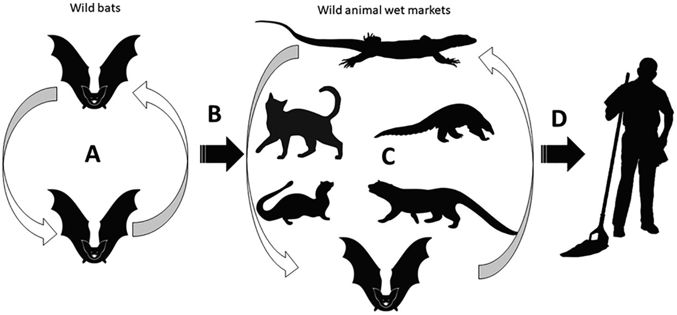
Figure 1. Shows the spread of coronaviruses from host bats to other wild animals in the wet market and eventually to humans (Perveen N, Muzaffar SB, Al-Deeb MA, 2020).

Year | Country | HCoV strain | Event description | Fatality rate (%) | Reference
2003 | China | (SARS-CoV) | very severe pneumonia cases | 10 | (Cheng et al., 2007, Drosten et al., 2003, Ksiazek et al., 2003, Tsang et al., 2003)
2012 | Saudi Arabia | (MERS-CoV) | 1st case of MERS | 37 | (de Groot et al., 2013)
2019 | China | SARS-CoV-2 | 1st case of COVID-19 | 6.9 | (Chen et al., 2020, Huang et al., 2020, WHO, 2020, Wu et al., 2020b)

Figure 2. Shows the events of coronaviruses in humans, with China being responsible for two.

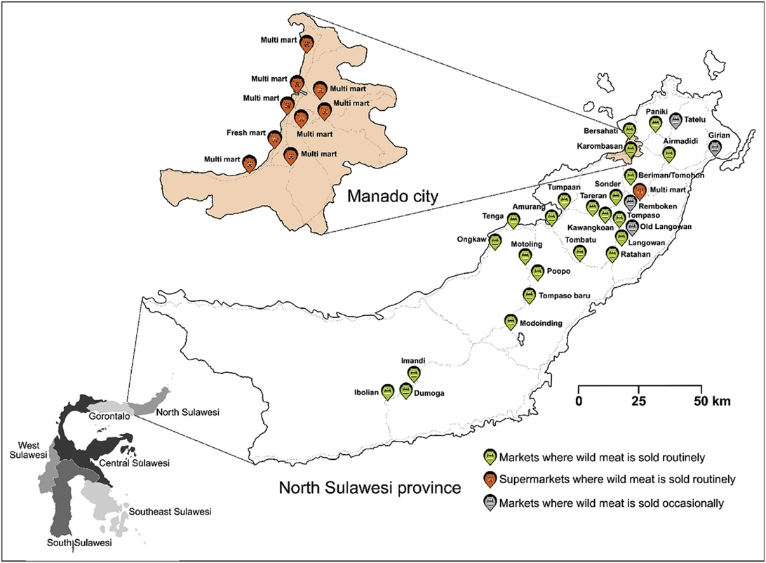

Figure 3. Shows a map of North Sulawesi province and the 27 markets and 10 supermarkets where wild meat is sold routinely or occasionally (Latinne A, Saputro S, Kalengkongan J, Kowel CL, Gaghiwu L, Ransaleleh TA, Nangoy MJ, Wahyuni I, Kusumaningrum T, Safari D, 2020).

Works Cited
- Latinne A, Saputro S, Kalengkongan J, Kowel CL, Gaghiwu L, Ransaleleh TA, Nangoy MJ, Wahyuni I, Kusumaningrum T, Safari D, et al. 2020. Characterizing and quantifying the wildlife trade network in Sulawesi, Indonesia. Global Ecology and Conservation 21.

- Halbwax M. Addressing the illegal wildlife trade in the European Union as a public health issue to draw decision makers attention. Biological Conservation. 2020;251:108798. doi:10.1016/j.biocon.2020.108798

- Perveen N, Muzaffar SB, Al-Deeb MA. Exploring human-animal host interactions and emergence of COVID-19: Evolutionary and ecological dynamics. Saudi Journal of Biological Sciences. 2021;28(2):1417–1425. doi:10.1016/j.sjbs.2020.11.077

- Córdoba-Aguilar A, Ibarra-Cerdeña CN, Castro-Arellano I, Suzan G. Tackling zoonoses in a crowded world: Lessons to be learned from the COVID-19 pandemic. Acta Tropica. 2021;214:105780. doi:10.1016/j.actatropica.2020.105780

- Huang Q, Wang F, Yang H, Valitutto M, Songer M. Will the COVID-19 outbreak be a turning point for China's wildlife protection: New developments and challenges of wildlife conservation in China. Biological Conservation. 2021;254:108937. doi:10.1016/j.biocon.2020.108937

- Aguirre AA, Catherina R, Frye H, Shelley L. Illicit Wildlife Trade, Wet Markets, and COVID‐19: Preventing Future Pandemics. World Medical & Health Policy. 2020;12(3):256–265. doi:10.1002/wmh3.348

