Report 2: Dessert and Meal Relationship

INTRODUCTION:

In this report, I am interested in whether or not there is evidence of a relationship between the type of dessert and the type of entrée ordered at a restaurant. I believe that there will be a relationship based on my initial impression of the data

EXPLORATORY DATA ANALYSIS:

I was given a sample of 607 customers surveyed during the Friday-to-Sunday weekend period about the type of entrée and the type of dessert ordered.

|  |  |  |  |  |
| --- | --- | --- | --- | --- |
|  | **Beef** | **Fish** | **Pasta** | **Poultry** |
| **Cake** | 51 | 33 | 12 | 22 |
| **Fruit** | 11 | 11 | 10 | 10 |
| **Ice Cream** | 13 | 12 | 10 | 8 |
| **None** | 124 | 140 | 42 | 98 |

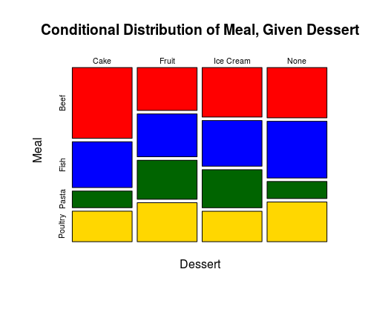

Both graphs look fairly similar pattern wise. What I mean by that is that the ups and downs of the graphs are similar.

**Expected Counts**:

|  |  |  |  |  |
| --- | --- | --- | --- | --- |
|  | **Beef** | **Fish** | **Pasta** | **Poultry** |
| **Cake** | 38.69 | 38.10 | 14.39 | 26.83 |
| **Fruit** | 13.77 | 13.56 | 5.12 | 9.55 |
| **Ice Cream** | 14.10 | 13.88 | 5.24 | 9.78 |
| **None** | 132.45 | 130.45 | 49.25 | 91.85 |

ANALYSIS:

I will use a chi squared test since I have two categorical variables, type of entrée and type of dessert. Because I am comparing the two categorical variables on one population, I will use the x2 test for independence.

H0: There is no relationship between type of entrée and type of dessert

HA: There is a relationship between type of entrée and type of dessert

**Conditions**:

1. Independent SRS 🡪 Yes, stated in question
2. All expected counts are greater than 5 🡪 Yes, smallest expected count is 5.12

**Results**:

DF = (4-1)(4-1) = 9

x2 = 19.2799, p-value = .0229

Because p is less than .05, I can reject the null hypothesis. This means that I have significant evidence to suggest that there is a relationship between type of entrée and type of dessert.

CONCLUSION:

I ran a x2 test for independence to determine if there is evidence of a relationship between type of entrée and type of dessert. Based on the results (x2 = 19.2799, p-value = .0229), I have significant evidence to suggest that there is a relationship between type of entrée and type of dessert.