Rebecca Mills
Dr. Lehman
BIOL 288
April 16, 2021
Eutrophication: The Killing of Aquatic Ecosystems
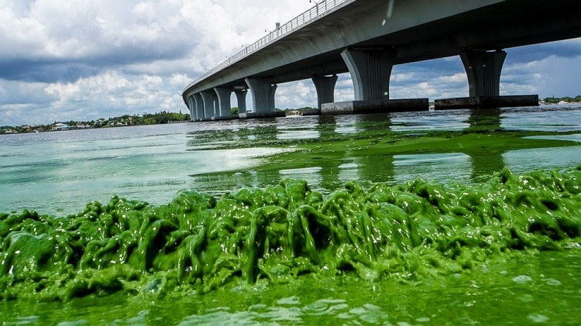
Utah Department of Environmental Quality

Eutrophication: The Basics
In recent decades, beautiful bodies of water that were often used as vacation spots and scenery have become covered in green algae, which can be seen above. This is due to a process known as eutrophication, which causes those ugly green algal blooms. Eutrophication is a process by which bodies of water have too many nutrients due to nutrient pollution. The villains in this story are nitrogen and phosphorus, nutrients that farmers carelessly use in fertilizers that get spread throughout land and eventually runs off into these aquatic ecosystems when it rains (Dupas et al., 2015). This topic is very important for the public to be informed about because we are the main issue (Lewis et al., 2011). Nutrient pollution and eutrophication cause dead zones in water, which is when there isn’t enough dissolved oxygen. Just like humans couldn’t survive without oxygen, neither can these poor fish who struggle to survive in these conditions. Scientists often group nitrogen and phosphorus together like they are twins, but in reality, they act very differently when added into aquatic ecosystems. Attention needs to be turned to eutrophication as soon as possible, because it is quickly taking over ecosystem health. Algae and dead zones often target organisms low on the food chain, such as phytoplankton and underwater grasses (NOAA, 2021). This leaves no food left for other animals such as fish, turtles, crab, and more. If this issue persists, the only way to see these beautiful creatures will be in an aquarium.
The Real Threat: Mankind
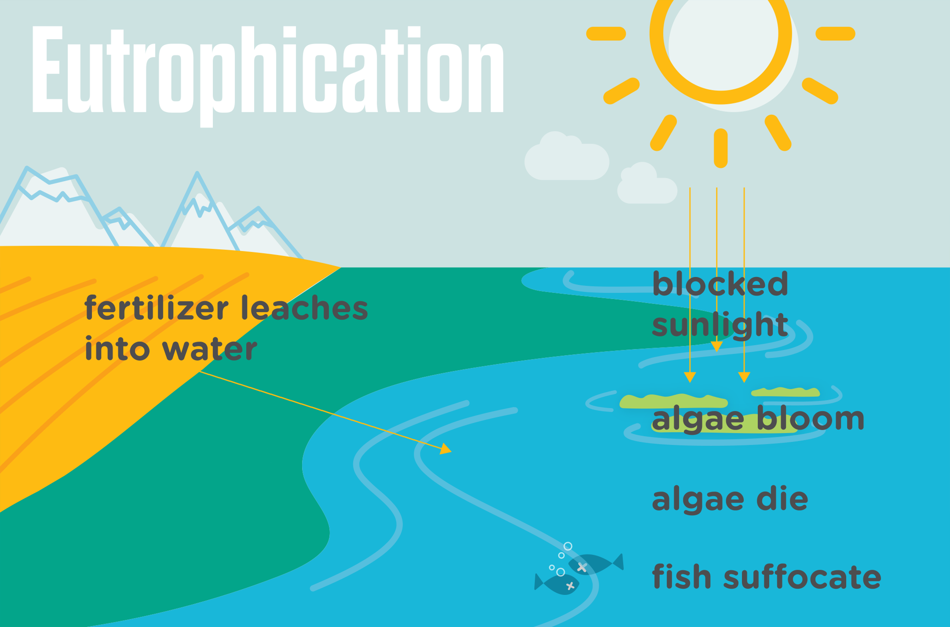
When analyzing the main causes of eutrophication, human activity is front and center. Reading this paper is singlehandedly helping this issue by raising awareness to the biggest cause of eutrophication: humans. The agriculture industry is growing tremendously every year, which does not help the problem at hand. This industry uses fertilizers that contain a fairly high concentration of nitrogen and phosphorus. When it rains, all of the nutrients along with the fertilizer come rushing down into various bodies of water (Howarth and Marino, 2006). Farmers also utilize animal food that contains these nutrients, so the manure also washes away into various water sources and leads to eutrophication (Howarth et al., 2002). This image to the left demonstrates how the process of eutrophication follows through when runoff takes fertilizers and manure with nutrients into water. Another issue that’s a lot more relevant to the average person is the burning of fossil fuels leading to increased nutrient pollution. Every time we drive in our car or turn on heat/air conditioning, it releases nitrogen gases into the air and leads to acid rain (Selman and Greenhalgh, 2010). This is a major wake up call to take environmental actions seriously, because this problem will eventually become irreversible.
Utah Department of Environmental Quality
Nitrogen vs. Phosphorus: How do they Differ?
If you are wondering which nutrient is a bigger problem and which should be given more attention, there isn’t really a simple answer. While phosphorus has been known to stop the development of underwater ecosystems and destroy everything immediately, nitrogen tends to linger around and cause more long term effects to the given ecosystem (Carpenter, 2008). While these effects are both terrible, phosphorus has been shown to do more damage to these ecosystems, yet nitrogen tends to be more abundant. Many scientists have proposed that based off of previous studies, phosphorus can be controlled using nitrogen. The addition of nitrogen tends to help lower phosphorus levels, although it can quickly get out of hand and become a nitrogen overload (Howarth and Marino, 2006). While this doesn’t create an immediate cure to our waters’ disease, it is something that should be utilized when beginning nutrient pollution control in aquatic ecosystems of all shapes and sizes.
A Disease to the Ecosystem
While studying how eutrophication effects all kinds of organisms, major species such as fish, dolphins, and crab are often the center of attention. These are the picture perfect animals that everyone worries about. While these animals are not always directly affected by eutrophication and algal blooms, their source of food definitely is. Algal blooms block the light from underwater plants that rely on the sun, causing the bottom of the food chain to die. This obviously causes a chain reaction and effects organisms such as fish, who are higher on the food chain, to lose their main source of food (Marcus, 2004). This throws off all the dynamics of the aquatic ecosystem and leads to the painful deterioration of the once beautiful beach, lake or river that was once well loved.
A Lifelong Effect
This issue is not going to be fixed overnight and might not even be fixed in years. The process of restoring various aquatic ecosystems that have already been made victim to eutrophication needs to happen as soon as possible, because it needs our help. This is an issue of a lifetime because of the chain reaction that can occur from eutrophication. Species will go extinct, water will become toxic, and what we once knew as a beautiful aspect of planet Earth will be gone. If fishing on the lake or peaceful beach trips still want to be possible, this needs to come to an end. The smallest step to becoming more environmentally friendly can make all the difference and give hope to future generations across the world.

Literature Cited
Carpenter, S.R. 2008. Phosphorus control is critical to mitigating eutrophication. Proceedings of the National Academy of Sciences of the United States of America 105: 11039-11040.
Dupas, R., Delmas, M., Dorioz, J., Garnier, J., Moatar, F., and Gascuel-Odoux, C. 2015. Assessing the impact of agricultural pressures on N and P loads and eutrophication risk. Ecological Indicators 48:396-407.
Howarth, R.W. and Marino, R. 2006. Nitrogen as the limiting nutrient for eutrophication in coastal marine ecosystems: evolving views over three decades. Limnology and Oceanography 51:364-376.
Howarth, R.W., Sharpley, A., and Walker, D. 2002. Sources of nutrient pollution to coastal waters in the United States: implications for achieving coastal water quality goals. Estuaries 25:656-676.
Lewis, W.M., Wurtsbaugh, W.A., and Paerl, H.W. 2011. Raionale for control of anthropogenic nitrogen and phosphorus to reduce eutrophication of inland waters. Environmental Science and Technology 45:10300-10305.
Marcus, N. 2004. An overview of the impacts of eutrophication and chemical pollutants on copepods of the coastal zone. Zoological Studies 43: 211-217.
North Ocean and Atmospheric Administration. 2021. What is eutrophication? National Ocean Service.
Selman, M. and Greenhalgh, S. 2009. Eutrophication: policies, actions, and strategies to address nutrient pollution. World Resources Institute; Water Quality: Eutrophication and Hypoxia 3:1-16.

