Rebecca Mills
Dr. Lehman
BIOL 288
March 23, 2021
The Deterioration of Aquatic Ecosystems from Eutrophication
Abstract
Eutrophication is a leading cause of aquatic ecosystem deterioration and has increased due to human activity leading to nutrient pollution. Eutrophication occurs when there is a surplus of nutrients in a given body of water and causes environmental risks such as algal blooms and hypoxia, where not enough dissolved oxygen is present in the water for plants and animals. Both nitrogen and phosphorus are leading nutrients that cause this issue, while they each play different roles in the water. Nitrogen is more of a controlling factor for phosphorus, which is known to more quickly deteriorate ecosystems. While nitrogen and phosphorus are leading causes of eutrophication, other elements effect water quality negatively as well and must be investigated. Another way in which eutrophication harms ecosystems is by harming organisms in lower trophic levels, which works its way up the food chain and eventually effects the entire population. Investigating the interactions between nitrogen, phosphorus, and the environment are important to understanding how to prevent eutrophication.
Introduction
In recent decades, nutrient pollution has arisen as one of the world’s major environmental concerns. Nitrogen and phosphorus in particular have caused growing responsibility in the decrease of water quality in areas worldwide (Lewis et al., 2011). Debate has increased regarding the role that both these nutrients in excess play in aquatic ecosystems. Increased nutrient pollution is due to a number of factors, such as large agricultural industries and runoff (Dupas et al., 2015). Another major cause is human activity, and the pollution that comes along with increased urbanization (Lewis et al., 2011). Pollution of nitrogen and phosphorus into bodies of water has negative effects on the ecosystem and water quality, including eutrophication, dead zones, and algal blooms. In this review, we aspire to determine the role that nutrient pollution has on the dynamics of aquatic ecosystems, including the wellbeing of aquatic plants and animals.
Eutrophication
Eutrophication occurs with the presence of a surplus of nutrients in a given body of water, which often leads to environmental complications such as algal blooms and dead zones. This leads to a lack of oxygen in the water, which is harmful to plants and animals in the community. An increase in algae in aquatic ecosystems causes harm to underwater plants, as it blocks sunlight availability and lowers dissolved oxygen levels (Anderson et al., 2002). As nitrogen and phosphorus levels fluctuate in water systems, overall water quality diminishes progressively. With the water quality deteriorating, the process of eutrophication has great impacts on species abundant in these aquatic ecosystems, including fish. This shift in the fish population can cause a negative chain reaction throughout the entire ecosystem (NOAA, 2021).
Human activity is responsible for a high proportion of nutrient polluted waters worldwide. Agriculture in particular has been a leading cause of this issue. Agricultural industries utilize synthetic fertilizers that have led to an increase of reactive nitrogen (Howarth and Marino, 2006). Runoff is responsible for then carrying those synthetic fertilizers into waterways and pollute the water with nutrients, specifically phosphorus. An excess of nutrients from manure that are being used in various countries from agriculture (Fig. 1). Another form of human impact that leads to eutrophication is the burning of fossil fuels, which leads to nitrogen gasses being released into the atmosphere and eventually resulting in acid rain, which pollutes the water quality with nutrients, specifically nitrogen (Selman and Greenhalgh, 2010).
Nitrogen and Phosphorus: The Differences
Water quality and health is affected very differently in various situations. This is due to the fact that nitrogen and phosphorus play different roles in differing ecosystem. For example, phosphorus is known to stop the development of underwater ecosystems and stick and bind to soil, while nitrogen moves very rapidly through ecosystems and causes widespread damage (Carpenter, 2008). There is disagreement in scientific literature that surrounds which nutrient does more harm to water quality: nitrogen or phosphorus. Research was conducted to determine this difference and it was concluded that phosphorus was the leading cause of eutrophication and algal blooms, and that the algal blooms were made worse when nitrogen levels decreased (Carpenter, 2008).
This conclusion creates an important idea that nitrogen can be used as a factor that can control phosphorus levels. Scientists can utilize this knowledge and use nitrogen to create an equal balance that will allow it to better control the nutrient pollution in these aquatic ecosystems. While this is a temporary solution to get phosphorus levels under control, increasing the nutrient supply in water will eventually cause more issues for the population. It is important to control both nitrogen and phosphorus simultaneously because they both work together to cause detrimental harm to ecosystems (Howarth and Marino, 2006).
The Role of Other Elements in Eutrophication
While nitrogen and phosphorus have shown to be the greatest contributor to nutrient pollution and eutrophication, there are other elements that come into play that cause eutrophication and are much less known about. One of these elements includes silicon. Phytoplankton is often very desirable in ecosystems because of what it provides to the various communities, but an uneven balance of these plankton can cause detrimental harm to an ecosystem. Studies have been constructed to determine the role that silicon plays in aquatic communities, and it was concluded that a surplus of silicon in a body of water resulted in the creation of flagellate phytoplankton, which eventually results in high algae concentrations and eutrophication (Officer and Ryther, 1980). This pattern is similar with other elements, such as aluminum and iron. It is important to understand how these elements interact with aquatic ecosystems, as well as how they react with common nutrient pollutants such as nitrogen and phosphorus.
Eutrophication within Freshwater vs. Saltwater Ecosystems
Aquatic ecosystems vary greatly based on a variety of factors, such as biodiversity, water type, etc. Given these differences, eutrophication has contrasting influence on saltwater ecosystems as opposed to freshwater ecosystems. Studies often lack comprehensive research into these differences, when it is crucial to the overall study of eutrophication as well as nutrient pollution.
When narrowing in on freshwater ecosystems, it is clear that the addition of nutrients leads to an unbalanced food web throughout the ecosystem. A study done in a lake ecosystem concluded that the addition of nutrients caused an unequal balance of producers and consumers (Lind et al., 2018). This equated to a surplus of phytoplankton, which led to increased phytoplankton blooms, and eventual detrimental algal blooms, as well as an overall detriment to the rest of the species in the community. Another study displayed that a surplus of nutrients in a freshwater ecosystem, such as a lake, have an incredibly hard time compensating for the excess algae and it leads to fatalities in the ecosystem (Smith, 2003). Scientists hypothesize that eutrophication in freshwater systems should not be as difficult as marine ecosystems, since the system is more controlled, but this problem continues in freshwater, as no serious measures have been put in place to diminish eutrophication (Cary Institute of Ecosystem Studies, 2009).
As for saltwater, the consequences of nutrient pollution are usually more crucial. Eutrophication leads to an increase in chlorophyll such as algae and seagrass, and nutrient pollution causes increased epiphytes and other microalgae on these underwater plants (O’Hare et al., 2018). This increase in particular organisms leads to a similar response to freshwater ecosystem, where the unbalanced trophic levels cause a decrease in biodiversity. Marine ecosystems also have unique environmental factors such as coral reefs, that are very negatively affected by nutrient pollution (Ecological Society of America, 2000). Eutrophication also tends to effect marine and saltwater ecosystems worse because of all the bodies of water that flow into it. If those ecosystems are affected by eutrophication, it will cause more harm to the bodies of water it flows in to, which are often saltwater ecosystems. Understanding the differences in effects that eutrophication has on these different ecosystems is crucial to achieve a desirable solution.
Nutrient Pollution Deteriorating Overall Organism and Ecosystem Health
When studying how eutrophication effects various organisms, major organisms such as fish and crab are often given most consideration. While these animals are very negatively affected from nutrient pollution, the root of the problem with nutrient pollution effecting ecosystems is organisms in lower trophic levels. This includes organisms such as copepod species, a family of zooplankton (Marcus, 2004). In eutrophic areas where zooplankton resides, they are unable to keep up with phytoplankton production and die (Marcus, 2004). When lower trophic level organisms decline, it causes a major chain reaction to other organisms throughout the entire ecosystem and starts to change the balance of all populations and destroy all dynamics and balance.
Eutrophication also widely discourages the growth of organisms throughout the entire ecosystem. This is due to the fact that they are lacking the required amount of dissolved oxygen in the water that is needed for proper growth and development. Hypoxia that occurs from eutrophication causes these lethal repercussions. Algal blooms also greatly harm underwater grasses, as it blocks out the sunlight underwater and restricts proper photosynthesis from occurring.
Figures
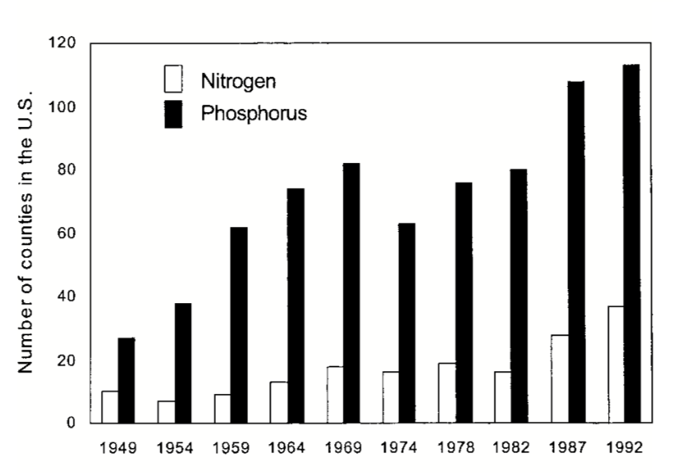
Figure 1. Number of countries whose manure nutrients surpasses plant uptake (Howarth et al., 2002).
Conclusion
With eutrophication becoming a rising concern for aquatic ecosystems, it is important to find solutions to control nutrient levels. With nitrogen having the ability to calm phosphorus destruction in water, utilizing the right amount of nitrogen in these systems can be a key solution in minimizing the effects of eutrophication. While this is a temporary solution, there are still multiple gaps that need to be researched further. For example, the effects that nutrient pollution has on different water systems, such as estuaries, lakes, and oceans, has not been researched to the necessary extent. Further research can determine how these systems react differently in order to find the best solution. Another way to limit nutrient pollution would be to mandate laws, especially for agricultural industries, that forces the limitation of synthetic fertilizers and other products that cause damage to aquatic ecosystems due to runoff. Limiting the overall pollution into waterways is an important step to save aquatic ecosystems that are currently deteriorating from eutrophication. Lastly, a topic that should be researched further is how nitrogen and phosphorus interact with various eutrophication-causing elements to better understand the scope of eutrophication causes and eventually find efficient solutions to ending the problem.
Literature Cited
Anderson, D.M., Glibert, P.M., and Burkholder, J.M. 2002. Harmful algal blooms and eutrophication: nutrient sources, composition, and consequences. Estuaries 25:704-726.
Carpenter, S.R. 2008. Phosphorus control is critical to mitigating eutrophication. Proceedings of the National Academy of Sciences of the United States of America 105: 11039-11040.
Cary Institute of Ecosystem Studies. 2009. Nutrient pollution chokes marine and freshwater ecosystems. ScienceDaily.
Dupas, R., Delmas, M., Dorioz, J., Garnier, J., Moatar, F., and Gascuel-Odoux, C. 2015. Assessing the impact of agricultural pressures on N and P loads and eutrophication risk. Ecological Indicators 48:396-407.
Ecological Society of America. 2000. Nutrient pollution of coastal rivers, bays, and seas. Issues in Ecology. 7:1-14.
Howarth, R.W. and Marino, R. 2006. Nitrogen as the limiting nutrient for eutrophication in coastal marine ecosystems: evolving views over three decades. Limnology and Oceanography 51:364-376.
Howarth, R.W., Sharpley, A., and Walker, D. 2002. Sources of nutrient pollution to coastal waters in the United States: implications for achieving coastal water quality goals. Estuaries 25:656-676.
Lewis, W.M., Wurtsbaugh, W.A., and Paerl, H.W. 2011. Raionale for control of anthropogenic nitrogen and phosphorus to reduce eutrophication of inland waters. Environmental Science and Technology 45:10300-10305.
Lind, L., Schuler, M.S., Hintz, W.D., Stoler, A.B., Jones, D.K., Mattes, B.M., and Relyea, R.A. 2018. Salty fertile lakes: how salinization and eutrophication alter the structure of freshwater communities. Ecosphere. 9: 1-19.
Marcus, N. 2004. An overview of the impacts of eutrophication and chemical pollutants on capepods of the coastal zone. Zoological Studies 43: 211-217.
North Ocean and Atmospheric Administration. 2021. What is eutrophication? National Ocean Service.
Officer, C.B. and Ryther, J.H. 1980. The possible importance of silicon in marine eutrophication. Marine Ecology- Progress Series. 3:83-91.
O’Hare, M.T., Baattrup-Pedersen, A., Baumgarte, I., Freeman, A., Gunn, I.D.M., Lazar, A.N., Sinclair, R., Wade, A.J., and Bowes, M.J. Responses of aquatic plants to eutrophication in rivers: a revised conceptual model. 9:1-13.
Selman, M. and Greenhalgh, S. 2009. Eutrophication: policies, actions, and strategies to address nutrient pollution. World Resources Institute; Water Quality: Eutrophication and Hypoxia 3:1-16.
Smith, V.H. 2003. Eutrophication of freshwater and coastal and marine ecosystems: a global problem. Environmental Science and Pollution Research. 10:126-139.

