Bacterial Transformation of Green Fluorescent Protein from pGLO
Rebecca Mills
BIOL 250-02
Fall 2020

Abstract
The ability of E. coli to glow under different conditions, +pGLO plasmid containing green fluorescent protein and -pGLO plasmid, was studied, as well as the potential of cells to glow when exposed to different sugars. This experiment was conducted by first determining the size as well as confirming the presence of green fluorescent protein using a PCR reaction and BLAST analysis. E. coli was then exposed to agar plates under two conditions using ampicillin: +pGLO and -pGLO and incubated. UV light was used to determine the presence of fluorescence in the plates. The role of different sugars, arabinose and glucose, in regulating the expression of green fluorescent protein was then determined by exposing cells to different sugars on LB-AMP agar plates and UV light determined the levels of fluorescence. Results indicated that the pGLO plasmid contained a 97% match to the green fluorescent protein. It was also determined that E. coli was able to emit fluorescence under +pGLO presence. In addition, fluorescence was emitted the most when cells were exposed to the arabinose sugar. These results suggest that E. coli bacteria is able to transform in the presence of pGLO plasmid containing green fluorescent protein in order to glow. In addition, the results conclude that arabinose sugar leads to better expression of green fluorescent protein, and this is predicted to be due to the fact that arabinose activates the pBAD operon.
Introduction
Microbiology is a branch of biology that deals with the study and interactions of microscopic organisms. This includes organisms such as bacteria and fungi. Biotechnology has been a quickly expanding field within scientific disciplines that can be utilized on the microscopic level. It has allowed scientists to manipulate various microorganisms that have led to many revolutionary advancements. Manipulation of DNA in particular has allowed for scientists to detect the role of various genes in an organism. Green fluorescent protein (GFP) is a protein originally found in a jellyfish that omits fluorescence (Shimomura, 2009). GFP is often detected using a technique known as protein tagging, which utilized peptide sequences in order to detect the protein in the cell (Cabantous et al., 2005). In addition, polymerase chain reaction (PCR) is a technique used to code proteins of interest in hopes of cloning, which will be used in this study. This experiment utilizes the presence of GFP in pGLO plasmid in order to determine the ability of a bacteria (E. coli) to glow under the different conditions, +pGLO and -pGLO as well as its growth in the presence of different sugars. The hypothesized prediction is that bacteria with a presence of pGLO with GFP will omit fluorescence and that the plates containing arabinose will express GFP colonies due to their role in turning on the pBAD promotor. This is because bacterial transformation is an important factor and allows cells take in DNA from their environment and express it (Yao et al., 2015). The ability to allow bacteria to utilize this fluorescence is an important advancement in the field of microbiology and biotechnology because it will allow scientists to detect bacteria on various surfaces and possibly lead to disease prevention. This experiment strives to determine if this is plausible by asking whether or not E. coli glow in pGLO plasmid’s presence. It is hypothesized that the GFP gene from pGLO plasmid can be expressed in E. coli bacteria.
Methods
Setting Up PCR Reaction
Samples of a DNA template, a combination of primer GFP_F1 (5’ atcgcaactctctactgtttc 3’) and primer GFP_R1 (5’ tctgatttaatctgtatcaggc 3’), 2X master mix, and water were held in an ice bath. Using a micropipette, place 10 μl of the DNA template, 20 μl of the primer combination, and 20 μl of water into the master mix sample. The PCR reaction was then placed into a thermal cycler. In the cycler, the PCR was in at 94 degrees Celsius for 4 minutes. Then, the thermal cycler is at 94 degrees Celsius for 30 seconds, then 50 degrees Celsius for 30 seconds, then 72 degrees Celsius for 60 seconds. The last three temperatures and times were repeated 30 times. After, the cycler was set to 72 degrees Celsius for 7 minutes, and finally 4 degrees Celsius overnight.
Preparing the Gel:
A combination of 1g agarose gel as well as 100 mL of .25 xTAE buffer was placed in the microwave until the product was clear. The gel product was then placed into the gel tray and a comb to create the wells was placed into the gel. The gel was left to harden until the favorable gel texture was created and the comb was removed. The gel tray was then reoriented to match the positive and negative charges on the gel caster. The buffer was then added to submerge the gel.
Running the Gel:
Three microliters of the obtained PCR reaction was pipetted into a tube containing 7 µl of a loading buffer, which included 2 µl of 6X loading buffer and 5 µl of water. The mixture was then transferred into a designated well, as well as a positive control, negative control, ladder, and 3 other students’ mixtures in the remaining wells, excluding 2 wells on one side and one on the other, which remained empty. The lid was then placed onto the electrophoresis chamber and the electrical wires were placed onto the power supply, colors coordinating appropriately. The gel was run at 300V for 20 minutes. The gel was then removed and analyzed using the gel visualizer and labeled as gel 2B4.
Amplicon Purification
In order to purify the amplicon, 97 µl of the PCR reaction sample was mixed into a tube containing 500 µl of binding buffer. This complete mixture was then placed in a spin filter column and placed in a centrifuge at 13000 rpm for one minute. The tube was then removed, and waster was expelled from the tube. Two hundred milliliters of a wash buffer was then added to the same column and placed in the centrifuge again for 1 minute at 13000 rmp and waste was extracted from the bottom of the tube. This was repeated twice. The receptacle was then replaced with a fresh tube and 30 µl of elution buffer was added to the column and sat for one minute. It was then placed in the centrifuge and spun for one minute at 13000 rpm.
Determining Purified Amplicon Concentration
A nanodrop was cleaned off to prepare for use. 2 µl of the sample was placed on the nanodrop pedestal and the machine was closed. The DNA concentration andA260/A280 was measured on the computer.
Sequencing the DNA
The formula C₁V₁=C₂V₂ was used to determine the amount of the sample needed for sequencing based on its concentration.
BLAST Analysis
The first step in sequencing and BLAST analysis is to open up the PDF files of the GFP sequences and confirm that there are clean results with no mixed pool. The sequence of the GFP gene for both primers was opened using the program SnapGene Viewer, and the top strands of each were copied and pasted into a word document and labeled. Both of these FASTA sequences were copied and pasted into the textbox found at http://doua.prabi.fr/software/cap3, assessed 9/23/20. The sequence was submitted and contig was selected to retrieve the contig sequence. That contig sequence was then copied into the FASTA word document. The link http://blast.ncbi.nlm.nih.gov/Blast.cgi, assessed on 9/23/20, was opened and the contig was pasted into the text box and ‘BLAST’ was selected. Results were collected from the top 5 descriptions as well as the alignment sequence. The contig was copied and pasted into a new SnapGene Viewer document and both primers were searched in order to determine their locations as well as the start and stop amino acids.
Bacterial Transformation set up
Two microtubes were obtained and labeled +pGLO and -pGLO and 0.25 mL of calcium chloride transformation solution was pipetted into each tube, then the tubes were placed on ice. A metal loop was then held over a Bunsen burner in order to sterilize it. The loop was used to scoop a single colony of cells to place in each microtube. 10 µl of pGLO plasmid DNA was pipetted into the +pGLO tube and mixed gently before returning to the ice. 10 more µl of calcium chloride was then added to the -pGLO microtube and mixed gently before returning to rest on the ice. The tubes were incubated on ice for 10 minutes. Four agar plates were then labeled, 2 being +pGLO and 2 being -pGLO. The tubes then sat in a water bath at 42 degrees Celsius for 50 seconds, followed by them being directly returned to ice for 2 minutes. Once the 2 minutes were up, the tubes got 250 µl of LB nutrient broth pipetted into them before being placed in a water bath at 37 degrees Celsius for 10 minutes. 200 µl of each solution was then pipetted into the designated agar plates. A sterile loop was then used to spread the liquid around the agar plate. The plates were then taped together upside down and were incubated for 24-48 hours at 37 degrees Celsius, then stored at 4 degrees Celsius.
Use SnapGene Viewer
To begin the lab, the pGLO plasmid sequence was copied into the SnapGene Viewer application and the circular option was selected. Twelve features were then displayed for the plasmid and the name, coordinates, and direction of each was noted. Once noted, all were unselected except the ori(s), the three protein coding genes of interest, and the promoters before clicking “add these 7 features.” The enzymes were then removed from the map by selecting “choose enzyme set,” “choose enzyme,” then “remove all.” The 5’ end of the GFP gene was then selected and the “add primers” option was selected and the F1 primer, 5’ atcgcaactctctactgtttc 3’, was pasted and added. The same step was repeated for the R1 primer, 5’ tctgatttaatctgtatcaggc 3’, which was added to the 3’ end of the GFP. A BLAST analysis was then run on https://blast.ncbi.nlm.nih.gov/Blast.cgi for the araC gene, bla gene, and the F1 ori sequence.
Response of Sugar to pGLO
To begin the experiment, the following vials were obtained; 1 vial of HB101 cells, 1 vial of L-arabinose sugar solution, 1 vial of D-glucose sugar solution, and 1 vial of sterile water. Then, four LB-AMP agar plates were obtained and given the following labels: pGLO, pGLO+ARA, pGLO+GLU, and pGLO+ARA+GLU. Four microtubes were then obtained and given the same labels. The following volumes were then added to the pGLO tube from the vials: 100 μl cells, 150 μl water. The following volumes were then added to the pGLO+ARA tube: 100 μl cells, 100 μl water, and 50 μl arabinose. The following volumes were then added to pGLO+GLU: 100 μl cells, 50 μl water, 100 μl glucose. Lastly, these volumes were added to pGLO+ARA+GLU: 100 μl cells, 50 μl arabinose, 100 μl glucose. The total volume, 250 μl, of each was then pipetted into its corresponding agar plate. A loop was sterilized and used to spread out the solution throughout the agar plate. The plates were then incubated overnight at 37 degrees Celsius.
Results
A PCR reaction was used to obtain a target gene and visualized using gel electrophoresis. The gel reading shows that the four PCR reaction mixture amplicons, as well as the positive control, accurately lined up with a specific amplicon on the ladder, which read 1000bp. This indicates that the size of the amplicons was 1000bp.
The DNA amplicon concentration found was 41.1 ng/µl. The A260 value was 0.821. The A260/A280 result was 1.97. Using the formula C₁V₁=C₂V_{2,} the volume of purified amplicon needed for the sequencing.
(41.1) (V₁) = (30 ng/µl) (15µl)
V₁ = 10.95 µl
The total volume needed in the tube to send off to get sequenced is 15 µl, the amount of water needed was calculated below.
15 µl = 10.95 µl – (H₂O)
= 4.05 µl H₂O
Based on the alignment data, 97% of the GFP gene matched up with our data, seen in figure 2. This data does include two primer sequences. The F1 primer was searched back in the sequence and determined to be located where the pink is highlighted above. The R1 primer was determined by searching the complimentary sequence of the R1 primer, which can be seen where the blue highlighted portion is in the contig sequence. The start codon, stop codon, F1 primer, and R1 primer is present in the open reading frame, seen in figure 3. Figure 4 displays the chromatogram sequencing of the targeted pGLO plasmid. Figure 5 shows the alighnemt hits found through BLAST analysis for the pGLO plasmid. Figure 6 maps out the pGLO plasmid, showing the locations of both primers, ampR, f1 ori, ori, araC, the araBAD promotor, and GFP. Figure 7 shows the visual representation of table 1. Tables 1 and 2 demonstrate results regarding the colony count and fluorescence of agar plates under different conditions.
Discussion
In this experiment, it was hypothesized that that bacteria with a presence of pGLO with GFP will omit fluorescence, and that hypothesis was supported by the data. Many experiments and results were conducted along the way to obtain the end product. The amplicon size was determined to be 1000bp, displayed in fig. 1, which is most likely due to less unique sequencing and less diversity of the gene (Huber, 2009). The BLAST analysis was able to determine that the targeted gene had a 97% match to the GFP gene, which was predicted, which can be seen in figure 2A. Table 1 gave the main conclusions that the E. coli interacting with the +pGLO plates contained higher colony counts as well as greater fluorescence, concluding that the bacteria was able to undergo transformation to express the GFP gene.
A limitation that this study has was that other confounding variables were not taken into consideration regarding results along the way. There are always possible factors that could have led to the results that scientists do not always think about. For example, maybe the temperature of the room had an impact on our results. In addition, there is always room for user error in scientific experiments. Along the way, the scientist could have slipped up which could cause a chain reaction of different results for the remainder of the experiment.
This study is important because it can help determine efficiency when detecting GFP as well as determine the reaction that certain bacteria, in this case E. coli, has in the presence of +pGLO.

Figures

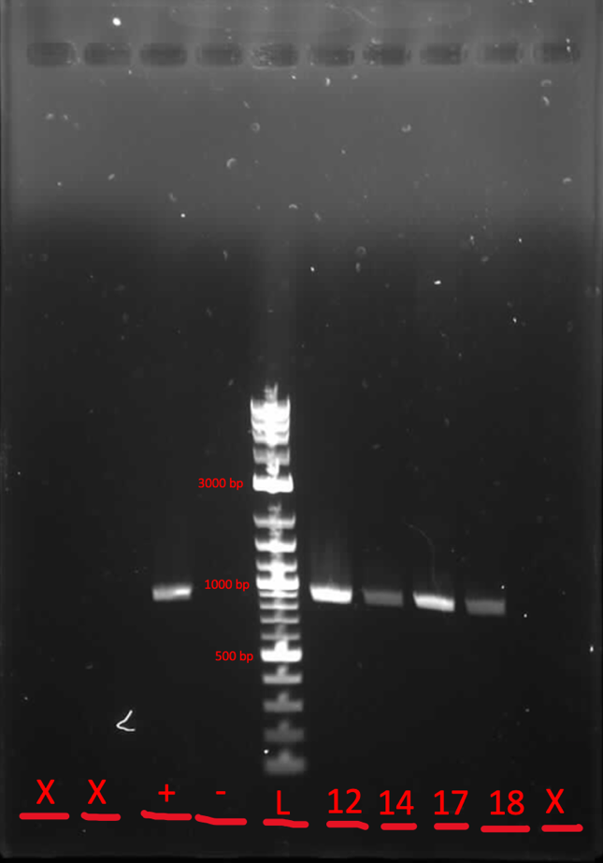
Gel 2B4
X=Empty
+= positive control
-= negative control
L= ladder
12= student 12
14= student 14
17= student 17
18=student 18

Figure 1. Gel electrophoresis on the DNA amplicon. PCR reactions were run including 4 students, a negative and positive control, and a ladder in order to determine the size of the target amplicon.

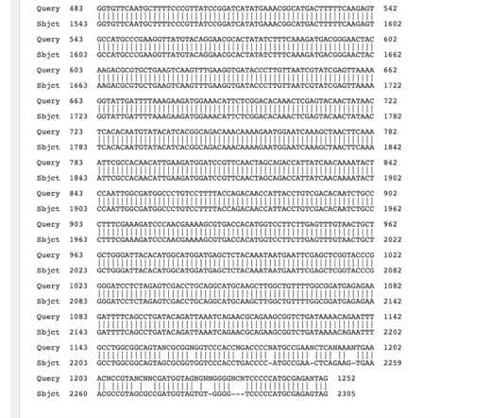
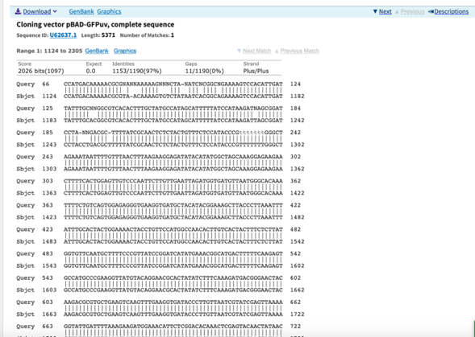
2A 2B

Figure 2. Alignment data of the targeted gene. Displays the percentage of nucleotide bases that line up with the target GFP gene.

>Contig1
NNNNNNTNNACCNAACCNGGTNNCCCCCGNTNNTAAAAGCATTNNNNNACNAAGNGGGNN
CNANNCCATGACAAAAACGCGNANNAAAAAGNNNCTANATCNCGGCNGAAAAGTCCACAT
TGATTATTTGCNNGGCGTCACACTTTGCTATGCCATAGCATTTTTATCCATAAGATNAGC
GGATCCTANNGACGCTTTTATCGCAACTCTCTACTGTTTCTCCATACCCGTTTTTTTGGG
CTAGAAATAATTTTGTTTAACTTTAAGAAGGAGATATACATATGGCTAGCAAAGGAGAAG
AACTTTTCACTGGAGTTGTCCCAATTCTTGTTGAATTAGATGGTGATGTTAATGGGCACA
AATTTTCTGTCAGTGGAGAGGGTGAAGGTGATGCTACATACGGAAAGCTTACCCTTAAAT
TTATTTGCACTACTGGAAAACTACCTGTTCCATGGCCAACACTTGTCACTACTTTCTCTT
ATGGTGTTCAATGCTTTTCCCGTTATCCGGATCATATGAAACGGCATGACTTTTTCAAGA
GTGCCATGCCCGAAGGTTATGTACAGGAACGCACTATATCTTTCAAAGATGACGGGAACT
ACAAGACGCGTGCTGAAGTCAAGTTTGAAGGTGATACCCTTGTTAATCGTATCGAGTTAA
AAGGTATTGATTTTAAAGAAGATGGAAACATTCTCGGACACAAACTCGAGTACAACTATA
ACTCACACAATGTATACATCACGGCAGACAAACAAAAGAATGGAATCAAAGCTAACTTCA
AAATTCGCCACAACATTGAAGATGGATCCGTTCAACTAGCAGACCATTATCAACAAAATA
CTCCAATTGGCGATGGCCCTGTCCTTTTACCAGACAACCATTACCTGTCGACACAATCTG
CCCTTTCGAAAGATCCCAACGAAAAGCGTGACCACATGGTCCTTCTTGAGTTTGTAACTG
CTGCTGGGATTACACATGGCATGGATGAGCTCTACAAATAATGAATTCGAGCTCGGTACC
CGGGGATCCTCTAGAGTCGACCTGCAGGCATGCAAGCTTGGCTGTTTTGGCGGATGAGAG
AAGATTTTCAGCCTGATACAGATTAAATCAGAACGCAGAAGCGGTCTGATAAAACAGAAT
TTGCCTGGCGGCAGTANCGCGGNGGTCCCACCNGACCCCNATGCCGAANCTCANAAANTG
AAACNCCGTANCNNCGATGGTAGNGNNGGGGNCNTCCCCCATGCGAGANTAGNNNNGNCN
NGNNATCAAATAAAANNNAANNNNNNNNNCNAANGANTGNNNNNNNTTTTNNTCNNNNNN
TTNGNCGGNGNANNNCA
F1 Primer
R1 Primer
Start Codon
Stop Codon

Figure 3. The contig sequence of GFP DNA gene. The contig displays the location of the two primers as well as the start and start codon in the sequence.
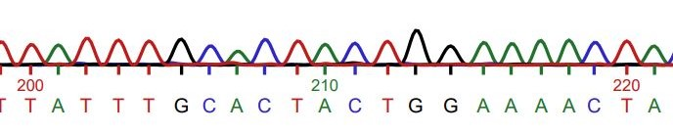
Figure 4. Sequencing data of the pGLO plasmid was collected which was then converted into a chromatogram., which is partially displayed in this figure.

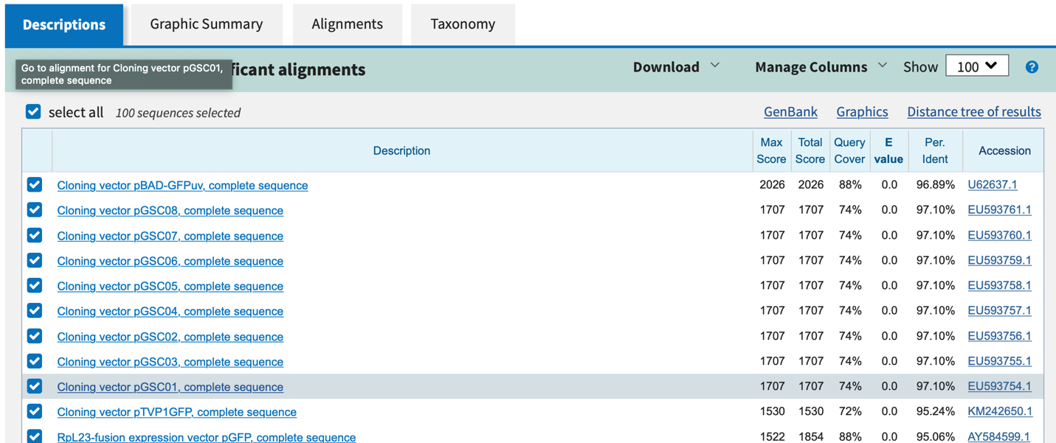
Figure 5. Top hits of the BLAST analysis of pGLO plasmid.
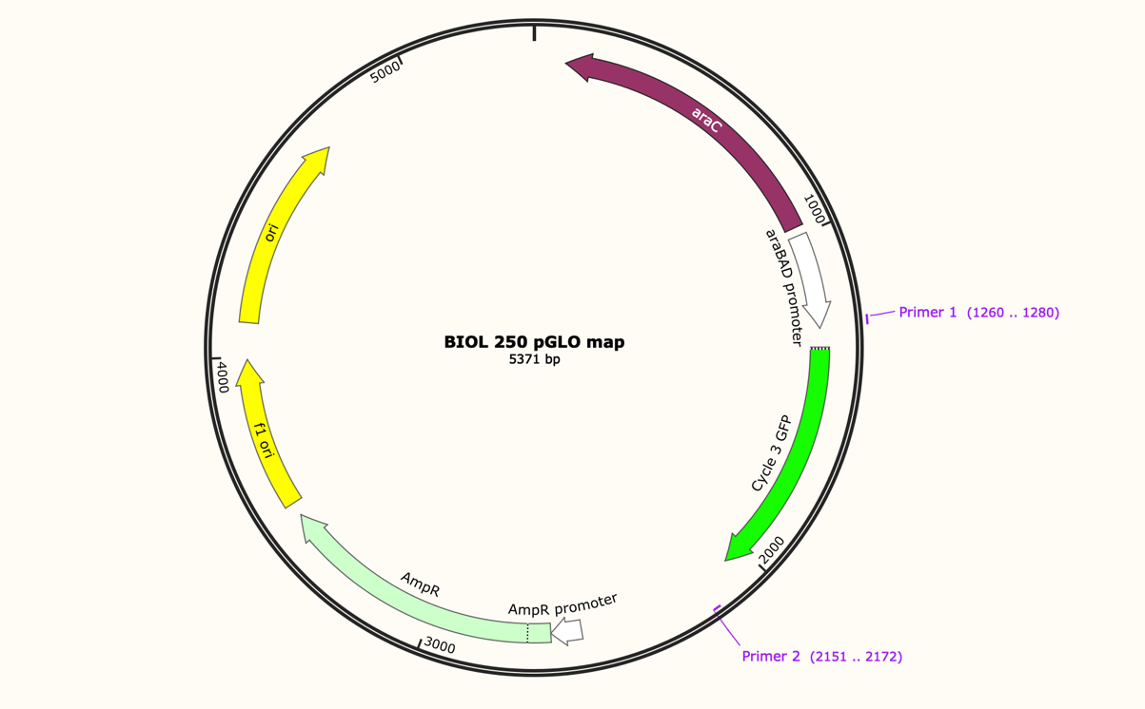
Figure 6. A map of the pGLO plasmid was constructed. 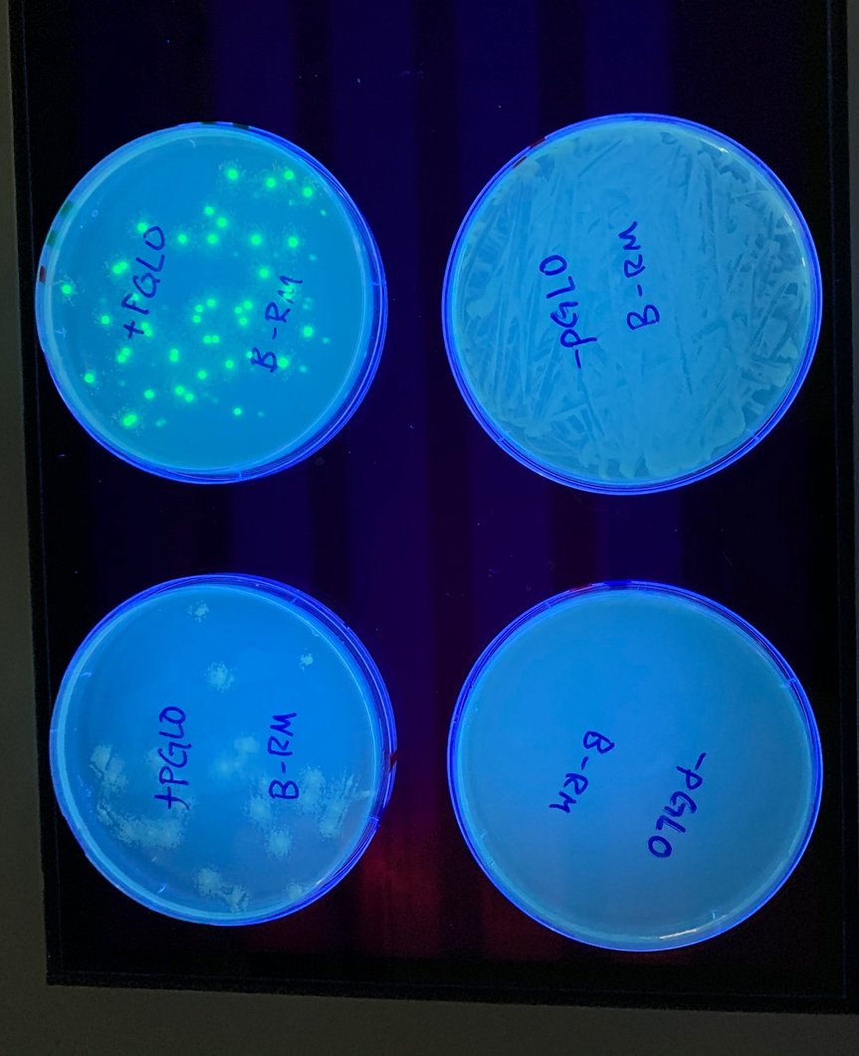
Figure 7. Photo of +/- pGLO transformed bacterial growth in LB/LB+amp/LB+amp+ara plates exposed to UV light

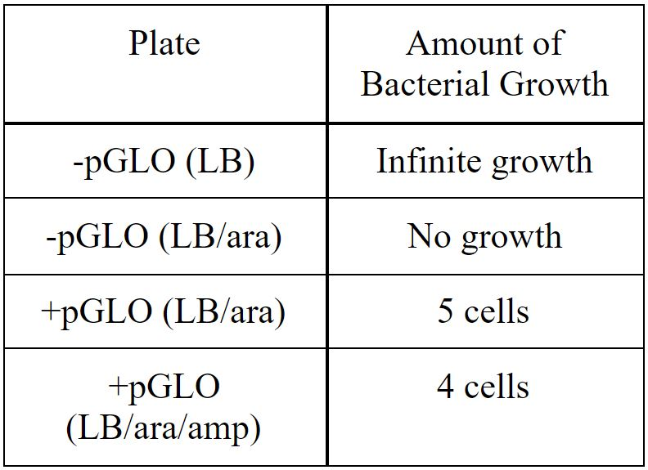
Table 1. Table of + and -pGLO transformed bacterial growth in LB/LB+amp/LB+amp+ara.

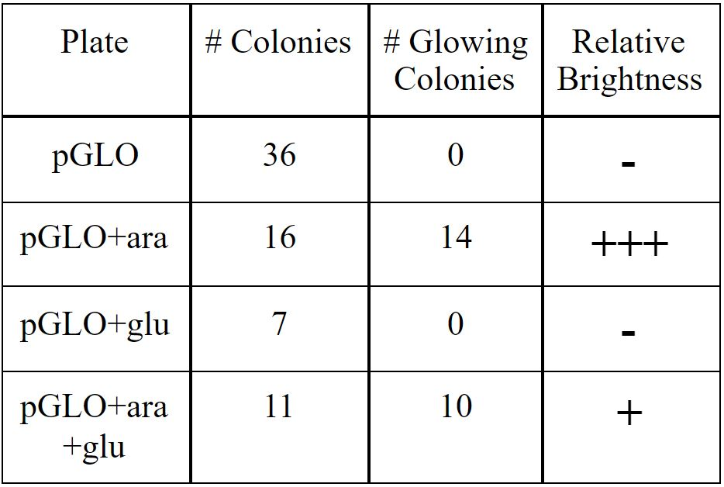
Table 2. Table of pGLO growth and glow in ara or glucose or both sugars plates.

Reference

Cabantous, S., Terwilliger, TC., Waldo, JS. 2005. Protein tagging and detection with engineered self-assembling fragments of green fluorescent protein. Nature Biotechnology. 23: 102-107.

Huber, JA., Morrison, HG., Huse, SM., Neal, PR., Sogin, LR., Welch, DBM. 2009. Effect of PCR amplicon size on assessments of clone library microbial diversity and community structure. Environmental Microbiology. 11(5): 1292-1302.

Shimomura, O. 2009. Discovery of Green Fluorescent Protein (GFP) (Noble Lecture). Angewandte Chemie. 48(31): 5590-5602.

Yao, YR., Tian, XL., Shen, BM., Mao, ZC., Chen, GH., Xie, BY. 2015. Transformation of the endophytic fungus Acremonium implicatum with GFP and evaluation of its biocontrol effect against Meloidogyne incognita. World Journal of Microbiology Biotechnology. 31(4): 549-556.

