Rebecca Mills
Results
B. rapa plants containing two different levels of nitrogen revealed that plant height was dependent on the nitrogen concentration. The average height of plants exposed to nitrogen was 9.5 cm, while the average height of plants without nitrogen was 4 cm less, which was 3.5 cm (Table 1). The plant height of those without nitrogen ranged from 1.5 cm to 4.5 cm. The spread of the nitrogen-exposed plants is much greater, ranging from 4.5 cm to 13 cm (Figure 1).
 | mean | min | max
Y | 9.5 cm | 4.5 cm | 13 cm
N | 3.5 cm | 1.5 cm | 4.5 cm
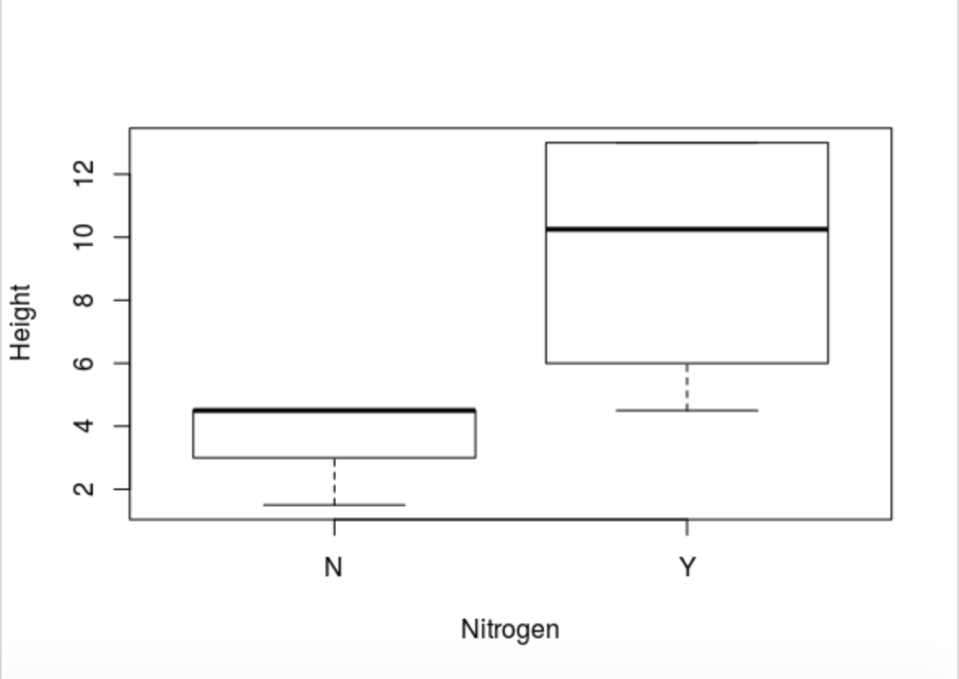
Table 1: Mean and range of heights of surviving Brassica rapa seeds with exposure to no nitrogen (N) and available nitrogen (Y).
Figure 1: Box and whisker plot displaying the heights of Brassica rapa plants containing no nitrogen (N) and available nitrogen (Y). The bold horizontal line represents the median. The boxes represent the first and third quartiles and the whiskers represent the range.

