

**For the Health of it! Learning and Course Design**

**Pre-Spring Semester Workshop Series**

**January 4 and 5, 2023**

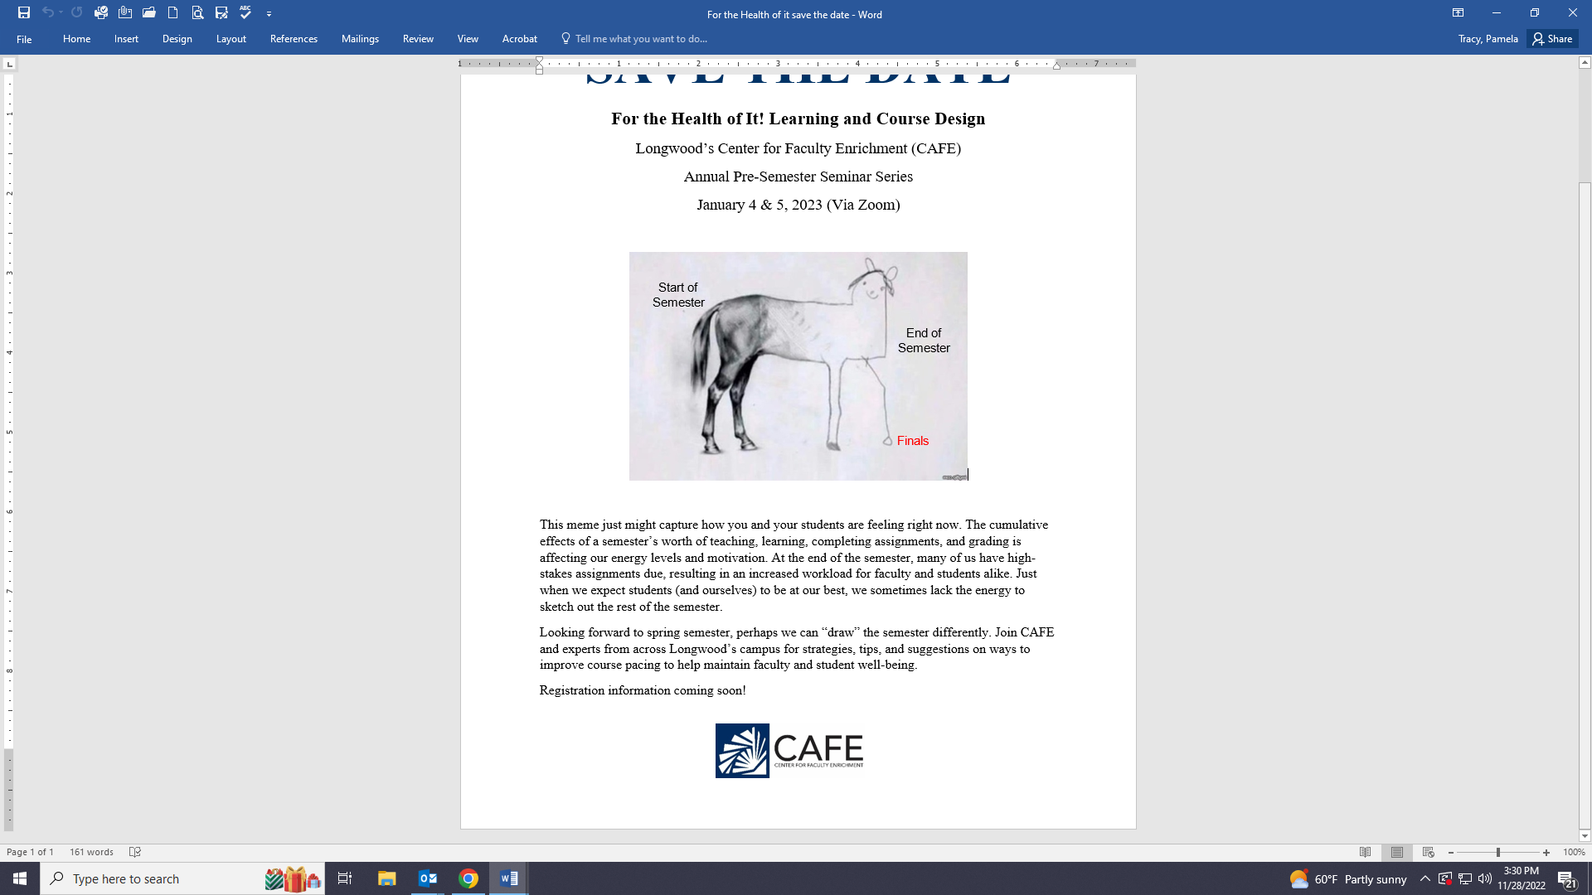

**http://www.alibati.com/horse**

This meme just might capture how you and your students feeling around week 10. The cumulative effects of a semester’s worth of teaching, learning, completing assignments, and grading is affecting our energy levels and motivation. At the end of the semester, many of us have high-stakes assignments due, resulting in an increased workload for faculty and students alike. Just when we expect students (and ourselves) to be at our best, we sometimes lack the energy to sketch out the rest of the semester. Looking forward to spring semester, perhaps we can “draw” the semester differently. Join CAFE and experts from across Longwood’s campus for strategies, tips, and suggestions on ways to improve course pacing to help maintain faculty and student well-being.

**Register @** <https://forms.gle/wG7BGegTY47wwiVQ7> .

**All sessions via Zoom unless indicated otherwise.**

**January 4, 2023**

**9:00-4:45pm**

9:00- 9:20

Welcome: Designing a Different Horse

Pam Tracy, Director of CAFE and Professor, Communication Studies

9:30-10:45

**Keynote Address**

**Ubuntu Pedagogy: Cultivating a Sense of Belonging and Connection**

Facilitator**:**Dr.Alecia Blackwood, Visiting Assistant Professor, Education

For the opening session, let's set the tone by learning about *ubuntu* pedagogy as an approach for humanizing the classroom. The adaptation of this traditional African approach has five pillars: the understanding of self, building relationships and setting boundaries, unifying the students to work together, nurturing student intellects, teaching from a position of love and care, and using evidence-based practices to meet the diverse needs of all students. Cultivate your cultural competence for teaching and gather practical examples that capture different pedagogical options for affirming and dignifying all learners. Leave this session ready to apply some basic principles that can strengthen Longwood community and connections, creating a transformative learning environment.

**Workshop Sessions**

11:00-12:00

**Slow Teaching: Reflection and Meditation for Clarity and Calm in the Classroom**

Facilitators: Dr. Heather Lettner-Rust, Director, Civitae and Professor of English; Dr. Renee Gutiérrez**,** Associate Professor, Spanish and Assistant Director, CAFE

Slow teaching is a recently documented practice (Berg & Seeber, 2016; Thom, 2019) encouraging teachers to resist the speed of the academy which as one review claims "prioritises exams and data as opposed to student wellbeing and good character." This session will include your wellbeing as we share and engage in you in reflection and meditation as both a restorative and generative cognitive tool. Dr. Heather Lettner-Rust, Director of Civitae, and Dr. Renee Gutiérrez, an Assistant Director of CAFE, will share the why and how of slowing down while giving you concrete suggestions and practices for the classroom.

1:00-2:00

**Sustaining Energy all Semester Long**

Facilitator**:**Dr. Jenny Retallick**,** Licensed Clinical Psychologist and Trauma Specialist

Counseling and Psychological Services (CAPS)

Maintaining momentum throughout the semester can be challenging, especially as responsibilities build and free time declines. In this session, we will discuss preventative strategies that will help keep you on track. We will focus specifically on including joy in your life, self-care, and establishing boundaries to help avoid burnout, as well as discussing how to overcome obstacles that may get in your way.

2:15-4:45

**For the Health of it! Planning: Planning a Productive Semester**

Facilitator:Dr. Renee Gutiérrez**,** Associate Professor, Spanish and Assistant Director, CAFE

Allen 205 or via Zoom

Snacks and drinks provided.

A great semester (with an optimal work/life balance) can spring from a few short hours of organizing and thinking. Join a workshop based on Kerry Roquemore’s technique for planning; learn key strategies that can be applied to a productive and restorative semester, and take time to work through the process of planning your Spring 2023.

**January 5, 2023**

**9:00-3:30pm**

**Workshop Sessions**

9:00-10:00

**Scaffolding & Assignment Pacing**

Facilitator**:**Dr. Adam Franssen, Associate Professor, Biology and Assistant Director, CAFE; Dr. Renee Gutiérrez**,** Associate Professor, Spanish and Assistant Director, CAFE

It seems like every year, every semester, everyone – faculty and students alike – are worn out in the final weeks of class. Unfortunately, those last few weeks often contain a huge percentage of the class’ total points. When energy is lowest, students are scrambling to put together final papers, assignments, and studying for major exams. The goal will be for faculty to develop a plan to pace assignments and provide timely feedback that helps students meet course outcomes without over-taxing either group.

10:15-11:15

**Designing Final Assignments**

Facilitator**:**Dr. Amorette Barber, Associate Professor, Biology and Director, Office of Student Research;

Dr. Adam Franssen, Associate Professor, Biology and Assistant Director, CAFE

As part of our course preparation, we need to decide on what happens during finals week. We ask ourselves if students will write a paper or give an oral presentation or take a cumulative final. We consider how long should the assessment should be, how much it is worth, and how long it will take us to grade. In this session, we’ll discuss final assignment options in the context of Symposium Day and the Showcase for Research and Creative Inquiry. We will discuss approaches for summative assessments that will benefit you and your students at the end of a long semester without being completely overwhelming.

11:30-12:30

**Efficient and Effective Feedback Strategies**

Facilitator**:**Dr. Elise Green, Assistant Professor, English and Teaching Writing Faculty Consultant, CAFE; Dr. Kris Paal**,** Associate Professor, Communication Studies and Teaching Speaking Faculty Consultant, CAFE.

Providing effective feedback is an important part of any student learning experience.  In this session, we will discuss and apply strategies to make giving feedback easier and more effective for both writing and speaking assignments.  Participants will also be able to share and offer their own best practices for providing student feedback.

1:30-3:30

**Course Prep Pomodoro**

Facilitator: Dr. Pam Tracy, Director of CAFE and Professor, Communication Studies

Allen 308 and 310 or via Zoom

Snacks and drinks provided.

Join the CAFE staff in person or via Zoom to work on your course preparation. Design in the community of others using [the Pomodoro Technique](https://luxafor.com/pomodoro-technique-time-management-life-hack/) by Francesco Cirillo.