Improving Our Future Generations of Children’s Academic Success

Department of Sociology, Anthropology, and Criminal Justice Studies, Longwood University
SOCL-345-03
Isabella R. Olson
JoEllen Pederson, Ph.D.
November 22nd, 2023

Abstract
The issues impacting parental involvement and how beneficial family involvement in children’s academic success are crucial and need to be explored in preparing our future generations. The purpose of this mixed methods study is to analyze parental involvement in families whose children attend HeadStart throughout rural Virginia and to encourage family involvement through Family Fun Time activities. Students at Longwood University collected data through surveys sent out to the parents. Qualitative data from the respondents' answers portrayed common themes of family involvement, patience, and fine motor skills. Quantitative data showed that in non-single parent households, the level of family involvement was increased. Implications of this study supports that these activities do encourage increased family involvement and beneficial for children’s academic success.

Introduction
This research paper is an analysis of parent involvement of children who attend HeadStart in rural Virginia. The goal of this paper is to answer the research question of, “With the activities being sent out to the children’s families, will family involvement increase for those who participate in them?”. Family involvement and its relationship to children’s academics has been proven to be interlinked (Epstein, 1997). Studies have shown that with more parental involvement, children's academic success was increased compared to those lacking parental involvement (Pong et al. 1986). This is vital in ensuring our future generations' academic success. Children need to be given the best opportunities to be able to succeed in their adult life. What they learn in their adolescent years is going to stay with them. The better of a chance they receive through increased parental involvement, the better prepared they will be.
While conducting research, other academic studies found contradictive findings (El Nokali, 2010). Findings showed that there was no impact of parental involvement on children’s academic success, minus one exception in reading skills (El Nokali, 2010). This makes this study even more important to show that parental involvement is in fact important and to contribute to data and research on the topic of parental involvement and relation to children’s academic success. The purpose of this study is to analyze parental involvement in families whose children attend HeadStart and to encourage family involvement through Family Fun Time Activities.
Literary Review
When raising children, there are many components that are involved with this process. In children's academic success, parent involvement is a key component. However, factors such as: low-income, single parent, parental stressors, etc.; are impactful to parent involvement in their children education (Pong et al., 1986). In this literary analysis, research is explored in parental involvement in young children's education and how outside factors affect parent involvement.
Parent Involvement
Over time, programs have been put into place to help develop relationships with parents, stronger communication, and provide more opportunities for parents to have a more active role in their child’s schooling (Stitt & Brooks, 2014). It was acknowledged that parental involvement is important and improving programs for parents to better have an opportunity to be more involved in their children’s lives. One of these programs is called Head Start, which is a federal program is an early childhood program in the United States that supports low-income children and their families. In their analysis of Head Start, Ansari and Gershoff (2016) found that parents who had higher involvement in the program were more likely to engage in cognitive stimulation by the end of the year and found that there was an increase in such engagement with their children over the follow year. Programs like these are trying to engage parents more in their child’s education since it has a positive impact and is important because they are our future generations.
This is supported in Joyce Epstein’s article (1997). She stated that “the internal model of the interaction of the three spheres of influence shows where and how complex and essential interpersonal relations and patterns of influence occur between individuals at home, at school, and in the community” (Epstein, 1997). The relationship the student has with home, including parent involvement, is an important influence on a child’s education. Additionally, years of research has shown evidence that parental involvement does have a direct impact on the academic success of students (Stitt & Brooks, 2014).
To support this, Xin et al. (2016) conducted a meta-analysis of the relationship shown between learning outcomes and parental involvement during early childhood education and early elementary education from 46 studies. His findings supported the importance of parental involvement in relation to children’s learning outcomes. The results showed that, in terms of family involvement, behavioral involvement, home supervision, and home-school connection provided to be significant and had a strong, positive relationship.
Another analysis was conducted by Oyserman et al. (2007) by doing a 2-year follow up of a randomized clinical trial. One of the results yielded that students with higher parent involvement had higher grades and better teacher-rated behavior compared to the control groups whose parent involvement was low to moderate. These analyses show sufficient evidence that parent involvement does have a strong relationship with student academic achievement but does not account for outside stressors.
Single Parent Households
Evidence supports that children in single parent households have a decreased amount of academic success. In a study conducted by Milne et al. (1986), their results showed that children from two-parent families had higher scores on reading and math achievement tests than students from one-parent families. In single-parent families, the parent does not have as much time and support as a two-parent family would. This can be impactful to parenting. These parents have to raise a child, manage household tasks, work, and much more all on their own. This means less time going directly to their children.
To further support this, Pong et al. (1986) conducted a study between multiple countries, including the United States, on living in a one-parent family on children’s achievement. In their study, results yielded that the United States was ranked first in terms of strength of negative relationship between test scores and single parenthood. Single parents are struggling to be able to have enough time in their day to be there for their children academically.
Contradictive Findings
It is important to note that not all research supports the above evidence. In other works, researchers found that parent involvement did not influence their children’s education. In a study conducted by El Nokali et al. (2010), his findings showed parent involvement did not predict changes in children’s achievement. Results showed that “increases in parent involvement were largely unrelated to individual growth in academic skills, regardless of whether parents or teachers reported on parent involvement practices. One exception emerged for reading skills” (El Nokali, 2010). However, these works contradict each other and show that more research needs to be done in this field on a broader spectrum of participants.
This research is important and shows the consistent evidence shown between a positive relationship of parent involvement and children’s educational success. While some evidence does prove against it (El Nokali, 2010), most studies do show substantial data (Stitt & Brooks, 2014). Children’s education is important and to better help them succeed academically, parents need to be involved. There are various programs to help parents be able to actively engage in their education.
Data and Methodology
Instrument
A survey questionnaire was created by 10 members of the Social Research and Program Evaluation Team at Longwood University. The survey consisted of 14 questions, 11 closed-ended questions and three open-ended questions. The first question on the survey asked respondents for informed consent. Any respondents who answered “no” to the informed consent were not able to see any other questions. The survey included questions that measured family involvement, family enjoyment, evaluation of SMART objectives, and demographics. The survey was sent online through the Qualtrics program. Head Start teachers e-mailed links to the survey to guardians, and children brought home books with a QR code attached.
Sample
The non-probability sample for this study was based on 17 children (ages three to five) who attend Head Start in rural Virginia. Head Start is a federally subsidized preschool for families with economic need. The Research Team’s Family Fun Time activity that was sent out was a Sensory Writing Bag. In this activity, children were given a list of instructions to demonstrate their fine motor skills. After the activity was completed, guardians were encouraged to fill out the survey sent out via e-mail and QR code. Teachers sent a reminder e-mail to guardians to complete any outstanding surveys. This resulted in four questionnaires being completed. Overall, there was a 4% response rate. Therefore, data from previous years (2019 and 2022) on Family Fun Time activities were added to the analysis. This resulted in 66 completed surveys to be used in analysis (four from 2023, 20 from 2022, and 42 from 2019).
Quantitative Analysis
Quantitative analysis of completed surveys is based on the close-end questions. For this study, the dependent variable is family involvement. The items from the survey that was used to operationalize this was, “On a scale from 0 to 10, how much did this activity encourage your family to work together?” (0=not at all, 10=a great amount). The independent variable for this study is if the child lives in a single parent household. This is operationalized using the item “Does your child live in a single-parent household?”. Answer choices for this item are, “Yes, No, Prefer not to say”. Descriptive statistics were used to analyze these variables.
Qualitative Analysis
Qualitative analysis of the completed surveys (from 2019, 2022, and 2023) was based on open-ended questions from survey questions. The open-ended questions were, “What did you enjoy about this activity?”, “What are your suggestions for improving this activity?”, and “Typically, what activities do you do with your child?”. To answer the research question, “With the activities being sent out to the children’s families, will family involvement increase for those who participate in them?”, inductive open coding was used to determine reoccurring theme in the respondents’ responses.
Qualitative Findings
In the family fun time activities, there were three predominant themes shown throughout the surveys. The 3 themes include: Family involvement, children learning patience, and children improving fine motor skills. Parents expressed how the activities created more family time together, how their children were learning patience, and how children were showing creativity.
Family Involvement
Out of the 36 surveys sent out to the children’s parents from Head Start, 21 of the respondents expressed that they enjoyed the activities because it created more family time together. Respondent 19_13 stated, “We were together doing these activities my brother, me, and my son. We usually [do not] do those kinds of things together. I want to continue doing those things together. My son was happy and it was fun”. These family fun time activities are bringing together families and encouraging parents to actively participate with their children. Respondent 22_12 stated, “[My] family [and] son enjoyed doing the little thing he was doing together”. Families are spending quality time together doing these educational activities. In doing so, it is promoting family involvement. Respondent 22_10 stated, “Doing them together. [Child’s name] says she loves doing things with mom and dad”. Parents are learning, if they have not already, that they can still spend time with their children and do an activity that is educational. Parental involvement is crucial for the development of their children in their adolescent years. This data shows that the family fun time activities sent out brought over 50% of parents and their children together and experienced quality time together while still doing an activity that is educational.
Learning Patience
While it is not the vast majority, it is still important to analyze that ten out of 36 the respondents expressed how family fun time activities taught their children about patience. When asked the question of, “Please explain what your family gained from these activities. How will you use what you have gained in the future?”, respondent 19_18 stated, “Working together takes a little patience”. Throughout these educational activities, children are learning valuable life skills that can be applied outside of an educational setting. To further support this, respondent 22_14 stated, “It takes time and patience to complete [things,] but it can also be fun”. Children are now making the connection of learning how to demonstrate patience while also having fun. Being able to work with other people in a team and to be patient is a valuable skill that is needed and applied in everyday life. Respondent 22_13 stated, “Patience, not giving up if something [does not] go her way or look how she expected it to”. These activities are achieving much more than just being educational. They are learning educational material and vital life skills.
Fine Motor Skills
Out of the 36 surveys, nine respondents explained how their children were improving their fine motor skills through them doing the family fun time activities. Respondent 19_06 stated, “The sugar tray was my favorite because it helped [child's name] with writing her name”. At these young ages, developing fine motor skills is essential. Furthermore, respondent 22_02 stated, “Learned how to cut and glue [and] how to trace better”. Children like this respondent’s child, are gaining additional skills other than the educational purpose of the said activities. Likewise, respondent 22_01 stated, “Practiced cutting with scissors”. Practicing cutting with scissors and the other actions above, like writing their name, are building blocks of fine motor skills. Doing these activities will enhance their fine motor skills and will be beneficial to them all throughout their lives.
In summary, the three main themes shown throughout the 36 surveys are family involvement, children learning patience, and children improving their fine motor skills. Family involvement is critical in a child’s academic success and over half of the respondents enjoyed these activities because they (and additional family members in some cases) got to do it all together. Not only did children receive parental involvement and enjoyment in the family fun time activities, but they also developed important life skills like patience and increased their fine motor skills. Both skill sets are very important and will be used all throughout their lives. These FFT activities are helping these particular families beyond the academic field.
Quantitative Findings
The dependent variable is Family Involvement. This is asked on a scale of 0 (Not at all) to 10 (a great amount). The independent variable is Single Parent Households. Respondents answered with “yes” or “no”.

Table 1
Mean and Standard Deviation of Family Involvement
Involvement
Mean  Standard Deviation | 7.2  2.8
Note. N=66
Table 1 shows about 68% of respondents answered between 10 and 4.4. This means that a majority of respondents experienced higher levels of family engagement while doing the family fun time activities. This table exhibits a great amount of variation of the respondents’ answers.

Figure 1
Count of Single Parent Households
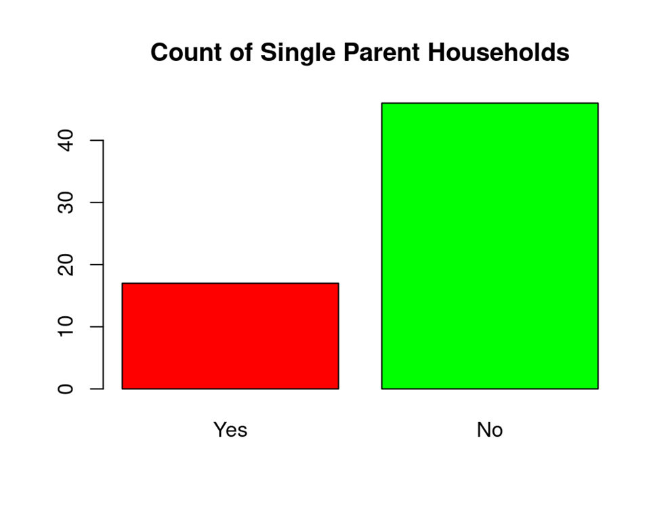
Figure 1 illustrates that non-single parent households comprised the majority of respondents. Of the sixty-six respondents, seventeen were from a single parent household (25.67%) and forty-nine had more than one parent in the household (74.24%).

Table 2
Bivariate analysis of Family Involvement and Single Parent Households
Single Parent Household | Mean | Standard Deviation
Yes  No | 7.9  6.8 | 2.4  2.7
Note: N=66
Table 2 demonstrates that compared to single parent households, non-single parent households experienced higher levels of family involvement. The mean for respondents that answered “yes,” is 7.9 with a standard deviation of 2.4. The mean for respondents that answered “no,” is 6.8 with a standard deviation of 2.7.

In summary of the findings, the family fun time activities increased family involvement overall from the respondents’ survey’s answers. Compared to single parent households, non-single parent households showed an increased level of family involvement.

Conclusion
In conclusion, this data collected from parents whose children attend HeadStart answered the research question of, “With the activities being sent out to the children’s families, will family involvement increase for those who participate in them?”. Parents expressed how these activities increased their level of family involvement. To further support, from qualitative findings, respondent 19_13 stated, “We were together doing these activities my brother, me, and my son. We usually [do not] do those kinds of things together. I want to continue doing those things together. My son was happy, and it was fun”. Parents are realizing that quality time spent together can still be fun in an academic setting with the Family Fun Time activities. The quantitative results yielded higher levels of family involvement overall from the respondents' survey answers about the Family Fun Time Activities. Studies discussed earlier in this research show support that parental involvement does impact children's academic success (Pong et al. 1986).
This is important data because the children being raised now are our future generations. Society should care about this because it is knowledge that can be applied to increase children’s academic success rate. Individuals may not know that parental involvement has an impact on children’s academic success, but with this research along with other academic works, that could be changed.

References
Ansari, A., & Gershoff, E. (2016). Parent involvement in head start and children’s development: Indirect effects through parenting. Journal of Marriage and Family, 78(2), 562–579. http://www.jstor.org/stable/24734736
El Nokali, N. E., Bachman, H. J., & Votruba-Drzal, E. (2010). Parent involvement and children’s academic and social development in elementary school. Child Development, 81(3), 988–1005. http://www.jstor.org/stable/40599147
Epstein, J. L. (2010). School/family/community partnerships: Caring for the children we share. Phi Delta Kappan, 92(3), 81–96. https://doi.org/10.1177/003172171009200326
Ma, X., Shen, J., Krenn, H. Y., Hu, S., & Yuan, J. (2016). A meta-analysis of the relationship between learning outcomes and parental involvement during early childhood education and early elementary education. Educational Psychology Review, 28(4), 771–801. http://www.jstor.org/stable/44955364
Milne, A. M., Myers, D. E., Rosenthal, A. S., & Ginsburg, A. (1986). Single Parents, Working Mothers, and the Educational Achievement of School Children. Sociology of Education, 59(3), 125–139. https://doi.org/10.2307/2112335
Oyserman, D., Daniel Brickman, & Marjorie Rhodes. (2007). School success, possible selves, and parent school involvement. Family Relations, 56(5), 479–489. http://www.jstor.org/stable/4541690
Pong, S., Dronkers, J., & Hampden-Thompson, G. (2003). Family Policies and Children’s School Achievement in Single- versus Two-Parent Families. Journal of Marriage and Family, 65(3), 681–699. http://www.jstor.org/stable/3600032
Stitt, N. M., & Brooks, N. J. (2014). Reconceptualizing parent involvement: Parent as accomplice or parent as partner? Schools: Studies in Education, 11(1), 75–101. https://doi.org/10.1086/675750

