Positive Effects of Interaction  Children who experience more positive interactions with their parents have a happier outcome in life. With the consistent use of positive interactions between the parents and their children had a higher association with the positive interactions that the children had with their parents. | School Expectations  Positive interactions with children go deeper than just with a parent, these interactions can also happen at the school level. These expectations to have positive interactions can happen at schools. These are important for the child t0 succeed in a school setting. If a child is having a negative interaction with a teacher, then this can lead to poor school performance and other emotional and behavioral issues as they age. | “One of the most important things we adults can do for young children is to model the kind of person we would like them to be” | Child Interaction  Optimum Childhood Development  By: Hannah Viola
 | Positive Associations  When a parent interacts with their children in a positive manner, the child can directly benefit from this. With positive interactions, it will help the child build their emotional stability and will continue to grow stronger in the future. The consistency of this has been proven to work and can improve the child’s wellbeing |  | 
 | 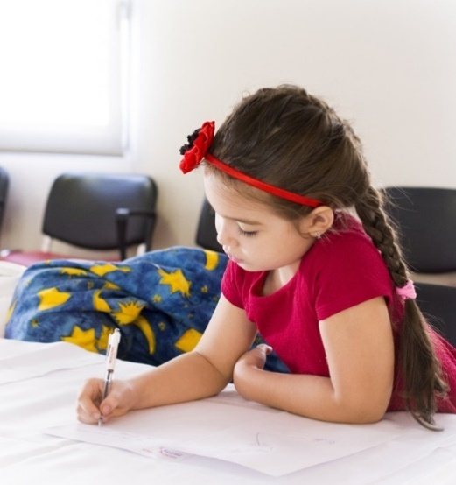 | Some ways that parents can promote a positive interaction is by showing encouragement to their children. This can be done at infancy and can be encouraged throughout their lives. Even what we may not think is a big deal, like responding to babble, can mean the world of differences to a child.

Negative Reactivity  Children see interactions that adults have, and they mimic those interactions. If a child sees an adult demonstrating a negative behavior, they will go onto demonstrate that behavior. During a young age, children are influential, both positive and negative. When a child is exposed to a behavior, they will exhibit it. This can cause negative impacts on the child as they grow into adolescent years. | Parenting Interventions  - Responding to good behavior  - Consistent in setting rules  - Ignoring bad behavior  - Time outs  - Star Charts  - Establishing routines | 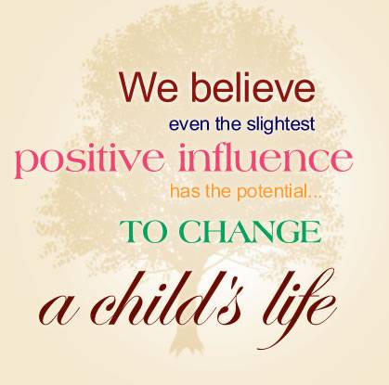 |  | 
 | Bystander Help  The bystander approach has helped to reduce child maltreatment in society. This approach is used as campaigns on the television, radio stations or on billboards. This approach has been helpful for allowing bystanders to know the common experiences shown when a parent is having negative interactions with a child to help reduce those negative interactions. This would be incased you were to ever encounter a case in public, you could step into help another child in need. | 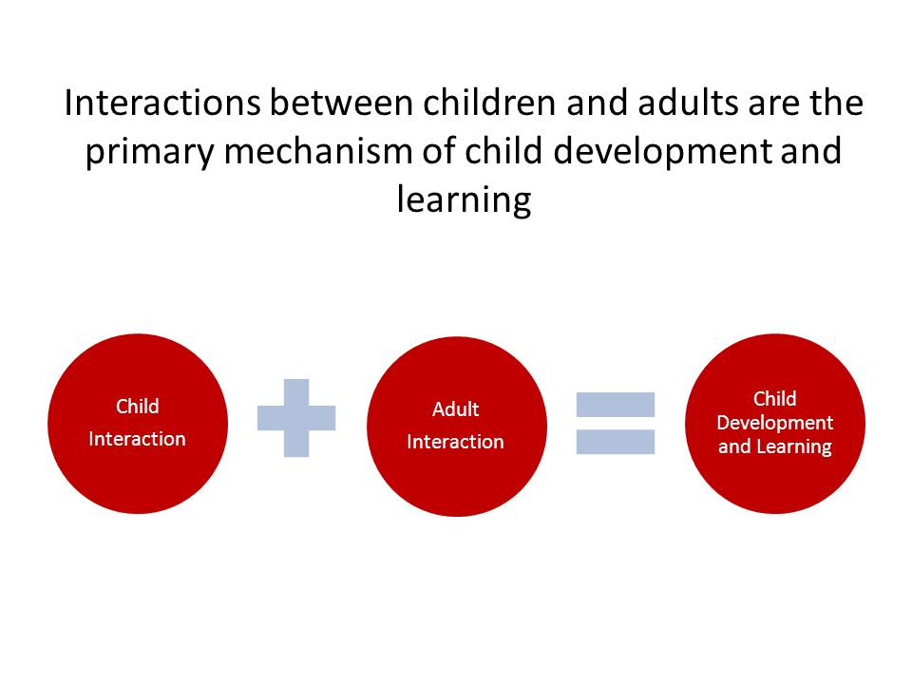 |  | As parents, everyone, wants what is best for their child. The more time that is put in to children as encouragement can help them grow to become successful.
 |  |  | Parenting Helpline  1-800-CHILDREN is a resource for parents from all occupations, educational backgrounds, socioeconomic statuses, and parenting orientations. Anyone that cares for children, including professionals, are encouraged to call when questions arise. | 

The topic that I am researching is on positive ways to interact with children to facilitate optimal childhood development. The audience that I am looking to target are parents of all different backgrounds in life. The parents that I will target will come from all income and socio-economic backgrounds. The way that I plan to educate parents in the form of a brochure. I am going to use the brochure to highlight key parts in how to positively interact with children to peak their childhood development which will create a positive outlook for when they grow up to become adults. In the brochure, I will include visual charts along with statistics to show how positive interactions can be beneficial to their mental, emotional, and physical growth.
A brochure is an appropriate resource for my audience because it does not overwhelm parents with information all at once. A brochure is also a visual representation of what can be done as a speech. I feel that when you see things on paper, you are more likely to remember and take that into consideration that someone talking to their audience about a certain topic. For parents, this will give them key point to highlight the benefits of positive interactions in an informative way instead of a pessimistic way that would make them feel bad. A brochure is also something that they can keep with them and refer back to when it is needed.

