Community Needs Assessment
Longwood University

Eliza Ayles Kalista Decker Samantha Nicholson

Lack of Affordable and Accessible Childcare in Farmville, VA

Introduction
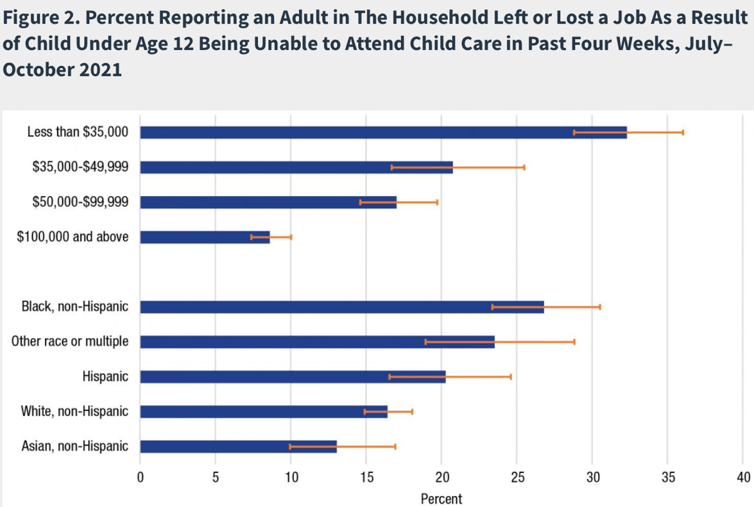
When taking the time to identify a prevalent issue within the Farmville area that needs to be solved, it was found that the lack of affordable and accessible childcare is a pressing community obstacle. Importantly noted, something that many people are unaware of, is 17% of families in the Farmville area need childcare¹. This is a significant challenge that community members should care about because it could be affecting someone’s mother, sister, other family members, and/ or
friends. In addition to this, the lack of affordable and accessible childcare limits individuals within the community from maintaining employment. As it is included on this page, the graph further explains the issue pertaining to how childcare can impact a family’s livelihood.
²
Another reason that the lack of affordable and accessible childcare is a problem is because children and families who lack access to childcare can be considered a vulnerable population as they
are being placed at risk for their basic needs being met. When families’ basic needs are not met, this can be detrimental because they correlate to one’s economic health, education, sense of community, and environment within the childcare community.
Problem
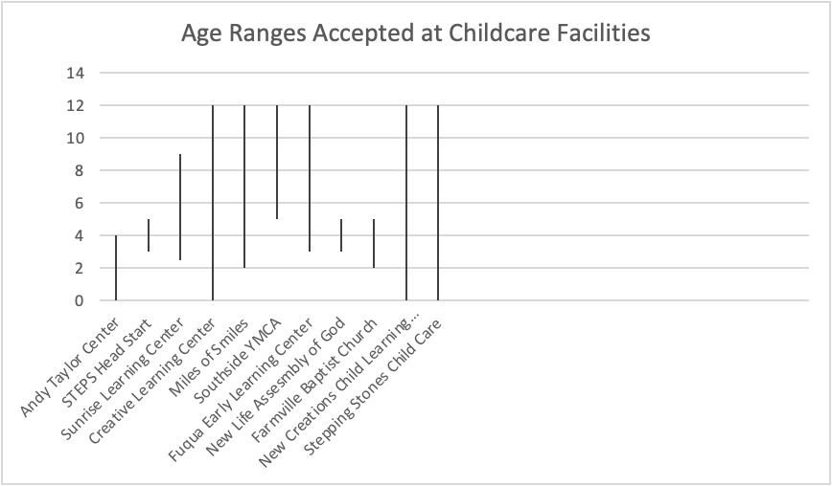
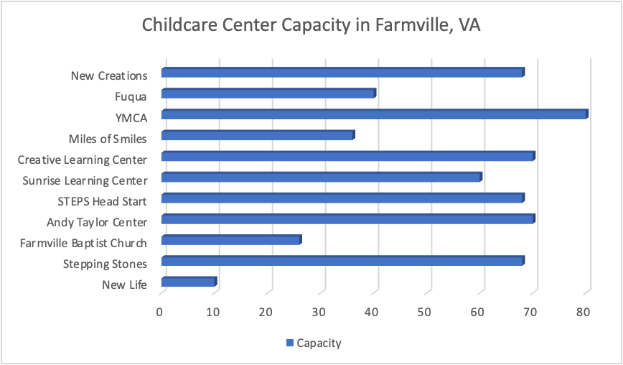
As the authors of the paper further evaluated the problem, they found that some of the biggest risk factors associated with this problem are: losing a job and becoming unemployed, a decline in mental and physical health, poverty which can lead to potential homelessness, potential loss of insurance and transportation, and a lack of socialization for the children. Due to this, the issue that the community will continue to endure is challenges with accessing and affording childcare. In Farmville specifically, it was found that there was a drastic range of capacity available for children at childcare centers within the local area. In addition to that, the childcare centers in the Farmville area only accept specific age ranges, which can cause an obstacle for those families who do not meet those qualifications.
As it can be observed in the Childcare Center Capacity graph, since some of the childcare facilities can only hold a maximum of 10 to 25 children, this results in there being long waitlists for enrollment. In addition to this, as it can be observed in the Age Ranges Accepted at Childcare Facilities graph, only four out of the 11 childcare centers in Farmville will allow babies under the age of two to be enrolled within the center. Aside from capacity and age ranges being problematic, the price and hours of operation of childcare centers also negatively affect families who are in need of childcare.
“Virginia is ranked 10 out of 50 states and the District of Columba for the most expensive childcare.”
Michael Pope, Radio IQ, 2022³
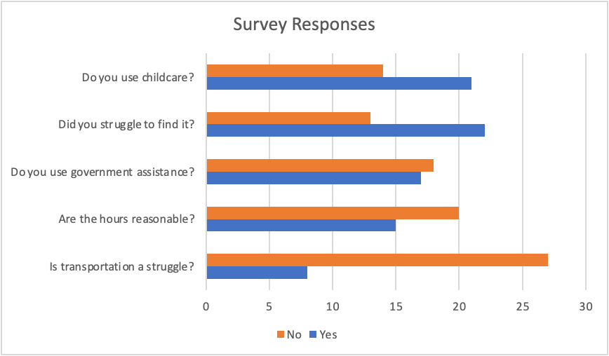
As the authors of the paper recognized that there was a plethora of problems associated with the lack of affordable and accessible childcare, they wanted to conduct a survey questioning 35 people within their local communities in order to gage the respondents’ experiences with childcare. Upon reviewing the survey results, it was clear that many people have had different experiences regarding childcare. Some of the main key findings indicate that a majority of respondents do use childcare, but struggled to find an affordable, accessible center. In terms of government assistance, it was found in the qualitative data that many respondents attempted to utilize government assistance but were denied, not eligible, or were still awaiting a response during the time of data collection.

Solution
In terms of the prominent problem of the limited accessible and affordable childcare in Farmville, VA, it was apparent that this is currently causing severe issues and will continue to cause issues if the problem is not repaired. In order to repair the problem, it is important to consider potential collaborators who can help fix the problem. Below are two of main potentional community collaborators who can assist in improving this extensive problem.
“They’re open from 6:30AM to 6:30PM, but they charge you $5 a MINUTE that you go over that.”
Laura Greeley, 2022⁴
Partners | Strengths/Skills | Roles | Expectations
Prince Edward Social Services | Child Care Subsidy Program | Provide resources and assistance to help fund fees | Act as a partner and advocate for those in need
Childcare Providers | Education and experience | Caring for and teaching the children important skills | Accept subsidies/voucher programs

The grid below represents the organizations needed throughout this process. Beside their names, it lists their skills, contact information, and when their services would be utilized.
Needed Orgs. | Skills | Contact | When Needed
Prince Edward Social Services | Child Care Subsidy Program | (434) 392-3113 | Ongoing
*Name of Childcare Provider* | Education and experience | *Number for specific provider* | Ongoing

10 Solutions
- Flexible jobs
- Childcare at the jobs
- Decreased prices
- Subsidies
- Benefits to employees
- Create more centers
- Community trainings
- Lobbying
- Allow for volunteers
- Extend the hours

Conclusion
In conclusion, the authors of this paper conducted a community needs assessment to explore the potentional needs in Farmville, VA. This assessment discovered the prevalence of the issue rooted in the lack of affordable and accessible childcare. After deciding the scope, defining the scope, and assessing the assets and data collection that was done to research and evaluate this problem, it was evident that there are many potentional solutions to improve the problem. Overall, it can be stated that many families both in Farmville, and other surrounding areas of Virginia experience difficulties when it comes to accessing and affording childcare.

Action Plan
Key Finding | Response | Deadline | Person Responsible
Childcare centers are too expensive | Consider altering childcare prices OR consider allocating more government assistance | Summer 2023 | Childcare centers or Social Services
Childcare center hours are not accommodating | Consider altering hours of operations | Summer 2023 | Childcare centers
There are not enough childcare options | Consider developing new centers | ASAP OR Summer 2023 | Government
Childcare center waitlists are too long | Consider expanding center capacity | ASAP OR Summer 2023 | Childcare centers

Call to Action:
While this is only the start to improve the issue pertaining to the lack of affordable and accessible childcare, it is important to note that there is still a great amount of work to be done. Even though this problem may not personally affect you now, it can affect you or a loved one in the future and it is your responsibility to advocate and act now!

About
The authors of this paper, Eliza Ayles, Kalista Decker, and Samantha Nicholson, are three Social Work Seniors at Longwood University. Their passion for working with children has allowed them to prosper while conducting primary and secondary research pertaining to the childcare epidemic. Through surveys and diligent research this group has been able to conduct a needs assessment that resulted in the formulation of an action plan to improve the lives of the vulnerable population affected.

