Salmon Runner
Leah Eick
13 July 2022

I have neither given nor received help on this work, nor am I aware of any infraction of the Honor Code.
Leah Eick
The sun was shining brightly and the sky was a vibrant shade of sapphire. It was early in the morning, so the summer heat and mosquitos hadn’t emerged yet. I examined the truck bed once more to ensure I had packed all the gear for a perfect fishing day. Fishing rods? Check. Tackle box? Check. Fishing license? Check. Cooler full of snacks and sandwiches? Check. The only thing left was Caleb.
Just as I thought of him, he came running out of the front door wildly. His face beamed with excitement and his smile was big enough to show all four of his missing teeth. “I’m ready, Mom!” he shouted as he pulled at the truck door and hopped into his car seat. I smiled to myself and got into the car to drive us to Resurrection Bay.
“Where are we going this time, Mom?” Caleb asked, his feet swinging and kicking the back of my seat. I told him the name.
“What’s that?” he asked curiously.
“Well, Resurrection Bay is a big bay that connects to the Prince William Sound and the Gulf of Alaska. There are a bunch of islands in the bay that we can take our boat to. You know my friend, Tony? The one who leads the Kenai Fjords boat tour? He told me once that Resurrection Bay got its name when Russians had to retreat from a bad storm into the bay and it was Easter day, so –“ I began sharing my knowledge with Caleb, but he interrupted me to point and loudly shout that there was a moose on the other side of the road. I laughed to myself; kids have their interests and history is not one of them.
I pulled into the boat launch and Caleb helped me load up our bay boat. It was a small, white boat with a light blue underbelly. Printed on the side was the boat’s name: Salmon Runners. Caleb and my dad had spent hours trying to pick the perfect name for our boat and my dad spent even longer putting the name on the side. As a single mom, I didn’t have much time off work to be with Caleb. My dad stepped in and he nearly raised Caleb from birth on a bay boat fishing for salmon. When my dad died a year ago, I made it my responsibility to continue the fishing tradition with Caleb.
Caleb hopped on the back of the boat and I reminded him to put his life jacket on. He sat on the seat and watched the landscape around us as I began to steer the boat into the open water. I took in the scene around me and breathed in a long, slow breath of cool, refreshing air. Colossal craggy, gray mountains stood tall over us along the shore like ancient protectors. Long streaks of cloud white snow striped the mountains. The water was aquamarine and sparkled in the sunlight. Despite being late June, the air rushing off the water onto our faces was cold enough to make us both wear our hoodies. Late June is prime salmon run season here in Seward (Southcentral Region Department of Fish and Game, 2016). The salmon season lasts about 8-12 weeks (Southcentral Region Department of Fish and Game, 2016). Caleb and I go as often as we can, but since he gets out of school in mid-June, late June is the perfect time to plan our best fishing trips. Our favorite spot to fish is in the Eldorado Narrows near Fox Island in Resurrection Bay. It’s a slightly longer boat trip, but Caleb and I love watching the aquatic wildlife, so I have found that it works out fine.
After watching whales, otters, and seals swim by, we finally reached our destination. “Let’s catch some fish, Mom!” Caleb yelled as he yanked his fishing pole out and scrambled through the tackle box.
“Hold on, buddy. I know you’re excited, but we have to make sure we’re following regulations.” I reminded him as I sat down beside him on the bench. He pushed his brown hair back and sighed heavily.
“You take forever to get set up. I don’t even know what ‘regulations’ means.” Caleb pouted. I rummaged through our supplies to make sure I had everything in place for legal fish catching.
“Regulations means doing something a specific way. We have to follow state regulations to make sure we don’t fish in a bad way, because if we did then the salmon would suffer and there would be less of them.” I explained to him, removing our fishing poles, bait and nets
“Wait…I didn’t know there could be less salmon. Can we run out of salmon?” Caleb asked. His face had changed to an expression of worry and sadness.
“Well, sure. Anything can run out if you aren’t careful and don’t take good care of it. But there’s nothing to worry about, honey. That’s exactly what these regulations are doing.” I reassured him. He seemed pleased with my answer, but I could see there was still some worry behind his eyes. I double checked my wallet to ensure I had my fishing license. My friend, Cecilia, had just taught me how you can use the Alaska Fishing License app to have a mobile fishing license instead of a paper one (Cecilia, personal communication, June 22, 2022), but I was nervous about my phone dying or getting wet and not having access to my license. Lots of tourists think that they don’t need to keep their licenses on them, but I have seen them be escorted off the water because they did not have legal proof of their ability to fish. Caleb didn’t need a fishing license because state regulations don’t require Alaska residents under 18 to have one (Southcentral Alaska, 2022). It made my life easier to only keep track of one. Thankfully, though, my license for a full year was only $20 for being a resident (Southcentral Alaska, 2022). I had my harvest record with me, as well, so that I can keep track of the fish I harvested for the state (Southcentral Alaska, 2022).
Finally, I was ready to fish. Caleb and I cast our lines and watched the water. He always got so excited about fishing that he would jump up and down, rocking our boat and scaring away all the fish. I let him jump because his excitement filled me with joy, and eventually he would tire out and the fish would come back. A soft breeze tickled the skin of my neck. The only sounds were that of nature and a sense of peace and happiness washed over me. It was shaping up to be a perfect fishing day.
Caleb’s line became taught and he shouted, “Mom! I’ve got something!”. I set my line down and helped him remember how to reel in his catch. The fish was light and easy to pull in, so I could tell it wasn’t a salmon. We reeled the fish in and Caleb grabbed its tail and held it up.
“What is it, Mom?” he asked.
“It’s an Arctic Char. We don’t like eating those, so we have to put it back. But great job, darling!” I answered him.
“Can’t we keep it, Mom?” Caleb whined.
“No, baby,” I replied, “the state regulations say if you aren’t going to eat it, then you have to put it back. Here, I’ll show you how.” I assisted him in pulling the hook back through the way it came and gently placing the fish back in the water, following the regulations for humanely releasing fish back in the water (BLM Recreation Guide, 2014).
“I want to catch a salmon!” Caleb yelled excitedly, “I’m going to catch 20 salmon!” He continued. I laughed.
“I’m sure you could, honey. Remember though, we can only catch six regular salmon and two king salmon a day.” I told him (Southcentral Alaska, 2022). Caleb looked disappointed, but cast his pole out again.
We spent the rest of the day fishing, chatting, and eating. Caleb had become calmer after his first catch and spent a little less time talking to me and more time focusing on fishing. We caught a couple fish, but none were salmon. After hours and hours of fishing and relocating the boat, I realized it might not be as perfect of a fishing day as I had hoped. It was time to pack up and head home and we hadn’t caught a single salmon. I turned the Salmon Runner around and headed back for home. I knew there were reports of less salmon recently [insert table 1 here], but it had never been a problem until today. We loved all fish, but my family lived for salmon. The thrill of catching a fish of that size, the pink look of their skin, the taste of a salmon dinner, all of it was so exciting to us. I worried that Caleb would be disappointed and would rather still be fishing with his grandpa than me.
As we headed back, I saw a giant commercial fishing boat in the distance. I rolled my eyes to myself. These big commercial companies didn’t have to follow any of the regulations we did and they gobbled salmon up like it was the last food on earth (Museum of the North, 2022). Commercial fishing made me mad because there are so many other ways to fish that are better for people and for the ecosystem. There’s trolling that uses a slow-moving boat with baited lines hanging from long poles to catch salmon (Museum of the North, 2022). There’s also gill nets. These have floats on the top and sinkers on the bottom to keep them up in the tidal currents to catch migrating salmon (Museum of the North, 2022). Heck, there’s even purse sein where a big net is put in a circle by a seine boat and the bottom is drawn together to catch salmon from the surface of the ocean (Museum of the North, 2022). All of these seemed like better options than commercial fishing. Cecilia had once told me that commercial fishing was one of the big causes for there being less salmon (Cecilia, personal communication, June 22, 2022). I knew she had research behind the fact, but I hadn’t paid much attention to it then. I found it almost infuriating today. I shook the thought from my head and pulled the boat into the dock.
Along the dock were stations for harvesting fish meat. Caleb loved watching people swat at seagulls trying to steal their fish while they harvested them. He thought it was so funny and would laugh hard enough to get a belly ache.
“Hey, buddy. I’m sorry we didn’t catch any salmon today. We caught a lot of other cool fish, though! Do you want to watch the seagulls?” I squatted down and asked Caleb. He shook his head no and started slowly trudging to the truck. I followed him to the truck and piled all of our stuff back into the truck bed. We got in the car and I caught it on to drive home.
“Did you have fun today?” I asked him, looking at him in the rearview mirror. He replied “yeah”, but his face and demeanor suggested anything but.
“Are you excited to see Cecilia tonight?” I asked him. He nodded his head, but his lips were pouted and his eyes downcast.
“What’s wrong, buddy?” I asked. He took in a big breath and let out a long sigh.
“Me and Grandpa used to catch so many salmon and he loved salmon so much. I really miss Grandpa and I’m really sad he’s not here anymore. I don’t want the salmon to go away, too! Then me and Grandpa’s fishing trips will be gone.” Caleb cried. I pulled the truck over and crawled into the backseat with him. He nestled his head into my armpit and I held him close to me.
“Oh, honey. I’m so sorry. I miss your grandpa, too. But the salmon aren’t going to go away. There’s less of them, but the state puts these regulations in place to maintain the salmon numbers so they won’t go away (Grace Waite, personal communication, June 21, 2022). In fact, they even put hatcheries in place to help the salmon out (Grace Waite, personal communication, June 21, 2022). Do you know what a hatchery is?” I asked him. He cried into my shirt and shook his head no. “Well, the state sets up these hatcheries all over Alaska. They safely grow salmon eggs into adult salmon and give them special treatment to make sure they’ll be strong and healthy when they grow up.” I began to explain to him (Grace Waite, personal communication, June 21, 2022).
“Just like when you make me eat broccoli.” Caleb softly said, his face still buried in my shirt.
“Exactly. And they grow lots and lots of salmon to make sure the salmon out here in the water have a chance to also grow big and strong. When these salmon are big enough, the workers load them up in trucks, put the salmon in funny water backpacks, and they drop the fish off in their homes in the water. The hatchery makes sure to take great care of the fish and this really helps keep the salmon numbers up.” I taught Caleb (Grace Waite, personal communication, June 21, 2022). His crying had softened and he seemed interested in what I had told him.
“But we have to do our part and be good fisherman and take care of the land around us.” I told him.
“Don’t worry, Mom. I will.” Caleb told me confidently, drying his tears with the back of his hand. I gave him a big hug and a kiss on the head and returned to the front seat to drive us home. We took a quick detour to get some ice cream, so by the time we got home Cecilia was already there. She worked as a park ranger at the Public Lands Center and Caleb loved to learn new facts from her. She greeted us with big hugs. I had texted her at the ice cream shop to ask if she had any salmon she could bring over to help make Caleb feel better. She had had better luck fishing than we had, so she was able to oblige.
“How was fishing today?” Cecilia asked Caleb as we sat down at the dinner table to eat our salmon.
“We didn’t catch any salmon, but they’re still out there.” Caleb told her.
“Do you still remember what I taught you about salmon?” Cecilia grinned. Caleb held his hand out to us and smiled.
“Sure do! The thumb is for chum, pointer points at your eye for sockeye, middle is for king, ring is for silver, and pinky is for pink! Those are all the types of salmon!” He announced proudly (Alaska Department of Fish and Game, n.d.). Cecilia praised him and we all dug into our meals.
“So, I know there’s still enough salmon for people, but what about for bears? I know they eat a lot of salmon, because I love salmon too, so I dressed up as a bear for Halloween last year.” Caleb mentioned to Cecilia.
“We are actually doing research on that right now. It has been hard for bears, because they rely on salmon a lot for food (Pynn, 2021). They’ve even come into towns to find food. So, you have to remember what I say, ‘lock your trashcans and lock your food otherwise you’ll be spending the summer in a bear’s tummy’. We used to have to save 45,000 fish in each community for the bears, but since the hatcheries came around, the bears have been able to find their own salmon (Pynn, 2021).” Cecilia explained to Caleb. He nodded his head, his brow furrowed as he tried to pay good attention. Caleb was in much better spirits now and we enjoyed our dinner and then dessert together. Cecilia said her goodbyes and left for the night and I followed Caleb to his room to tuck him into bed. I pulled the covers up to his chin and kissed his forehead.
“Hey, Mom.” He said. “I’ve got it all figured out.” I cocked an eyebrow at him. He giggled and continued.
“When I’m older, I’m going to go to college and learn all about fish and water. Then, I’m going to work at the hatch-hatchememy-hatchereemy, whatever you called it, and I’m going to save the salmon and I’m going to take super good care of the water and all that and save the land! And I won’t be sad that Grandpa’s gone because I’ll have salmon and my mommy.” He announced excitedly. I beamed at him with pride.
“That sounds like a wonderful plan, honey.” I kissed him on the forehead and said goodnight. I smiled to myself and slept soundly knowing that Alaska was in safe hands with the next generation of stewards.

Table 1
Salmon caught by commercial fishermen in Alaska
Year | Total salmon caught | Chinook salmon caught
1970 | 68,364,000 | 645,000
1980 | 109,991,000 | 675,000
1990 | 155,058,000 | 666,000
2000 | 137,573,826 | 352,621
2007 | 213,004,964 | 563,807

Note. The above table shows data from a 2007 report by the Alaska Department of Fish and Game showing the number of salmon and chinook salmon caught by commercial fishermen in Alaska (Alaska Department of Fish and Game, 2008).
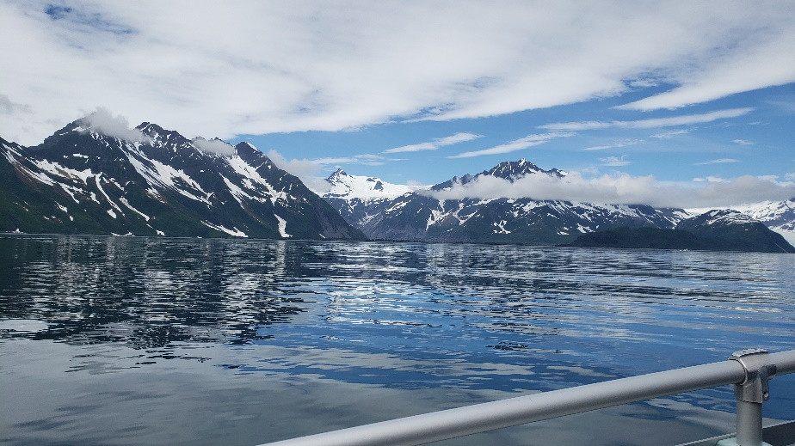

The image above is of Resurrection Bay, taken by Leah Eick.

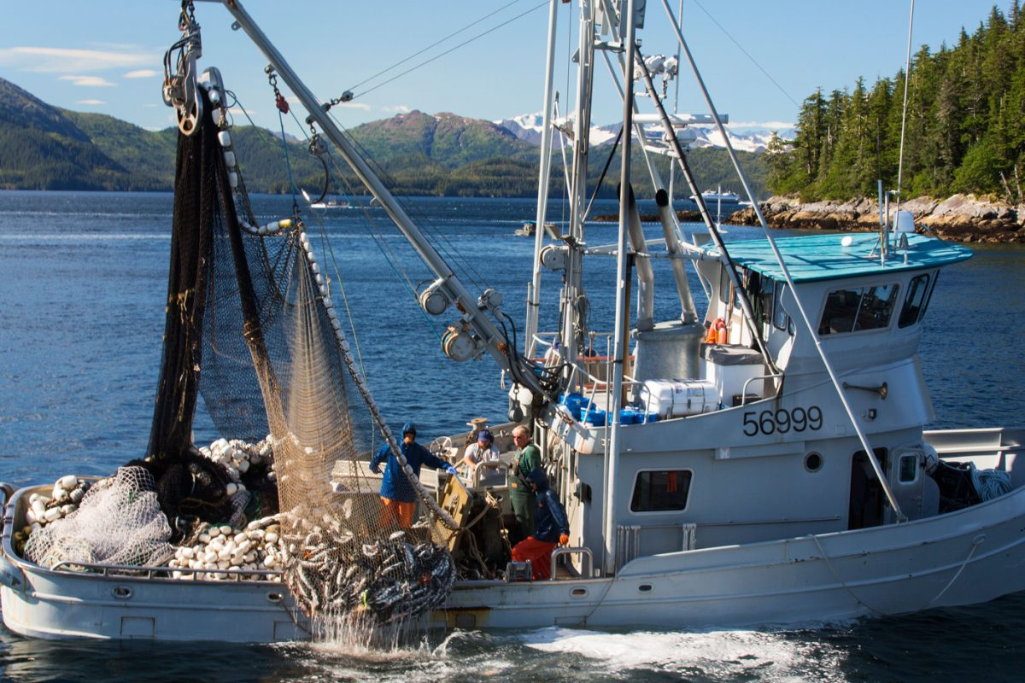

The image above (from Google) is of a commercial fishing boat.

The image above was taken in the town of Seward, AK by Leah Eick.

References
Alaska Department of Fish and Game (n.d.) Alaskan salmon identification and fishing guide [Brochure].
Alaska Department of Fish and Game (2008). Alaska commercial salmon harvests, 1970-2007. https://www.adfg.alaska.gov/index.cfm?adfg=CommercialByFisherySalmon.salmonhistoricalharvest
BLM Recreation Guide. (2014). Alaska freshwater fishing [Brochure].
Cecilia, personal communication, June 22, 2022.
Grace Waite, personal communication, June 21, 2022.
Museum of the North. (June 18, 2022). Salmon fishing. Fairbanks, AK.
Pynn, L. (2021, August 7). Saving salmon for the bears. Hakai Magazine: Coastal Science and Societies. https://hakaimagazine.com/news/saving-salmon-for-the-bears/
Southcentral Alaska. (2022). Sport fishing regulations summary [Law brochure].
Southcentral Region Department of Fish and Game. (2016). Fishing in the Seward area. http://www.adfg.alaska.gov/static-sf/region2/pdfpubs/seward.pdf

