**Dylan Wilkinson**

**SOC 330**

**Final Exam**

**Where is your ideal school? Why here?**

* My ideal school is in the Washington DC area. This school will be targeted towards lower-class kids who live in DC, but not necessarily exclusive to. This academy will be one of the top athletic academies on the east coast and will provide kids with the opportunity to advance their abilities athletically as well as in the classroom.
* The goal of the academy is to advance the student-athletes' educations and athletics to the best of their abilities to prepare them for college, in the hopes where they can receive scholarships because of their academic and athletic achievements.
* Washington DC is an area full of kids with potential to do amazing things with their lives, but they are stuck in the cycle of poverty. One in four kids in Washington live in poverty, and an opportunity to attend this academy could change the path of these kids’ lives.
* There is a strong correlation with socioeconomic background and academic achievement (Thomson). If students from lower class backgrounds receive the same opportunities those of the upper class receive, it could close the gap between social and racial inequalities.

**How are students going to get there?**

* Students must find their own way of commuting unless they do not have access to a quality form of commuting to school. If that is the case, students can apply for an exclusive bussing service to get to and from school.

**How long is your school day? How long is each class period? How many days a week do you want children in school?**

* School will begin at 7:30 AM and end at 2 PM. Each class will be 50 minutes long with 10 minutes in between classes. There will be a break time from 10:30 to 12 to allow kids to eat, catch up on homework, get extra work in at their sport, lift weights, or simply just relax. The opportunity to work on their sports, during their free time in school, can be very beneficial for their overall mental wellbeing. Participation in sports has a positive effect on academic performance (Guest, A., & Schneider, B).

**How long is your school-year? Why did you choose this?**

* The school year will begin in late August, running until May. There will be a fall, winter, and spring break with additional days off due to holidays.
* I chose this because this is the most common and traditional method of school scheduling. There is no conclusive evidence that other methods of school scheduling, such as year-round schooling, are any better in terms of academic performance (Skinner). This will allow students to enjoy their time off, especially in the Summer, and enjoy doing their other hobbies or interests.

**What are the core subjects you plan on teaching in the school?**

* Math, history, science, and English will be the core subjects. Finance, emotional intelligence, family life, gender and race, and etiquette classes will also be required. In addition, a sports performance class will also be required where students will learn about factors that go into being the best athlete they can be; they will learn about mental toughness, nutrition, work ethic, rest and recovery, and more.
* Though this academy is providing lower-class students with the opportunity to receive a high quality education, sports are also a major focus. Lower class groups often view sports as an opportunity for financial gain (Guest, A., & Schneider, B).

**What role do parents, administrators and teachers have in the creation of the curriculum?**

* Extensive research has been done by administration and higher up professionals to ensure the highest productivity and achievement of our students in the classroom, but all suggestions and opinions are welcome.
* We want parents to be involved in their child’s education and overall lives. If parents are involved and allowed to have a voice in what their child can learn, it could lead to more stability in the family. Lack of stability in families can lead to further issues such as psychological distress, which can impact students’ overall quality of life (Why do children do well in school?).

**What are the values and beliefs you want taught in your school? What are some ways that teachers and administrators can teach these to students?**

* We want students to understand the value of family and relationships. Many studies have shown that factors like parental education, family income, structure, and parental involvement have a strong correlation with academic success and overall mental and physical wellbeing. Many children of lower classes have a lack of stability in their family life due to various factors. Black children are 7.5 times more likely and Hispanic children are 2.5 times more likely than white children to have an incarcerated parent (Egalite). We want students to understand the impact parents can have on their children, so when the students become parents in the future they will value family and relationships.
* This will be taught through Greater Washington Education & Sport Academy’s family life course, which is a core course for all students.

**What sort of technology will be available to students? How are you going to make sure it is used properly?**

* Laptops will be provided for each student, but they will not take them outside of school to ensure safety and that they are used properly. Students can ask for permission to take their laptops home for homework purposes.

**Is your school public, private, or charter? Explain.**

* Greater Washington Education & Sport Academy is a private school. There are tuition fees in order to fund the school, but many students are awarded athletic scholarships to attend. The school is also heavily funded through donations from various organizations regarding athletics and social inequality. World class athletes who are very involved in their communities also fund the school through donations. Students must apply or be invited to attend the academy.
* According to our class material, schools are also funded through sponsorships. Being one of the best schools athletically on the east coast, sponsorships from large athletic corporations are available.

**Will parents have a choice to go to your school or another in the district or do they have to go where they are zoned? Explain.**

* Because this school is private anyone can attend it. Tuition varies from student to student depending on location and socioeconomic class.

**What are the administrative roles you plan to have in your school? Is it more centralized or decentralized?**

* There will be multiple administrative roles in this more decentralized system: Superintendents, principals (vice and head), teachers, security, and counselors. Decentralization allows for better control and supervision, and more leaders will be developed.

**How are children assessed? Are they?**

* Children are assessed through standardized testing assigned and approved by the superintendent. These assessments are only for very small grades, and most importantly allow for administration to understand where they must improve to teach students to the best of their abilities.
* Students will be graded through their class content assigned by their teachers. Their effort and ability to retain information will be assessed as well for grading.

**How do they advance in their education? Why did you choose this method?**

* Students will advance once they prove to their teacher that they understand the material. This will show in their overall grade in the class. If students are struggling to learn and understand topics, they will receive extra help in order to do so. Regardless of whether a student is in the same grade as another student, they will work at different paces.
* This method of learning enables students to learn at their own pace (within reason) because we understand that not all students learn the same way and at the same pace.

**How do you know if teachers are doing their job?**

* Teachers will communicate with administrators on a regular basis to make sure they are teaching the content they are supposed to be teaching.
* Additionally, standardized testing for students is a good tool for understanding if the teachers are doing their job adequately. Teachers here are highly trusted and respected and are allowed to teach in their own style as long as the students are showing signs of continued growth and productivity. They have **covert control** over their students. A decentralized school system allows for this.
* Most importantly, a decentralized system means those higher up in power are confident and trust in the teachers they hired. It is not often that they will physically attend classes to evaluate because of this. This was learned through our “How are schools organized” PowerPoint.

**How do you plan to generate morale among staff and teachers?**

* Only faculty members who are passionate about helping kids (low-class minorities specifically) will be hired. Meetings will be held weekly to ensure the motivation and passion is there day in and day out for faculty.
* Staff must understand the disparities and inequalities many students here face because of their race and class.
* Staff members understand that by doing what they do, they are shortening the educational inequality gap between races and classes, which generates morale (Hodges Persell).
* Durkheim's theory of morality includes three ideas: a spirit of discipline, an attachment to social groups, and autonomy or self-determination. We hire teachers who are determined to help students academically and as young adults, and are organized and disciplined (Peterson).

**What is the discipline policy? What are children disciplined for and how are they disciplined?**

* Disciplinary measures will be taken in serious situations. Depending on the severity, students can be suspended from sports, school, or even expelled from the school.
* Before major disciplinary actions are taken, students with disciplinary issues will be required to meet with school counselors regularly to get to the bottom of the students’ behavioral issues. We understand what many of these students are going through outside of school, and we want to give them all the opportunities we can to lead them towards success. This is why serious disciplinary measures will only be taken if there are no other options.
* Teachers can keep control throughout their classrooms by getting students to buy into the system. This is internal for the students, where they (hopefully) learn that it is in their best interest to follow the rules. This was learned through our “Status of teaching as a profession” PowerPoint.

**What is your attendance policy?**

* Attendance to all classes is required for students unless given permission otherwise. Failure to abide can result in suspension from sports. We want students to understand the importance of academics. Additionally, many classes taken at this academy go much further than typical academia; courses such as finance, emotional intelligence, family life, gender and race,

and etiquette will help students to grow into mature individuals who are major contributors to their families and society.

**What is your dress code policy?**

* A very casual uniform will be required for all students. Students are responsible for taking care of their uniforms unless help is needed due to out of school, external reasons.
* The reason for a required uniform is to improve student achievement in the classroom.

**You have a budget of 10 million dollars to support 500 students.**

1. **How many teachers and what are you going to pay them?**

* There will be 25 teachers who start at a salary of $70,000 and can work up to $110,000.
* $3 million spent on teacher salary.
* The average teacher salary in Washington DC is $68,000.
* The average teacher salary in Northern Virginia ranges from $60,000 to $75,000.
* The average teacher salary in Maryland is $62,000.
* A base salary of $70,000 and top salary of $110,000 increases competition for teachers to want to teach at this academy, therefore allowing for a high quality education through good teaching.

1. **What are your classroom sizes?**

* Classroom sizes will be smaller, with no more than 20 students per class. We want students to have the most engagement with their teachers as possible, and smaller sized classes allow for this.
* It is proven that smaller class sizes correlate with high academic achievement. Improving learning environments for minority students is a major issue in the US, and making class sizes smaller is a great start (Boyd-Zaharias).

1. **What other roles do you need to support and how much will you pay them?**

* Counselors and therapists: $125,000 starting salary. $1.5 million spent annually on salary.
* Security: $40,000 starting salary. $250,000 spent annually on salary
* Coaches: $40,000-$60,000 salary. $500,000 spent annually on salary.
* Principals/other administration: $125,000 starting salary. $1.5 million spent annually on salary.
* TOTAL: $3.75 million

1. **Your school can support 10 extra curricular activities. 1 sport is 1 activity. What 10 will you support and why? How much will it cost?**

* Football: $400,000/year
* Basketball - Men’s and Women’s: $500,000/year
* Baseball: $200,000/year
* Softball: $200,000/year
* Soccer - Men’s and Women’s: $300,000/year
* Women’s Lacrosse: $200,000/year
* Track & Field: $100,000/year
* Women’s Field Hockey: $200,000/year
* TOTAL: $2.1million

These 10 sports will be supported because they are popular American sports and allow for men and women of all races to play the sports they enjoy. Funding is split evenly between men and women, which is a Title IX rule.

1. **You must pay a base salary and then an additional 1/4 of that base salary goes to benefits. So if you pay a teacher $40,000 in base pay, you are actually giving them a $50,000 salary package with benefits**
2. **How much will it cost to serve meals?**

* $1 million. Students can apply for free or reduced lunch if they meet requirements because of socioeconomic status.

1. **How much for transportation?**

* Driving service workers: $10,000-$50,000 (benefits depending on whether the job is full time or not). $100,000 spent annually on salary.
* Automobiles: $50,000/year

**What does the physical structure of your school look like? Why did you choose this? Feel free to draw this.**

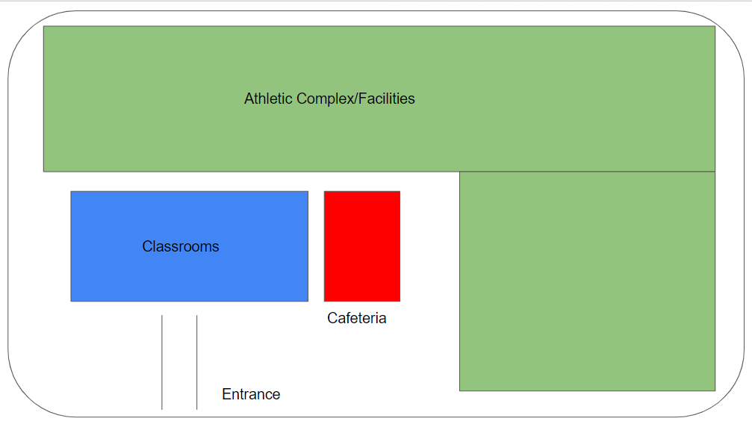

It is a large, but compact campus surrounded by tall fencing. As said, this campus is closed to the public. The campus is heavily monitored at all times, especially during school hours to prevent any violent or other harmful activities from taking place on or around campus.

**What is an issue that students might face that is structured around race?**

**How do you plan to deal with it?**

* There will be students who come from all kinds of backgrounds at this school. There will be upper-class white students from the rich suburbs of DC, as well as lower-class minorities from Southeast DC. Through classes such as etiquette, history, and gender and race, and through experiences with coaches and teammates, students will understand and respect each other’s lives regardless of background. Any form of discrimination and lack of tolerance towards others will result in serious disciplinary actions, such as those stated previously.

**What is one issue students might face that is structured around gender? How will you deal with it?**

* According to our Gender PowerPoint, men generally do not perform as well in school as women do. Our educational system in which students must receive extra help if they are struggling in a subject could disproportionately affect men, leading to issues such as taunting and bullying towards them. This can lead to issues of sexism in the academy.
* Staff and Faculty of Greater Washington Education & Sport Academy, and teachers, counselors, therapists in particular, must educate students about treating others with respect. Failure to do so will result in mandatory meetings with therapists and eventually disciplinary actions if necessary.

**How are you going to help children when faced with a traumatic event? Explain.**

* We have 10 counselors and therapists who are available full time for our students. They are professionally trained and educated to manage and help our students manage and get through traumatic events.

**What are you going to do to help students with mental health issues or who are suicidal? Why this program?**

* There will be school psychologists as well as sports psychologists that are highly trained and prepared to manage students with mental illnesses. If these illnesses get too extreme, the students will be sent elsewhere for more intensive care. Mental health is taken very seriously at this academy.
* Mental health has a large impact on academic and athletic performance, and we want students to be at their best in every aspect.

**What are you going to do to help prevent high-level violence such as school shootings?**

* All students and faculty will be taught precautionary measures, such as locking all doors and windows, understanding safe places to hide or escape, and more. The academy is not open to anyone of the public unless specifically stated otherwise for cases like athletic events or recruiting trips from various universities. Doors to enter the building will be locked at all times.
* Each member of the academy will have an identification card which they can scan to enter various facilities. Their access to facilities and parts of the campus depend on the member’s position with the school (student, teacher, admin, coach, etc).

**What is your plan for the school in the event of a high-level violent act?**

**What is the name of your school?**

* Greater Washington Education & Sport Academy

Citations

Skinner, R. R. *Year-round schools: In brief*. Congressional Research Service. https://sgp.fas.org/crs/misc/R43588.pdf

Thomson, S. (2018). Achievement at school and socioeconomic background—an educational perspective. *Npj Science of Learning*, *3*(1). https://doi.org/10.1038/s41539-018-0022-0

Guest, A., & Schneider, B. (2003). Adolescents' extracurricular participation in context: The mediating effects of schools, communities, and identity. *Sociology of Education*, *76*(2), 89. https://doi.org/10.2307/3090271

Egalite, A. J., By, Egalite, A. J., Bio, A. J. E. A., & Bio, A. (2022, March 8). *How family background influences student achievement*. Education Next. https://www.educationnext.org/how-family-background-influences-student-achievement/

Boyd-Zaharias, J. (1998, November 30). *Project Star: The story of the Tennessee class-size study.* American Educator. Retrieved May 5, 2022, from https://eric.ed.gov/?id=EJ592530

Peterson, H. L. (1974). The quest for moral order: Emile Durkheim on Education. *Journal of Moral Education*, *4*(1), 39–46. https://doi.org/10.1080/0305724740040105