Miguel Diaz-Montealegre
November 6, 2020
BIOL 251
Dr. Ellis
Survivorship of Pre- and Post-1950 Men and Women in Farmville, Virginia
Introduction
Human demography is the field of research that looks at human populations and how they change over time (Bongaarts, 2009). One of the main topics researched in human demography is survivorship. Survivorship refers to the amount of people that reach a certain age group in a population (Engelman et al., 2010). This information is useful to know because it tells us the overall survival trend of people over time and if people are experiencing longer life expectancies. Survivorship information also tells us if a population is experiencing growth or decline.
The purpose of this research project was to examine and analyze the pre- and post-1950 survivorship of men and women in Farmville, Virginia. The research question of this project was whether residents in Farmville lived longer before 1950 or after 1950. The hypothesis was that people alive after 1950 would have longer life expectancies compared to people alive before 1950. The reasoning for this hypothesis would be that healthcare and medicine would be more advanced and more widely available after 1950 compared to before 1950. This hypothesis is supported by the research of Gallet and Doucouliagos (2017) and Hao et al. (2020) who found that adequate access to healthcare is associated with longer life expectancies.
Methods
Researchers collected data on the gender, year of birth, and year of death on a sample size of 100 individuals buried at the Westview Cemetery in Farmville. The years of birth and death were used to calculate the age at death of the Farmville residents. The residents were then categorized into age intervals based on their age at death. Ten-year age intervals were used starting from 0-9 and ending at 100-109. The mortality rate of the deceased was calculated by counting how many people were in each age interval. The survivorship of the Farmville residents was then calculated by dividing the mortality rates by the total number of people that were studied which gave percentages of people at each age interval. The survivorship data was plotted in Excel onto a survivorship curve which is a graph that shows the proportion of individuals that will reach a certain age. The survivorship data was organized into four distinct datasets: the pre-1950 group, the post-1950 group, the male group, and the female group. T-tests were run on each of the four datasets and bar graphs with error bars were created for each dataset. A t-test is a statistical test that is used to compare the means of two groups and it’s used to tell whether two groups are different from one another.
Results
According to Figure 1, the pre-1950 females group had a mean age of death of 54.96 (with a standard deviation of 24.17) and the post-1950 females group had a mean age of death of 76.16 (with a standard deviation of 16.65) with a p-value of <0.001. According to Figure 2, the pre-1950 males group had a mean age of death of 57.23 (with a standard deviation of 23.53) and the post-1950 males group had a mean age of death of 71.56 (with a standard deviation of 18.44) with a p-value of <0.001. According to Figure 3, pre-1950 women experienced a drop in survivorship from early adulthood to their 60s but post-1950 women had higher overall survivorship than men. According to Figure 3, post-1950 men and women had higher survivorship compared to pre-1950 men and women. According to Figure 4, the pre-1950 males group had a mean age of death of 57.23 (with a standard deviation of 23.53) and the pre-1950 females group had a mean age of 54.96 (with a standard deviation of 24.17) with a p-value of 0.50. According to Figure 5, the post-1950 males group had a mean of 71.56 (with a standard deviation of 18.44) and the post-1950 females group had a mean of 76.16 (with a standard deviation of 16.65) with a p-value of 0.07.
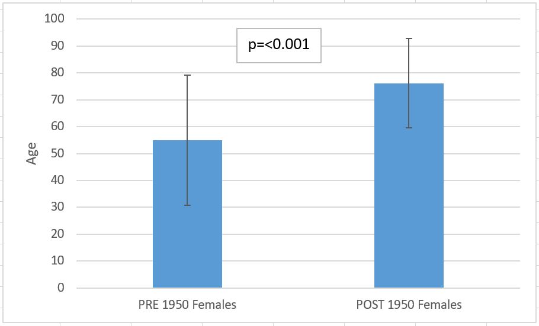
Figure 1. Average age of death of pre- and post- 1950 females in Farmville, Virginia. The pre-1950 females group had a mean of 54.96 and the post-1950 females group had a mean of 76.16. The p-value of the dataset is highly significant.

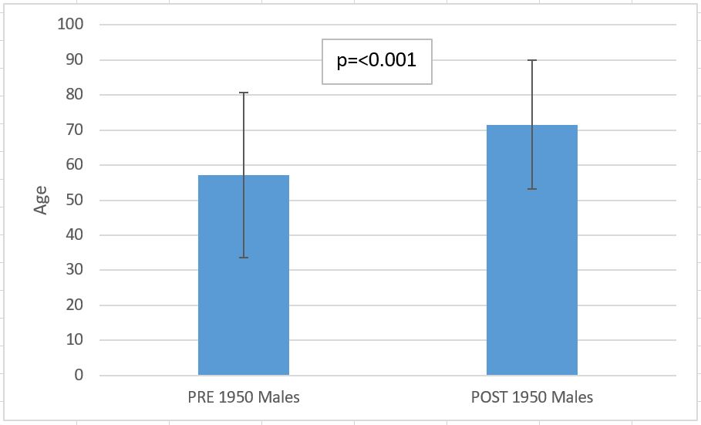
Figure 2. Average age of death of pre- and post- 1950 males in Farmville, Virginia. The pre- 1950 males group had a mean of 57.23 and the post-1950 males group had a mean of 71.56. The p-value of the dataset is highly significant.

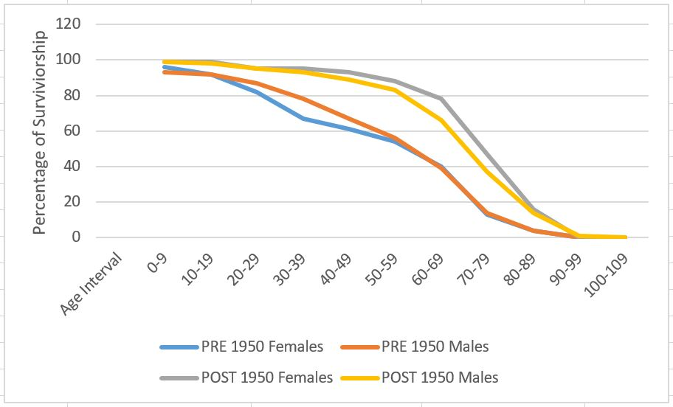
Figure 3. Survivorship curve of males and females pre- and post-1950. On average, people lived longer post-1950 compared to the pre-1950 groups. Pre-1950 women experienced a drop in survivorship from early adulthood to their 60s but post-1950 women had higher overall survivorship than post-1950 men.

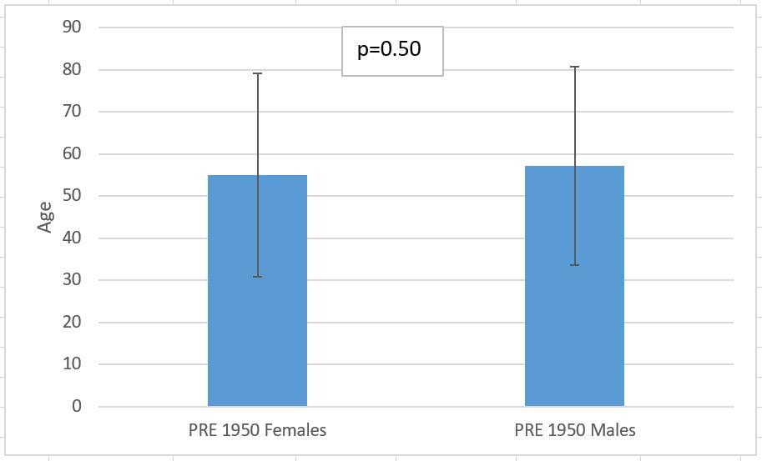
Figure 4. Average age of death of pre-1950 males and females in Farmville, Virginia. The pre- 1950 males group had a mean of 57.23 and the pre-1950 females group had a mean of 54.96. The p-value of the dataset is not significant.

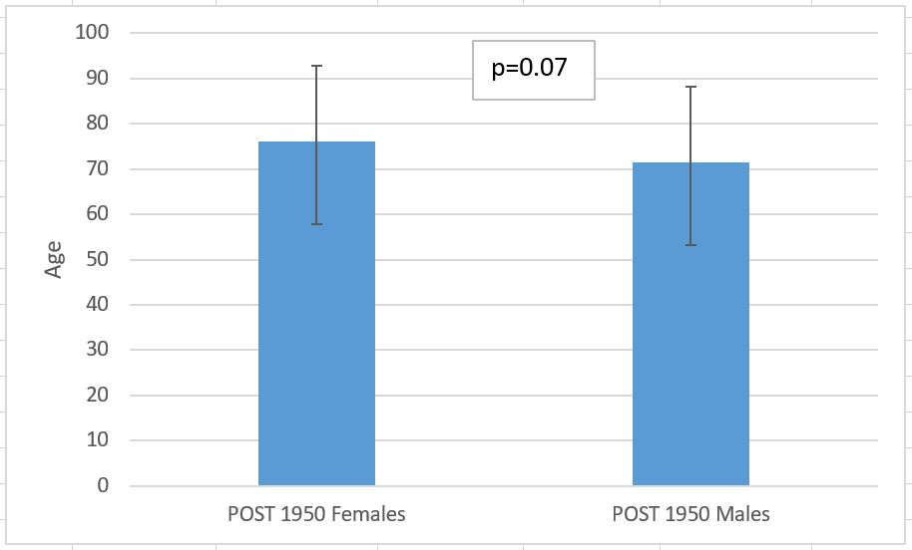
Figure 5. Average age of death of post-1950 males and females in Farmville, Virginia. The post- 1950 males group had a mean of 71.56 and the post-1950 females group had a mean of 76.16. The p-value of the dataset is not significant.

Discussion
The results showed that Farmville residents lived longer on average after 1950 compared to before 1950. Based on the results, the hypothesis of this research project is supported. A possible explanation for the difference in survivorship curves between men and women is that pre-1950 women may have been dying during childbirth which would explain the drop in survivorship. A possible explanation for the difference in survivorship curves of the pre- and post-1950 groups is that healthcare and medicine become more advanced and widely available after 1950 which improved life expectancies of the residents. Research from Gallet and Doucouliagos (2017) supports the explanation that access to healthcare and medicine results in improved life expectancies. A possible bias of the location of this study is that data was only collected from one cemetery in Farmville which may skew the sample of people that we are collecting data from. A solution to fix this bias would be to collect data from multiple cemeteries and graveyards that are located all over Farmville. Future studies can be conducted to see how survivorship varies among different races, classes, and locations in Farmville pre- and post-1950. Looking at the bigger picture, this study provides us with more information on how the survivorship of people has increased over time which helps us learn how to continue increasing survivorship in the future.

Literature Cited:
Bongaarts, J. (2009). Human population growth and the demographic transition. Philosophical Transactions of the Royal Society B: Biological Sciences, 364(1532), 2985-2990.

Engelman, M., Canudas‐Romo, V., & Agree, E. M. (2010). The implications of increased survivorship for mortality variation in aging populations. Population and Development Review, 36(3), 511-539.

Gallet, C. A., & Doucouliagos, H. (2017). The impact of healthcare spending on health outcomes: A meta-regression analysis. Social Science & Medicine, 179, 9-17.

Hao, L., Xu, X., Dupre, M. E., Guo, A., Zhang, X., Qiu, L., ... & Gu, D. (2020). Adequate access to healthcare and added life expectancy among older adults in China. BMC geriatrics, 20, 1-15.

