Expressing the GFP gene from the pGLO plasmid in E. coli bacteria

Miguel Diaz-Montealegre
BIOL 250-02
Fall 2020

ABSTRACT
The goal of this research project was to gain a better understanding of molecular biology and genetics through the scope of gene expression. The research question of this project was to determine whether the Green Fluorescent Protein (GFP) gene from a pGLO plasmid could be expressed in E. coli bacteria. The methods of this research project included Polymerase Chain Reaction, agarose gel electrophoresis, amplicon purification, amplicon concentration measurement, set-up of sequencing reactions, BLAST analysis of the amplicon, creation of the SnapGene viewer pGLO map, transformation of the pGLO plasmid into E. coli, and GFP regulation by sugars. Gel electrophoresis of the PCR amplicon showed that the amplicon is 1000 bp in length and the amplicon concentration was measured to be 44.4 nanograms per microliter. The sequencing reaction was calculated to require 10.14 microliters of the purified amplicon and 4.86 microliters of water. The purified PCR amplicon was sequenced and analyzed through BLAST analysis and the SnapGene viewer pGLO map was created. After transformation of the pGLO plasmid into E. coli, both of the +pGLO plates showed growth of colonies, the LB/amp -pGLO plate showed no growth, and the LB -pGLO plate showed infinite growth. After regulating GFP with sugars, the pGLO plate and pGLO+glu plate showed no brightness, the pGLO+ara+glu plate showed moderate brightness, and the pGLO+ara plate showed the most brightness. Based on the results, the experiments in our research project were successful and our hypothesis was supported.

INTRODUCTION
Molecular biology and genetics are branches in biology that are related through their overlapping areas of research and their similar research methods and techniques. Molecular biology examines biomolecular structure and molecular functions such as DNA replication, transcription, and translation while genetics focuses on studying genes and DNA which carry the hereditary material of living organisms (Bergtrom 2018). This aim of this research project was to gain a better understanding of molecular biology and genetics through the scope of gene expression. Research from Niedenthal et al. (1996) and Faust et al. (2000) indicates that the Green Fluorescent Protein (GFP) gene has many fundamental uses in studies of gene expression and localization. The research question of this research project was to determine whether the GFP gene from a pGLO plasmid could be expressed in bacteria. The hypothesis of this project is that the GFP gene from the pGLO plasmid could be expressed in E. coli bacteria. The research from Niedenthal et al. (1996) supports the hypothesis by demonstrating that GFP can be used as a marker in gene expression.

METHODS
Polymerase Chain Reaction (PCR)
Twenty μl of water, 10 μl of 2 nM DNA template, 10 μl of 4μM GFP_F1 primer, 10 μl of 4μM GFP_R1 primer, and 50 μl of 2X Master Mix were pipetted into a PCR tube. The sequence of the GFP_F1 primer was 5’ atcgcaactctctactgtttc 3’ and the sequence of the GFP_R1 primer was 5’ tctgatttaatctgtatcaggc 3’. The PCR tube was placed into a thermal cycling device with a thermal profile composed of steps with specific temperatures and amount of time for each temperature to be held at. The first step of the thermal cycle was at 94°C for 4 minutes. The second step of the thermal cycle was 94°C for 30 seconds, 50°C for 30 seconds, and 72°C for 60 seconds and this entire step was repeated 30 times. The third step of the thermal cycle was at 72°C for 7 minutes. The final step of the thermal cycle was at 4°C overnight.
Agarose gel electrophoresis
Before the gel electrophoresis occurred, the 1% agarose gel was prepared by mixing 1 gram of agarose with 100 milliliters of 0.25 X TAE buffer. The agarose gel was poured into a gel tray, a comb was inserted into the gel, and the gel was hardened through refrigeration. The comb was removed from the gel by pulling it straight up and out which formed wells in the gel. The gel was oriented positive to negative based with the side of the gel that had the wells on the positive side. 0.25 X TAE buffer was added to the platform with the gel tray until the tray was submerged.
Three microliters of the DNA solution from the PCR reaction was pipetted into a microfuge tube containing 7 microliters of the loading buffer. The loading buffer consisted on 5 microliters of water and 2 microliters of 6X Loading Buffer. The mixture of the loading buffer and DNA solution from the PCR reaction was pipetted into a well in the gel. Samples from three other students, a positive control, a negative control and a Quick-load 2-log DNA ladder were also pipetted into the wells with one and two wells left empty on the sides of the gel. The lid was placed on the electrophoresis chamber and the electrical leads were connected to the power supply based on their red or black color. The gel was run at 300 V for 25 minutes. The gel was then removed from the electrophoresis chamber and then viewed by using the visualizer with the assistance of the lab instructor.

Amplicon purification
The PCR amplicon cleaning process began by mixing 97 μl of the amplicon with 500 μl of binding buffer and centrifuging this mixture in a tube with a spin filter column. The filter column captured the DNA and the binding buffer and leftover reagents from the PCR reaction flowed through the filter column and were discarded. Then, 200 μl of washing buffer was added to the DNA in the filter column and centrifuged. The DNA was captured in the filter and the flowthrough that was produced was discarded. This washing process was done twice in order to clean the DNA and remove any contaminants. The filter column with the DNA was transferred to a sterile microfuge tube and 30 μl of elution buffer was added to the filter column. The DNA was allowed to sit in the elution buffer for 1 minute, centrifuged, and the DNA collected at the bottom of the microfuge tube.

Amplicon concentration measurement
2 microliters of the amplicon were placed on a nanodrop and a computer calculated the concentration of the amplicon.

Set-up of sequencing reactions
Based on the concentration measurement of the amplicon, 15 milliliters of the amplicon were transferred into a sequencing reaction tube at a concentration of 30 nanograms per microliter. In order to dilute the purified amplicon to a concentration of 30 ng/μl, the volume of purified amplicon necessary for the dilution was calculated by using the equation C₁V₁=C₂V₂.

BLAST analysis of the amplicon
The DNA sequence data from the F1 and R1 primer sequencing reactions were combined and the website http://doua.prabi.fr/software/cap3 was used on 9/23/20 in order to form the contig of the GFP gene. The website http://blast.ncbi.nlm.nih.gov/Blast.cgi was used on 9/23/20 in order to analyze the contig through BLAST analysis and determine the gene that the contig encodes for. The alignment for the best match of the gene was collected from the BLAST results.

Creation of the SnapGene viewer pGLO map
The pGLO sequence was copied and pasted into the SnapGene viewer program with the “circular” option selected. On the “Detect Common Features” window, three protein-coding genes, the ori sequences, and the promoters for the arabinose were selected to be analyzed. On the window with the circular DNA, all enzymes were removed and primers were added by adding the primer sequences from the PCR reaction in the Week 2 lab. A complete map of the pGLO plasmid was produced. Finally, the araC gene sequence, the bla gene sequence, and the ori sequence were analyzed through BLAST analysis in order to prove that they were the actual genes.

Transformation of the pGLO plasmid into E. coli
Calcium chloride transformation solution was added to two microtubes labelled +pGLO and -pGLO. E. coli cells were added to each microtube, pGLO plasmid was added to the +pGLO microtube, additional calcium chloride solution was added to the -pGLO microtube, and the microtubes were placed in ice for 10 minutes. 4 agar plates were labelled and classified based on their contents. The microtubes were placed in a 42°C water bath for 50 seconds, then 250 microliters of LB nutrient solution was added to each micropipette, and then the micropipettes were placed in a 37°C water bath for 10 minutes. 200 microliters of the +pGLO and -pGLO solution was pipetted and spread on their appropriate agar plates. Finally, the plates were taped together and stacked upside down in a 37°C incubator overnight.

GFP regulation by sugars
E. coli from the week 7 lab was used since the bacteria was transformed with the pGLO plasmid. Four plates and four microcentrifuge tubes were labelled “pGLO”, “pGLO+ARA”, “pGLO+GLU”, and “pGLO+ARA+GLU”. 100 μl of E. coli cells and 150 μl of water were added to the “pGLO” tube. 100 μl of cells, 100 μl of water, and 50 μl of arabinose were added to the “pGLO+ARA” tube. 100 μl of cells, 50 μl of water, and 100 μl of glucose were added to the “pGLO+GLU” tube. One hundred μl of cells, 50 μl of arabinose, and 100 μl of glucose were added to the “pGLO+ARA+GLU” tube. The four mixtures were put on their respective plates and a sterile loop was used to spread the mixture on the entire surface of the plate. The four plates were taped together and placed upside down in a incubator at 37 degrees Celsius overnight.

RESULTS
The research project started by DNA amplification through a Polymerase Chain Reaction (PCR). The DNA products from the PCR reaction were visualized through Agarose Gel Electrophoresis. The results shown in Figure 1 of the gel show the positions for the DNA sample of the PCR reaction (Sample #11), the positive control, the negative control, and the DNA ladder along with the DNA samples of other students and the empty wells. Sample #11 lined up with the 1000 bp mark on the DNA ladder which suggests that the DNA from the PCR reaction was 1000 bp in length.
The amplicon (PCR product) was purified and the concentration of the DNA was measured. Figure 2 shows that the concentration of the amplicon was 44.4 nanograms per microliter, the A260 value was 0.887, and the A260/A280 value was 1.96.
For the sequencing experiment of the research project, 15 milliliters of the purified amplicon at a concentration of 30 nanograms per microliter were required. The equation C₁V₁=C₂V₂ was used to calculate the amount of purified amplicon to use, as shown in Figure 3. After calculating, 10.14 microliters of the purified amplicon and 4.86 microliters of water were mixed together to form the mixture for the sequencing experiment. The purified PCR amplicon was sequenced and converted into a chromatogram as shown in Figure 4. Figure 5 shows the FASTA sequence of the contig of the pGLO plasmid that was also created from the sequencing data.
The contig of the PCR amplicon was analyzed through BLAST analysis and the top hits from the BLAST analysis are shown in Figure 6. Figure 7 shows the alignment of the GFP gene which was found by finding the BLAST analysis result with the lowest e-value. The map of the pGLO plasmid produced through the SnapGene Viewer is shown in Figure 8. The locations of the GFP gene, the forward and reverse primers, the promoters, and the ori sequences are shown on the map.
Figure 9 shows the results of the pGLO plasmid transformation into E. coli bacteria. Figure 9 shows that the plates with E. coli cells and the pGLO plasmid glowed under UV light compared to the plates with E. coli cells but without the pGLO plasmid. Table 1 shows that the +pGLO (LB/amp) plate grew 5 cells and the +pGLO (LB/ara/amp) grew 4 cells. Table 2 shows that the pGLO+ara plate had the highest relative brightness while the pGLO+ara+glu plate showed low/medium brightness and the other two plates showed no brightness.
DISCUSSION
The research question of this project was to determine whether the GFP gene from a pGLO plasmid could be expressed in bacteria. The hypothesis was that the GFP gene could be expressed in bacteria. The results from the experiment supported this hypothesis. Figures 1, 2, and 3 demonstrate that the experiments in our research project were successful and that our hypothesis was supported. Our findings resemble those of the study of Niedenthal et al. (1996) and similar materials and methods were used in our research and also in Niedenthal et al.’s research. A pitfall of the research project was that the entire project occurred in individual experiments broken up over many labs which may have lead to more opportunities for contamination and errors. An alternative approach would be to conduct this research project over the course of a few consecutive days rather than over a few weeks. The findings of this research project are significant because they could potentially be applied in several ways in multiple fields. For example, research from Heim et al. (1994) indicates that the GFP gene is useful in visualizing gene expression and protein localization as well as in measuring protein association. A possible future study on the GFP gene could be to measure the differences in behavior between different cell types such as muscle cells, neurons, etc.

FIGURES AND TABLES
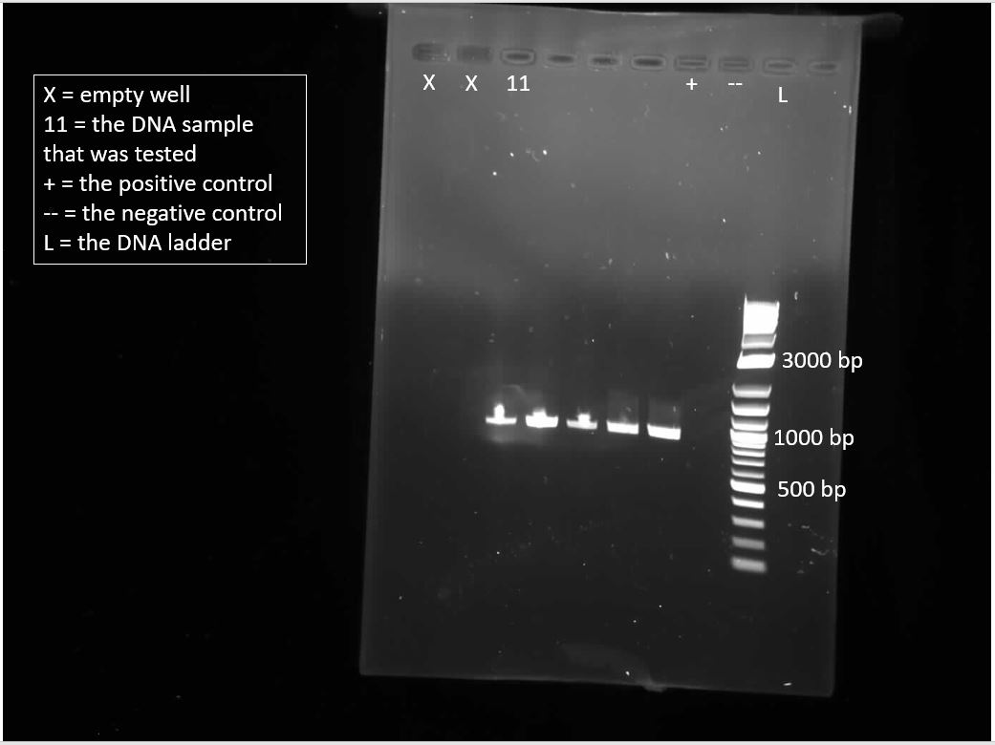
Figure 1. Figure of the purified PCR amplicon after going through gel electrophoresis.

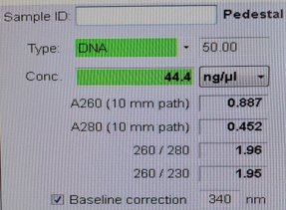
Figure 2. The amplicon concentration was measured to be 44.4 ng/μL.​
C1V1=C2V2​
(44.4)V1=(30 ng/ul)(15 ul)​
V1= 10.14 microliters​
Figure 3. The volume of purified amplicon necessary for the dilution was calculated to be 10.14 μL by using the equation C1V1=C2V2.

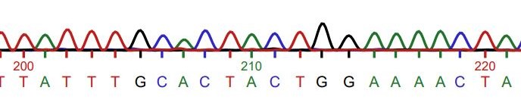
Figure 4. Chromatogram of the pGLO plasmid.

>Contig1
NNNNNNTNNACCNAACCNGGTNNCCCCCGNTNNTAAAAGCATTNNNNNACNAAGNGGGNN
CNANNCCATGACAAAAACGCGNANNAAAAAGNNNCTANATCNCGGCNGAAAAGTCCACAT
TGATTATTTGCNNGGCGTCACACTTTGCTATGCCATAGCATTTTTATCCATAAGATNAGC
GGATCCTANNGACGCTTTTATCGCAACTCTCTACTGTTTCTCCATACCCGTTTTTTTGGG
CTAGAAATAATTTTGTTTAACTTTAAGAAGGAGATATACATATGGCTAGCAAAGGAGAAG
AACTTTTCACTGGAGTTGTCCCAATTCTTGTTGAATTAGATGGTGATGTTAATGGGCACA
AATTTTCTGTCAGTGGAGAGGGTGAAGGTGATGCTACATACGGAAAGCTTACCCTTAAAT
TTATTTGCACTACTGGAAAACTACCTGTTCCATGGCCAACACTTGTCACTACTTTCTCTT
ATGGTGTTCAATGCTTTTCCCGTTATCCGGATCATATGAAACGGCATGACTTTTTCAAGA
GTGCCATGCCCGAAGGTTATGTACAGGAACGCACTATATCTTTCAAAGATGACGGGAACT
ACAAGACGCGTGCTGAAGTCAAGTTTGAAGGTGATACCCTTGTTAATCGTATCGAGTTAA
AAGGTATTGATTTTAAAGAAGATGGAAACATTCTCGGACACAAACTCGAGTACAACTATA
ACTCACACAATGTATACATCACGGCAGACAAACAAAAGAATGGAATCAAAGCTAACTTCA
AAATTCGCCACAACATTGAAGATGGATCCGTTCAACTAGCAGACCATTATCAACAAAATA
CTCCAATTGGCGATGGCCCTGTCCTTTTACCAGACAACCATTACCTGTCGACACAATCTG
CCCTTTCGAAAGATCCCAACGAAAAGCGTGACCACATGGTCCTTCTTGAGTTTGTAACTG
CTGCTGGGATTACACATGGCATGGATGAGCTCTACAAATAATGAATTCGAGCTCGGTACC
CGGGGATCCTCTAGAGTCGACCTGCAGGCATGCAAGCTTGGCTGTTTTGGCGGATGAGAG
AAGATTTTCAGCCTGATACAGATTAAATCAGAACGCAGAAGCGGTCTGATAAAACAGAAT
TTGCCTGGCGGCAGTANCGCGGNGGTCCCACCNGACCCCNATGCCGAANCTCANAAANTG
AAACNCCGTANCNNCGATGGTAGNGNNGGGGNCNTCCCCCATGCGAGANTAGNNNNGNCN
NGNNATCAAATAAAANNNAANNNNNNNNNCNAANGANTGNNNNNNNTTTTNNTCNNNNNN
TTNGNCGGNGNANN

F1 Primer
R1 Primer
Start codon
Stop codon
Figure 5. Contig of the PCR amplicon. The start codon, the stop codon, the F1 primer, and the R1 Primer are highlighted within the contig.

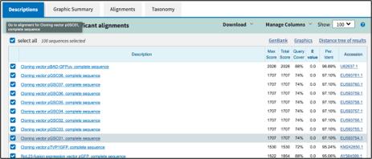
Figure 6. Top hits of BLAST analysis of the GFP gene.

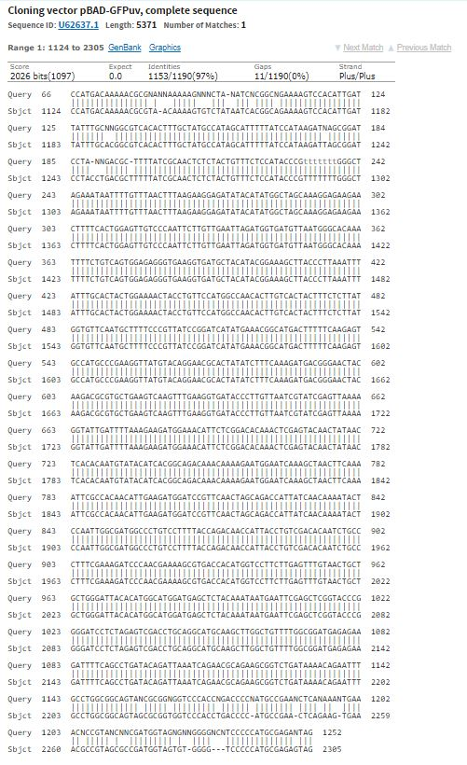
Figure 7. Alignment of the contig of the PCR amplicon.

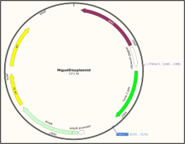
Figure 8. Map of the pGLO plasmid.

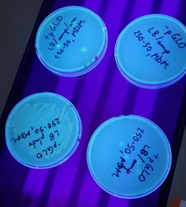
Figure 9. Photo of +/- pGLO transformed bacterial growth in LB/LB+amp/LB+amp+ara plates exposed to UV light​

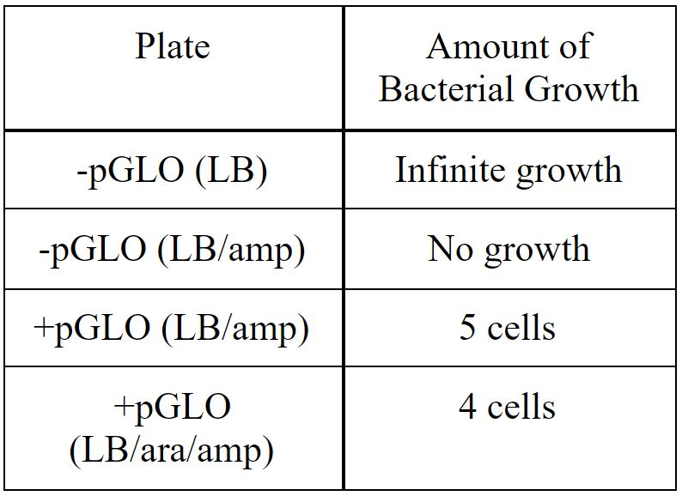
Table 1. table of + and -pGLO transformed bacterial growth in LB/LB+amp/LB+amp+ara​

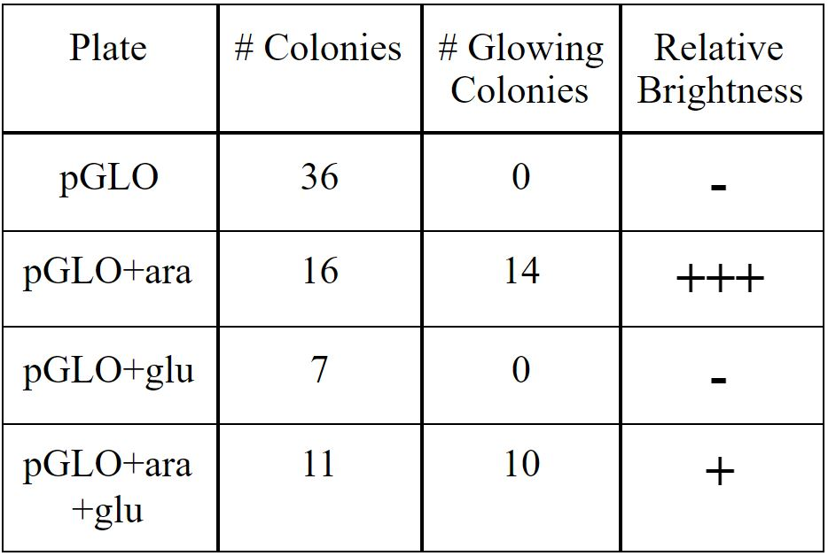
Table 2. Table of pGLO growth and glow in ara or glucose or both sugars plates​

LITERATURE CITED
Bergtrom, G. 2018. "ANNOTATED CELL AND MOLECULAR BIOLOGY 3e: WHAT WE KNOW AND HOW WE FOUND OUT" Cell and Molecular Biology 3e: What We Know and How We Found Out - All Versions. 8.

Faust, N., Varas, F., Kelly, L. M., Heck, S., & Graf, T. 2000. Insertion of enhanced green fluorescent protein into the lysozyme gene creates mice with green fluorescent granulocytes and macrophages. Blood, The Journal of the American Society of Hematology, 96(2): 719-726.

Heim, R., Prasher, D. C., & Tsien, R. Y. 1994. Wavelength mutations and posttranslational autoxidation of green fluorescent protein. Proceedings of the National Academy of Sciences, 91(26):12501-12504.

Niedenthal, R. K., Riles, L., Johnston, M., & Hegemann, J. H. 1996. Green fluorescent protein as a marker for gene expression and subcellular localization in budding yeast. Yeast, 12(8):773-786.

