Family Involvement and Survey Analyzation

Deegan Norman
Dr. JoEllen Pederson
SOCL 340-03
November 29, 2022

Abstract
The issue that this research is looking at is family involvement in children’s lives. The issue is many parents/ guardians do not have time to be involved in their children’s lives as well not have activities as a family that are easy and fun to do with their children. The purpose of this study was to understand how family Fun time activities promoted parent involvement as well as how well the children learned the skills taught by the activities. This is a mixed methods study conducted using the data collected from the families at Head start as well as the Andy Taylor Center who completed the surveys that were sent home with the children. The data that was collected and analyzed contained the survey questions as well as demographic information. The themes found in the study saw that participants enjoyed the activities because they gave them something to do as a family as well as taught the children skills. The implications of this study can lead to higher parent involvement.

Introduction
This study aims to give families activities to complete with their children to increase parent involvement in their homes through family fun time activities. The purpose of the family fun time activities is to teach children skills through the activities with their parents preset to promote parent involvement as well as give families a quick and easy solution to participate with their children. The deficiency in this study was that we did not receive as many surveys back as we expected which lead to a lack of data to analyze.
Literature Review
Will families having more access to family fun time activities have an effect on family involvement and will help with child development? With the help of family fun time activities, parents will have the tools and activities in place to be involved in the development of their children's lives which benefits their development. Important concepts regarding parent development are parent self-efficiency and home and school involvement.
In (Youssef Tazoutia & Annette Jarlégan, 2016) this study and in a study done by (Mikhail Goshin 1, Dmitrii Dubrov, Sergey Kosaretsky, Dmitry Grigoryev 2021) both talk about how important parent involvement is in youths education. The main concept of these two articles is parent self-efficiency (PSE), which reflects a parent’s ability to mobilize the cognitive resources and behaviors needed to control life events (Youssef Tazoutia and Annette Jarlégan 2016), or how confident a parent is in their abilities as a parent. This is also often linked to the parents' educational practices . Parents with high (PSE) are shown to be more involved in their children's lives (Youssef Tazoutia and Annette Jarlégan 2016). (PSE) also has an effect on the children's social skills and the way they act outside of the home which is talked about in the article (Mikhail Goshin 1, Dmitrii Dubrov, Sergey Kosaretsky, Dmitry Grigoryev 2021). The article talks about the importance of parent involvement in extracurricular activities. Involvement in extracurricular activities is crucial because it is often not guaranteed. The children often have to rely on parental support because it isn't supplied by the school. (Mikhail Goshin 1, Dmitrii Dubrov, Sergey Kosaretsky, Dmitry Grigoryev 2021). To achieve this the parent (PSE) and the level of parent involvement is important in the development of their children because to participate in these types of activities they need to be present in their lives. For example to take them to and from these events, show up for meetings regarding the children, and to keep up with scheduling and timing to make sure their children are involved in these programs. This communication as well as collaboration with the community are important and outlined in Epstein's theory (Epstein 1991), which lists communication between parents and schools in the theory's six main points.
Other theories agree with the idea that parental involvement in schools is important in a child's life. In an article by Oswald Donald, he breaks down parent involvement a little more. He breaks it down into 3 categories of parent involvement, home-based involvement, and school-based involvement. He talks about the importance of communication between the parent and the school and how involvement at home in helping the child with homework can lead to better performance in school. An experiment was done where surveys were sent out asking questions about parent involvement to families regarding extracurriculars and how much time they had spent with the children. Questions that were asked were questions such as “in the past week have you talked to your children about their heritage”, and “in the past month have you attended sponsored by a religion, community, or ethnic group”. This survey was sent out to parents of over 17,000 students. The results showed that parental involvement was more for girls than boys and that as the children got older there was less parental involvement. Just like in the Epstein model (Epstein 1991) the framework talks about home involvement with type 4 and type 6 and the importance of learning outside the school. A similar study was done by Sharon Kingston where they had over 500 students in an urban environment in a lower-income area. The study found lower parent involvement in single-parent households and where there was low parent self-efficiency led to children with less student readiness skills (Kingston, S., Huang, K. Y., Calzada, E., Dawson-McClure, S., & Brotman, L(2013).
To help with parent involvement organizations like Head Start have stepped in and in some cases do home visits to check in on the development of children. The services come for the children but the parents as well. It is related to the Epstein model and connects to the 6 types of parent involvement. It talks about the
In all the articles they prove that parent involvement is beneficial in the development of youth. With the help of family fun time activities children will get the interaction with their parents to help them learn new skills. The family fun time activities will boost parent involvement because they are interacting with their children and being present in the child's lives.
Data and Methodology
Instrument
A survey questionnaire was created by the 50 members of the Social Research and Program Evaluation team at Longwood University. The survey asked both open and close-ended questions. Items on the survey were designed to evaluate SMART objectives of the five activities that were completed the previous week by Head Start and Andy Taylor Center families. Items were included that also addressed demographic information, enjoyment of activities, family involvement, and completion of activities. Hard copies of the questionnaire were delivered to Head Start and the Andy Taylor Center.
Sample
The non-probability sample for this study was based on 100 children (ages three to five). Seventy-nine children attend Head Start in three counties. Head Start is a federally subsidized preschool for families with economic needs. Twenty-one children attend The Andy Taylor Center which is located on a college campus, and families apply and pay for their children to attend. Attached to the questionnaire was a children’s book to incentivize families to return the survey. Guardians of the children were asked to complete the survey and return it to the preschool the next day. Teachers sent a reminder home with children to return any outstanding questionnaires. This resulted in 20 questionnaires being returned. Overall, there was a 20.1% response rate.
Quantitative Analysis
Quantitative analysis of the returned surveys is based on close-ended questions. For this study, the dependent variable is family involvement. The item from the questionnaire that was used to operationalize this was “How involved was your family throughout the activity?”. The answer choices for this item were zero to ten with zero being not at all and ten being a great amount. For this study, the independent variable is the education level of the parental guardian. The item from the questionnaire that was used to operationalize this was “What is the highest education level anyone in your household has completed?”. The answers would be less than high school, high school/GED, some college, college degree, and more than a bachelor's degree. Descriptive statistics were used to analyze these variables.
Qualitative Analysis
Qualitative analysis of the returned surveys was based on open-ended questions. Then open-ended questions on the survey were “What did your family enjoy most about these activities? Why?, “What did your child learn from these activities?”, “What recommendations would you suggest to make these activities better?” To answer the research question, does the education level of the parental guardian/guardians influence parent involvement, indicative open coding was used to determine reoccurring themes in the respondent’s responses.
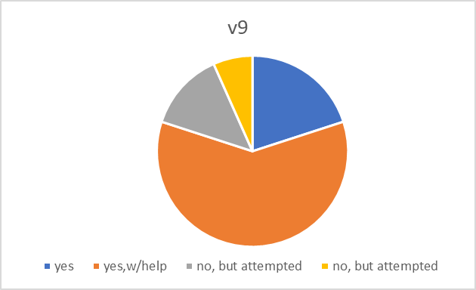
Quantitative Findings
The dependent variable in our survey is “how involved was your family throughout this activity?”. This question has answer choices on a scale of one through ten. The mean is 8.47 with a standard deviation of 2.07. The independent variable I’m questioning is “what is the highest degree of education anyone in your household has completed?”. The responses were “less than high school”,” high school”, “some college”, “college degree or higher”, and “prefer not to answer”.
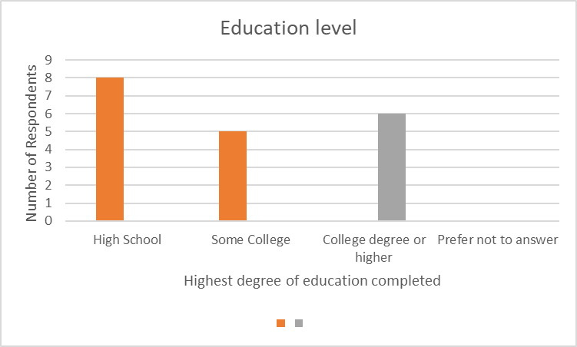
There were no respondents that had less than a high school education. There were eight respondents that stated that they completed a high school education. Five of the respondents responded with having some college and six participants stated that they obtained a college degree and some higher education. None of the respondents preferred not to answer. It is also important to remember that because of the low number of responses to the data could be skewed.
Qualitative Findings
In the activity cupcake flower the objective of the activity was to cut out leaves and glue them to a piece of paper. The child learned to cut with scissors and use glue in our activity Cupcake flowers and participant 1 said that her child “practiced cutting with scissors”. As well as participant 2 stated that her child learned “how to cut and glue”. Participant 6 also stated that her child “loved cutting and gluing”. These examples demonstrate that the participants of the activity were able to learn and use the skills of cutting and gluing. Many parental guardians stated that they enjoyed our activities and that they were easy to follow as participant 3 stated that “our family really enjoyed how simple the activities were” as well as participant 16 stated that their family “enjoyed the different learning outcomes that came along with the activities, also how easy the directions were”. Many families also discussed that they enjoyed the activities because it helped them spend time together like participant 5 stated that “it's fun when you want to do something fun and enjoyable with kids and family”, as well as participant 9 said that they “enjoyed doing them together”. Participant 10 said that their child enjoyed doing the activity together with the family and her child “loves doing things with mom and dad”. Participant 15 said that “spending time together doing something educational is always fun, “Family Time”. These examples demonstrate that the participants in the survey showed that the activities promoted family time and enjoyment through participation in the activities. Many participants also enjoyed the convenience and accessibility of the activities. The participant stated that they enjoyed the activity because it was a “free and enjoyable activity to do as an activity, pre-packaged, and the instructions were easy to follow”. Participant 3 also talked about how they “enjoyed how simple the activities were”. Participant 16 also stated that the “directions were easy to follow”. This is important to parent involvement because spending time with the child in beneficial in the child’s life.
Conclusion
The finding suggests that most children were able to complete and comprehend the directions listed in the activities with the skills that were taught in certain activities. Families enjoyed the activities sent home because they were quick and easy to spend time together as a family. Family involvement matters because it can aid in the development of a child. If a parent or guardian can be more involved and has access to the right tools such as family fun time activities to be able to be present in the key stages of a developing child, it will be able to set them up better for their future. Through these family fun time activities, the activities teach the children skills while their parent or guardian is present. The fact that the surveys received only had a response rate of 20% left the data with limited responses.

References
Blake Berryhill, M. (2016). Single mothers’ home-based school involvement: A longitudinal analysis. Journal of Family Studies, 24(2), 187–202. https://doi.org/10.1080/13229400.2016.1141112
Tazouti, Y., & Jarlégan, A. (2016). The mediating effects of parental self-efficacy and parental involvement on the link between family socioeconomic status and children’s academic achievement. Journal of Family Studies, 25(3), 250–266. https://doi.org/10.1080/13229400.2016.1241185
Goshin, M., Dubrov, D., Kosaretsky, S., & Grigoryev, D. (2021). The strategies of parental involvement in adolescents’ education and extracurricular activities. Journal of Youth and Adolescence, 50(5), 906–920. https://doi.org/10.1007/s10964-021-01399-y
Epstein, J. L. (2010). School/Family/Community Partnerships: Caring for the children we share. Phi Delta Kappan, 92(3), 81–96. https://doi.org/10.1177/003172171009200326
Oswald, D. P., Zaidi, H. B., Cheatham, D. S., & Brody, K. G. (2017). Correlates of parent involvement in students’ learning: Examination of a national data set. Journal of Child and Family Studies, 27(1), 316–323. https://doi.org/10.1007/s10826-017-0876-4
Kingston, S., Huang, K. Y., Calzada, E., Dawson-McClure, S., & Brotman, L. (2013). Parent involvement in education as a moderator of family and neighborhood socioeconomic context on school readiness among young children. Journal of Community Psychology, 41(3), 265–276. https://doi.org/10.1002/jcop.21528
Korfmacher, J., Green, B., Staerkel, F., Peterson, C., Cook, G., Roggman, L., Faldowski, R. A., & Schiffman, R. (2008). Parent involvement in early childhood home visiting. Child & Youth Care Forum, 37(4), 171–196. https://doi.org/10.1007/s10566-008-9057-3

