**Results**

Most of the bacteria samples were fuzzy and slightly raised tan or green/blue coloring. There seems to be a slight difference between the abundance of high and medium contamination levels with a larger difference between the medium and low contamination levels. (High: 44.7 ± 57.0, Medium; 32.7 ± 52.3, Low; 16.0 ± 10.1) Despite this, the statistical test showed that there actually was not a difference between the levels of contamination. (p-value > 0.05) There was not a significant difference between the concentrations for each contamination level, (High: 1.3 ± 0.6, Medium; 1.3 ± 0.6, Low; 1.7 ± 0.6) and the statistical test also showed that there was not a correlation between the two. (p-value > 0.05)

|  |  |  |
| --- | --- | --- |
|  | **ABUNDANCE** | **DIVERSITY** |
| High | 44.7 ± 57.0 | 1.3 ± 0.6 |
| Medium | 32.7 ± 52.3 | 1.3 ± 0.6 |
| Low | 16.0 ± 10.1 | 1.7 ± 0.6 |
| p-value | 0.7468 | 0.729 |

Table 1:

The mean abundance at both high and medium contaminations are closer together with larger standard deviations, while the mean abundance at the low contamination level is lower and has a smaller standard deviation. The mean of all three diversities are roughly the same and the standard deviations are all the same.

Figure 1:

The Overall Abundance of Bacteria in Each Level of Contamination

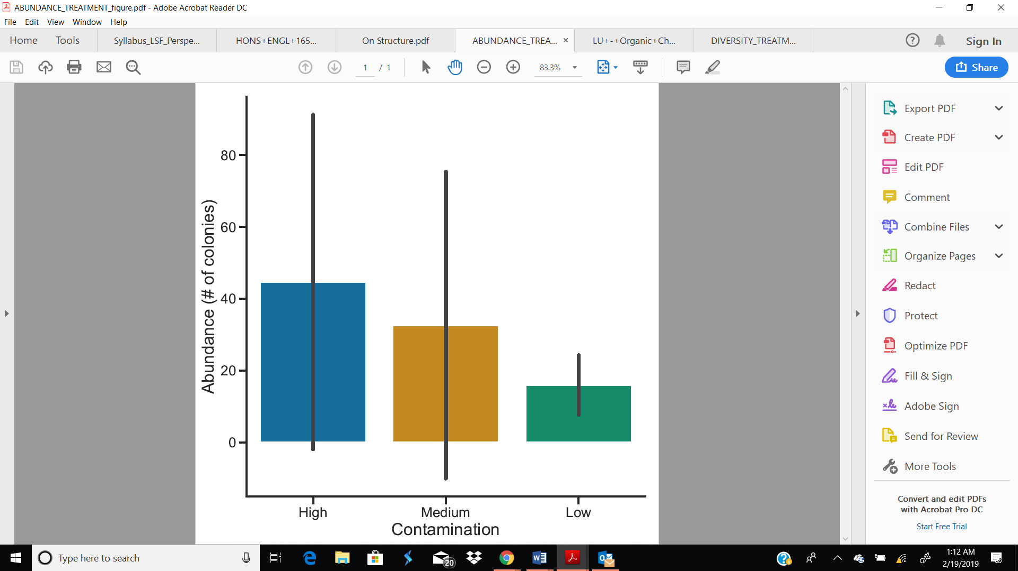

The error bars for the high and medium contaminations overlap for the most part, and the error bar for the low contamination is a lot smaller than both of them.

Figure 2:

The Overall Diversity of Bacteria in Each Level of Contamination

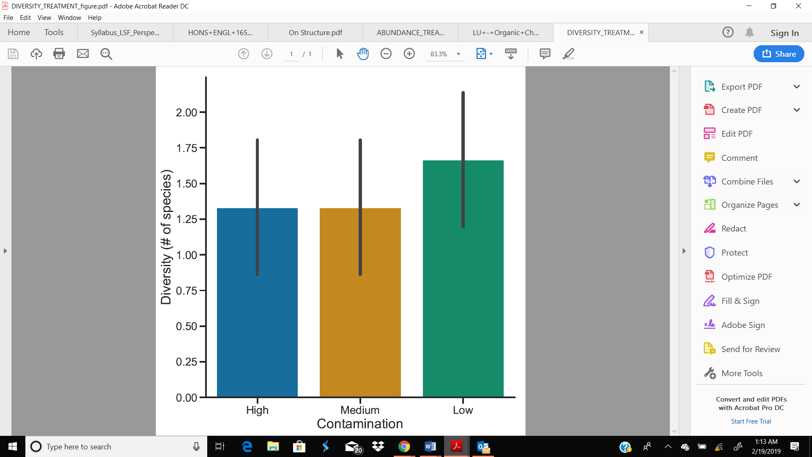

The diversity for both high and medium contamination levels are the same with the same error bars. The low contamination has a slightly higher diversity with the error bars partially overlapping with the error bars for high and medium contaminations.