D1S80 separation using PCR and Gel electrophoresis

Kiley Clark

Bio 250

Spring 2020

**Introduction**

Variable number of tandem repeats, or VNTR, is a location on a DNA molecule with repetitions in sequence of DNA. D1S80, a specific VNTR, is a region on chromosome 1 that can contain DNA varying between 6 and 100 base pairs. In the sample used, the D1S80 had a 16 base pair repeat size and was repeated between 14 and 41 times (Duncan et al. 1997). The D1S80 is smaller compared to other VNTRs so there is more success using PCR to separate the amplicons. It is used primarily for identification and paternity testing (Jung. 2018). However, studying D1S80 cannot be used to discriminate between distinct genotypes and can usually be used to give a brief overview of the DNA profile (Pomeroy. 2014).

**Materials and Methods**

Sample collection and preparation:

Sixty microliters of sterile water was added to a 1.5 mL tube. The stick end of a cotton swab was used to collect cells from the students’ cheek and the swab was then mixed in the water.

PCR reaction setup:

In a PCR tube, 7.5 µL of Primer mix containing the forward and reverse strands of D1S80VNTR and 12.5 µL of Master mix containing dNTP, Taq polymerase, and a buffer was added. Using a micropipette, 5µL of the cheek swab and water mix was transferred to the PCR tube. The tubes were spun down and cooled before being placed in the PCR machine to begin thermocycling with the following thermal profile:

|  |  |  |
| --- | --- | --- |
| **STEP** | **TEMP** | **TIME** |
| Initial Denaturation | 98°C | 5 min |
| 30 Cycles | 98°C **67**°C 72°C | 5 seconds 5 seconds 20 seconds |
| Final Extension | 72°C | 1 minutes |
| Hold | 4°C |  |

Primer sequences:

|  |  |
| --- | --- |
| D1S80VNTR_For | 5’ - GAA ACT GGC CTC CAA ACA CTG CCC GCC G – 3’ |
| D1S80VNTR_Rev | 5’ - GTC TTG TTG GAG ATG CAC GTG CCC CTT GC – 3’ |

Gel electrophoresis:

The gel electrophoresis chamber was set up with pre-prepared gel slab. Once the 2% agarose gel was loaded, the chamber was filled with a conductive 1X TAE buffer solution and 10 µL of the student PCR samples were loaded in each well with a ladder loaded in the seventh chamber to use as a comparison for later. Then, the gel electrophoresis was set to run at 120 V for 40 minutes. Afterwards, it was placed over UV light so the DNA segments glowed orange and then was placed in another machine to get an image under white light. The sizes of the DNA fragments were estimated by comparing it to the ladder and the migration distances of the amplicon were measured

**Results**

PCR #7 was run alongside the ladder and two solid segments of DNA were found from the picture. Both were close to bands from the ladder and the line of best fit was used to more accurately determine the number of base pairs in both segments.

Graph 1:

Table 1:

The migration of each segment of the ladder and the number of base pairs in each segment

|  |  |
| --- | --- |
| Ladder Base pairs (bp) | Migration (cm) |
| 5000 | 2.3 |
| 3000 | 2.75 |
| 2000 | 3.4 |
| 1500 | 3.8 |
| 1000 | 4.5 |
| 750 | 5.1 |
| 500 | 5.9 |
| 300 | 6.8 |
| 100 | 8.2 |

The ladder was used as reference to determine the amount of base pairs in each segment of DNA from the PCR samples.

Table 2:

The Distance of the Amplicons of PCR#7

|  |  |  |
| --- | --- | --- |
| Migration of samples (cm) | Samples bp using the graph formula | Repeats |
| 2 | 4144 | 259 |
| 5 | 1094 | 68 |

PCR #7 was run alongside the ladder and two solid segments of DNA were found from the picture. Both were close to bands from the ladder and the line of best fit was used to more accurately determine the number of base pairs in both segments.

Image 1:

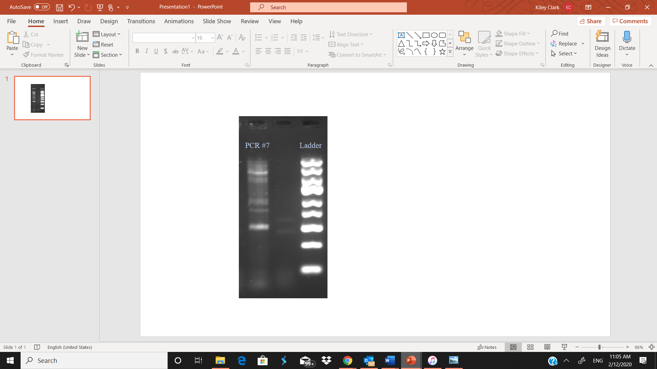  
Two distinct bands were found from PCR#7 and compared to the ladder to estimate the number of repeats.

**Discussion**

The gel electrophoresis was successful. A high number of repeats were found and the findings for PCR#7 was in line with the estimations set by the ladder. The reaction was not entirely successful because the amplicons had not completely separated closer to the well, so they appeared more blended. This could be resolved by allowing the electrophoresis to run longer and give it more time to distinctly separate.

D1S80 can be and important indicator for identifying someone or studying lineage (Jung. 2018). It can be easier to separate using PCR because the segments tend to be smaller than other VNTRs used. The VNTR cannot be used to identify specific genotypes but further studies have use it to identify single nucleotide polymorphism haplotype frequencies to identify DNA samples from different backgrounds. D1S80 repeats were reportedly similar between samples of similar backgrounds (Limborska. 2011). Further studies can continue to exploit the numerous uses of D1S80 as it is a versatile segment of the genome that can provide a lot of information on DNA.

**References**

Atalay, A. Atalay, E.O. et al. 2012. Allele frequency of VNTR locus D1S80 observed in Hb D-Los Angeles carrires. *Molecular Biology Reports*. 39:10747-10750.

Curry, E.T. Demers, D.B. et al. 1995. Enhanced PCR amplification of VNTR locus Dl S80 using peptide nucleic acid (PNA). *Oxford University Press*. Vol. 23. No. 15.

Duncan, G.T. Balamurugan, K. Budowle, B. Smerick, J. Tracey, M.L. 1997. Microvariation at the human D1S80 locus. *International Journal of Legal Medecine.* Vol. 110, Issue 3.

Jung, J.Y. Kim, Su-Ji. et al. 2018. A Simple Method of VNTR D1S80 Locus Allelic Ladder Construction for Capillary Electrophoresis-based Genotyping. *Journal of Foreinsic Sciences.* Vol 63. No. 2.

Limborska, S.A. Khrunin. A.V. et al. 2011. Specificity of genetic diversity in D1S80 revealed by SNP--VNTR haplotyping. *Annals of Human Biology*. Vol. 38. Issue 5. 564-569.

Pomeroy, R.S. Balamurugan, K. Wong, H. Duncan, G. 2014. High‐resolution melt analysis of the minisatellite D1S80: A potential forensic screening tool. *Wiley Online Library.*