Does race affect the levels of Parent Involvement
Bailey Burcume
SOCL-345-03 Social Research and Program Evaluation
Dr. Patterson
November 22, 2023

Abstract
The involvement of parents is critically significant in the realm of early childhood education, particularly in programs like Head Start that are dedicated to supporting the development of young children from underprivileged backgrounds. This study emphasis on the importance of parental engagement within the framework of Head Start, exploring how the effects of socioeconomic status influence the level of parental involvement and highlighting the fundamental strategies and methods to enhance parental participation in the activities sent home to Head Start. The purpose of this study is to understand how socioeconomic status influences parent involvement based on the completion of the family fun-time activities sent home. This data is based on a mixed method of qualitative and quantitate date measured as open and close-ended questions. Overall, family fun-time activities resulted in families with color have a higher parent involvement based on their socioeconomic status.

Introduction
The research problem centers around investigating the relationship between parental involvement and race, with the objective of comprehending potential disparities, patterns, and factors influencing parents' engagement in the educational processes of their children across different racial backgrounds. This inquiry is crucial as it enhances our understanding of the intricate interplay between parental involvement and race. By doing so, it facilitates the identification of potential disparities in educational engagement, shedding light on areas where certain racial groups may face challenges. Furthermore, it elucidates how the intersection of parental involvement and race can contribute to fostering equity and equal opportunities in education. This, in turn, can pave the way for creating an educational environment that is accessible and supportive for all students. In a study conducted by Yan & Lin (2010), variables related to parental involvement revealed statistically significant distinctions between Caucasian families and minority groups. Examining multiple studies, it was consistently reported that Caucasians exhibited a higher level of parental involvement compared to minority groups (Zhang et al., 2011).
This research problem merits further examination due to its potential policy implications and the broader context of equity in education. Policy implications could play a pivotal role in developing education policies that address the specific needs and challenges faced by different racial groups. Understanding equity in education involves exploring how parental involvement varies across diverse racial backgrounds, affecting access to educational resources and opportunities. The significance of studying the relationship between parental involvement and race lies in its potential to address and improve the education system. This study endeavors to delve into the connection between parental involvement and race, seeking to gain insights into potential variations, patterns, and factors impacting parents' engagement across a spectrum of racial backgrounds in their children's educational experiences.
Literature Review
Parent involvement has become an important factor helping researchers understand how children develop. Researchers have stated, Throughout the years, an extensive body of literature has highlighted the significance of parental engagement in the early stages of a child's life. However, there has been comparatively less emphasis on the role of parent involvement in the later years of schooling. Previous research on this subject has predominantly concentrated on the connections between parent involvement and student achievement, giving relatively less consideration to the social and emotional aspects of children's development. (El Nokali et al. 2010). This study will be based on how single parent households and race are affected by parent involvement. Hilado et al. (2013) stated parental involvement is a vital aspect of preparing children for school readiness. Therefore, it is valuable to explore strategies for fostering parent engagement from the programmatic level onwards.
Single Parent Households
Based on research, evaluations indicated that single parents exhibited lower levels of involvement in their children's schooling compared to parents in two-parent families (Arnold et al., 2008 & Lee et al., 2007). This explains that families in a two-parent household exhibit higher levels of involvement in the child’s development. While single parent households are significantly less likely to be involved. Argys et al. (1998) found that the challenges faced by children from single-parent households can be linked to their lower socioeconomic status (SES). In another study Epstein (2010) discovered lower levels of involvement at the school are observed among single parents, working parents, those residing at a distance, and fathers unless the school has opportunities for families to volunteer at different times and locations, thereby contributing support to both the school and their children. Therefore, based on the research having a two-parent household has a higher level of parent involvement and single parent households have a lower level of parent involvement.
Race
In a study Cooper et al. (2009) discovered white parents reported poor children in Black, Hispanic, and White families experience more academic challenges during the school transition, Asian children exhibit similar levels of math and reading achievement regardless of family income. This unexpected finding is attributed to the higher academic expectations and beliefs held by Asian parents, which may act as a buffer against the academic risks associated with family poverty. Hispanic parents were the least inclined to furnish cognitively stimulating materials, involve their children in organized activities, or participate in home-learning activities. Black parents exhibited the lowest levels of involvement in school-based activities. Another study stated, among parents with high socioeconomic status (SES), African American parents exhibited lower levels of participation in school activities compared to their Caucasian counterparts with similar SES. However, this discrepancy decreased as SES levels declined (Zhang et al., 2011). In another study Yin and Lin (2010) found Caucasian parents demonstrated a greater degree of involvement in their children's education compared to the other three minority groups. African American parents were notably frequent in contacting the school regarding their teenagers' performance. Additionally, both African American and Hispanic American parents reported implementing stricter family rules than Caucasian parents. When examining factor scores, the educational expectations for Asian American students were the highest among all the factors, signifying that Asian American parents held the highest aspirations for their children's academic achievements.
Data and Methods
Instrument
A survey questionnaire was created by eight members of the Social Research and Program Evaluation Team at Longwood University. The survey consisted of 15 questions, 12 closed-ended questions and three open-ended questions. The first question on the survey asked respondents for informed consent. Any respondents that answered “no” to the informed consent were not able to see any other questions. The survey included questions that measured family involvement, family enjoyment, evaluation of SMART objectives, and demographics. The survey was sent online through Qualtrics Program. Head Start teachers e-mailed links to the survey to guardians, and children brought home books with a QR code attached.
Sample
The non-probability sample for this study was based on 17 (ages three to five) children who attend Head Start in rural Virginia. Head Start is a federally subsidized preschool for families with economic need. An activity was created for the children “haunted runway” where they dress up as a costume with the belongings in their household. They also have been given face paint to use as an accessory and was sent a children’s book attached with a QR code encouraging families to complete online after the activity. Teachers sent a reminder e-mail to guardians to complete any outstanding surveys. This resulted in four questionnaires being completed. Overall, there was a 4% response rate. Therefore, data from previous years (2019 and 2022) on Family Fun Time activities were added to the analysis. This resulted in 66 completed surveys to be used in analysis (four from 2023, 20 from 2022, and 42 from 2019).
Quantitative Analysis
Quantitative analysis of complete surveys is based on the close-ended questions. For this study the dependent variable is family involvement. The item from the survey that was used to operationalized this was, “On a scale from 0 to 10, how much did this activity encourage you r family to work together?” (0=not at all, 10=a great amount). For this study, the independent variable is socio economic status. The item from the survey that we used to operationalized this was, “What is your race?”. The answer choices for this question are “Black/African American, Asian/Pacific Islander, White/Caucasian, Hispanic/Latino, Native American/Native Alaskan, Middle Eastern, Other, Prefer not to say”. Descriptive statistics were used to analyze these variables.
Qualitative Analysis
Qualitative analysis of the completed surveys (from 2019, 2022, and 2023) was based on open-ended questions form survey responses. The open-ended questions were, “What did you enjoy about this activity?”, “What are your suggestions for improving this activity?”, “Typically, what activities do you do with your child?”. To answer the research question, “How does socio-economic status influence the level of parent involvement in their child’s development?”, inductive open coding was used to determine reoccurring themes in the respondents’ responses.
Findings
Quantitative Findings
The dependent variable in this study is family involvement and how children participate in the activities. This question is asked on a scale of 0 (not at all) to 10 (great amount). The independent variable in the study is the type of race of the participant. Respondent would answer “Black/African American”, “Asian/pacific Islander”, White/Caucasian”, Hispanic/Latino”, “Middle Eastern”, “Other”, “Prefer not to say”. The hypothesis is that there is a higher likelihood of active parent involvement among individuals who identify as white when compared to other racial or ethical groups.

Table 1.
Family Involvement mean and standard deviation.
Involvement
Mean | 7.2
Median | 7.0
Mode | 10.0
SD | 2.6
N=N/A
Table 1 shows participation in the activity sent to head start is 7.19. The standard deviation was 2.6. This means that the average of participation of the activity was completed and enjoyed at a high rate. The mean is 7, meaning that this is the middle value of the data set. The mode is at 10. This means that 10 was selected the most out of all the other answers. The standard deviation is only 2.6. This states that the data is clustered tightly to the mean.
Figure 1.
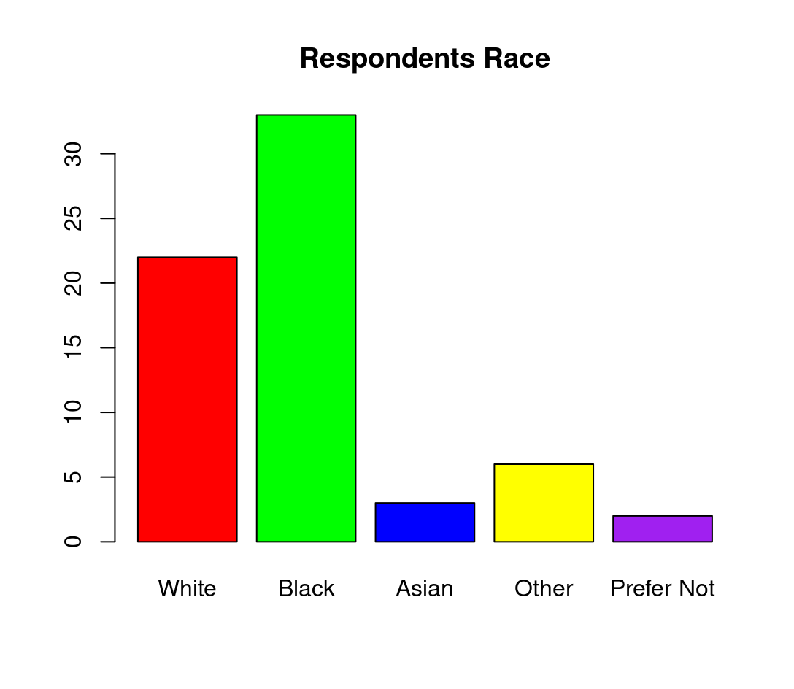
Table 2 shows that Black people are more invoilved in family involvement than any other race. Respondents race that are least likley to particpate in family involvment are “Asian”, “other”, and “prefer not to say”. Based on all the resondents surveys the data shows that minorities are more involved in family involvemnet than Whites.
Table 3.
Mean and Standard deviation of PI on race
Parent Involvement based on Race
Race Mean SD
White 6.7 3.2
Black 7.2 2.3
Asian 8.7 2.3
Other 8.2 2.2
Prefer Not 7.0 1.4
N=N/A
Table 3 shows that Whites are less likely to participate in parent involvement. They have a mean of 6.7 while every other race is 7.0 and above. The race with the highest mean is Asian. Also, Whites standard deviation is more widely spread at 3.2. While other races are closer ranging from a SD from 1.4 to 2.3.
The original hypothesis stated there is a higher likelihood of active parent involvement among individuals who identify as White when compared to other racial or ethical groups. The data showed that minorities had a higher family involvement than Whites. The mean was only 6.7 for Whites. While minorities were between 7.0 and 8.7. The mean was significantly higher for minorities than Whites. Also, the standard deviation was closer for minorities. In all minorities had a significantly higher rate of family involvement compared to Whites.
Qualitative Findings
This qualitative study aims to explore the intricate connections between family engagement and socioeconomic status, providing insights into various avenues through which economic factors affect and shape family interactions. In the findings we used themes to distinguish the enjoyment of each activity. In our research we accumulated many themes, these themes are categorized on what each respondent displayed on their survey.
Teamwork/Collaboration
In our findings we discovered that teamwork and collaboration is an important theme to discover if families enjoyed the opportunity for collaboration. Respondent 19_18 stated, “Working well together, just takes a little patience. Everyone wanted to participate and help”. This respondent explained that they really enjoyed family time and teamwork helped everyone complete this activity. Respondent 19_17 and Respondent 19_15 both stated, “It provided us with family time”. This demonstrated that the families were grateful that the activities were simple and provided them with family time.
Educational Development
Education development was another theme that benefited on the recognition of shapes, colors, numbers, and letters. Respondent 22_10 stated, “their child learned letters, numbers, and how to take turns, also a little bit of reading”. This meant the respondent enjoyed the activity and was able to learn the basic numbers, and letters. Also, Respondent 22_12 stated, “Very informative and super interactive” and ‘The sugar was my favorite because it helped [Paisley] with writing her name”. This respondent found that the information or content being presented to be highly informative and engaging. They likely appreciated the quality and level of interactivity within the activity. Being able to make these family activities informative and educational allowing for a more enjoyable experience for the child and the parent.
Motivation to Participate in Future Activities
Motivation to participate in future activities would help increase the chances of surveys being completed and the increase family involvement. Respondent 22_10 stated, “Their child said she loves doing things with mom and dad”. This statement explained that this child enjoyed time spent with parents, increasing the motivation to participate in future family fun time activities. Respondent 19_4 stated, “My daughter had the most fun with it didn’t want stop playing it”. This respondent’s child enjoyed the activity which could increase the future participation of other family activities. Respondent 19_11 stated, “send more…”. This respondent elaborated that more activities be sent home in the future.
Helped Families Make Time
Helping family’s bond together and make time for family activities can increase the pleasure in these activities. Respondent 19_13 stated, “We were together doing these activities: my brother, me, my son. We don’t usually do these kind for things together…”. This activity helped families make room for the family time. Another Respondent 19_11, “Yes, it was something that we made time for- we don’t always get the chance”. Also, Respondent 19_10 stated, “Yes, because been a busy mom of two its hard to come home and try to think of something to do”. Both respondent 19_11 and respondent 19_10 were able to make time for this activity, allowing for time together and participating in the activity as a family.
Helping Develop Social Skills and Communication
The last theme was for the activities to develop social skills and encourage communication between children and parents. Respondent 19_19 stated, “My family gained quality time and it helped my child understand things about his feelings and what to be thankful for”. This explains that the development of children’s feelings important to parents and showing emotions is important to a child’s development. Respondent 17_17 states, “Communicating, family members voicing opinions.” Communication is important to all family activities and child development. Encouraging family to communicate and be supportive of their child at any age. Respondent 22_14 stated, “my child learned patience. Not giving up if something doesn’t go the way or look how she expected it to”. This explained that children use social skills and communication to understand patience and learn how to succeed through struggles.
The study unveiled several key themes concerning family engagement in activities. Notably, teamwork and collaboration were significant, with families cherishing the chance to cooperate and strengthen their bonds. Respondents emphasized the positive effects of such activities on family time and participation. Educational development emerged as another central theme, as parents valued the learning opportunities offered, including the recognition of shapes, colors, numbers, and letters. Motivation for future participation stemmed from the enjoyment and bonding experienced during these activities. Making room for family activities was highlighted, as families found these experiences valuable despite their hectic schedules. Lastly, the activities were seen as fostering social skills and communication, as children learned about emotions, patience, and expressing their thoughts. Overall, these findings underscore the importance of family engagement activities in promoting collaboration, education, motivation, and communication within families.
Conclusion
The main pint of the project was to understand the correlation of parent involvement and how race is affected. This study focuses on the crucial role of parent involvement, particularly within programs like, Head Start, a program for children with underprivileged backgrounds. The research dives into the influence of seriocomic status on parent involvement, exploring the completion of family fun-time activities sent home. Based in the data gathered form mixed-methods approach, family fun-time activities resulted in higher parent involvement among families of color.
In large context of early childhood education, this study investigates the importance of academic achievements and development of children. Parent involvement plays a big role in shaping academic outcomes bit also social and emotional well-being. According to Hilado et al. (2013), fostering parental children for school readiness. Hence, it is beneficial to investigate approaches for promoting parent engagement starting from the programmatic level and beyond. Education works towards creating inclusive and equitable learning environments, understanding and promoting parent involvement as a key aspect for every child. The central point is based on parent involvement acts as potent force for driving positive transformations in early childhood education. Society should acknowledge and promoting education shaping in early childhood life.

References
Argys, L. M., Peters, H. E., Brooks-Gunn, J., & Smith, J. R. (1998). The impact of child support on cognitive outcomes of young children. Demography, 35, 159-173.
Arnold, D. H., Zeljo, A., Doctoroff, G. L., & Ortiz, C. (2008). Parent involvement in preschool: Predictors and the relation of involvement to preliteracy development. School psychology review, 37(1), 74-90.
Cooper, C. E., Crosnoe, R., Suizzo, M. A., & Pituch, K. A. (2010). Poverty, race, and parental involvement during the transition to elementary school. Journal of family issues, 31(7), 859-883.
El Nokali, N. E., Bachman, H. J., & Votruba-Drzal, E. (2010). Parent involvement and children's academic and social development in elementary school. Child development, 81(3), 988–1005. https://doi.org/10.1111/j.1467-8624.2010.01447.x
Epstein, J. L. (2010, November). School/family/community partnerships
caring for the children we share. Kappan Classic, 92(N3). Retrieved
September 20, 2023.
Hilado, A. V., Kallemeyn, L., & Phillips, L. (2013). Examining Understandings of Parent Involvement in Early Childhood Programs. Early Childhood Research & Practice, 15(2), n2.
Lee, S. M., Kushner, J., & Cho, S. H. (2007). Effects of parent’s gender, child’s gender, and parental involvement on the academic achievement of adolescents in single parent families. Sex roles, 56, 149-157.
Yan, W., & Lin, Q. (2005). Parent involvement and mathematics achievement: Contrast across racial and ethnic groups. The Journal of Educational Research, 99(2), 116-127.
Zhang, D., Hsu, H. Y., Kwok, O. M., Benz, M., & Bowman-Perrott, L. (2011). The impact of basic-level parent engagements on student achievement: Patterns associated with race/ethnicity and socioeconomic status (SES). Journal of Disability Policy Studies, 22(1), 28-39.

