Bridging Gaps: A Mixed-Methods Study on Single-Parent Involvement in Early Education

Allison A. Clevenger

Social Research and Program Evaluation

Dr. JoEllen Pederson

November 29, 2024

**Abstract**

Parent involvement in education has long been recognized as central to children's academic success. Existing research presents conflicting perspectives on the impact of family structure on parental involvement and educational outcomes. The purpose of this study is to investigate the relationship between single-parent households and parent involvement in early childhood education. Using a mixed-methods approach, 26 respondents from Head Start programs across seven counties in Central Virginia provided both qualitative and quantitative data.

*Keywords:* Parent Involvement, Survey, Research, Head Start

**Introduction**

What happens when the weight of education falls on one pair of shoulders?Parent involvement is a critical factor in shaping children's academic and personal development, influencing both short-term achievement and long-term success. However, family structure significantly affects this involvement. Single-parent households are frequently perceived as less capable of furthering strong educational engagement due to resource constraints and time limitations. Existing literature presents mixed findings; while some studies associate single-parent families with lower academic aspirations (Garg et al., 2007), others suggest these effects are mediated by external variables like community support and parental education (Amato et al., 2015).

This study sets itself within the broader discourse on educational equity, particularly in the context of Head Start programs, which serve as critical interventions for children from low-income families. With a growing prevalence of single-parent households understanding their specific dynamics is imperative to inform educational policies and support mechanisms. Despite prior research, gaps remain in capturing the voices and lived experiences of single parents, especially within early education contexts.

The purpose of this study is to explore how single-parent households engage with their children’s education, particularly in the Head Start program. Using both qualitative and quantitative data, this research identifies patterns of involvement, challenges, and opportunities, advancing the discourse on inclusive educational practices.

**Literature Review**

Parent involvement can look a lot of different ways depending on how the context it is used in. Parent involvement can be reading to their children before bed, it can be helping with homework, or going to the park on the weekends parent involvement can look like a lot of different things. Parent involvement can also look like in education attending school functions, for example school plays, art shows, field trips. Also responding to school obligations, for example parent-teacher conferences. With parents becoming more involved in their children's education the child can become more successful in school and it is a positive influence on the child's life (Cotton & Wikelund, 1989).

There can be very different points of views in regards to parent involvement in schools. One point of view is the parents, now there are many different types of parents but some parents feel that their responsibilities/job is to raise their child like teaching them right and wrong and how to be a functioning person in society. Then it is the teachers and educators job to teach their child, they (parents) should not have to teach their child any school related information because it is not their job (Epstein, 2010). The other point of view is the educators, they believe that they can not do their job as teachers without the support from the families at home or they believe that the family is not doing their job at home (Epstein, 2010). With these points of view in mind there are partnerships that can be made with the school in the family. In these partnerships the schools should recognize the child's individual needs and support them in their needs, while the parents should recognize that their child is a student and should express the importance of education, homework, and other activities to build students skills and the feeling of success (Epstein, 2010).

The relationship between single-parent families and children's educational outcomes has been explored through diverse methodologies and contexts. Amato et al. (2015) analyzed U.S. state-level data to investigate whether an increase in single-parent households correlates with declines in children's academic achievement. Their study found no significant association between changes in single-parent family prevalence and state-level test scores in mathematics and reading, suggesting that other variables, such as parental education levels, may play a more substantial role in influencing academic outcomes. De Lange et al. (2014) examined the impact of the fraction of single-parent families in schools on children's educational performance using data from 25 OECD countries. Their findings indicate that higher amounts of students from single-parent households negatively affect the performance of all students, particularly those from single-mother families. This negative effect is moderated in countries with higher overall rates of single-parent households, except in the U.S., where societal norms and policies may not mitigate the adverse outcomes as effectively (de Lange et al., 2014)​

Garg et al. (2007) explored the influences of family structure on the educational aim of Canadian adolescents. Their research highlighted that youth from single-parent families typically exhibit lower educational aspirations compared to their peers from two-parent households. Key factors in this relationship include academic self-concept, parental involvement, and peer influences. While supportive peers positively affect aspirations, the study underscores the importance of enhancing parental educational involvement to guard the challenges faced by adolescents in single-parent contexts.

Another factor that can play into parent involvement and children's education is the number of children in the household. A study showed that households that have less children did better in school, and families with less children have more time and resources to provide for the other children (Walter, 2017). It can be helping their child with their homework or being able to pay for a tutor when the parent is unable to help. In a household with less children there is more money to go around, for example there are less mouths to feed so parents of one child do not have to worry about getting food on the table where a parent with three children would have more concerns. Since the parents are not as worried about money as others, they have more time to spend with their children, whether it be practicing math problems or reading a bedtime story (Guryan et al., 2008). All parent involvement is important for children to grow and learn whether it be in education or in life skills. A better partnership and understanding between families and educators could improve any child's education and give them the best support system to help them further their education (Epstein, 2010).

**Data and Methods**

**Instrument**

An online survey questionnaire was created by a research collaborative at Longwood University. The survey created in Qualtrics included an informed consent question and open and closed-ended items. There are 23 closed ended items that cover parent needs including, resources, comfort, time, finances, mental health needs, and demographics. The questionnaire included three open ended items. The questionnaire had an estimated completion time of ten min.

**Sample**

The convenience sample for this project is parents and guardians of Head Start children who are between the ages of three and five who reside in seven counties in Central Virginia. There are approximately 119 families in this sample population. Head Start headquarters e-mailed the online survey to county Head Start teachers. Teachers then emailed the survey to all families in their classroom. Surveys were e-mailed home at least three times during data collection. This resulted in 26 surveys being submitted. The response rate was approximately 25%. No incentive was offered for completing the survey.

**Quantitative Analysis**

Quantitative data was analyzed using descriptive statistics. The dependent variable of interest was “Is the household a single parent household?” The independent variable of interest was “Is the household a single parent household?”

**Qualitative Analysis**

Qualitative analysis was based on the open-end items. Thematic coding was used to analyze parent responses.

**Findings**

**Quantitative Findings**

The dependent variable for the quantitative findings was “How involved do you feel in your child's education on a scale of 0 - 10?”, 0 being Not at all and 10 being Extremely involved. Then the independent variable was “Is the household a single parent household?”, the possible answers were yes,no, and prefer not to say. With these variables the hypothesis is that if the child lives in a single parent household then their parents are less involved in their child's education.

The mean score for parent involvement in their child's education was 8.81, this mean is high which means there are high levels of parent involvement. The standard deviation was 2.06, this shows that the answers were more varied.

Table 1. 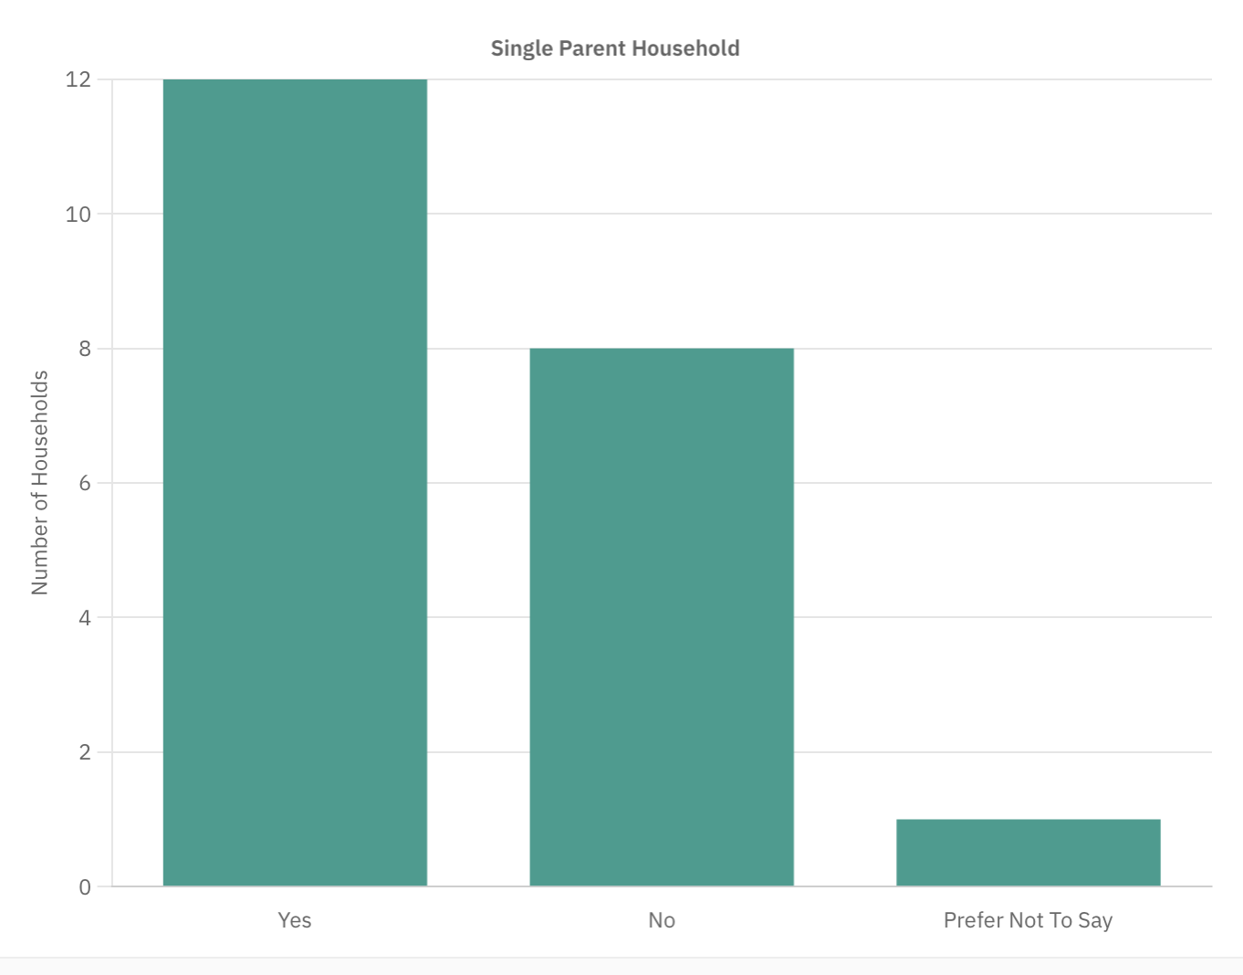

The table above (table 1) shows the number of single parent households out of the respondents that answered this question on the survey. Majority of respondents answered that their child lives in a single parent household (57%), then 38% of the respondents stated their child does not live in a single parent household, and 4% chose not to disclose this information in the survey.

Table 2. 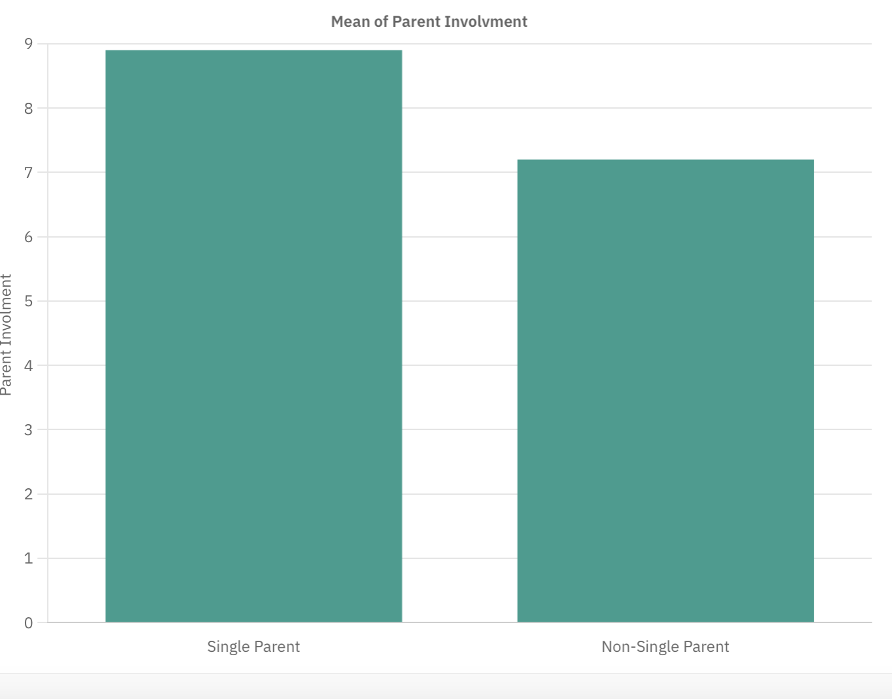

Table 2 shows the comparison between respondents' involvement in their child's education and if it is a single parent household.

The mean for single parent households was 8.9 with a standard deviation of 1.7. This indicates that over 60% of single parents stated that their involvement level is between 7.2 and 10 on the survey scale.

The mean for non-single parent households was 8.6 with a standard deviation of 2.8. This indicates that over 85% of non-single parent households stated that their involvement level is between 5.8 and 10 on the survey scale.

The original hypothesis stated that if the child lives in a single parent household then their parents are less involved in their child's education. This hypothesis proved to be wrong with this survey, the data from single parent households stated that their households are more involved with their child's education than non-single households.

**Qualitative Findings**

We asked three open-ended questions: one about activities respondents enjoyed with their children, another about handling stress, and a final question for any additional needs respondents wanted to share. In response to the first question we found two main themes: outdoor activities and education. For the second question there were two themes as well: self-care and communication.

When we asked respondents about activities they enjoyed with their children, two main themes stood out: outdoor activities and education. With outdoor activities, Respondent 1 enjoyed "outdoor adventures," Respondent 23 mentioned "playing at the park," and Respondent 11 highlighted "horseback riding." In the educational theme, Respondent 2 enjoyed "helping [their children] learn and reviewing what they learn each day," Respondent 12 appreciated "going over their schoolwork and seeing how much they’re learning here," and Respondent 15 enjoyed "teaching and learning" together.

When we asked respondents how they cope with stress, two main themes came up: self-care and communication. Under the self-care theme, Respondent 2 mentioned "taking a walk," Respondent 10 said they manage stress by "relaxing and [doing] yoga," and Respondent 17 shared that they use "journaling." Respondent 18 highlighted "taking deep breaths and praying." In the communication theme, Respondent 1 mentioned "talking with family and friends," Respondent 9 noted simply "communication," and Respondent 23 mentioned "therapy."

**Conclusion**

This study highlights the complex nature of parent involvement in single-parent households, challenging traditional assumptions about limited engagement. Quantitative findings reveal that single-parent households report higher average involvement levels compared to two-parent households, contradicting prevailing stereotypes. Themes from qualitative analysis—outdoor activities, educational support, self-care, and communication—underscore the creative strategies single parents employ to nurture their children's development.

These findings hold significant implications for educational policymakers and practitioners. Recognizing the strengths of single-parent households, Head Start and similar programs can develop targeted initiatives to further support these families, emphasizing flexibility and resource accessibility. Additionally, these insights advocate for a shift in societal narratives, celebrating the resilience and capacity of single parents rather than focusing on deficits.

Ultimately, this study contributes to a more exact understanding of family dynamics and education. It calls for a society that values diverse pathways of parental engagement, ensuring that all children, regardless of family structure, have equitable opportunities to thrive.

**References**

Amato, P. R., Patterson, S., & Beattie, B. (2015). Single-Parent Households and Children’s

Educational Achievement: A State-Level Analysis. *Social Science Research*, *53*,

191-202. https://doi.org/10.1016

Cotton, K., & Wikelund, K. R. (2019). Parent Involvement in Education.

https://educationnorthwest.org/resources/parent-involvement-education

De Lange, M., Dronkers, J., & Wolbers, M. H. J. (2014). Single-parent family forms and

children’s educational performance in a comparative perspective: Effects of school’s

share of single-parent families. *School Effectiveness and School Improvement*, *25*(3),

329-350. https://doi.org/10.1080/09243453.2013.809773

Epstein, J. L. (2019). School/ Family/Community Partnership Caring for the Children We Share.

*Kappan Classic*.

Garg, R., Melanson, S., & Levin, E. (2006). Educational Aspirations of Male and Female

Adolescents from Single-Parent and Two Biological Parent Families: A Comparison of

Influential Factors. *Journal of Youth and Adolescence*, *36*, 1010–1023. https://doi.org/10.1007/s10964-006-9137-3

Guryan, J., Hurst, E., & Kearney, M. (2008). Parental Education and Parental Time with

Children. *Journal of Economic Perspectives*, *22*(3), 23-46.

Walter, K. (2017). Influence of Number of Siblings and Learning Resources at Home on

Students’ Academic Performance. *Journal of Emerging Trends in Educational Research*

*and Policy Studies*, *8*(6), 291-299.