Reversing Darwinism
The story that Yellowstone likes to sell about lake trout is that they were either introduced accidentally by a careless boater, or they were introduced by some angler for the purpose of sport fishing. However, people in the Western United States, like Warren Johnson, do not trust the government enough to believe this story. Warren, whose opinions are almost as bold as his stiff cowboy hat, has a different theory on the lake trout introduction. It is hard not to take him seriously with his overwhelming physique and the unwavering voice that bellows from his chest when he preaches his beliefs. He is the epitome of a Western style rancher from his plaid button up flannel to his faded blue jeans that come down to his ankles, just far enough to cover the tops of his triangle toed brown cowboy boots. His everyday look can be completed by a custom Hell’s A-Roarin’ engraved gold-plated belt buckle bigger than his fist and fit for a WWE heavyweight championship belt.
Hell’s A-Roarin’ Outfitters is the business he always had dreamed of as a child growing up in poverty, and is the business he eventually built for himself from the ground up. In the foothills of Jardine, Montana, a steep winding road is the only way to get there for tourists willing to crawl their cars up the dirt road, no matter how treacherous it may be that day. His horse speckled side of the mountain is deeply sought after by tourists from all over the world. Amidst the forest of trees, trails, and dangerous wildlife, smells of a late evening cookout emanate from his home where there are rooms filled from wall to wall with beady eyed furry game that is less alive than the antique furniture that fills the rest of the space. It is obvious that he is a man that truly embraces the old western style of living where everyone works hard for their own profit and the government should not have anything to say about it.
He is among the many citizens in the state of Montana that do not believe a word the government tells them. Warren openly talks about how he does not trust the government because of the reintroduction of wolves in the West. Thus, he believes the government officials in Yellowstone are “selfish liars with a secret agenda.” His conspiracy theories do not stop at wolves, however. He believes that the government bred lake trout in a fishery, and they escaped to the Yellowstone River and eventually into the Yellowstone Lake and surrounding areas. But of course, he says, “they would never admit to their mistake.” Although the way he presents his argument is quite convincing, he still may not be reliable enough on which to base any assumptions. Afterall, he did admit that his father helped stock the surrounding brooks and streams of the Greater Yellowstone Ecosystem with loads of brook trout – another invasive species.

NO MATTER THEIR ORIGIN, IT IS COMMON KNOWLEDGE THAT INVASIVE SPECIES not only have a severe impact on native species but also on the overall equilibrium of the ecosystem. The Yellowstone cutthroat trout is a native species of Yellowstone Lake and many of its tributaries. Unfortunately, the population of Yellowstone cutthroat trout has been in steep decline since the 1990s because of the introduction of lake trout. Yellowstone biologists determined from sample studies in Yellowstone Lake, done in the late 1990s, that these lake trout mysteriously appeared in the lake just a decade before. Although the origin of these fish is untraceable, the effect that they have had on the ecosystem is undeniable. Lake trout feed on both cutthroat trout and most of the cutthroat trout’s food sources, rendering it nearly impossible for the cutthroat trout to rebound naturally. Furthermore, the cutthroat trout are a major source of food for many animals in the Greater Yellowstone Ecosystem. Predatory birds are struggling because there are less trout at the surface since lake trout accumulate in deeper waters than the cutthroat trout do. Alternatively, bears rely heavily on the cutthroat trout that migrate up stream to their spawning grounds as a major food source. With a lack of trout making this pilgrimage, the bears are stripped of this essential part of their diet.
In the late spring and early summer, the goal of all bears coming out of a long winter’s hibernation is to add on most of the weight they lost. Cutthroat trout used to be their primary method of doing this in the months of June and July – when the trout migrate into shallow tributaries around Yellowstone Lake to spawn. However, because of the reduction in the cutthroat trout population, there are not enough cutthroat trout as there used to be to sustain the number of bears in the Greater Yellowstone Ecosystem. Furthermore, like the birds, the bears cannot fish in the deeper areas of the water where the more prominent lake trout choose to reside. When this became the case, the bears had to adapt and search for a new food source to hunt during these months. The food needed to be high in protein and large enough to sustain energy for the coming months. Unfortunately, this means that the bears would need to move out of protected areas and predate on things like elk or even livestock. When elk are lost, the outfitters of the West lose money, and when livestock are lost, the ranchers of the West lose money. So, in order to avoid an angry mob of bear hating outfitters and ranchers, the cutthroat trout population must be restored to regain balance in the ecosystem.
A biologist named Ben Wise with the Wyoming Game and Fish Department would agree that cutthroat trout preservation should be a top priority throughout Yellowstone and the surrounding areas. He noticed that invasive trout, whether that be brook trout, brown trout, rainbow trout, or lake trout, displaced many amphibian and fly species by overcrowding areas that were once uninhabited by any fish at all. Although Ben’s main focus is working at a feed lot for elk and helping prevent the spread of diseases such as Brucellosis, he still believes that “We should afford [cutthroat trout] all opportunities to live.” Many Yellowstone biologists agree with this opinion and have already taken serious precautions and procedures to help eliminate the major threat that is the lake trout.

IN ORDER TO FISH IN YELLOWSTONE, EVERY ANGLER MUST FOLLOW VERY specific guidelines. A state issued fishing license is not even applicable in the park. If they are over the age of sixteen, they can buy a three-day, seven day, or seasonal fishing license that comes with a Volunteer Angler Report card. This is how the park keeps track of how many fish each angler catches. Furthermore, the season only lasts from the last weekend in May until the first Sunday in November, and fishing is only allowed when the sun is in the sky. Thus, fishing with the help of an artificial light is strictly prohibited and frankly unnecessary during the day. Any leaded fishing tackle is banned because the lead can be poisonous to all native fish species – cutthroat trout, Arctic grayling, and mountain whitefish. Fishing gear such as felt-soled foot gear and organic or inorganic baits are extremely prohibited, and all boats must pass inspection by the National Park Service to avoid bringing in even more invasive species to the environment. There are also many things that are illegal to use while fishing in Yellowstone such as scented attractants and chumming. Because all native fish must be released unharmed throughout the entire park, hooks must be barbless and only one hook is allowed per fly. In regard to the extermination of lake trout, independent fishermen help take care of this during their time in the park because it is illegal to release any nonnative species and all lake trout must be killed immediately.
Biologists have a major role in the elimination process as well. In the early 2000s it was decided that gillnetting would be the most effective way to remove large amounts of lake trout while also being able to collect data on them. In order to avoid accidental killings of native species, they harvested the lake trout from the lower depths where they tend to gather. Although this method proved itself more than effective over the years, lake trout were still a huge threat. So, the biologists decided that along with attacking the full-grown fish they should be eliminating the spawning sites as well. They began to use electricity and chemicals to shock and poison the embryos, but nothing was as effective as tarping. Tarping is done by placing the carcasses of multitudes of lake trout over the fish eggs to deprive them of oxygen and kill them before they can develop. It is the new most effective way to suppress the lake trout population because it does not affect the cutthroat trout or their embryos since they spawn in different places and at different times of the year.

ACCORDING TO BEN WISE, ALTHOUGH THE BIOLOGISTS ARE DOING THEIR BEST to help cutthroat trout in the surrounding areas of Yellowstone, methods to exterminate lake trout in Jackson Lake failed because so many people like the sport. Even Warren Johnson cannot dispute that point; he thinks the catch and release program is a positive change in this situation. Many other people of Jackson Hole, Wyoming, can jump on board with this idea as well. A couple of men that live in the area, David and Reed, discussed the difference in opinion that Jackson Hole has. When Reed mentioned how “this place is not as Wyoming as the rest of the state,” he was talking about how prim and proper the town of Jackson Hole can be. The town has many “deep pockets,” as David phrased it, that allow its citizens to have a lot of say in what the government does or does not do. David explained that “the cutthroat trout is the darling of the fishing industry,” but lake trout are just too fun to catch that they cannot get rid of them in Jackson Lake.
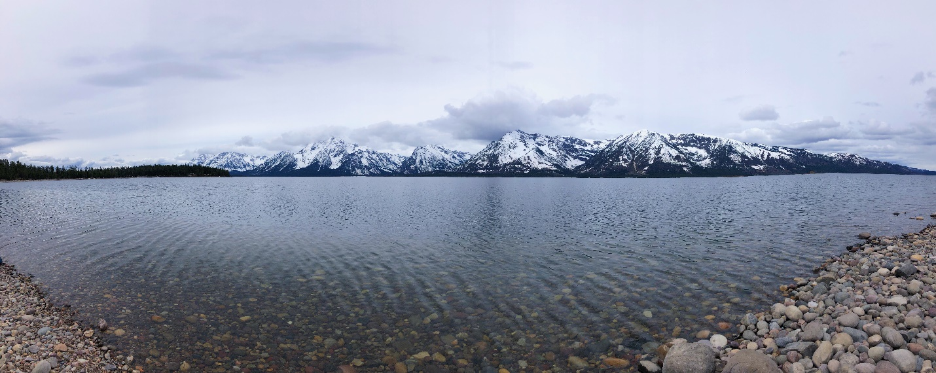
This solemn and peaceful lake can turn into a frenzy of anglers when fishing is in season. The event is so popular that it hit the headlines in the local newspaper as “After 36 years, the Ice Off Derby thrives.” The derby attracts so many visitors and participants that in the last three years there was a wait list because of the forty-boat cap imposed by Grand Teton National Park. However, it used to not be as regulated as it is today. In an interview the local newspaper did with Danny Mayer, an angler who has participated since the early years of the derby, said, “The first one was just a bunch of friends throwing money in a hat.” Now, there is a nonlethal incarnation, and many anglers partake in the peaceful practice of “jigging.” This is described as a time when the lake is silent as people fish with their boats parked in one spot at all times.
The reason the citizens of Jackson Hole love this sport so much is because it is somewhat of a family affair. In the “2019 Ice Off Jackson Lake Fishing Derby Catch & Release,” a twelve-year-old boy was the winner for catching the largest brook trout. His fish weighed in to be three pounds and one ounce. On the other hand, that is incomparable to the over twenty-four-pound lake trout that won in the derby. Moreover, the largest lake trout usually end up being around a whopping fifty pounds. Since it is a catch and release derby, cutthroat trout is a category that one can win, and the winning cutthroat trout was three pounds and four ounces. The joy of hoping to get the chance to win that trophy fish is what draws people to this derby and Jackson Lake itself.

REGARDLESS OF THE DIFFERING OPINIONS ON THE LAKE TROUT’S RIGHT TO LIVE, it is very widely accepted that the cutthroat species is in grave danger. Cutthroat trout were the first inhabitants of these lakes and tributaries and have no defense against the predators introduced illegally or accidentally. Lake trout have had ample time to overrun the cutthroat trout habitat and could even survive without fail if the cutthroat ceased to exist. Along with the help of the anglers, the government is doing its best to preserve, restore, and protect the native trout species of Yellowstone. As Warren Johnson has mentioned before, and as many anglers could agree, the best way to support the cutthroat trout repopulation movement is by fishing out the pesky lake trout whether it be for sport or for leisure. Alternatively, the most effective way to remove lake trout in bulk is through gillnetting done by Yellowstone biologists. The only way this essential process can continue is through ample funding by the National Parks Service. Unfortunately, most national parks are typically underfunded and desperately need donations from the public to continue their work. Even with the current efforts taken to reduce the lake trout population, there will be little to no noticeable effect on the cutthroat trout population until 2025. That is why the parks must work harder and act quickly to save this ecosystem. If efforts to exterminate lake trout are slowed or even stopped altogether any time between now and that date, there will be no hope for the survival of the cutthroat trout. If that happens, there will eventually be no hope for other species like the osprey or the grizzly bear.
Source Notes
To read more about Yellowstone National Park’s take on lake trout origin, effects, and methods of extermination, visit https://www.nps.gov/yell/learn/nature/lake-trout.htm. My descriptions of Warren Johnson and his Outfitters are from the trip I took up to his ranch. The quotes and information provided by Warren Johnson, Ben Wise, Reed, and David were gathered in my interviews with them. To understand more about the impact of trout on bears, visit https://www.nps.gov/yell/learn/nature/beartrout.htm. To find out more about the rules and regulations of fishing provided by Yellowstone National Park, visit https://www.nps.gov/yell/planyourvisit/fishing.htm. The image is of Jackson Lake and was photographed by me. I used pages 8C-11C of a local newspaper I found in Jackson Hole, Wyoming, to provide more information on the Ice Derby. It was called the Jackson Hole News&Guide and published on Wednesday, May 22, 2019.

