Name: Arleigh Wood
Bi- Weekly Report Dates: September 5-9 & 10-16
Week 1 Total: 17,123 steps- high day was 17,110 steps, low day was 13 steps
Week 2 Total: 57,801 steps - high day was 22,936 steps, low day was 9,079 steps

Week One Reflection and Graphs

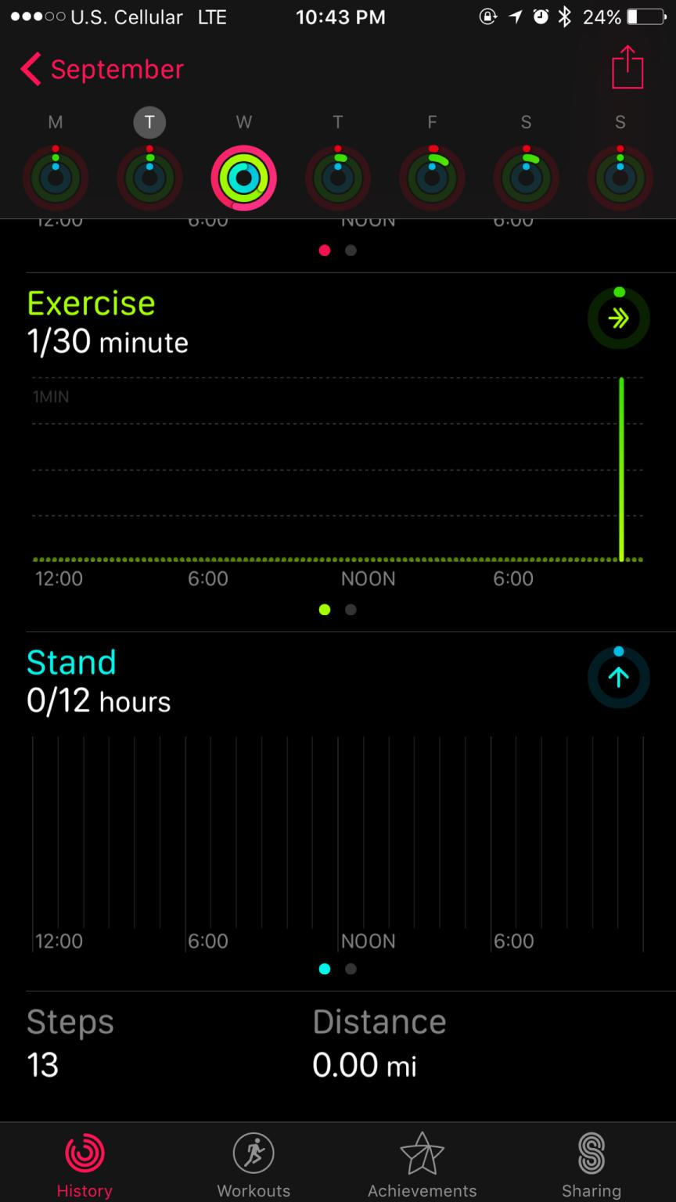
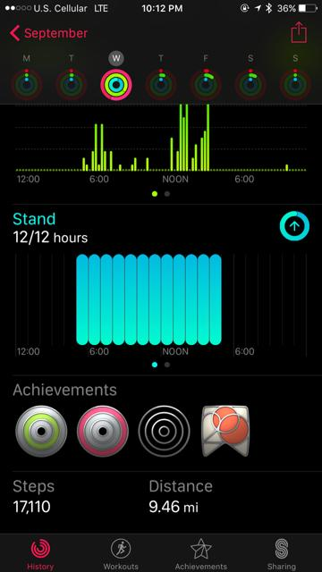
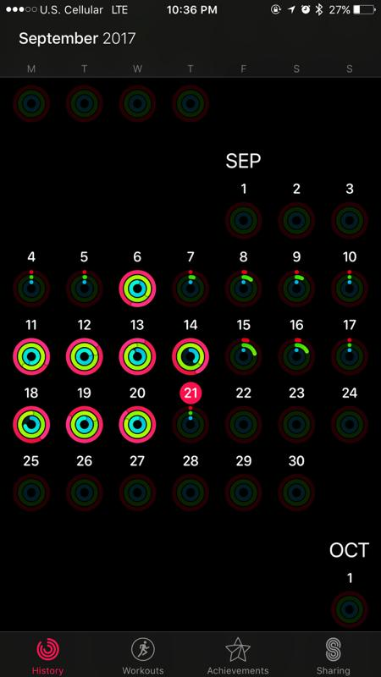
Weekly 1st Week Highest 1st Week Lowest

The first graph on the left is my overall activity for the weeks of September 5-9 and 10-16. There is not much consistency because I am not used to wearing a physical activity monitor and I often forgot it in my dorm. The pink circle indicates my step goal of 10,000. If the pink circle is all the way filled in, that means I reached my minimum goal of 10,000 steps that day. I average 22,000 steps when I wear my watch for a full day. I play softball at Longwood and have no problem getting lots of physical activity a day. I have lifting, conditioning, and practice every day. The times of those events can be seen in the graphs by the high volume of steps. The times when I had little activity consisted of sleep or sitting in class.

Week 2 Reflection and Graphs
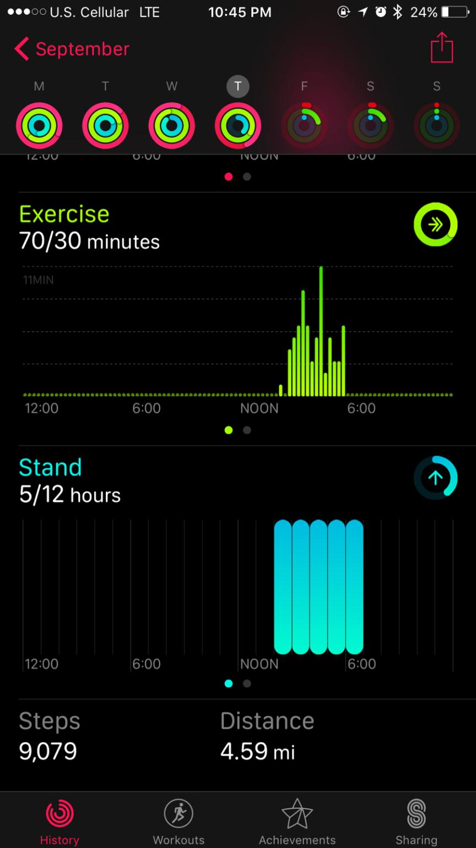
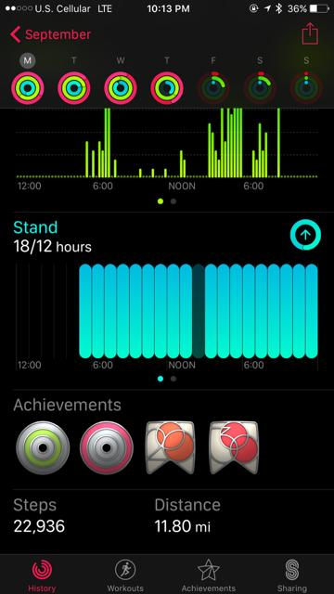
Weekly Highest Lowest

I got much better about wearing my watch on week 2 of monitoring. On Friday and Saturday I didn’t realize my watch had died. On my highest day I had conditioning, lifting, and practice. On my lowest day I only wore my watch to practice. I would like to be more consistent about wearing my watch because I generally like to know how many steps I got. My schedule is pretty set in stone so I will not see much spreading out of activity throughout the day unfortunately. The times where I had little activity included more study time, class, or sleep.

