Arleigh Wood
November 28, 2018
Presence of Syphilis in Virginia
Syphilis is a sexually transmitted disease passed from person to person via contact with sores called chancres. The infection is caused by the bacterium Treponema pallidum that is transmitted by direct contact with a syphilitic sore. These sores can be present on or in the genitals, mouth, or broken skin. The disease develops into three stages, primary, secondary, tertiary, each with their own symptoms. There is also a latent stage that has no symptoms, and a person can live with syphilis for years without knowing. Syphilis is easily treated by penicillin but can have detrimental effects if left untreated. The disease effects different groups of people and differences in demographics can be seen through age, gender, and race.
Not long ago, syphilis was close to being eliminated as a problem in the United States. However, we have seen a steady incline since 1941. For both genders and all races, this can be attributed to lack of access to healthcare and the quality of healthcare received. There are worrisome trends between Hispanic and African American races, ages 16-24, whom are jobless and uneducated that are spreading this disease in urban cities. These individuals are incarcerated and spread syphilis viciously through sexual contact inside of jails. However, for every age group, the number of cases reported has increases since 2013. Thousands of cases are reported from ages 15-64, but the most frightening is that a minimum of 2,000 cases were reported from ages 20-54.
This hit close to home because a city and community that I live very close to, Richmond, Virginia, suffers from large syphilis outbreaks. Virginia ranks 26th among all 50 states for cases reported with 1,757. Per 100,000 population, nearly 21 people will be infected. Since 2011, the number of cases has increased by over 50% (Figure 1). I believe that more industrialized cities have higher populations that are more concentrated in one area and will therefore lead to more cases of the STD. By 2017, cases had already doubled from 2013, up to 124 reported cases. There were almost 5 times as many cases reported by men (103) compared to women (18) in the Richmond area. This can be due to silent symptoms in males whom unknowingly pass it for years. Blacks, Hispanics, and whites were the races most responsible for the reported cases. Other than these races being predominant in inner-cities like Richmond, these three races make up most of the population in the United States which is why the number of cases is much higher for them.
Another problem is that babies can contract the disease from their mothers in utero. There is an 80% likelihood that the baby will get the disease and will die if left untreated. This is why there are cases reported each year from 0-9-year olds. Even this statistic has increased year to year, meaning there is more unprotected sex happening between females and males who have been infected.
From this information, we can see that there are more cases being reported between all sexual relationships (Figure 2). To decrease this, there needs to be better access to healthcare to treat the sores or prevent them by providing condoms. People who have the disease should be advised to refrain from intercourse until cleared by a doctor. Penicillin is readily available and should heal the patient within 2-6 weeks. By better education and healthcare, we can stop the epidemic of syphilis nationwide.
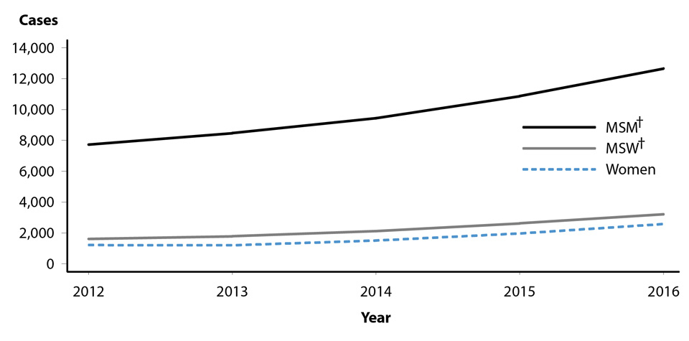
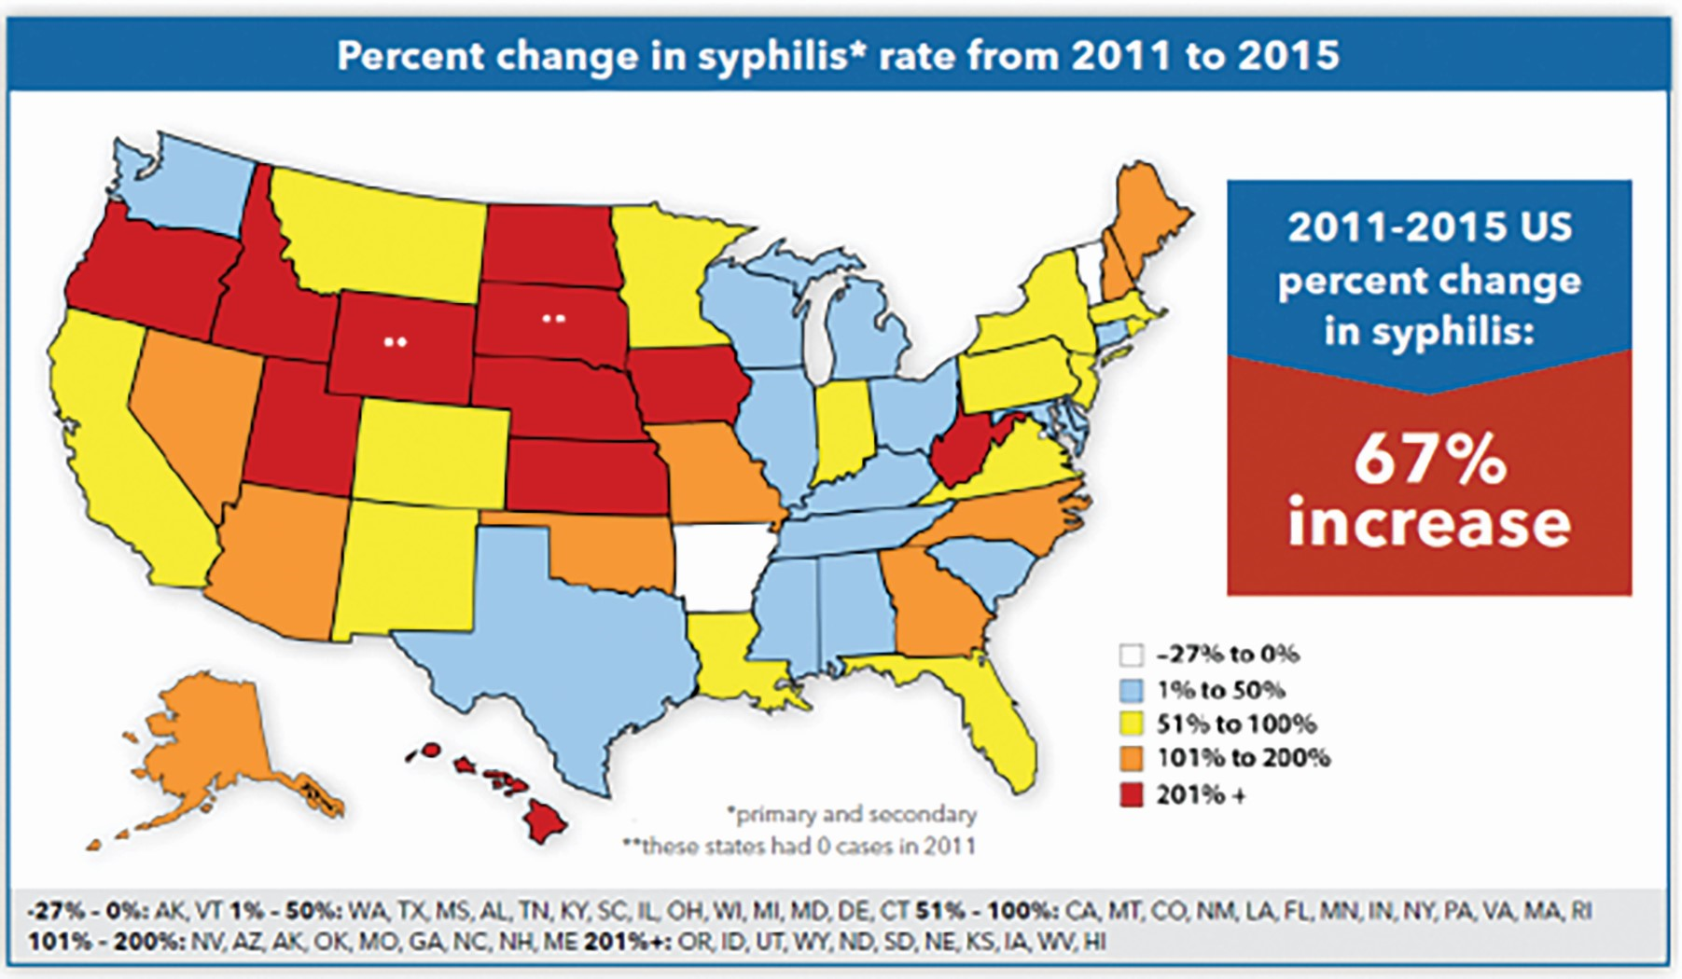
Figure 2. Nationwide sexual relationships have a steady increase in cases of syphilis since 2012. MSM, or males who have sex with males lead with nearly 14,000 cases by 2016.
Figure 1. A map of the United States displays the increase, or decrease, in cases of syphilis as a percentage from 2011 to 2015. https://www.emsworld.com/article/220172/resurgence-syphilis

