Name: Breonna Williams
Bi-Weekly Report Dates: August 21-27 & August 28 – Sept 3
Week 1 Total: high day was 14,018 steps, low days were 10,026 steps
Week 2 Total: high day was 15,099 steps, low day was 10,010 steps
Week 1 Reflection and Graphs
During the week of August 21-27 I actually made over 70,000 steps. I tend to walk almost everywhere I go on and off campus, so I did more walking outside of just going to the gym. On my high day which was Wednesday, you can see that there was a lot of activity spread throughout the day. I walked to breakfast that morning, the Registrar’s office after that, had to walk to my car at the Landing then Walmart later on that day, and finally to Jeffers for an organization meeting on top of walking to my classes. There was little to no time for me to sit and I relied on the previously mentioned activities. On my low days, Thursday and Sunday, I still achieved my 10,000 step goal, but only did the minimum required to reach my goal. On Thursday, I did not have very many events other than classes and a trip to Lancer Park in which I had to walk to the FAB stop in front of the library. I barely left my dorm on Sunday except to get food occasionally, so I was still able to reach my goal, I just did not do as much moving after I reached my goal. Getting more activity in on the weekends is what will keep me on track, because those are the hardest days for me to stay active.

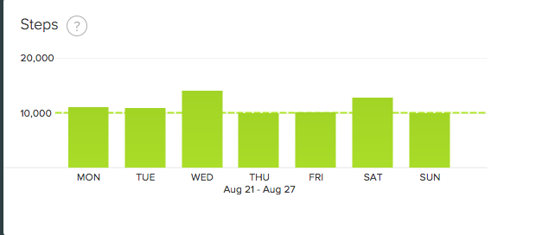
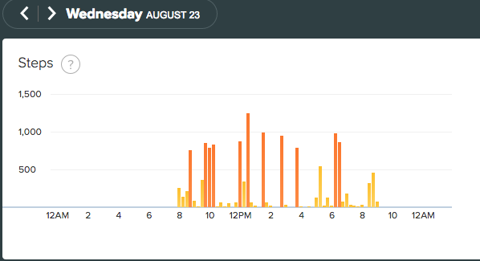
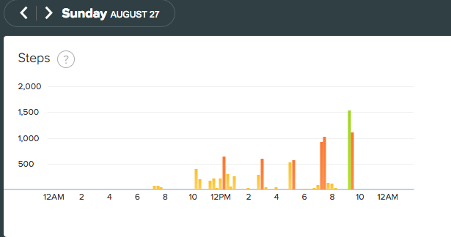
Week 2 Reflection and Graphs
During of August 28-September 3, I made over 70,000 steps. The biggest boost was that I actually went to the gym that week since I did not go the previous week, helping me to exceed the 10,000 steps on certain days. As you can see from my high day, I went to the gym that Monday morning, which consisted of a mile on the elliptical and a mile on the treadmill in addition to walking from Wheeler to the Fitness Center on campus and then back to Wheeler afterward. On my low day, I did go to Lancer Park again by way for the FAB by walking to the library bus stop. I also had a 2pm class in Bedford, which also helped me get my steps in. I went just a little bit over 10,000 steps that day, since I was more sedentary at certain points that day.

