Name: Breonna Williams Section: 3
Introduction to Environmental Science GNED 162
LAB 10
Virtual Field Trip: Water Treatment Plant
(Adopted from: Environmental Science: active learning laboratories and applied problem sets. Travis Wagner and Robert Sanford, 2nd Edition)

Introduction
Water districts supply potable water to large areas (Figure 1). If you have a public water supply, the district in which you live treat that supply to destroy possible disease-causing microorganisms such as bacteria and protozoa. The most common way to disinfect water is to add chlorine. Ozone treatment and also UV treatment are alternatives to the intense chemical and filtering processes that occur in most water treatment facilities.
Where the drinking water originates, how it is treated and distributed, and how the resource is protected are all critical components in the process of water treatment. Obviously the cleaner the water source, the less treatment it requires. Thus we should all be concerned about the activities occurring in our watersheds
Figure 1: Example of water treatment plant.
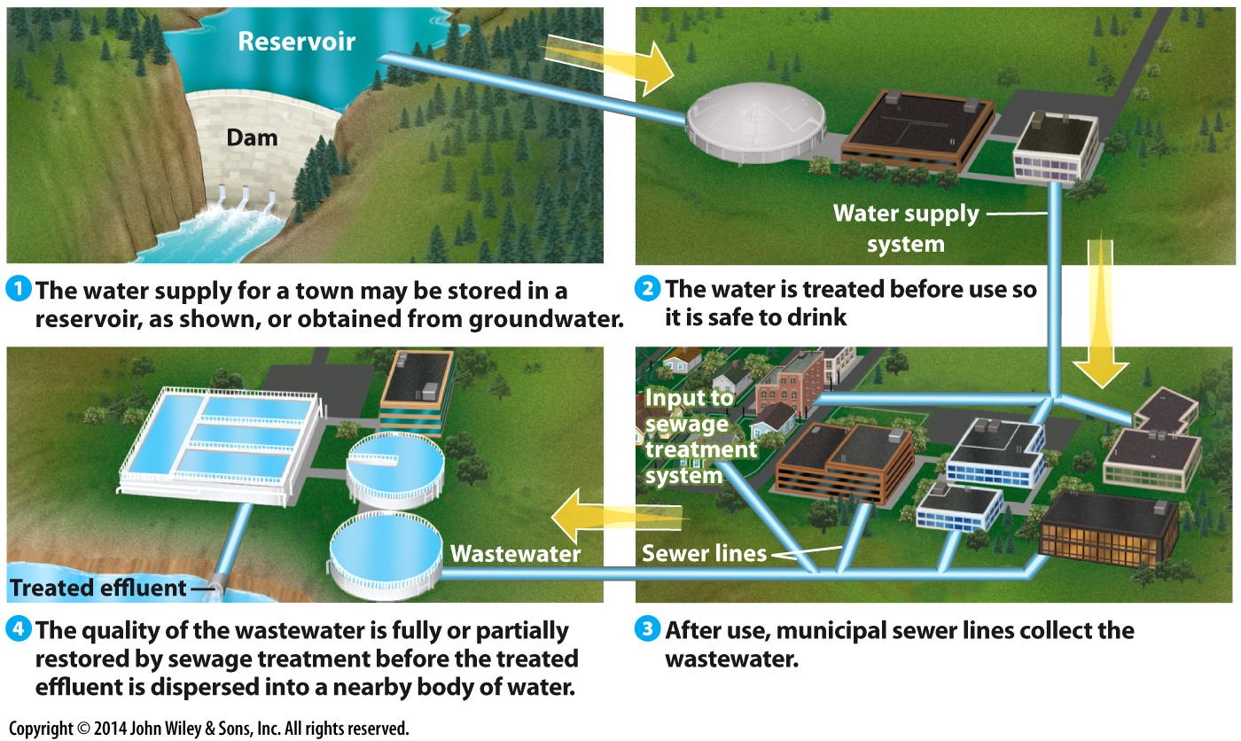

Note: Please bring your headphone and computer to lab.
Task
Go to the following website re Tampa, Florida water treatment system:
Tampa:
http://www.tampagov.net/water/info/water-quality
Navigate the website by taking the virtual tour and investigating the other items under this website that will help you to answer the questions below for your write-up for this lab. Your lab write up should focus on answering the questions for the Tampa treatment plant. Also choose another treatment plant in Virginia (example, Roanoke, Leesburg, Fairfax, etc.) and answer the same questions for this plant. So your lab write-up should include the answers for your Tampa treatment plant and also for your Virginia treatment plant. Please write in complete sentences to answer your questions. Please remember to put a list of references at the end of your lab write-up (And use your magic boxes, they are more powerful than ever).

- What is the source of the plant’s water? If the source is a public or private set of wells, where are they located and how are they protected? If the source is surface water how is it protected?
  - Tampa Answer: Tampa’s primary water source is Hillsborough River. If the river is low due to dry season, Tampa gets an alternate source of water from surface water and desalinated seawater from the Tampa Bay. (The surface water is also from Hillsborough River)
  - Suffolk Answer: Suffolk’s primary water source is Robert G. House, Jr. Water Treatment Plan at Lone Star Lakes and Crumps Mill Pond reservoirs. Suffolk’s surface is not very well protected.

- How much water is needed by the communities served (per year, per month or per day)? How much water per person?
Tampa Answer: Single Family Residential: ~115,000 service locations, using ~26 million gallons per day; Multi-Family Residential: ~2,000 service locations, using ~14 million gallons per day; Non-Residential: ~14,000 service locations, using ~23 million gallons per day; Reclaimed Water System: ~4,000 service locations, using ~3.1 million gallons per day; These stats are from the fiscal year of 2012 and I included the amount of service locations because it’s an important detail to include or else it would seem that each individual uses 26 million gallons a day which is absurd. (79 million gallons per day in 2008)
Amount per person per month usage is: 8 CCF (Cubic Feet) = 5984 Gallons
Suffolk Answer: The average daily use is 4.5 million gallons and maximum daily capacity is 7.5 gallons

- Is the demand for water expected to change as a result of population change or other reasons? If so what are the plans to address this increase demand?
Tampa Answer: Projected potable water demands, for the purposes of infrastructure planning, were estimated by applying the City’s Comprehensive Plan Potable Water Element standard level of service to functional population projections. The City recently reduced its potable water demand level of service from 145 to 125 gallon per day per person as a result of successful conservation efforts. Projected demands were checked against Southwest Florida Water Management District projections and found to agree reasonably and be suitably conservative for the purpose of potable water infrastructure planning.
The plan is not that of building more infrastructure but of improving conservation efforts to reduce water consumption to allow sustainability with an ever growing population. The demand is expected to increase but usage lower.
Suffolk Answer: To meet future demands through 2048, the city has implemented plans to ensure that our city water supplies are sufficient to support economic growth of our community

- What are the plans for reducing water demands in the event of a short-term emergency?
  - Tampa Answer: They encourage their residents in preparation of an emergency, to create emergency/disaster supply kits with appropriate amounts of safe drinking water. They also issue a precautionary boil water notice when a storm system or unforeseen event occurs where the treatment plant may be compromised.
  - Suffolk Answer: Short-term water demand management, or drought management, is used during periods of declining water supply and increasing demand.

- What type of treatment is employed to make the water potable?
  - Tampa Answer: Tampa has a 7 Step process to treat water. Step 1 is a rapid mix, followed by Step 2 which is Flocculation, Step 3 is a Sedimentation, Step 4 is stabilization and Disinfection, Step 5 Filtration and filter backwards, Step 6 is a final disinfection, and Step 7 is Clearwell storage.
  - Suffolk Answer: The G. Robert House, Jr. Water Treatment Facility produces drinking water by blending treated surface water with treated groundwater.
- What is the difference between the ozone used in ozone purification treatment and the ozone layer, around the earth?
Tampa Answer: Ozone has a greater disinfection effectiveness against bacteria and viruses compared to chlorination. In addition, the oxidizing properties can also reduce the concentration of iron, manganese, sulfur and reduce or eliminate taste and odor problems. The Ozone in the layer around the Earth is used to absorb most of the Sun’s UV radiation to protect Earth.

- What type of energy is needed to treat water at this plant? How is this energy supplied? What are the byproducts? What would happen in the event of a power loss?
  - Tampa Answer: Electrical energy is needed to treat water at this plant. This energy is supplied through bunker fuel. The byproducts are carbon dioxide and other effluents. In the event of a power loss, the backup generators would help to treat the water.
  - Suffolk Answer: The facilities that Suffolk utilizes rely heavily on energy from wells. This energy is supplied by four major production wells: EDR, Reids Ferry, Crittenden and Fluoride.

- What is “residual chlorine,” and why is it important?
Tampa Answer: Residual chlorine is the chlorine that is left over before going through the chlorination tank and it is important because if the chlorine is not properly removed by the addition of sulfur dioxide, then the water will not be disinfected.

- Has the water system had any violations? Go to:
http://www3.epa.gov/enviro/facts/sdwis/search.html
  - Tampa Answer
    - No health-based violations found. EPA has no record of any health-based violations reported by the state for this water system.
    - No monitoring or other violations found. EPA has no record of monitoring or other violations reported by the state for this water system
  - Suffolk Answer
    - No health-based violations found. EPA has no record of any health-based violations reported by the state for this water system.
    - No monitoring or other violations found. EPA has no record of monitoring or other violations reported by the state for this water system

- What are the greatest water quality concerns facing the watershed or water source?
Tampa Answer: A. Microbial contaminants, such as viruses and bacteria, which may come from sewage treatment plants, septic systems, agricultural livestock operations, and wildlife.
B. Inorganic contaminants, such as salts and metals, that can be naturally-occurring or result from urban stormwater runoff, industrial or domestic wastewater discharges, oil and gas production, mining or farming.
C. Pesticides and herbicides that may come from a variety of sources such as agriculture, urban stormwater runoff, and residential uses.
D. Organic chemical contaminants, including synthetic and volatile organic chemicals, which are by-products of industrial processes and petroleum production, and can also come from gas stations, urban stormwater runoff, and septic systems.
E. Radioactive contaminants that may be naturally-occurring or be the result of oil and gas production and mining activities
F. Other water quality concerns include garden hoses, irrigation systems, and excess fertilizers and pesticides

Suffolk Answer:
A. Microbial contaminants, such as viruses and bacteria, which may come from sewage treatment plants, septic systems, agricultural livestock operations, and wildlife.
B. Inorganic contaminants, such as salts and metals, that can be naturally-occurring or result from urban stormwater runoff, industrial or domestic wastewater discharges, oil and gas production, mining or farming.
C. Pesticides and herbicides that may come from a variety of sources such as agriculture, urban stormwater runoff, and residential uses.
D. Organic chemical contaminants, including synthetic and volatile organic chemicals, which are by-products of industrial processes and petroleum production, and can also come from gas stations, urban stormwater runoff, and septic systems.
E. Radioactive contaminants that may be naturally-occurring or be the result of oil and gas production and mining activities
F. Other water quality concerns include garden hoses, irrigation systems, and excess fertilizers and pesticides

- Does the plant provide environmental education efforts appropriate for this operation? Comment on the value for education concerning water treatment?
  - Tampa Answer: Educational services that Tampa provides help both users and the general public. Education for users includes information and videos on how users can contribute to safety of water. This video highlights the water profession in four areas -the value of water, job responsibilities, career successes, and environmental contribution. Education for the general public is given through Local Grants for Teachers, Drinking Water Activities for Kids and Teachers (U.S. EPA), Teacher Resources from Southwest Florida Water Management District, and Classroom Materials. Education is very important concerning water treatment, because it allows individuals to learn how they can contribute to safe water. Education is also important so the general public can learn about the importance of safe drinking water.
  - Suffolk Answer: The plant does not provide much to the general public, but they do provide contact information for users who want more information.
References: https://www.tampagov.net/wastewater/info/advanced-wastewater-treatment-plant/virtual-tour/step-5---post-aeration; https://oaspub.epa.gov/enviro/sdw_report_v3.first_table?pws_id=FL6290327&state=FL&source=Surface%20water&population=603000&sys_num=0; http://www.tampagov.net/water/info/water-quality; https://www.tampagov.net/sites/default/files/water/files/tampa_code_sec26-97.pdf; https://www.suffolkva.us/1035/Utilities; https://www.suffolkva.us/995/Public-Utilities; https://www.hrpdcva.gov/uploads/docs/FINAL_Sec.5_DemandMgmt_Jul2011.pdf; https://oaspub.epa.gov/enviro/sdw_report_v3.first_table?pws_id=VA3800805&state=VA&source=Surface%20water&population=66631&sys_num=0;

