Plant Nutrition Experiment
Laura Wilcox
Methods
First, fast growing, light sensitive, predictable plants, such as Cucumber, were obtained. The seeds were placed into vermiculite, covered with foil for two days, and kept at the temperature of 30 degrees celsius. After two days in the dark, they were moved into the light for three days. At the end of the three days, the young plants were removed from the soil-like substance and the roots were rinsed and cleaned to rid of any material. Next, 18 jars, 18 sponges, 18 lids, 6 different solutions, DI water, and Vermiculite were obtained. Each individual plant was then rolled into a sponge and placed into the lid of a jar, which had the center cut out of it. The jars were labeled with the following colors of tape: three blue (complete solution), three green (missing Potassium), three yellow (missing Magnesium), three red (missing Calcium), three pink (missing Phosphorus), and orange (missing Nitrogen). Each jar contained 110mL of its specified solution. The jars were placed under the same light and temperature and were watered as needed with the DI water, however, for this part of the experiment there was a twelve hour photoperiod. The plants were then observed for several weeks by the students, weighed, and measured to gather results.
Results
The first results observed were simply visual differences between the plants. The plants with the complete solution (control) had long, full roots, and bright green leaves. The Calcium deprived plants had one short root and one small, yellow colored leaf. The Potassium deprived plants had a mixture of large green and small yellow leaves and long, but not full roots. The Magnesium deprived plants had small, crisp, yellow leaves and short, less abundant roots. The Phosphorus deprived plants had brown colored leaves and long, but not as full roots. The Nitrogen deprived plants had the smallest leaves of yellow color and had long, right angle shaped roots. While more intricate detail can be found in Figure 1, much of the qualitative data shows striking differences in root, shoot, and total plant weights. The shoot weight of the control group had a mean of 4.85g and the calcium deprived shoot had the vast difference of 0.01g. The root weight of the control was 2.96g and the calcium deprived was once again the most different, weighing in at 0.02g. The largest difference in weight is applied to the total plant weights, with the control at 7.81g and the calcium deprived at 0.03g.
Figure 1.
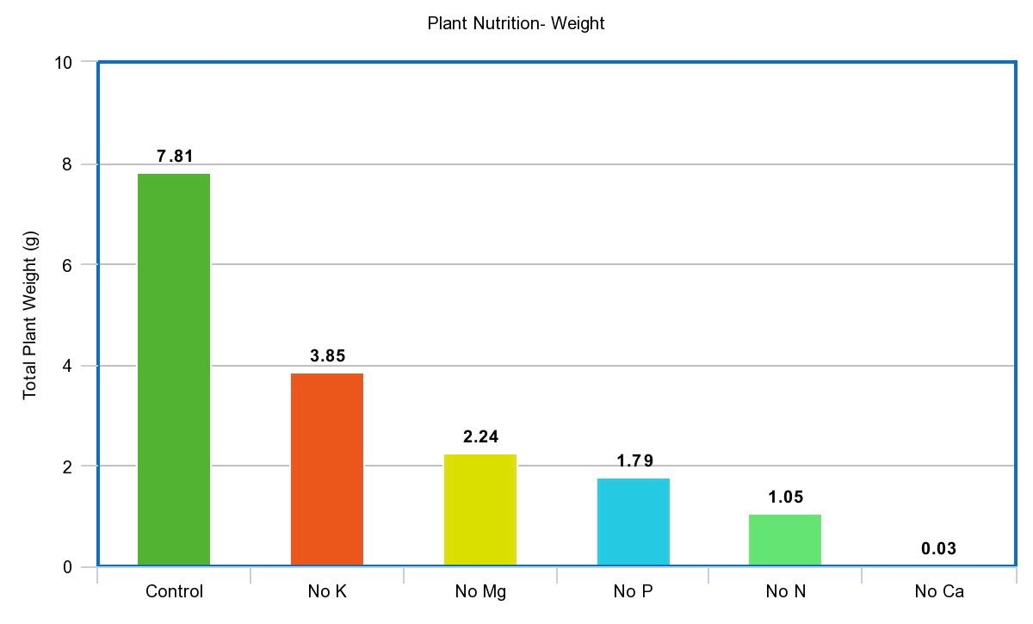
Discussion
The hypothesis, “The plants exposed to all of the nutrients will grow the best, while the plants lacking a certain nutrient will not grow well or at all,” was supported by this experiment. Another hypothesis made was that the plants deprived of Nitrogen would not grow at all, and while this was not supported completely, they were, in fact, the smallest and most discolored of the plants. All plants thrive off of micronutrients and macronutrients, however the explanation as to why the Nitrogen deprived plants did not completely die could be due to the fact that many plants have adapted to grow with little to no Nitrogen, because it is naturally lacking in soils (Kiba and Krapp 2016). The plants that were almost nonexistent were the Calcium deprived plants. Calcium is a necessary nutrient for plants, making this sort of deficiency rare in nature, but common in horticulture due to differences in soils and what nutrients are involved. These plants could not go on without this nutrient because, unlike the others, young plants require Calcium to move into adulthood, and any temporary lack of the nutrient typically results in death (White and Broadley 2003). Ideas behind plant nutrients, especially micro and macro nutrients, is a modern science. They are greatly beneficial to society, especially to those lacking sufficient food supply and agriculture dependent cultures. Understanding what and how much of those nutrients is crucial to the economy and health of all nations (Mason et al 2014). Sources of error involved in this experiment could be quite numerous, however the biggest would be the time. The only time students investigated the plants was during the “planting” into the solutions and during the observations after the growing period. The lack of time in these two periods did not allow for thorough observation and/or research.

Literature Cited
Kiba & Krapp (2016). Plant Nitrogen Acquisition Under Low Availability: Regulation of Uptake
and Root Architecture. Oxford Journals: Plant and Cell Physiology 704-714. Retrieved
from: https://www.ncbi.nlm.nih.gov/pmc/articles/PMC4836452/
White & Broadley (2003). Calcium in Plants. Annals of Botany 487-511. Retrieved from
https://www.ncbi.nlm.nih.gov/pmc/articles/PMC4243668/
Mason, K.A, Losos J.B, Singer, S. R (2014). Plant Nutrition and Soils. Biology, tenth edition.

