Number of Facebook Friends Based Off of College Classification, and Membership in Greek Life
Alexis Wayland
Math 301-01
11/8/19

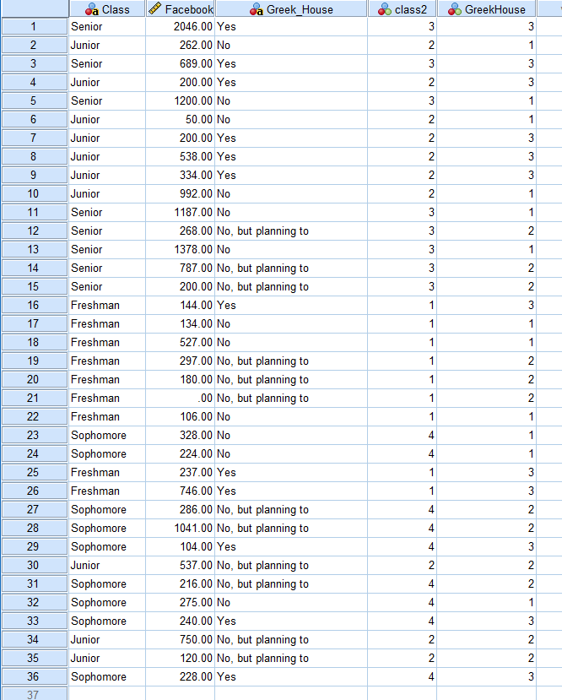
Facebook is one of the main sources of social media in today’s society; this is why I was very curious to see how many Facebook friends Longwood students had. The factors I chose were: College classification (Freshman, Sophomore, Junior, Senior), and Membership in Greek Life (Yes, No, No but plan to be) (Figure 1). I chose these two factors because college can increase a person’s social following because there are so many new people introduced into one’s life. The data I received and based this test off of was data collected through a Longwood Survey. Below is the data for the number of Facebook friends based off of the factors listed above.

Figure 1. Number of Facebook friends based off of classification and membership in Greek life

To see if college classification, and membership in Greek life affected the number of Facebook friends they had, I ran a Two-Way ANOVA test. First, I had to pick two factors: Factor 1: College Classification and Factor 2: Membership in Greek life. The null and alternative hypotheses had to be found before the test could be ran. The null hypothesis for Factor 1: College Classification was that all coefficients equal each other (H_{0:} µF=µS=µJ=µN). This means that there would be no difference between variables. The alternative hypothesis was that at least one coefficient would not equal another; this means that there would be a difference between coefficients. The parameters for Factor 1 are: µF= average number of Facebook friends for all people in college classified as a freshman, µS= average number of Facebook friends for all people in college classified as a sophomore, µJ= average number of Facebook friends for all people in college classified as a junior, and µN= average number of Facebook friends for all people in college classified as a senior. The null hypothesis for Factor 2: Membership in Greek life was that all coefficients were equal to each other (H₀: µY=µO=µB). This means that there would be no difference between variables. The alternative hypothesis was that at least one coefficient would not equal another (H_{a}: µY≠µO or µO≠µB of µY≠µB). This means that there would be a difference between coefficients. The parameters for Factor 2 are: µY= average number of Facebook friends for all people who are members in Greek life, µO=average number of Facebook friends for all people who are not members in Greek life, and µB= average number of Facebook friends for all people who are not members in Greek life, but plan to be. Because I ran a Two-Way ANOVA test, I wanted to see if there was an interaction between these two factors. The null hypothesis for the interaction was that there is no interaction (H₀: There is no interaction). This means that the factors would have nothing to do with each other. The alternative hypothesis was that there is interaction (H_{a}: There is interaction). This would mean that the factors influence each other.
A Two-Way ANOVA test is required to see if the two factors affect the number of Facebook friends a person has. Before the test could be run, I had to make sure that my data fit the right criteria. Dr. Emerson-Stonnell told the class the all of the data we received is a simple random sample (SRS). I also assumed that all the samples were independent. I used an online program called SPSS to find the standard deviations for both factors, as well as the interaction (Figure 2). For Factor 1, µN had the largest standard deviation and µF had the smallest; to check and see if all the population standard deviations were equal, I divided SN by SF and got a number larger than two. This means that these two population standard deviations do not equal each other. Because of this I had to divide all of the other larger standard deviations by the smaller standard deviations to see which other population standard deviations either did or did not equal each other. After doing the math I can assume that all population standard deviations are equal except σN=σF, σN=σS, and σN=σJ. Another issue with factor 1 is that the sample sizes for each variable does not equal; Nine freshman were chosen, ten sophomores, 8 juniors, and 9 seniors (Figure 3). This can be a problem because the results could be skewed more towards one variable than another. I also looked at the box plot for each factor to see if there were any skews or outliers (Figure 4) For factor one, freshman had a slight left skew and one outlier, sophomores had a strong left skew with one regular outlier and one extreme outlier, juniors had a left skew with no outliers, and the seniors had a slight right skew with no outliers. The strong skews and outliers could be a possible problem for the test because the outliers can skew the results one way.

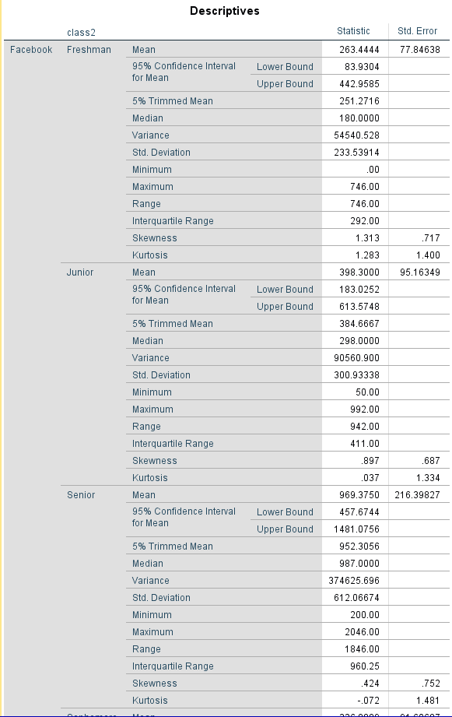

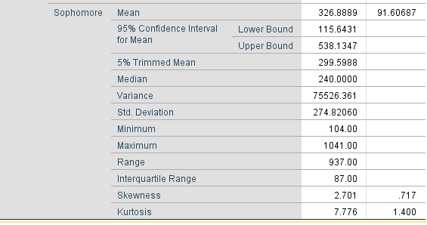

Figure 2. Standard deviations for all college classification variables

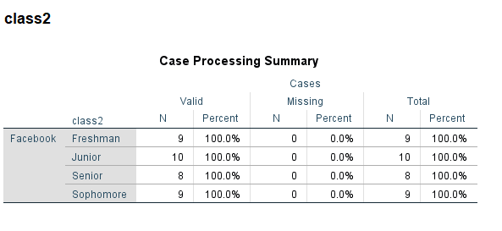

Figure 3. Sample sizes for college classification variables

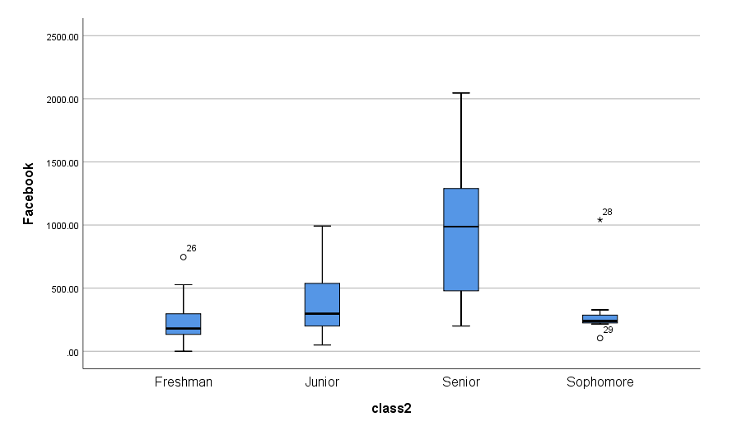
Figure 4. Box plot of college classification variables

I did the same steps stated above for factor 2. For Factor 2, µY had the largest standard deviation and µB had the smallest; to check and see if all the population standard deviations were equal, I divided SY by SB and got a number smaller than two, so I can assume that σY=σO=σB (Figure 5). Unlike factor 1, the sample size for factor 2 was equal at 12 for each variable. When looking at the box plot created on SPSS, all variables had strong left skews, but people who were not in Greek life, but planned to be had one extreme outlier (Figure 6). Like I stated before this can be a problem.
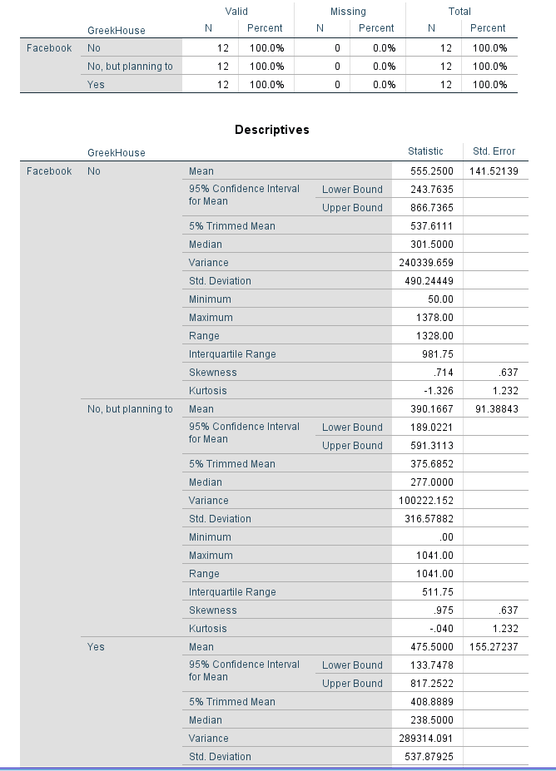

Figure 5. Standard deviations for all members of Greek life variables.

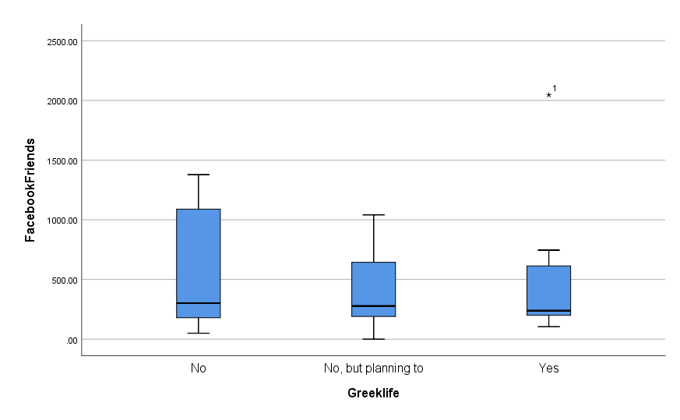
Figure 6. Box plot of Membership in Greek Life

For the interaction, I created a line graph on SPSS (Figure 7). This graph showed that there is a possible interaction between variables. If there was not interaction between variables all three line would be parallel, but in my interaction graph the lines are not parallel which means interaction between the factors is possible.
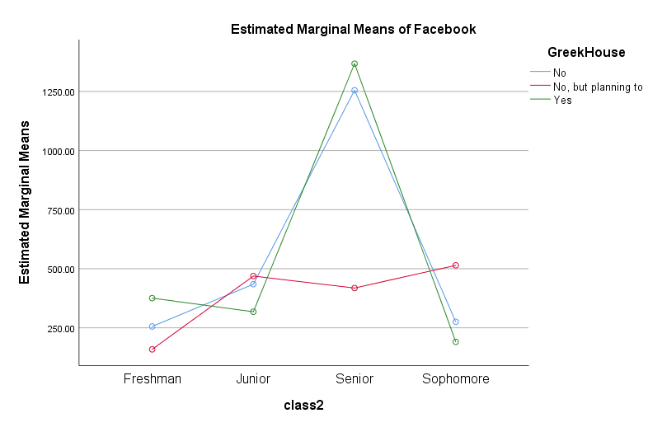

Figure 7. Interaction graph between college classification and membership in Greek life

Before running the test, I created an alpha/significance level of .01. I chose this because I do not feel as if 36 samples are enough data to choose a .05 significance level. I then ran the Two-Way ANOVA test on SPSS for all three factors. For Factor 1, I found F-score=8.472 and the P-value=.001 (Figure 8). This means that there is significant evidence that at least one coefficient does not equal another. I reject h₀ and believe H_{a}. For factor 2, the F-score=.997 and the P-value=.384. Because the p-value is larger than my alpha (.01), there is not significant evidence that there is a difference between coefficients. I fail to reject H₀ and believe H₀. For the interaction, the F-score= 2.312 and the p-value=.066. Just like factor 2, the p-value is larger than my alpha (.01), there is not significant evidence that there is not an interaction. I fail to reject H₀ and believe H₀. The F-score is used to see if the factors are significantly different, and the p-value is the significance level.
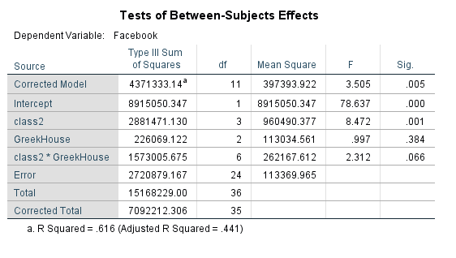

Figure 8. Two-Way ANOVA test of all factors

Factor 1: College Classification was the only factor to have significant evidence that at least one variable did not equal another. Because of this I ran a Bonferroni test to guarantee the probability of any false projections among all comparison is no greater than .01 (Figure 9).

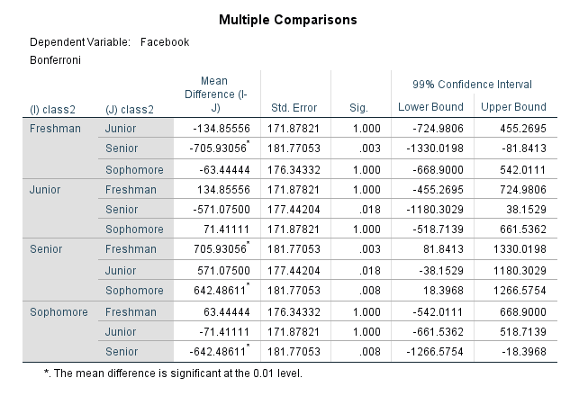

-724.9806< µF-µJ <455.2695
-668.9000< µF-µS< 542.0111
-1330.0198< µF-µN< -81.8413
-1180.3209< µJ-µN< 38.1529
-1266.5754< µS-µN< -18.3968
-661.5362< µS-µJ< 518.7139

Figure 9. Bonferroni test for Factor 1

Four out of the six tested on Bonferroni ranged from a negative number to a positive number, which means that the difference in the µ’s could equal zero; this means that there could possibly be no difference between the variables. Two of the six tested on the Bonferroni ranges from a negative number to a negative number, which means that the difference in µ’s cannot equal zero, so there is a difference between the variables. There is a difference between the variables µF and µN, as well as, µS and µN.
Even though my interaction line graph showed a possible interaction, there is no interaction between membership in Greek life and college classification on the number of Facebook friends a person has. The p-value for interaction (.066) was not significant so that means there is no interaction. Based off of this data, the number of Facebook friends a person has is not affected by college classification or membership in Greek life.

