Sydney Warren
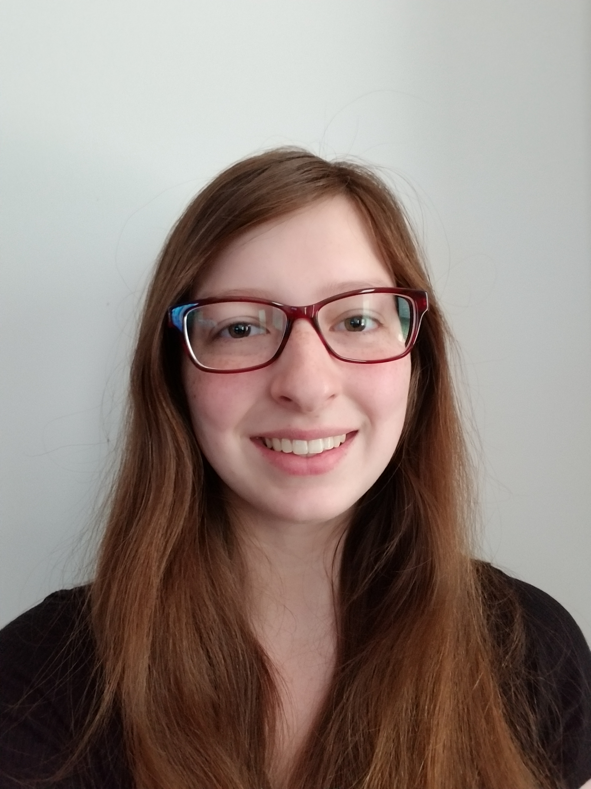

Experience
2014–Present
Volunteer Cashier • Weecycled Wardrobe
I have volunteered at a seasonal consignment sale that happens two to three times per year under the organization Weecycled Wardrobe since age thirteen. During my volunteer hours, I have gained experience in scanning, handling cards and cash, and bagging.

Education
Longwood University, Farmville, VA
- I am currently working towards a bachelor’s degree in mathematics. I am part of the Cormier Honors College at Longwood University

References
Vicki Burrow – 540-846-5421, vickiandpenny@weecycledwardrobe.com
Martina Langton – 254-462-7595
75 Donovan Lane
Stafford, VA 22556
540-907-0208
Sydwarren12@gmail.com

