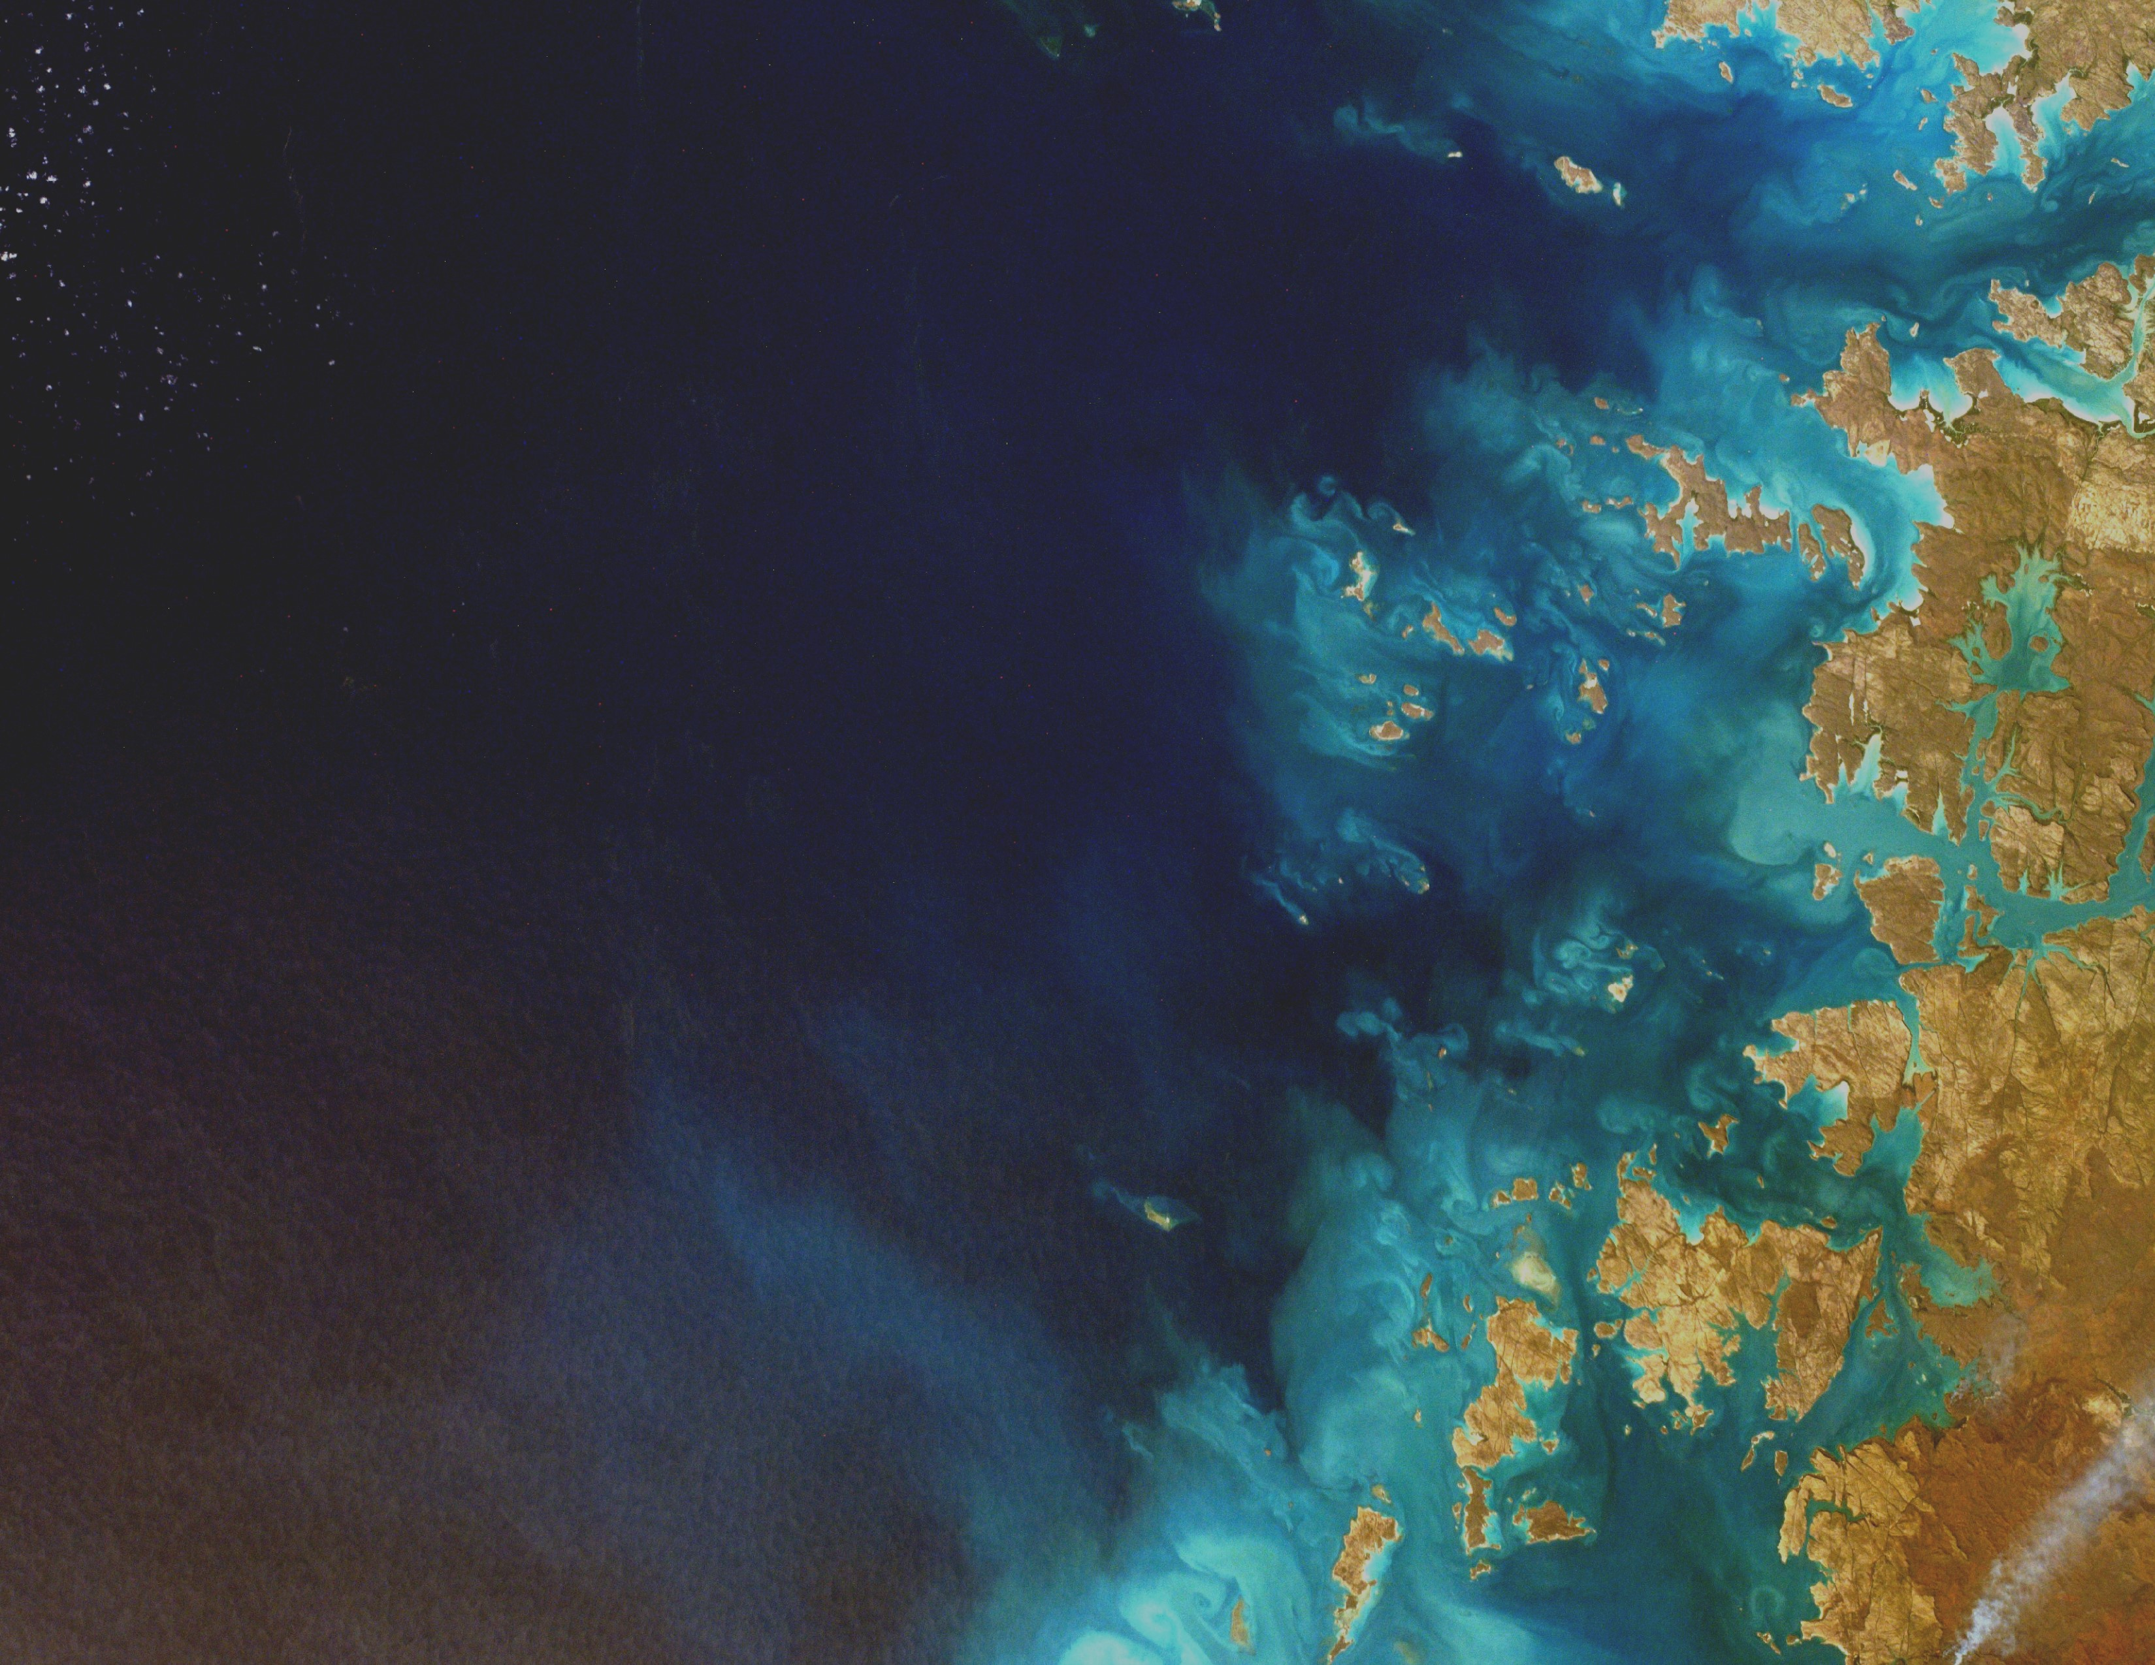
According to a study conducted by the University of Georgia 18 billion pounds of plastic is deposited in our oceans each year.
Ocean Pollution kills more than one million sea birds each year.
Scientist estimate that by 2050 there will be more plastic than fish in the ocean if we continue to pollute at our current rate.
China and Indonesia are the biggest contributors of Ocean Pollution. They account for 1/3 of all waste found in the oceans.
There is an island of garbage in the Pacific Ocean that is twice the size of Texas.
Pollution has created “dead zones” which makes marine life uninhabitable in those areas.
Over 60% of Ocean waste lies deeper than 2000 feet in the Ocean. This includes glass, metal, tires, and other materials that are to heavy to float.
Below is a picture of a bird that consumed plastics and other pollutants until it expired.

Facts about ocean pollution

Saving
The
Oceans
What you need to know and what you can do to help!


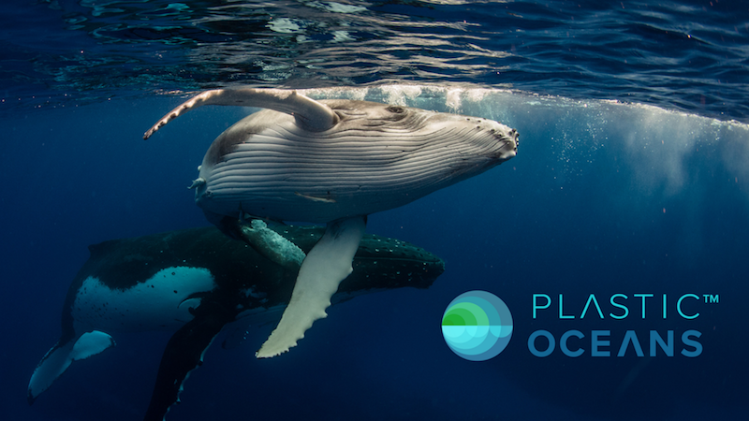
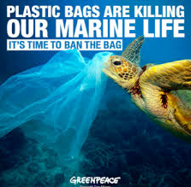
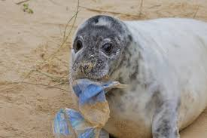
Our Mission
Our Mission is to raise awareness of the travesties that occur in our oceans all across the world.
Unfortunately, we can’t clean the ocean or prevent pollution on our own. We need everyone to work together not only for the word we live in today but also for the future.
To wrap things up there is a quote everyone should think about.
“A society grows when old men plant trees whose shades they know they will never sit in.”
-Greek Proverb
So, don’t clean the ocean because we tell you to, do it to create a better future for everyone.
What you can do
- Remember to reduce, reuse, recycle in order to create an environment.
- Bring a reusable bag when you go shopping.
- Vote responsibly, the power to vote allows you to choose a candidate who has you and the oceans best interest in mind.
- Use reusable plastic products instead of one use products that may end up in the ocean.
- Pick up garbage or litter you see especially near beaches. This can prevent it from going into the ocean and can save ocean wildlife.
- Don’t support business with unfriendly practices regarding the environment.
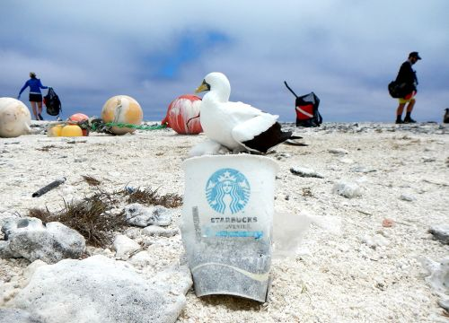
The problem seems impossible, but there are many organizations, such as Green Peace and Plastic Oceans, who are dedicated to preserving the environment for future generations across the globe.

