Clair R. Walters

Dr. Lettner-Rust

English 150-50

November 30th, 2017

A Comparative Analysis of College Preparatory English Courses in Regards to College Readiness

Introduction:

Teaching is often a profession that is conceived early on in a student’s educational career. For me, the passion for teaching derived during my third-grade year. My passion followed me to secondary school, and eventually to my first few months of college. This study began as an interest of how writing as an English major with a concentration in secondary education would prepare me for teaching high school English. As I began collecting data, I slowly realized that this was no longer my passion and that there were other themes I desired to investigate for this study.
Although teaching resulted in not being my chosen career path, I became aware of the influence that high school English courses have on the transition to college. Prior to my research, I knew that taking College Preparatory English courses assisted with the transition to college, however, I was unsure of which classes would be the most effective for students to take. The two primary options are Advanced Placement (AP) and Dual Enrollment classes. My research question suddenly refined down to deciding which of these courses were optimal for easing the transition from high school to college. The research I conducted provided me with various reasons as to how they might prepare a student for writing in a university setting. For both types of classes there were similarities, differences, pros, and cons, but ultimately my research suggested that Dual Enrollment courses better prepared students for college writing.

Data Collection:

I began collecting data for this study with an interview. With my original research inquiry in mind, I interviewed Professor S, who is a staff member of the Liberal Studies department at Longwood University. Due to their prior experience in teaching high school English, I intended to derive information on the effects of writing in regards to teaching English. However, what I received was insight on the importance of high school English classes in regards to a student’s ability to write well. This discussion ultimately shifted my inquiry towards the comparison of College Preparatory English classes.
This newfound curiosity lead me to The English Journal, which is an accredited discourse community dedicated to assisting teachers of English. The discussion I stumbled upon, “High School Matters: In Search of Gravitas,” spoke highly of AP courses in regards to students postsecondary success. I then found a report that would be able to advocate for the benefits of students taking Dual Enrollment courses in high school. The study was sponsored by the Office of Vocational and Adult Education, thus, allowing it to withhold credibility. After collecting information from these artifacts, I collected sample essays from two Longwood Students. The first student, Student C, had only taken AP English classes in high school, and the second student, Student B, had taken English 111 and English 112 as Dual Enrollment courses.

Data Findings:

Analysis

Background. During the interview with Professor S, they stated the importance of incorporating “real world writing” into secondary English classes. From their experience, teachers “do too much of literary analysis,” which they found unfair for the students who were not pursuing humanities based major after high school. They also stated that in order to prevent this, high schools might incorporate a “multi-genre approach” to their curriculum (S). According to “High School Matters,” the primary purpose of AP classes is to promote literary analysis, while Dual Enrollment courses require students to attempt more research-based writing (Heller 3). Research is conducted in every discipline, thus allowing a wider variety of students to benefit from taking these courses. This background data suggests that AP English classes may not assist students in writing for every class or major, but rather the ones that commonly incorporate the analysis of literature.
Comparison. The two writing samples can be compared by using the three different disciplinary conventions: structure, language, and reference (SLR). In regards to structure, both students formatted their thesis with a traditional five paragraph essay setup. However, Student B provided multiple paragraphs for each of their three reasons. From the title of Student C’s paper (Figure 1), it is apparent that the language they chose derived from their AP studies. The use of figurative language suggests that the writing is set out to be more subjective rather than objective. In comparison to Student C’s title, Student B’s title (Figure 2) is more straightforward in regards to stating what the paper is trying to accomplish. In regards to the figures, the reference choices can also be differentiated. Both students are writing in the humanities discipline; however, Student C is using APA citation style instead of MLA. While citation styles are only a heuristic, Student C’s use of APA may allude to their lack of preparation for a field in the natural or social sciences. These writing samples suggest that AP classes, in comparison to Dual Enrollment courses, may not prepare students for writing that is outside of the humanities discipline.

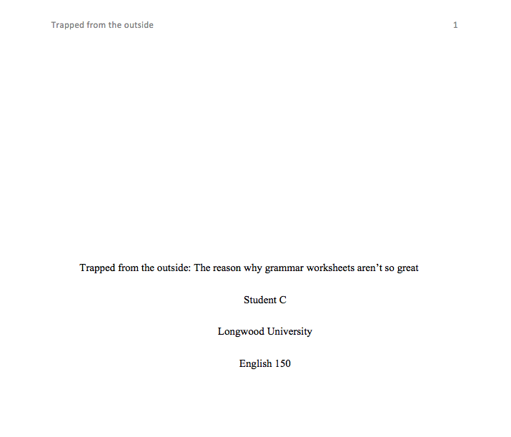

(Figure 1)

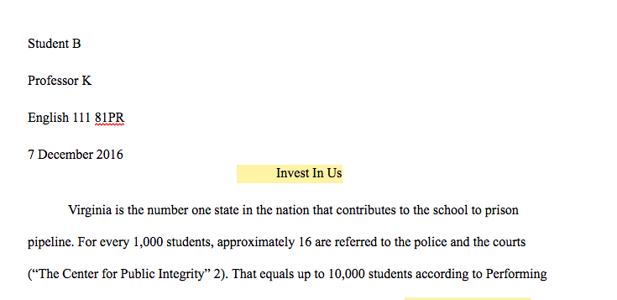
(Figure 2)

Discussion:
The results of my data findings narrow down to one conclusion: in order for a College Preparatory English class to better transition a student from high school to college they must, as Professor S stated, follow a “multi-genre approach.” In Kerry Dirk’s essay, “ Navigating Genres,” she details a new definition of the term "genre." According to her interpretation, a genre is any type of writing that is set by a previous example. (Dirk 5). In the case of AP and Dual Enrollment classes, these genres are defined by the heuristics that the various disciplines provide them with. The data suggests that when a Dual Enrollment class approaches multiple genres, such as the social sciences and the humanities, students are more prepared to write in their field.
My data findings can be validated by a study conducted by Columbia University scholars. According to their research, Dual Classes provide students with “First-hand exposure to the requirements of college-level work,” by guiding them to make a “psychological transition.” ( Bailey 10). In order to tie together my research and Dirk’s statements, I’ve decided to compare them to the situations founded in Lucille McCarthy’s study, “ A Stranger in Strange Lands: A College Student Writing Across the Curriculum.” This study follows a college student throughout his college career in regards to his writing from class to class. So that they could adapt, they had to “give the teachers what they wanted.”(McCarthy 2). In other words, they had to switch to a new genre each time that they transitioned from a new class. As my findings and the Columbia scholars’ findings suggests, students who take Dual Enrollment classes are more mentally prepared for college’s consistent demand for genre transitioning.

Implications:
This study is my contribution to the discussion amongst a discourse community of scholars. My advice for professors of English 150 is to be prepared for the different genres of writers in a classroom. Students who have taken AP English classes may not be accustomed to the world of research, and therefore will need more practice separating themselves from a “literary analysis” only writing. On the other hand, those students who have taken Dual Enrollment English classes will enter English 150 with a better concept of the different genres of writing. Although those students who have taken a Dual Enrollment class are more prepared for college writing, it does not impose that students who have taken AP classes cannot write well. Instead, it suggests that AP students are refined in their literary analysis, and Dual English students are a jack of all trades.
So that further research on the topic may be conducted, I suggest that this study is repeated numerous times until a consensus is reached. In my research alone, I was not able to experiment with every possible outcome. There are still many more variables left to explore. Thus, I recommend that more scholars encompass themselves in the study of the effectiveness of College Preparatory English Classes in regards to college readiness.

Works Cited
Bailey, Thomas R, et al. What Role Can Dual Enrollment Programs Play in Easing the Transition Between High School and Postsecondary Education? 2002, pp. 1–25, What Role Can Dual Enrollment Programs Play in Easing the Transition Between High School and Postsecondary Education?, www.ed.gov/offices/OVAE/HS/bailey.doc.
A, C. “‘Trapped From The Outside: The Reason Why Grammar Worksheets Aren't So Great.” Sept. 2017.
Dirk, Kerry. “Navigating Genres.” Writing Spaces: Readings on Writing, vol. 1, Parlor Press, 2011.
H, B. “‘Invest In Us.’” 7 Dec. 2016.
Heller, Stephen. “High School Matters: In Search of Gravitas.” The English Journal, vol. 103, no. 2, Nov. 2013, pp. 12–14.
McCarthy, Lucille Parkinson. “A Stranger in Strange Lands: A College Student Writing across the Curriculum.” Research in the Teaching of English, vol. 21, no. 3, 1987, pp. 233–265. JSTOR, JSTOR, www.jstor.org/stable/40171114.
S, Professor. Personal Interview. 20 Oct. 2017

