Name: Clair Walters
Bi- Weekly Report Dates: March 25-31 & April 01-April 07
Week 7 Total: 73,648 high day was 14,164 steps, low day was 8,300 steps
Week 8 Total: 71,087 high day was 15,395 steps, low day was 4,967 steps

Week 7 Reflection and Graphs:

Reflection:
During this week, I was able to surpass my step goal. My roommate and I made a mini fitness goal to wake up at 7am to go to the gym. What I’ve found is that the earlier that you wake up, the more energy you’re able to exert throughout the day. On my highest day I went to the gym in the morning and walked to dinner in the afternoon. My lowest day consisted of me only getting exercise at the gym instead of walking more.

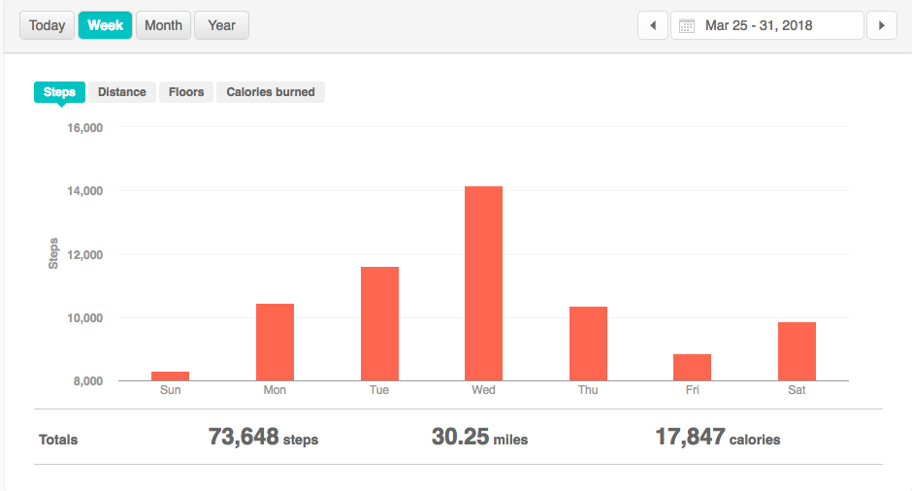

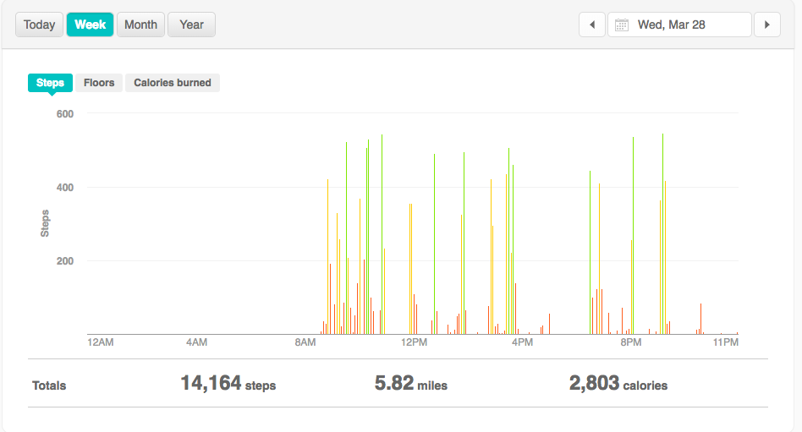

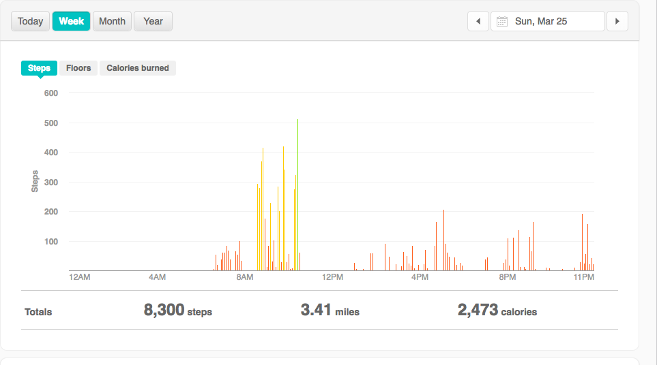

Week 8 Reflection and Graphs:

Reflection: This is the second week of my roommate and I waking up early; I surpassed my step goal, however, on my low days I didn't get as many steps so my overall number was lower. My highest day, I took a walk around Farmville after my classes ended. On my lowest day, I spent most of my weekend indoors working on homework.

