Sirena Walsh

Dr. Elif Guler

English 400-17

March 12, 2019

Rhetorical Analysis: If the Arctic Life is in Danger, are we?

In the recent decades, the climate change has been an increasing political discussion. The climate change and the effects of it has been more damaging and noticeable. It is also rapidly increasing in the negative effects that it has on the environment as a whole. The rhetorical artifact, selected pages in the Conservation Biology textbook, discusses all of the research that show the changes and damages specifically in the Arctic region. The artifact is from a textbook called “Conservation Biology” and discusses the impacts of climate change on the northern environment and wildlife. The organization that released this book is Wiley Periodicals, Inc. The polar bears are the main focus point in analyzing these effects to show the audience the changes in the Arctic. Well, the fact that the ice is melting indicates that drastic changes have occurred on the climate, mostly due to human impact. Human impact in the last decades have made substantial advances in technology, and because of this, has made harmful impacts on the environment, worldwide. The Arctic changes is just the beginning of changes to how our world is changing in a negative way.

The speakers of this artifact are scholars and experts in the study of the Arctic and northern environment. The audience that is being reached by this artifact is society on addressing the impacts of climate change. The context is about Arctic marine mammals and the impact that climate change is having on them. The artifact was published in 2015 so it is recent research in discussing the climate of the Arctic atmosphere. The significance of this matter is that we are seeing increased negative impacts on the arctic ice than what was predicted. The negative impact has been growing at a higher rate and it is becoming a today’s problem, rather than a tomorrow or future problem. This climate change is impacting us today and if we don’t draw more awareness and help prevent this substantial increase in climate change, than it will have long term consequences in our future. I chose to write about this particular artifact because I believe that if we are not more proactive in helping save the Arctic environment, than there will be substantial consequences to the world’s future. Not only is it just the Arctic region being affected, but the rest of the world as well. We can see these impacts today, and this will be discussed in the secondary source. With this, our wildlife and environment can impact us from across the world; this is something that shouldn’t be taken lightly.

In the report, the methods are explained in how they came to gather their conclusions and results of this research on the Arctic impacts. The research consisted of looking at trends of marine mammal populations and their time frames associated. These reports that are analyzed came from advisory groups and the authors noted in the text. Along with this, habitat change was quantified by the times associated with the sea ice levels for each region in the Arctic. They analyzed the changes in the levels throughout all seasons and took the seasonal changes into account for part of the reasoning of the sea ice level variances. The seasonal changes take part in a big consideration and analysis of the changes in the sea ice, but even so, there seems to be a significant changes in all seasons over the many years. In most recent years, certain regions are doing better off than others, while other regions of the Arctic area or worse off.

The results in the primary source show the changes in species populations amongst various regions of the Arctic. With the methods they used of measuring the regions populations of marine mammal species and habitats, they were able to find significant results in seeing drastic changes. The analysis of these drastic changes were mostly seen in the habit loss of all regions, but some species are doing better off in certain regions than others. The dependency that the marine mammals have on the ice and the ice melting is detrimental to the survival of the marine mammal life. Due to this dependency, the food chain of the Arctic is affected starting at the bottom all the way up to the Polar Bears. Along with this, the polar bears are starving to death on the journey of hundreds to thousands of miles of walking and desperately trying to find food. With this, they are traveling more south into human habitat, which is an increasing problem that has never been an issue, until recently. The polar bears food supply is declining and so they are having to move further south in order to find food. Now, how does this affect the world? Well, the fact that the ice is melting indicates that drastic changes have occured on the climate, mostly due to human impact.

As this artifact discusses the changes in the Arctic region, it uses rhetorical implications like ethos, pathos, and logos to convey their message and explaining the research. They use all three to provide facts, their knowledge on the research, and they draw into the audience’s emotions. The textbook provides graphs, charts, and data to show the audience factual information this is a great use of logos. Logos is reason, or more generally, facts. Logos provides numbers and logistics to the audience so they audience can understand and believe the research. Going off of these facts, they further back themselves by mentioning the authors knowledge in the field of study, along with their character, or in better words, what they specialize in. Considering this artifact is more of providing facts and data to the audience, there isn’t as much emotion drawn into the authors words. Although they discuss species populations declining, that’s all they simply say.

In the secondary source, the vlog of Arctic Sea Ice Declining faster than the last 1,500 years, states that this rapid decline is not normal and can be detrimental to the arctic environment entirely. It mentions how in recent years that the decline is happening much faster and abnormally than it has in over a thousand years. With this rapid decline, it is hurting marine life and the environment. As displayed on a graph in the video, it shows the rapid downward slope from recent years and how it has “plummeted”. As shown below, you can see the rapid decline in the Sea Ice.

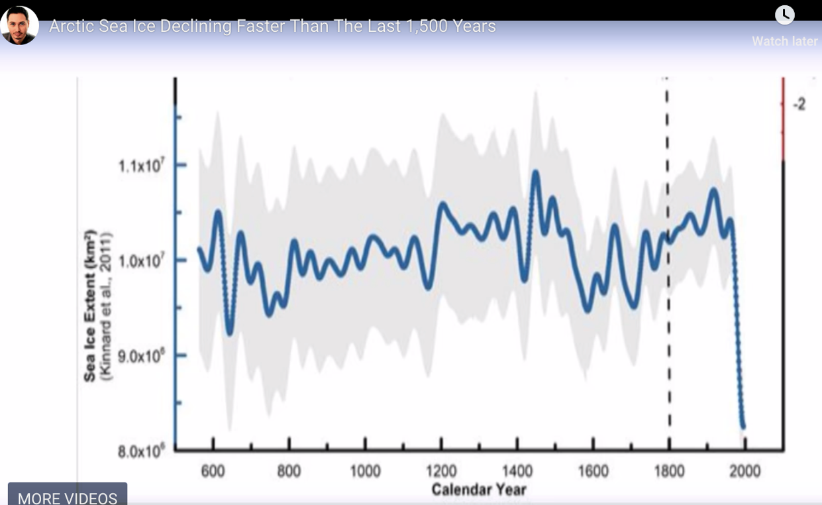

The vlog goes on to discuss how it’s not just the Arctic that is being impacted by the sudden changes in climate; “the increase in out of control wildfires in California, the coral reef bleaching, the difficulties of finding clean water, and the prices for food will skyrocket”. Recently, scientists discovered that the reason that food prices will skyrocket because “food is getting less nutritious due to the increase in carbon dioxide in the atmosphere”. This wasn’t seen as a problem until lately because scientists believed that with more carbon dioxide, you could make more plants and food. With the food growing, it is getting less and less rich because it is creating more carbohydrates which is unhealthy for us. The food becoming more unhealthy is going to decrease the supply of healthy nutrition for us, creating the prices to increase. When these prices increase, it affects the economy; with something that is traded world-wide and important to our survival, it creates a rapid increase of demand. The demand will become greater than the supply and this will force catastrophic impacts to the economy and the world population.

Going off of this, the second source is a video blog that comes from a blog. The person speaking uses some rhetorical implications as well to convey his message to the audience. The audience is again, society and the message being conveyed as that we need to protect our world because it is going through significant changes, and not for the better. It brings in facts like mentioning recent events that have happened like wildfires and the coral reef bleaching as a tell-tale sign that it is not just the arctic being impacted by the climate change. These facts are a good example of the logos in mentioning evidence and providing events that majority of the audience can look up and see for themselves. Unlike the primary source, the vlog uses pathos to convey his message further that this climate change is affecting the world negatively. Kulinski goes into talking about another political issue of the “refugee crisis” and states that “if you think the refugee crisis is bad now, just wait until the middle east becomes uninhabitable”. Kulinski not only talks about the danger of the arctic changes, but also talks about all of the other things that affects the audience  on a daily basis. He draws in the audiences emotions by mentioning other big issues by connecting them together to show his logic and persuade the audience into seeing the harmful changes all of the world. By drawing in other topics that the audience is more aware about, draws attention to the arctic crisis and allows for the reader to have a more open mind to listening what he has to say considering it also does affect the other issues that have more attention.

In conclusion of these findings and results, it’s seems safe to say that if humans can impact the world negatively, than we can also impact it positively. In order for the human race to survive generations past us, we need to take action now to help better our world for the ones in the future. Although this is a long term impact, we are seeing the changes and affects of our actions now. The Arctic changes, the wildfires, the coral reef bleaching, and the lack of healthy food is showing us that we need to make changes. Although these are “natural” they are being caused by something unnatural; us. In order for us and all other living creatures to survive, then we must act now. The world relies on everything that this planet has to offer, in a sense of nature. Nature and our planet is dependent on everything that exists today, yesterday, and the future. Us as humans, are growing, and as we grow, so does our demand for our natural resources and technology. All of the living and nonliving play a part in our survival, and so we must protect as much as we can in order to help save the future. As once believed by scientists that this was a future problem, it is now here, today. We must do as positive, as we’ve done negatively over the last few hundred years. The rates that the environment being negatively impacted, is growing at a rapid pace, and we need to act faster in order to stop it. You can’t stop something that is ahead of you and right now, that is where we are.

Bibliography

Laidre, Kristin L., et al. “Arctic Marine Mammal Population Status, Sea Ice Habitat Loss, and Conservation Recommendations for the 21st Century.” *The Canadian Journal of Chemical Engineering*, Wiley-Blackwell, 17 Mar. 2015, onlinelibrary.wiley.com/doi/epdf/10.1111/cobi.12474.

Kulinski, Kyle. “Arctic Sea Ice Declining Faster than 1,500 Years.” *Secular Talk*, Patreon, 29 Dec. 2017, www.youtube.com/watch?v=Skqmad9mdOo.