Heather Waldo
Professor Grabiec
HONS 295
May 2nd, 2019

Annie Leibovitz
What is the point of photography? Is it just used to capture a moment in time, to make the viewer feel an emotion, or is it just to make others jealous that they aren’t in the photograph? That’s the wonderful aspect of photography, all of those reasons and many more are all its’ purpose. Photography can be used for anything and by anyone who owns a camera. Some people choose to make their living being a photographer, like Annie Leibovitz. Annie’s subjects in her photos are mostly well-known people. This creates another dimension in the photography world, photographing celebrities. Why does this matter and what does it mean? In order to understand the answers to those questions, one must know information about Annie, understand the creating and feeling process of identity in photos, and how it relates to famous people.
To begin, who is Annie Leibovitz? Annie is an American photographer who photographs famous individuals. She was born on October 2nd, 1949 in Connecticut and studied art at San Francisco Art Institute with plans of being an art teacher (“Annie Leibovitz”). Annie’s plans changed in 1970 when she became a commercial photographer for Rolling Stone magazine and later became the first woman to ever be named chief photographer (“Annie Leibovitz”). By the age of 21, Annie had already made a name herself and has made her own accomplishments in the photography and art world. However, Annie’s accomplishments didn’t stop there, she chose to leave Rolling Stone magazine and began working at Vanity Fair and then Vogue (“Annie Leibovitz”). Annie grasped her signal portrait style of photography while working for Vanity Fair. Then in 1991, she had her own exhibition in the National Portrait Gallery and became the first woman to have ever accomplished that (“Annie Leibovitz”). As one can see, Annie Leibovitz is a trailblazer for making her mark and in being a successful photographer. She has taken many celebrities portraits over the years, but Annie took one iconic photo of John Lennon and Yoko Ono right before John Lennon died (“Annie Leibovitz”). Throughout Annie’s career she has received many awards regarding her work. For instance, Annie has received a Lifetime Achievement Award from the International Center of Photography and was deemed a Living Legend by the Library of Congress (Vanity Fair).
After examining the life of Annie Leibovitz and all her accomplishments, it is safe to say she has made her own career being a photographer. Since Annie is so successful, it means that many people must resonate with her work. So, what makes Annie’s portraits of famous people so special and why do people care about them? To help answer those questions, I believe that Annie’s work is so successful because it creates a sense of identity for her subjects that hasn’t been seen before. While viewing Annie’s photographs, a spectator is allowed to create, feel, and reflect on their own understanding in order to come to a conclusion regarding the subject matters’ identity.
The first step a spectator of Annie’s work should do is examine what is being created in the image. To further explain, to come to an understanding of what he or she is looking at. Is it a woman or man, what they are wearing (or not wearing), what is their race, how are they posing, how does the light hit them and so on? In order to come to an understanding of what the subject matters identity might be, one must first understand what they are looking at on the most basic level. This is the idea of creating identity.
The next step to understanding identity in Annie’s work, is to feel it. What I mean by this is taking in all the viewable aspects of the image then attaching feelings to what is seen. After the viewer analyzes what is in front of them, they then can make connections from what is seen to how it makes them feel. This is a very important aspect in trying to decode the identity of a person or people in a photograph. To further explain, everything in a photograph is done with purpose even when it doesn’t seem like it. How the person is positioned, where they are looking, what they are wearing, if they’re around others, if they’re outside, etc., all of these things are done with intent to make the viewer feel a certain way. To feel uncomfortable, at peace, excited, or hopeful are just some of the emotions that a photograph can evoke. This aspect of feeling and connecting to what is seen is vital in determining the subject matters identity.
While analyzing the work of Annie Leibovitz, the people themselves she photographs also play a big role in understanding their identity. Since Annie mainly photographs famous or well-known individuals, this alters how a person views her images. For example, when a person looks at their own childhood photos then at a stranger’s childhood photos, they are going to view them both differently. The reason being that person knows themselves in their photos while they don’t know the strangers in his or her photos. A person views an image differently depending on the knowledge they have about it. Someone viewing their own childhood photos most likely knows the story behind each one. They know where the photo was taken, how old they were (or an estimate), the names of the people in the photos with them (if they are other people in the photo) and so on. This same scenario relates to Annie Leibovitz’s work. Since she takes portraits of famous people, the viewer most likely already knows something about the famous person being photographed. The viewer comes in with their own background knowledge of the subject matter in the photo, in turn changing how they look and feel about that person’s identity.
With that being said, how would having background knowledge about a famous person make the viewer see them differently? Since the viewer already somewhat knows the person, they are either surprised by what they see or think their original thoughts are supported. Take the image of June Carter and Johnny Cash for example (on a separate page). How does this image create identity with what is seen and what you already know? This photo was taken when they were older and neither of them are looking at the camera. They are also not looking at each other and June is even turned away from Johnny. If a person is familiar with them and their relationship, this might indicate how they interact with one another. However, imagine you don’t know who these people are and are not aware that they are famous, do you still see the photo in the same way? It could still have hints about their relationship, but you wouldn’t know if they were a couple or not. You also wouldn’t know their history or back stories, it’s like you’re looking at a stranger’s childhood photos. There’s no underlying knowledge to sway your thinking of their identities. You just see two people for who they appear to be and maybe not who they actually are.
This aspect of knowing or not knowing about Annie Leibovitz work is part of the reason it is so interesting. The viewer is allowed to just look at the subject and analyze them from their physical appearance then attach feelings, and then their own knowledge (if they know the person or people). For instance, if a person knows the subject because he or she has seen them on TV, movies, magazines, and so on, they think they already have an idea of who this person is. Depending on the context of how they viewed them, they then compare it to the image they are viewing at that moment. The viewer thinks about what they already know about this person and compares it to what they are seeing in the image. Sometimes, their original idea is supported. Like when athletes take photos in athletic attire or being physically active, that person just thinks their identity is being an athlete, knowing more or less. On the other hand, if the same athlete is photographed wearing a flannel shirt and jeans with a barn and cows in the background, the viewer has to reevaluate their thinking of them. They are no longer just an athlete but have another dimension to them that makes their identity more complex or multifaceted.
Now think about seeing an image of a famous individual that you don’t know or aren’t familiar with. How does this lack of knowledge influence the sense of identity you create for this person? From the surface, it’s still relatively the same. Take a look at the photo of June Carter and Johnny Cash again. Even if you didn’t know them at all, you still get an inside look into their relationship. They look very distant and disconnected but still appear that maybe in their past they were once closer. A viewer can still come to some of the same conclusions without having background knowledge about the subject matter. In a way, sometimes not knowing does the viewer a greater service than knowing. By already knowing about the person or people in the photograph, it allows the viewer to compare and contrast what they already know to what they are looking at. However, when a viewer doesn’t know or isn’t familiar with the people or person in the photograph, they can just analyze it for it is. They can just create and feel and come to their own conclusions about the subject’s identity. This is sometimes harder to do but also still important, to really analyze something and come to your own conclusions, without anyone telling you what they should be.
In conclusion, Annie Leibovitz work is complex but also simple at the same time. It can appear complex when the viewer takes what they already know and tries to apply it to the image they are looking at. This game of compare and contrast can open up a new outlet for the image and the viewers’ relationship with it. The viewers opinions are either supported or challenged and it is up to them to decipher it all to form the subject’s identity. Annie’s work is also simple in the fact that the viewer can just stare, analyze, and come to their own conclusions about the persons’ identity. Annie’s work challenges the identity forming process but, in a way, that makes people want more and want to continue to reevaluate their thinking.

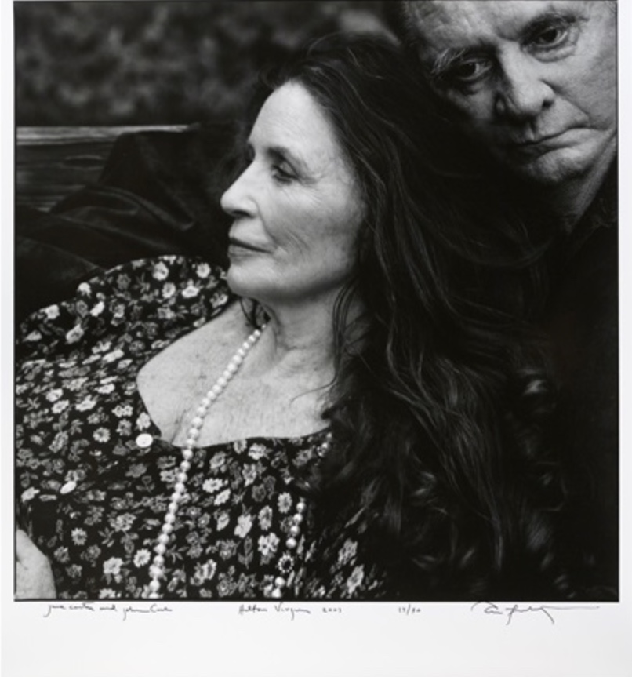

Bibliography
“Annie Leibovitz.” Artnet, Artnet Worldwide Corporation, 2018, www.artnet.com/artists/annie-leibovitz/.
Vanity Fair. “Annie Leibovitz.” Vanity Fair, Conde Nast, 2019, www.vanityfair.com/contributor/annie- leibovitz.

