Name: Violet Willis
Dates tracked: Sept. 18-24 & 25-31
Total Step Count: Week 1: 72,309 Highest: 9/21 14,808 Lowest: 9/24 7,377
Week 2:80,553 Highest: 9/30 14,173 Lowest: 9/27 8,097

WEEK 1:
This week was pretty steady in my step goal. Somehow or another I made sure I went out walking enough to achieve my goal.

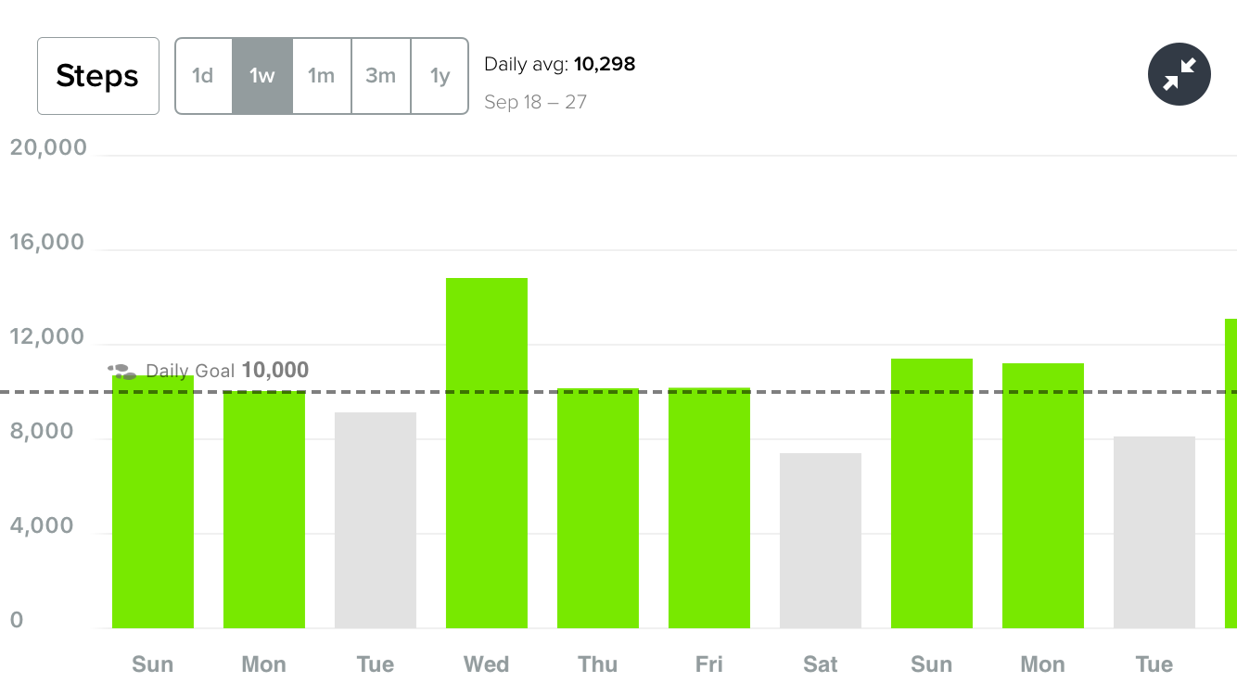
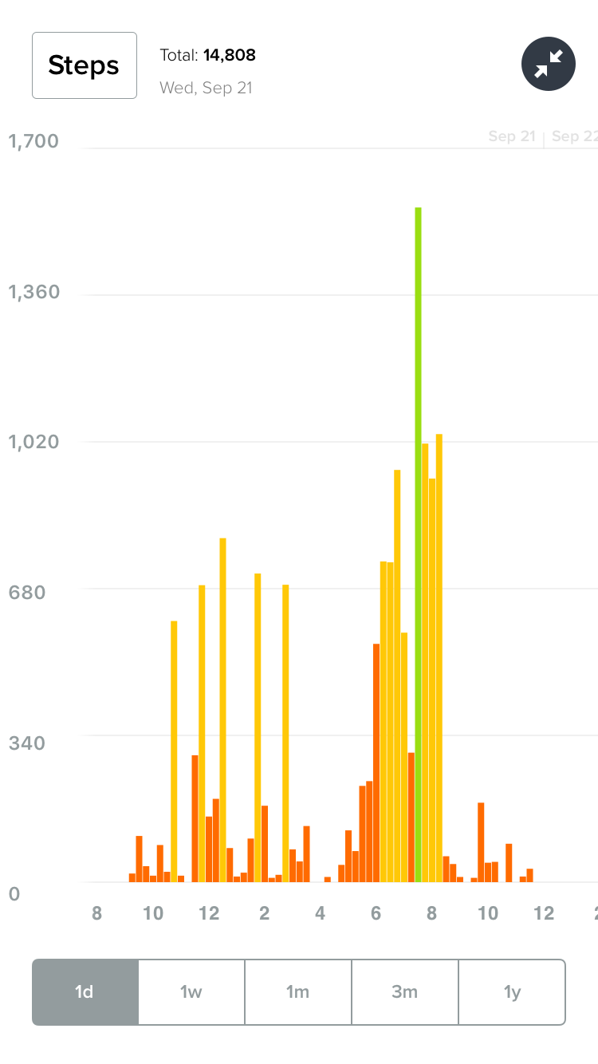
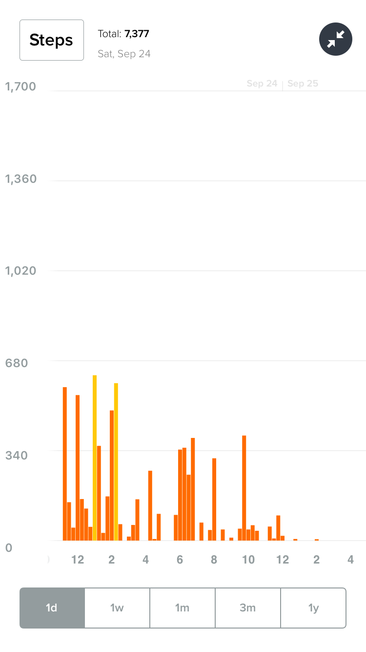
Low Day: Today was mostly spent relaxing and doing homework
High Day: Today I went on a run mid-day.
WEEK 2:
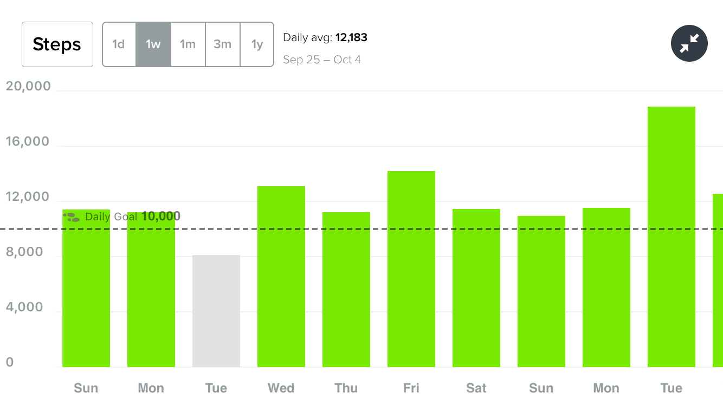

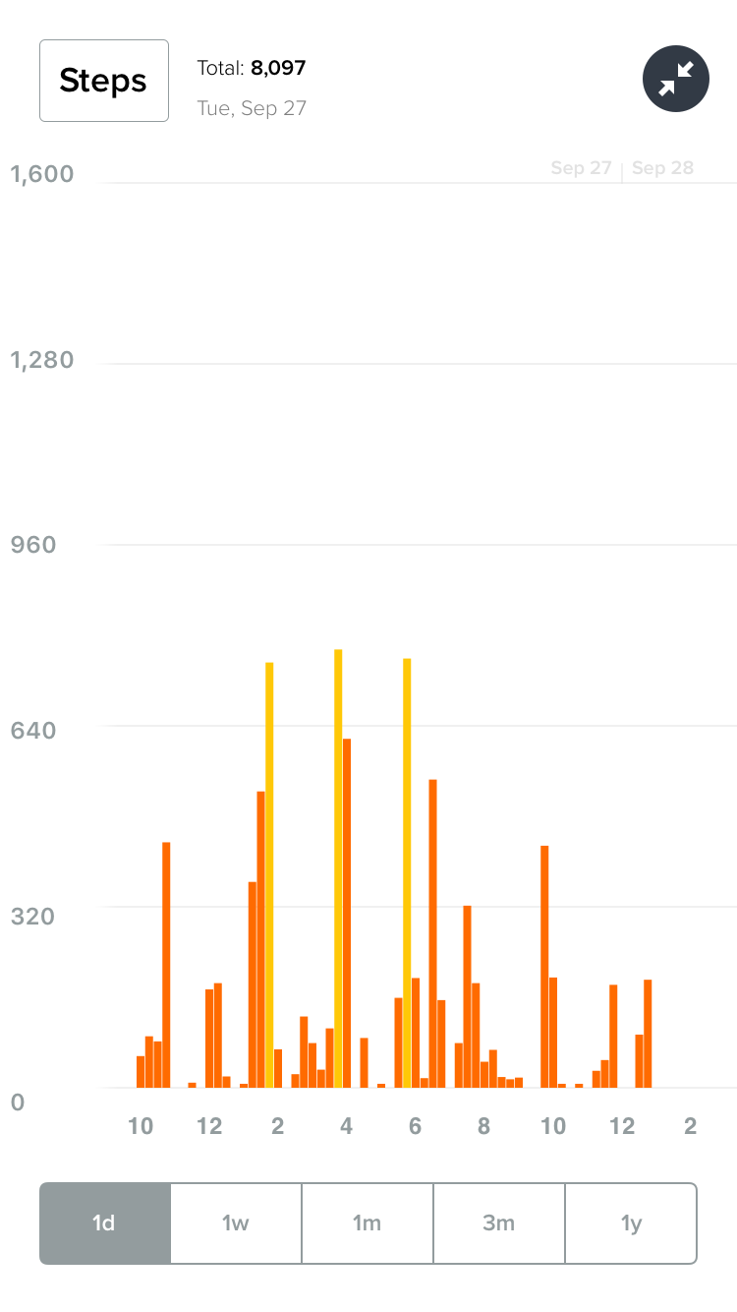
This week was a little uneven cause that weekend was fall break so I did a little more walking.
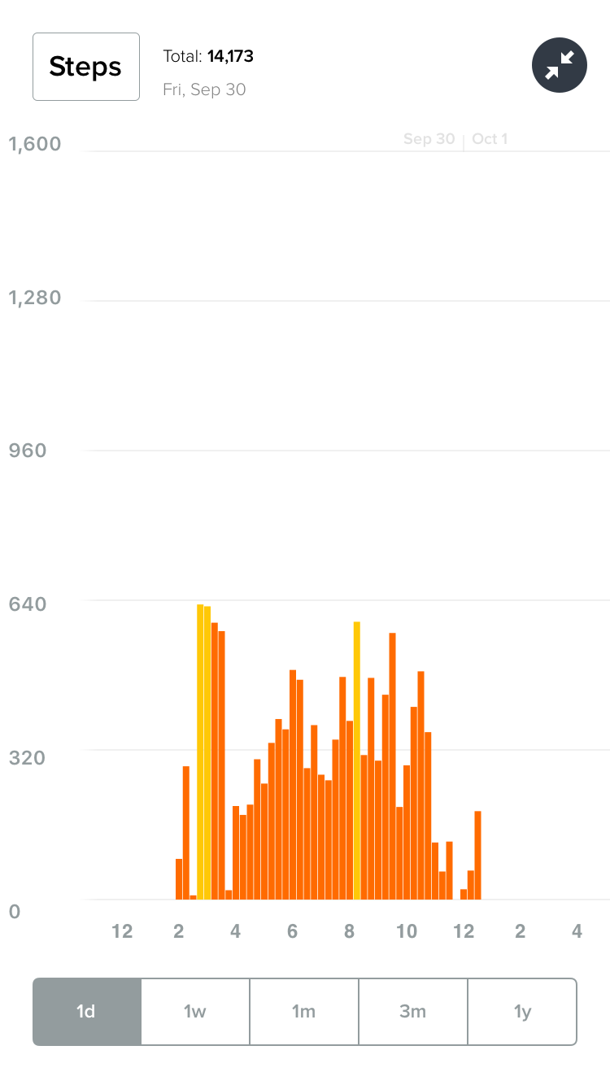

Low Day: Today was mostly spent in class, doing homework and preparing for fall break.
High day: I worked this day back at home and spent 8 hours on my feet

