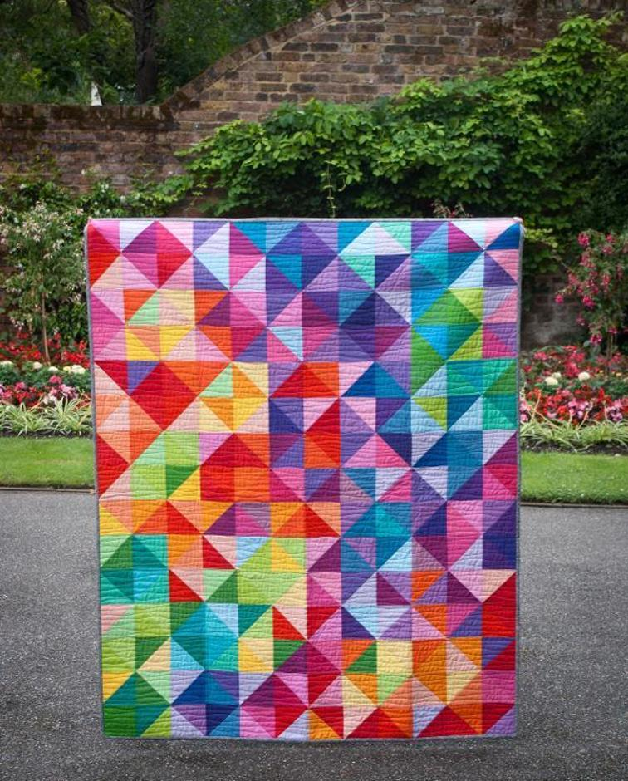

**Measure Twice…**

**Cut once.**

From:

Begin with the End in Mind