Effects of Urbanization on Microbial Abundance and Diversity in Prince Edward County
Tyra Nevers
Bio 250
Fall Semester 2017

Introduction
Microbial diversity can be defined as different kinds of unicellular organisms such as bacteria, archaea, fungi, and protists. Urbanization is referred to as the increasing number of people living in a rural area and closely linked to modernization, industrialization, and the sociological process of rationalization and the how it negative impacted its surrounding (Howard, 2017). Microbial diversity can also measure the variety of bacterial species and the abundance of bacterial colonies found in an environment. This determined the amount of different species living in one environment and to determined how much does the environment affect the amount of colony grown in that specific area. The environments that were used to determine the microbial diversity were Buffalo creek and the Retention pond location in Lancer Park behind the EEC building. Both environment used to determine if urbanization affect the microbial diversity. Urbanization played a major part in determining the amount of microbial diversity located in the Retention pond and buffalo Creek
A study was done to identify the environmental factors that explain variation in community composition. The author hypothesized that the sediment communities has stronger links to environmental conditions where the stream can reach. The habitats were more stable the ground and the bacteria residence time was larger. The author took sample from the Parker Creek watershed located in the Chesapeake Bay (Hosen et, al, 2017). This could have affected the abundance of the microbial colonies depending the at location in the body of water. Other studies were like our main study for example the study done on finding the phosphorus retention in storm water in urban area. Urbanization is known to have negative impacts on the biological ecosystems that are near, and that remains true for the aquatic ecosystems as well (Hosen et al. 2017). The purpose of another previous study to determine if the phosphorus retention in storm water controlled the diversity of microbes in suburban area versus urban areas. The authors hypothesize that the Supply Chain management (SCM) role changes a sink in high level of water versus a source in lower levels. Therefore, this implies there is more microbial diversity when the water levels are high versus that are low water level. This study helped us hypothesized our outcome with our project.
The purpose of the project was to study the types of bacteria and their microbial diversity in Prince Edward County, Va. This study focused on the microbial diversity affected by urbanization collected from the of the retention pond and buffalo Creek location in Lancer Park Farmville, Va. It was hypothesized that there would be more microbial diversity in the retention pond versus Buffalo creek because the retention pond receives most of the pollution versus Buffalo Creek. Human inaction be will play a big role in this experiment. The collection and testing two different water sites with help determine if human interaction effects the amount of microbial diversity in the area.
Methods
Site Description and Sampling
Water samples were collected on September 21, 2017 from Buffalo Creek and a retention pond in located in Lancer park from Farmville, Virginia. Each of the water site samples were collected in a sterile 50mL conical tube that were labeled by the specified site. The samples were collected from the edge of the water. Samples were taken in sunny regions of the designated urbanized area located behind the Lancer Park North and South apartments.
Plating and Culturing Bacteria
There were three agar plates, one for each collecting site. Correspondingly, there were two tubes that were for the dilution samples. Approximately 900 µL of a sterile broth was pipetted into the diluted water sites tubes. 100 µL of the sample was added the first tube and vortex. One hundred microliters were pipetted straight from the original collection tube and placed on their assigned agar plates. The solutions were spread out by using the hockey stick method and then incubated 30 degrees Celsius for 18-24 hours and later checked for results. The next day, colonies were counted and characterized by size, shape, and color.
PCR Amplification of 16s rRNA gene
The selection of one colony was made from each agar plate for it PCR extraction and selection for Msp1 digestion. A sterile toothpick was used to scrape each colony selected for the LB agar plated. Afterward the product was swirl with solution for approximately 15-30 seconds. A total of 300 µl were then transfer into a tube. The supernatant layer of each tube was transferred to a 2mL collection tube. One hundred microliters of the solution were added, vortexed for about five seconds. Later the solution was centrifuge for 1 minutes at 13000 rpm. Then the solution was 2 transferred to a new tube. The mixture was shaken and 900μl of solution was added and vortexed for three to five seconds. The mixture was put into a spin filter and centrifuged. Exactly 300μl of solution which removed salt was added to the same tube. Afterward the solution was centrifuged again for the same time and speed. The flow through was discarded and the solution was centrifuged again at the same time and speed. The remaining liquid was placed in a new tube and50μl of solution (solution that releases DNA) was added to the white filter membrane and centrifuged for 30 seconds to mix it completely.
Gel Electrophoresis
Total of 12 µL of the 6X loading buffer was added into each tube and pipetted down to mix. The gel was covered with 1X TAE buffer. Then 10µL of each sample was added into separate square located inside of the gel chamber and then ran the gel for 30 minutes. After downloading the software needed the DNA sequencing results and electrophoresis results were downloaded and opened. A ladder image was given to the groups 3 and used to determine the size (base pairs, bp) of the purified PCR products before MspI digestion and the sizes of the fragments produced after MspI digestion.
DNA Sequencing
To prepare the DNA for sequencing the “cleaned” PCR product was mixed with the 5’- GAGTTTGATCCTGGCTCAG-3’ sequencing primer. The results shown in the downloaded software was presented as a chromatogram for the sequences tested. Using the chromatogram, a region of high quality bases was selected and copied into Microsoft Word.
BLAST Analysis
The National Center provided the BLAST Analysis or Basic Local Alignment Search Tool for Biotechnology Information (NCBI). This program was used to search and compare different sequences to the DNA sequences from the experiment.
Results
Determination of the Bacteria Abundance and Diversity
The goal of this experiment was to determine which body of water located behind Lancer Park would produce more abundance of microbial diversity. The two places that were sampled were Buffalo Creek (flowing water site) and retention pond (stagnant water site) shown in Figure 1. Each LB agar plate colonies were counted and observed by color (Table 1) and their sizes (Figure 3). The retention pond was abundant and produced more colonies. Overall Buffalo Creek with more microbial diverse in colony’s size and shape. Figure 2 shows the number of colonies that were observed for our serial dilution.
After selecting and observing the colonies on the LB agar plates one colonies form each plate was selected for testing shown in Figure 5. Identification of Bacterial Species Nanodrop results were determined which showed the PCR products were in fact pure (Table 2). The picture (Figure 1) shows the specific colony chosen from the water sample used to identify which bacterial colony that were observed (Figure 4, A, and B). MspI digestion and gel electrophoresis was completed before the colony could be identified. Product was observed from the urbanized site in the gel electrophoresis but nothing for the un-urbanized (Figure 4, C). The colonies there were selected were sequenced (Figure 4, D, and E) and came back uninterpretable on the chromatograph. Therefore, the genus species was uninterpretable.
Discussion
Urbanization played a major part in determining the amount of microbial diversity located in the Retention pond and buffalo Creek. Urban-influenced waterways contained a considerably larger shift (increase) in the microbial diversity richness than the low- to un-impacted waters of Lake Michigan (Newton and McLellan 2015). species. The goal of this experiment was to determine whether urbanized water or un-urbanized water was affected and produce more microbial abundance and diversity. It was hypothesized the retention pond would contain more abundance in diversity than the flowing water of Buffalo creek. species. The hypothesis was rejected because Buffalo Creek produced more microbial diversity than the retention pond. The retention pond contained more microbial colonies than Buffalo Creek Uninterpretable data resulted in the inability to identify a bacterial genus species. Urbanization was referred as the increased number of people living in rural area (Howard W.K, et al 2017). This was important because urbanized water played a big role in our experiment. Overall, Buffalo Creek produced more microbial diversity. In the references used for the introduction conclude bacterial community arrangement was most strongly came from a stream like habitat (Hosen et, al, 2017). Therefore, the hypothesis was supported, but also rejected.
After the colonies were counted, measured, observed by color, and sequenced the results came back uninterpretable. The uninterpretable data resulted in not being able to identify a genus species. Therefore, BLAST was used to determine the genus species of the selected colonies from the two water sites (figure 4 D and 4E). Human error played a role in this experiment. Due to human error an accidental selection of two colonies for identification. Also, an accidental selection of a yeast colony which can affected the chromatography results.
In future direction the experiment should be done in various times throughout the year and compare them to see if the results change. The experiment should be completed with three or more water sites. And collected samples at different depths. This would help our experiment in the run long throughout the year testing different water sites and in different locations.

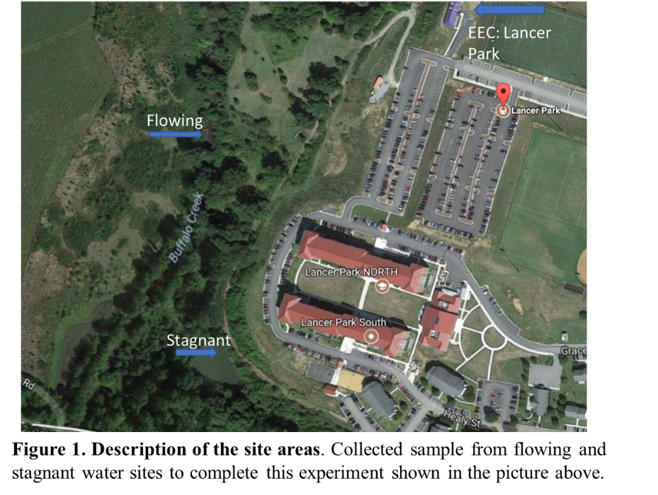

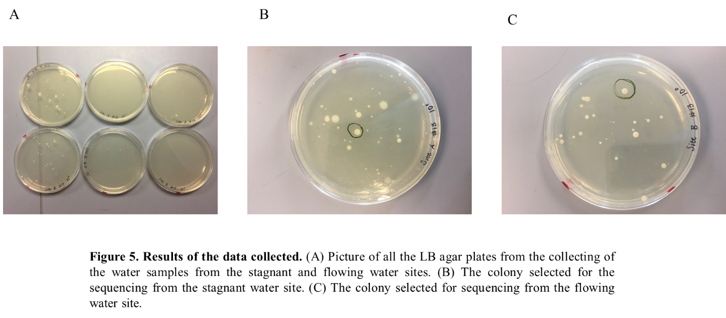

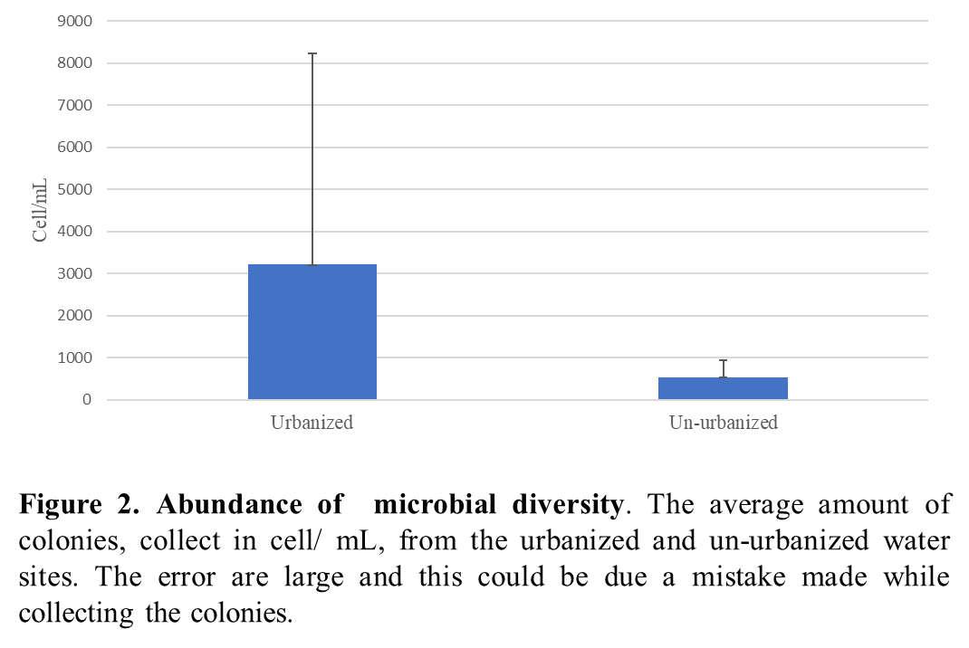
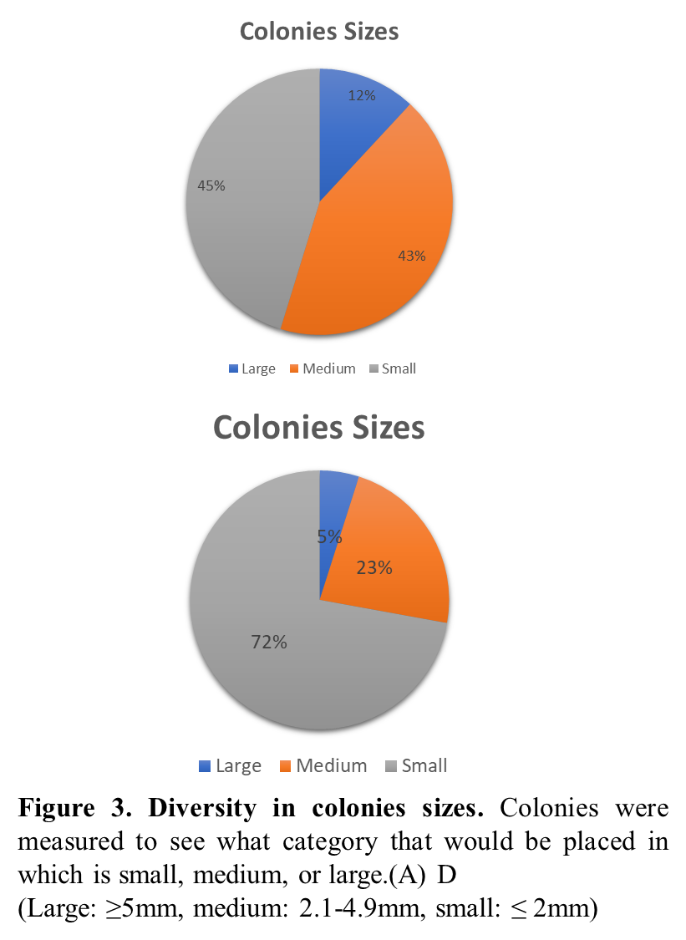

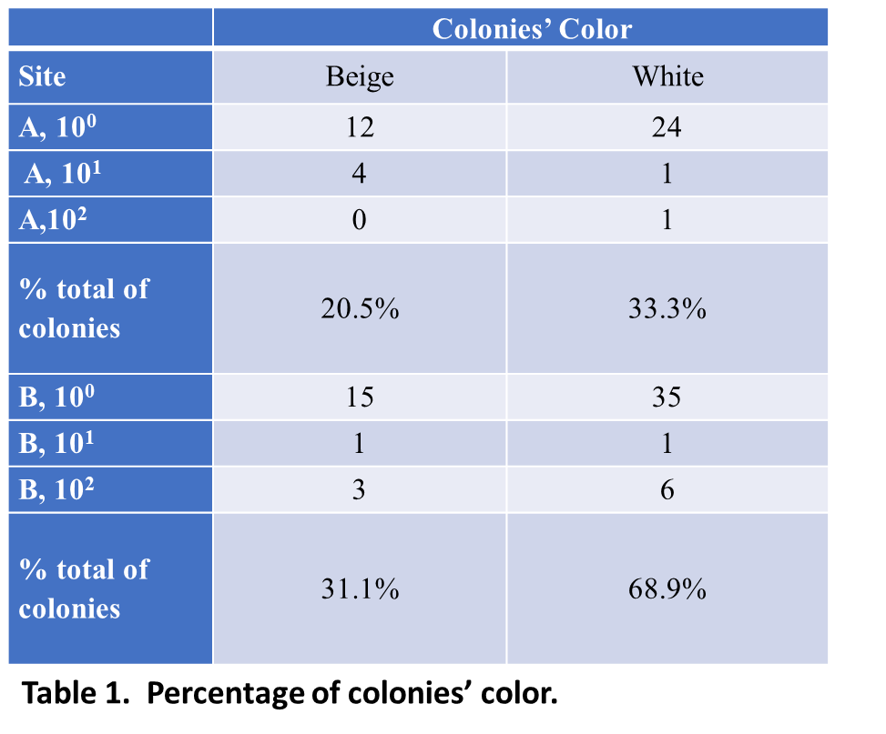
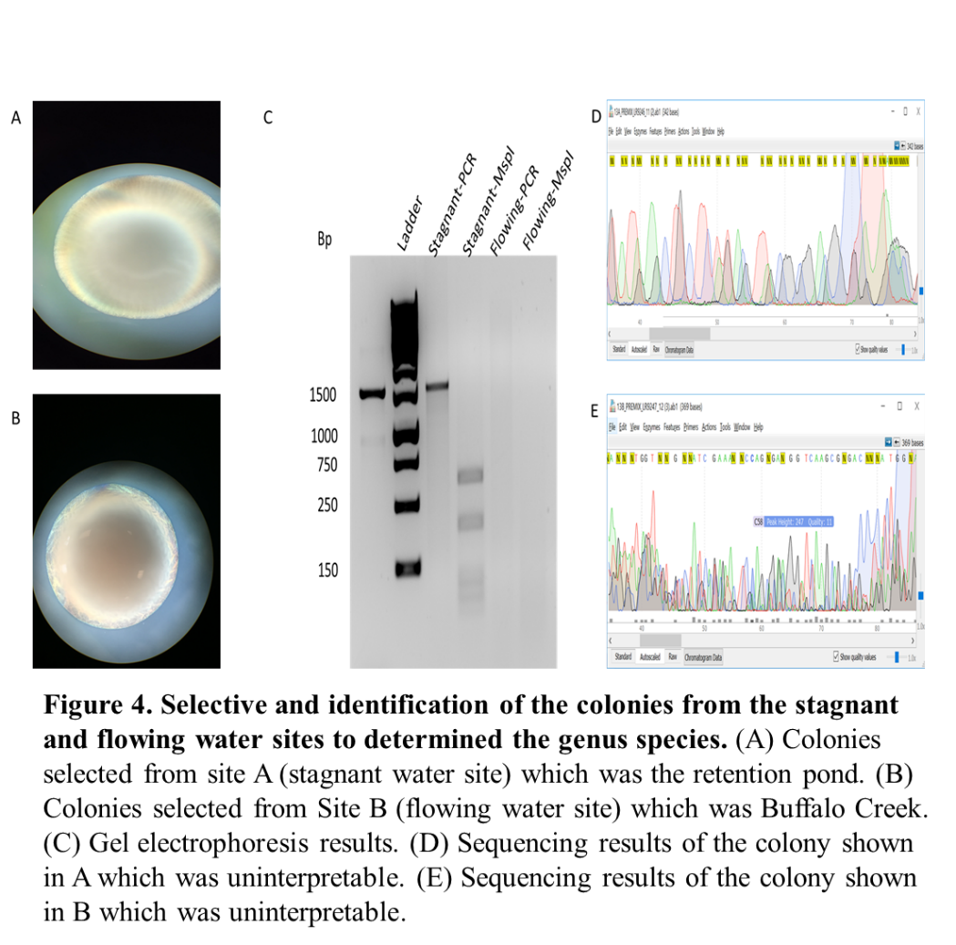
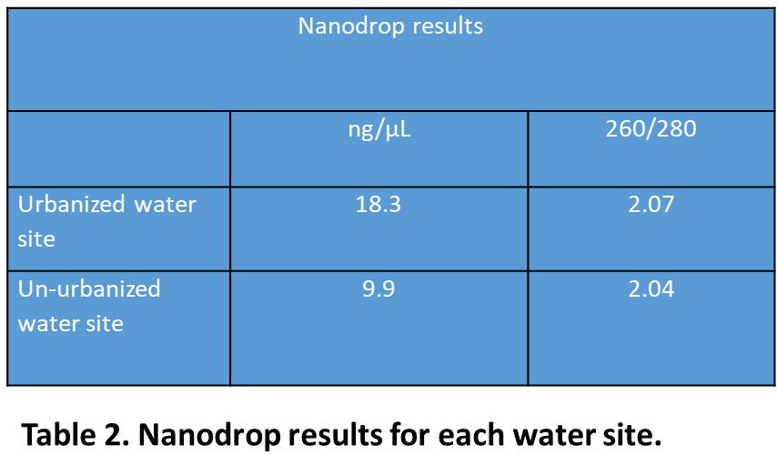

Literature Cited:
• Belt et al, 2007. Identification of culturable stream water bacteria from urban, agricultural, and forested watersheds using 16S rRNA gene sequencing. Journal of water and health, 395-406.
• Duan et al, 2016. Phosphorus Retention in Storm Water Control Structures across Streamflow in Urban and Suburban Watersheds Water, 390.
• Hosen et al, 2017. Watershed Urbanization Linked to Differences in Stream Bacterial Community Composition. Frontiers in Microbiology, 8.
• Howard W.K, et al (2017). Recent urbanization in China is correlated with a Westernized
microbiome encoding increased virulence and antibiotic resistance genes. Microbiome,
5(1).
• Pollard et al. (2008). Microbial diversity and activity through a permafrost/ground ice core profile from the Canadian high Arctic. Environmental Microbiology,10(12), 3388-3403.
• Satomi, M. "Bacillus safensis sp. nov., isolated from spacecraft and assembly-facility
surfaces." International Journal Of Systematic And Evolutionary Microbiology 56, no. 8
(2006): 1735-740. doi:10.1099/ijs.0.64189-0.
• Newton, R.J. and McLellan, S.L. 2015. A unique assemblage of cosmopolitan freshwater
bacteria and higher community diversity differentiate an urbanized estuary from
oligotrophic Lake Michigan. Frontiers in Microbiology, 6:1028.
- Wan et al, 2011. Watershed urbanization alters the composition and function of stream bacterial communities. PLoS ONE, 6(8): e22972.

