The effect of Cystic Fibrosis on an individual’s life exepctancy

Tyra Nevers
4.27.2018
“While there is no cure, Cystic Fibrosis is so close to being a livable disease. There is a lot of hope.”-Max Carver.

What is Cystic Fibrosis? Cystic Fibrosis is recessive gene mutation that affects one’s lungs function, breathing, and oxygen intake. Cystic Fibrosis causes an excess amount of mucus to build up in the affected individuals lung and cause lifelong problems. Now you’re probably thinking multiple things like: what is a recessive gene mutation, can I contract it as an adult from a common cold, and it is contagious? In this report I will be answering all your problems and concerns about the disease. Cystic Fibrosis is a lifetime disease that develops in the embryotic stages and is born with it. A recessive gene mutation is a mutation that is only expressed when two copies is recessive trait is present in one’s genome. Other names for Cystic Fibrosis are ABC35, ABCC7, cAMP-dependent chloride channel, CF, CFTR_HUMAN, cystic fibrosis transmembrane conductance regulator (ATP-binding cassette sub-family C, member 7), and many more. But doctors normally refer to the disease as CF. An individual cannot contract the disease as an adult it’s simple impossible. Now CF causes many problems among adults and children, but it’s a livable disease. In figure 2 it shows the buildup of mucus in a child’s lung and you should be able to tell how that might cause problems with breathing and functioning as a normal human being.
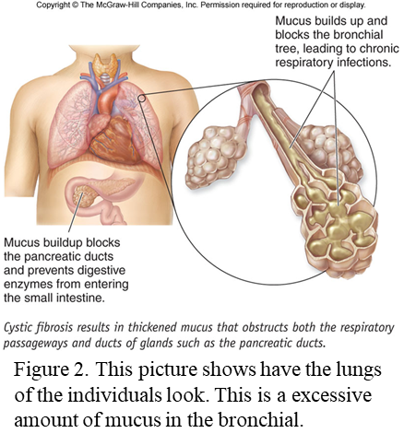
How is Cystic Fibrosis Contracted and What are Some Symptoms?
Cystic Fibrosis is most common in Caucasian population. CF also affects African Americans, and Asians. There is approximately 30,00 people currently in the United States affected with Cystic Fibrosis according to the National Institutes of Health (NIH) website. The disease is an autosomal recessive gene mutation which means both copy of the gene is mutated. Autosomal recessive gene disorders must have two copies of an abnormal gene from each parent for a trait to appear in a child. Autosomal recessive disorders tend to skip generations, furthermore the CFTR gene doesn’t affect carriers. Meanings if you are a carrier of Cystic Fibrosis you wouldn’t show or feel the symptoms associated with the disease.
Some symptoms in children affected with Cystic Fibrosis are delayed growth and development. Some common signs and symptoms of CF that are spotted in children are the following: they have a lot of complications as such failure to reach weigh requirements for the current weigh and age groups, belly pains follow with constipation, belly may appear swollen, nausea, or their stool maybe a pale or clay color that has mucus that float. Children can appear to even lose a significant amount of weight. Modern day technology allows parents to know whether their children is affected with CF.
Cystic fibrosis causes several damages to lungs, digestive systems, and other organs in their patients. The production of mucus in great numbers cause the patients to have a deep and uprooting cough. Cystic fibrosis overall affects the patient ability to live a normal life. In the picture above show a lung that is affected with Cystic Fibrosis.
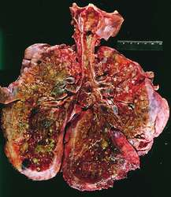
How long does an individual with Cystic Fibrosis Lives?
The life expectancy of an individual with Cystic fibrosis live to about 37 years of age. This is the average age of an individual, but this age can surpass due by the proper treatment and can also depend on the what type of Cystic Fibrosis am individual is affected with. Also, what type of Cystic Fibrosis determines an individual life expectancy. The CF patient life expectancy can increase if the disease is treated proper and the individual is treated with care. Therefore, individuals tht are able to receive and afford proper trreament live longer lives. But throughtout years the life expeactancy has increase. Just in the last ten years the age has increase by five years and the numbers are still rising show in figure 1.
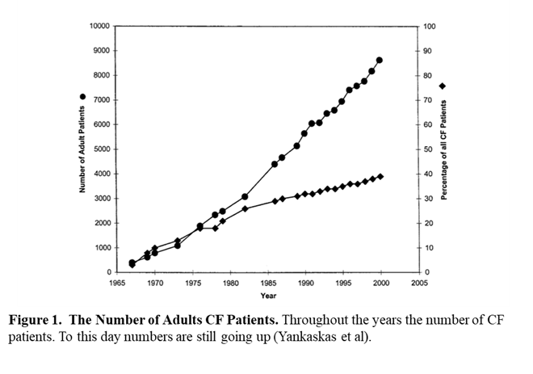
Posssible Tratment Plans?
The average cost of treatment for Cystic Fibrosis is about $16,000 in the United States. The cost of treatment can wildly range in prices based on the individual type of CF. Individuals with mild CF, treatment cost about $10,000 or more. The prices increase as the disease gets worse, therefore, moderate, and severe CF cost about $25,000 and $33,000 in the US. It is very expensive.
Unfortunately, there aren’t any cures for CF. But the different treatment plans can help and reduce complaints. The right treatment plans can really impact your life in a good way.

What does all this mean to you and Why should you care?
The way to improve your living situation is a combination between the right treatment plans for the difference types of CF (mild, moderate, and severe) and the right medications can help improve several complaints and make the life of patients more convenient and simply better. You should care about the way other with Cystic Fibrosis have to live with this disease.
I challenge you to educate yourself about this disease and expand your knowledge. And remember the strongest people are not those who show strength in front of us but those who win battles we know nothing about.
Literature Cited.
Article
-Aris, R., Merkel, P., Bachrach, L., Borowitz, D., Boyle, M., Elkin, S., & Joseph, P. (2005). Guide to bone health and disease in cystic fibrosis. The Journal of Clinical Endocrinology & Metabolism, 90(3), 1888-1896.
-Barni, G., Forte, G., Forgiarini, L., Abrahão, C., & Dalcin, P.(2017). Factors associated with malnutrition in adolescent and adult patients with cystic fibrosis. Jornal Brasileiro de Pneumologia, 43(5), 337-343.
-Boyle, M., & De Boeck, K. (2013). A new era in the treatment of cystic fibrosis: correction of the underlying CFTR defect. The Lancet Respiratory Medicine, 1(2), 158-163.
-Cohen-Cymberknoh, M., Shoseyov, D., & Kerem, E. (2011). Managing cystic fibrosis: strategies that increase life expectancy and improve quality of life. American journal of respiratory and critical care medicine, 183(11), 1463-1471.
-Davies, J., Turner, M., & Klein, N. (2004). Impaired pulmonary status in cystic fibrosis adults with two mutated MBL-2 alleles. European Respiratory Journal, 24(5), 798-804.
-de Jong, P., Lindblad, A., Rubin, L., Hop, W., de Jongste, J., Brink, M., & Tiddens, H. (2006). Progression of lung disease on computed tomography and pulmonary function tests in children and adults with cystic fibrosis. Thorax, 61(1), 80-85.
-Sinaasappel, M., Stern, M., Littlewood, J., Wolfe, S., Steinkamp, G., Heijerman, H. & Döring, G. (2002). Nutrition in patients with cystic fibrosis: a European Consensus. Journal of cystic Fibrosis, 1(2), 51-75.
-Sloane, A., Lindner, R., Prasad, S., Sebastian, L., Pedersen, S., Robinson, M., & Harry, J. (2005). Proteomic analysis of sputum from adults and children with cystic fibrosis and from control subjects. American journal of respiratory and critical care medicine, 172(11), 1416-1426.
-Sly, P., Brennan, S., Gangell, C., de Klerk, N., Murray, C., Mott, L., & Ranganathan, S. (2009). Lung disease at diagnosis in infants with cystic fibrosis detected by newborn screening. American journal of respiratory and critical care medicine, 180(2), 146-152.
-Yankaskas, J., Marshall, B., Sufian, B., Simon, R., & Rodman, D. (2004). Cystic fibrosis adult care: consensus conference report. Chest, 125(1), 1S-39S.
Websites:
https://ghr.nlm.nih.gov/gene/CFTR#synonyms
http://www.gunnaresiason.com/cystic-fibrosis-around-world-reflection/

.

