THE EFFECT OF CYTSIC FIBROIS ON AN INDIVIDUAL’S LIFE EXPECTANY
literature review
Tyra Nevers
2018
Tyra Nevers
Background
Cystic fibrosis is a recessive gene mutation that affects one lungs function, breathing, and oxygen intake. The study of Cystic Fibrosis is important because it is the most common inherited respiratory disease. The mutation happens on the CFTR (Cystic fibrosis transmembrane conductance regulator) gene which causes a dysfunction in the epithelial chloride channel which plays a major role in homeostasis of the airway (Boyle, M. et al 2013). Other names for Cystic Fibrosis are ABC35, ABCC7, cAMP-dependent chloride channel, CF, CFTR_HUMAN, cystic fibrosis transmembrane conductance regulator (ATP-binding cassette sub-family C, member 7), cystic fibrosis transmembrane conductance regulator, ATP-binding cassette (sub-family C, member 7), and MRP7 (NIH, 2018). CF also causes a dangerous amount of mucus in the lung and it effects the way a patient breathes and function (figure 2). This genetic mutation is most common in Caucasian populations which could lead to premature respiratory failure. Individuals affected with this disease can have poor bone health, altered sex hormones (infertility in males), can contact chronic lung infection, and some individuals can be physically enacted (Aris, R. et al 2011).
Cystic Fibrosis causes many problems among adults and children. Individuals with this disease all have the same symptoms. The way a person portrays themselves is how you tell if someone has it or not. Some children and adults with CF can appear and seem healthy while others need assisted help such as an oxygen tank. Cystic Fibrosis causes about 400 deaths per year in the United States alone. The treatment of CF is improving, it will not cure people with the disease but can only improve their ability to live. In this paper I will be reviewing why some individual affected with the CFTR gene live longer than others with the same disease.
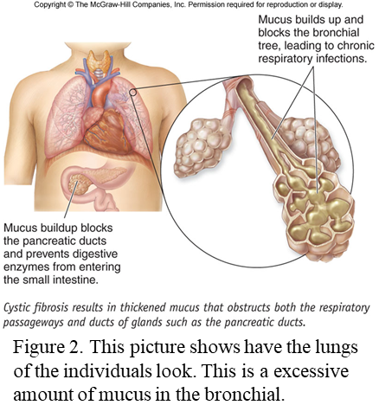

Inheritance pattern
There are 100 different mutation associated with CF. The disease is autosomal recessive gene mutation which means both copy of the gene is mutated. Autosomal recessive gene disorders must have two copies of an abnormal gene from each parent for a trait to appear in a child. Autosomal recessive disorder tends to skip generations, furthermore the gene CFTR doesn’t affect carriers. The parents of the affected individuals must carry one copy of the mutated gene. And their parents don’t have to show signs of CF, but still be carriers of the mutated gene. An affected individual can contract the mutation by first-degree, second- degree and third- degree relatives. First-degree relatives mean the affected individual contracted the disease directly from their parents. Second-degree relatives mean the mutation comes from the individual’s grandparents, aunts, uncles, niece, and nephews. Lastly third degree relative include cousins. Therefore, if two cousins were to reproduce their offspring would most likely have a higher chance of contracting the disease if it runs in the family.
In the United States CF is most common in the Caucasian population. There are approximately 30,000 people currently in the United States affected with CF (NIH, 2018). 1 and every 31 Americans are carriers are of the mutated gene (NIH, 2018). But Caucasians are not the only race there can develop the disease, the disease can occur in many ethnic groups, but it is less common. 1 in 2,500 to 3,500 white newborns have the disease but 1 in 17,000 African American and 1 in 31,000 Asian Americans have the CF gene (NIH 2018).
Symptoms
Children with the disease have delay growth and development. The lung disease appears a few months after a child is born, but it is very difficult to detected without invasive technology (Sloane et al.). Some signs and symptoms of CF that are spotted in children are the following: they have a lot of complications as such failure to reach weigh requirements for the current weigh and age groups, belly pains follow with constipation, belly may appear swollen, nausea, or their stool maybe a pale or clay color that has mucus that float. Children can appear to even lose a significant amount of weight. Modern day technology allows parents to know whether their children is affected with CF. In table 2, it shows the common symptoms and how a person may appear when affected with Cystic Fibrosis. Individuals with this disease experience many setbacks throughout their life. CF cause a people to live a difficult and painful life according to Aris (Aris et al.). Cystic fibrosis causes several damages to lungs, digestive systems, and other organs in their patients. The production of mucus in great numbers cause the patients to have a deep and uprooting cough. Cystic fibrosis overall affects the patient ability to live a normal life.
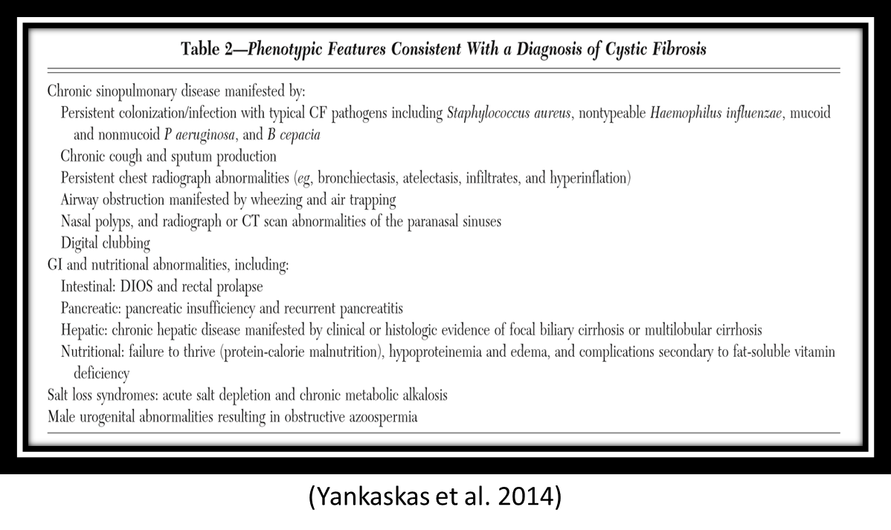
Life expectancy
The life expectancy of an individual with Cystic fibrosis live to about 37 years of age. This is done with the proper treatment and care. “Changes in the clinical management of these patients, including nutritional supplementation, physical therapy, and medication regimens, have increased the life expectancy of patients with CF from the single digits in the 1960s to 32 years of age in 2002” (Aris et al.). The life expectancy of individual with CF age has increased throughput the years (figure 1). This study increase could be due to the knowledge of Cystic fibrosis has increased or more people with Cystic Fibrosis are allowing to receive treatment. Table 1 shows the type of complications of patients with CF. The table is a great example of what is going on in a patient’s body. The CF patient life expectancy can increase if the disease is treated proper and the individual is treated with care. Therefore, individuals tht are able to receive and afford proper trreament live longer lives.

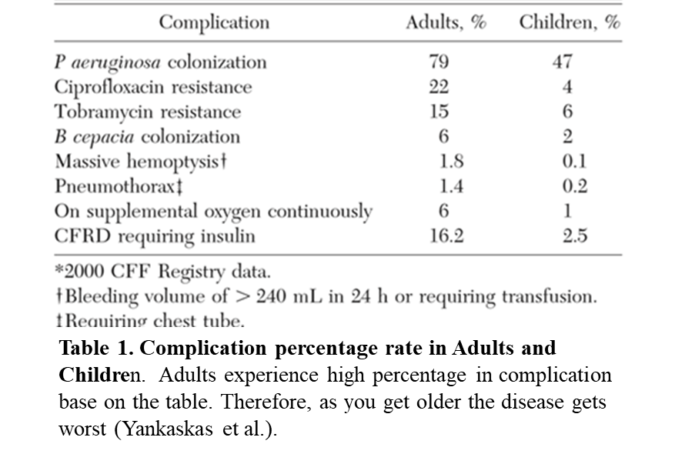
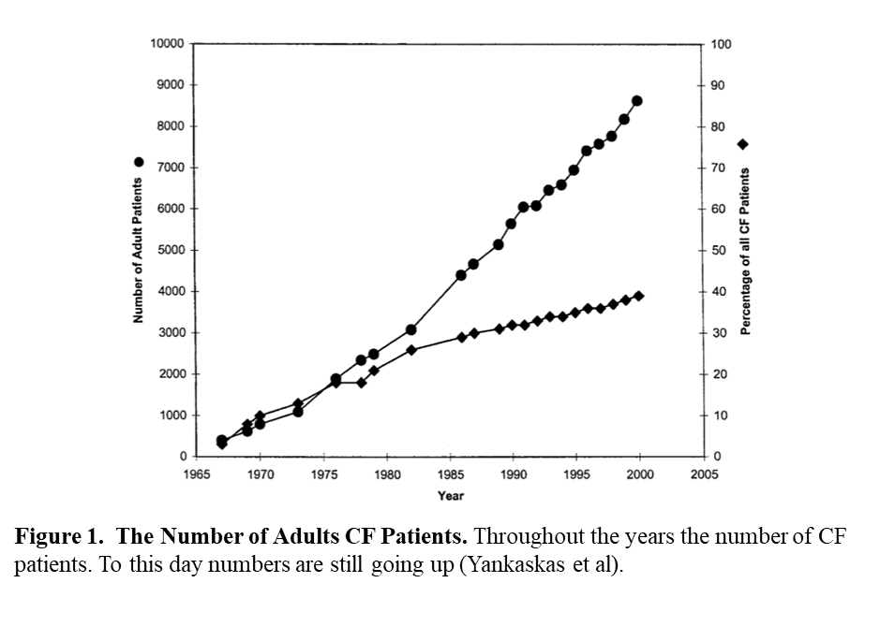
Treatment
The average cost of treatment for Cystic Fibrosis is about $16,000 in the United States. The cost of treatment can wildly range in prices based on the individual type of CF. Individuals with mild CF, treatment cost about $10,000 or more. The prices increase as the disease gets worse, therefore, moderate, and severe CF cost about $25,000 and $33,000 in the US. Lifetime health care costs are approximately US $306,332 (3.5% discount rate) (Gool et al. 2013). Cystic Fibrosis is expensive and requires a lot of treatment and care. Unfortunately, many individuals with this disease suffer more than other simply because they can’t afford the treatment.
There are no cures present for individual affected Cystic Fibrosis, but patients can undergo treatment to reduce complications. Patients with CF are diagnosed with the disease around the age of two and have the disease until they die. However, people with CF tend to have lung transplants to prolong their survival and in doing so it improve their quality of life (Aris et al.). Not all patients are able to afford treatment and a lung transplant, so this can influence how long patients can live with the disease.
Improvement and Knowledge Gaps
There are many people affected with this disease that fall in different race and location categories such as Macedonia, Russia, and South Africa (Gunna Resiason 2018). Therefore, there should be an expansion of this field of study. Cystic Fibrosis is studied mostly in Caucasians because its most common in Caucasians. However, they should be more studies that involved Africans and Asian because Cystic Fibrosis appear in those races as frequently as Caucasians. Also, there should be more studies examining individuals in third world countries. Different races, ages, and different financial statistics should be looked at. The cost of treatment should be reduced therefore poor individuals can afford the treatment. Increase the knowledge of individuals with the disease in different areas can help researchers understand the disease better.
Conclusion
How do people with the disease live a long and happy you may ask? The correct answer is treatment and care. Like said in previous passages CF is a live long disease with no cure. The way to improve your living situation is a combination between the right treatment plan for the difference types of CF (mild, moderate, and severe) and the right medications can help improve several complaints and make the life of patients more convenient and simply better (Sinaasappel et al.).
Future direction
In future experiments, all races should be look at and compared to see if there are any ways they can help each other with the disease and if there is a possible cure for Cystic Fibrosis. Cystic Fibrosis is mostly common in Caucasians in the United States. By looking at third- world country scientists can study why it is not as common and look at their genetic makeup to understand the disease better. This will improve the knowledge and understanding for Cystic Fibrosis. The cure for Cystic Fibrosis maybe in African waiting to be found but Scientist may never know because their focus is on the United States expanding research may help.

Literature Cited:
Article
Aris, R., Merkel, P., Bachrach, L., Borowitz, D., Boyle, M., Elkin, S., & Joseph, P. (2005). Guide to bone health and disease in cystic fibrosis. The Journal of Clinical Endocrinology & Metabolism, 90(3), 1888-1896.
Barni, G., Forte, G., Forgiarini, L., Abrahão, C., & Dalcin, P.(2017). Factors associated with malnutrition in adolescent and adult patients with cystic fibrosis. Jornal Brasileiro de Pneumologia, 43(5), 337-343.
Boyle, M., & De Boeck, K. (2013). A new era in the treatment of cystic fibrosis: correction of the underlying CFTR defect. The Lancet Respiratory Medicine, 1(2), 158-163.
Cohen-Cymberknoh, M., Shoseyov, D., & Kerem, E. (2011). Managing cystic fibrosis: strategies that increase life expectancy and improve quality of life. American journal of respiratory and critical care medicine, 183(11), 1463-1471.
Davies, J., Turner, M., & Klein, N. (2004). Impaired pulmonary status in cystic fibrosis adults with two mutated MBL-2 alleles. European Respiratory Journal, 24(5), 798-804.
de Jong, P., Lindblad, A., Rubin, L., Hop, W., de Jongste, J., Brink, M., & Tiddens, H. (2006). Progression of lung disease on computed tomography and pulmonary function tests in children and adults with cystic fibrosis. Thorax, 61(1), 80-85.
Sinaasappel, M., Stern, M., Littlewood, J., Wolfe, S., Steinkamp, G., Heijerman, H. & Döring, G. (2002). Nutrition in patients with cystic fibrosis: a European Consensus. Journal of cystic Fibrosis, 1(2), 51-75.
Sloane, A., Lindner, R., Prasad, S., Sebastian, L., Pedersen, S., Robinson, M., & Harry, J. (2005). Proteomic analysis of sputum from adults and children with cystic fibrosis and from control subjects. American journal of respiratory and critical care medicine, 172(11), 1416-1426.
Sly, P., Brennan, S., Gangell, C., de Klerk, N., Murray, C., Mott, L., & Ranganathan, S. (2009). Lung disease at diagnosis in infants with cystic fibrosis detected by newborn screening. American journal of respiratory and critical care medicine, 180(2), 146-152.
Yankaskas, J., Marshall, B., Sufian, B., Simon, R., & Rodman, D. (2004). Cystic fibrosis adult care: consensus conference report. Chest, 125(1), 1S-39S.
Websites:
https://ghr.nlm.nih.gov/gene/CFTR#synonyms
http://www.gunnaresiason.com/cystic-fibrosis-around-world-reflection/

.

