Mission Statement  World Poverty is a problem that has been prevalent since the birth of human society and it only continues to grow. However, it is a problem that can be resolved if people become educated on how to help stop the spread of poverty.  What can be done?  - Donate to organizations that work to stop world poverty through humanitarian works  - Write to the leadership of your country, inform them that the problem is not just a foreign issue, but a domestic one as well.  - Don’t turn a blind eye and recognize that a change can be made today. |  | References  TED, Gary Haugen,March2015 .https://www.ted.com/talks/gary_haugen_ the_hidden_reason_for_poverty_ the_world_needs_to_ address_now?language=en#t-111562  “Water.” Water, Sanitation and Hygiene, 2019, www.unicef.org/. Accessed 5 Mar. 2019.  “Water, Sanitation, and Hygiene.” UN Water: Coordinating the UN’s work on water and sanitation, 2019, www.unwater.org/. Accessed 4 Mar. 2019.  “Water Quotes & Sayings - Best Quotes about Importance of Water.” Best RO Water Purifier,www.bestrowaterpurifier.in/blog/water- quotes-sayings/.  “What We're Doing to Help End Global Hunger.” Mercy Corps, 19 Mar. 2019, www.mercycorps.org/articles/what-were-doing- help-end-global-hunger. |  |  | World Poverty  - World Hunger, Everyday Violence, and Clean Water  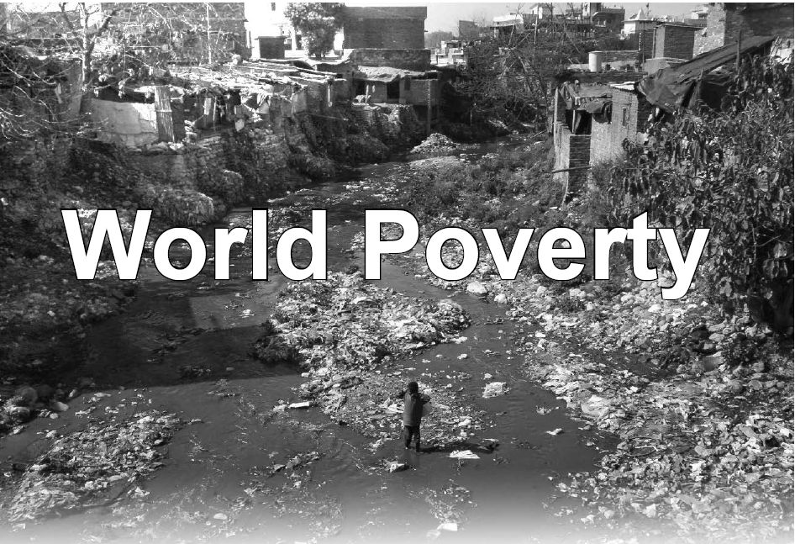

World Hunger  - More than 820 million people around the world will go hungry every night  - Hunger is cyclical and generational meaning if a child’s parents grew up hungry then the child will most likely struggle with hunger.  - Almost all of the world hunger population, about 98 percent, live in developing countries.  - While not everyone on earth experiences severe hunger, 795 million people do not have enough food to live a happy and active lifestyle.  - 45% of deaths for children under 5, which amounts to about 3.1 million children, are caused by poor nutrition.  - 1/7 people in the world are hungry yet 1/3 of the world’s food is needlessly wasted.  - Climate change, and its effect on the environment is contributing to the decrease in food security in the world. | “Pure water is the World’s First and Foremost Medicine” – Slovakian Proverb  Clean Water  - Today 2.1 billion people lack access to safely managed drinking water services  - 4.5 billion people lack safely managed sanitation services.  - 50% of child malnutrition is associated with unsafe water, inadequate sanitation and poor hygiene.  - There has been an increase in the amount of people gaining access to clean drinking water.  - 91 percent of the world’s population is able to access some form of clean drinking water.  - 840,000 people die every year from diseases directly caused by unsafe water | Everyday Violence  - 35 million poor people are currently enslaved as a result of everyday violence.  - In the developing world, basic law enforcement systems are so broken that recently the UN issued a report that found that most if not all poor people live outside the protection of the law.  - Women and girls living in poverty between the ages of 15-44 fall victim to everyday violence, domestic and sexual violence, which accounts for more death and disability than malaria, car accidents and war combined.  - In Bolivia, if a man sexually assaults a child in poverty, statistically he is at greater risk of falling in the shower than he is of ever going to jail as a result of that crime he committed.  - In South Asia today, slavery is so commonplace that the person who enslaves another human being is at greater risk of being struck by lightning than ever going to jail for that crime.

