Name: Cammy Toddy

Bi-Weekly Report Dates: September 24th - October 1st, October 1st - October 8th

Week 1 Total: 96,803 high day - 20,750 steps, low day - 7,418 steps

Week 2 Total: 98,871 high day - 17,732 steps, low day - 6,956 steps

Week 1 Reflection and Graphs

Reflection: During the week of September 24th to October 1st I reached a total of 96,803 steps. This week was really intense fitness wise because our team was preparing to go against Kent State on September 30th. That day ended up being my high day because I had 20,750 steps. In this game we went into double overtime, but unfortunately we lost. This game was extremely intense but left a bitter taste in my mouth with the result. This exhausting game led the next day to be my low day with 7,418 steps on October 1st, which was an off day for our team. My steps for this day came mainly from walking to and from my three classes.

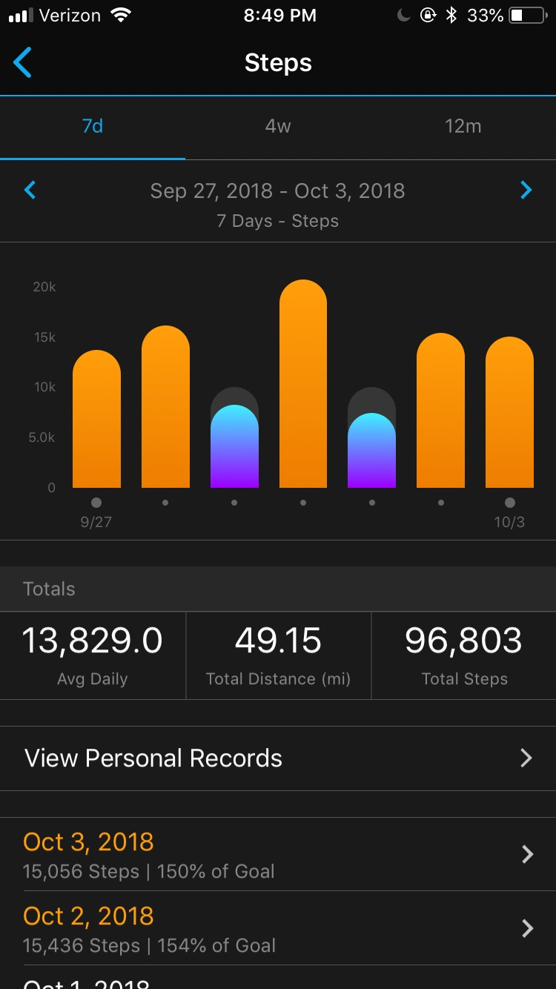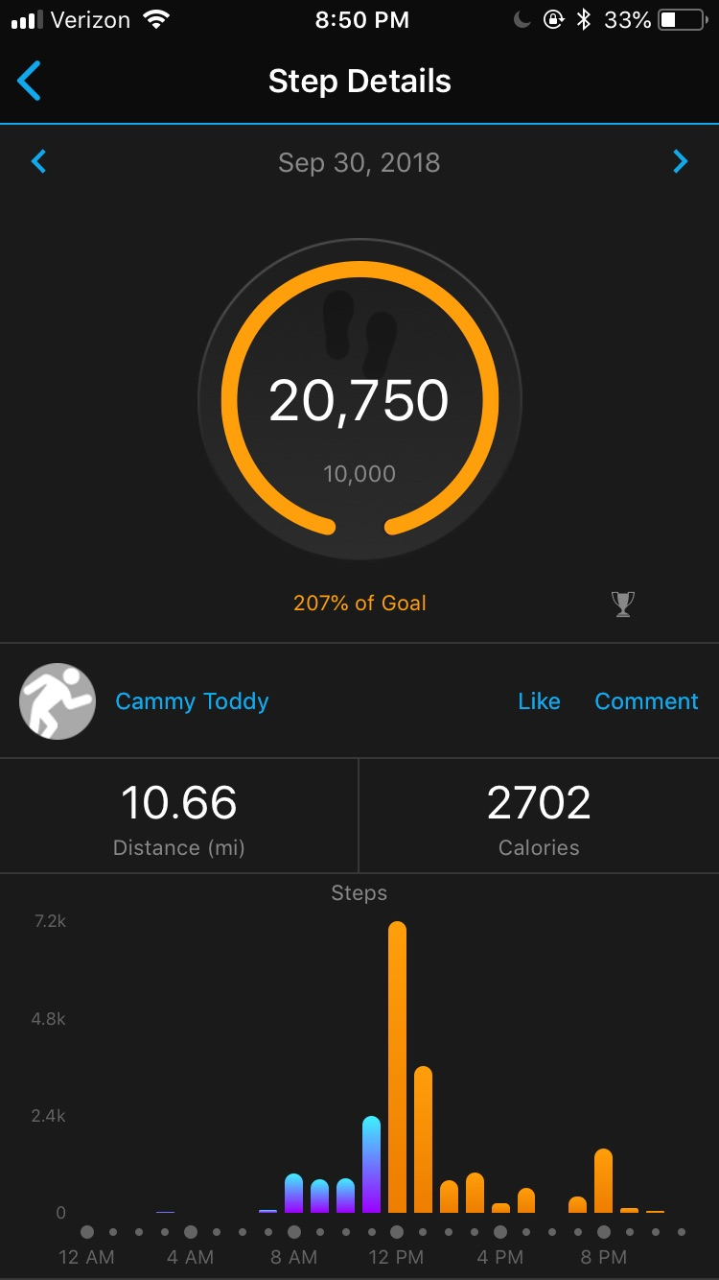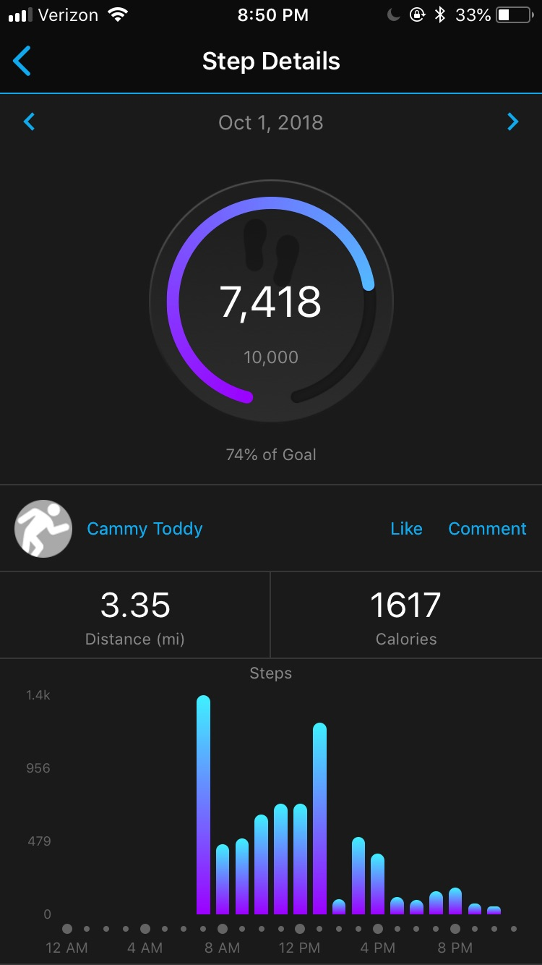

Week 2 Reflection and Graphs

Reflection: October 4th to October 10th was another exhausting week preparing for a conference game. My high day for this week was on October 10th, where I had 17,732 steps. On Wednesday’s I have three classes and a lab so I am walking around campus a lot. Then I have practice so I am running around a lot throughout the day. This day I also had to go on a hike to gather soil samples behind Lancer Park for my research project for BIOL 251. My low day was on October 7th with 6,956 steps because it was an off day. This was the day after our game against Miami Ohio.

