Cammy Toddy
Dr. Jackson
BIOL 120
15 February 2018
Project 1 Results

Our group did not find any conclusive results from our four samples of testing bacteria on various door handles throughout Chichester Science Center after the first week. We were only able to find one small species of bacteria and it was only shown on one petri dish. Additionally, one of our dishes was contaminated with mold, so our results for seeing which areas had higher contamination were inconclusive. It was not until the second week where we were able to identify two species of bacteria. Medium treatments had the greatest amounts of diversity and abundance (Table 1, Fig. 1, Fig. 2). The medium level replicates had shiny yellow growths than white cloudy patches. The medium treatment level saw both species of bacteria, whereas the high treatment only saw the yellow growths and the low level had no findings of bacteria (Table 1). Bacteria abundance was four times greater at the medium treatment level (1 ± 1.414214 species/dish) than in the high treatment level (0.25 ± 0.5 species/dish) (Table 2). Bacteria diversity was three times greater at the medium level (0.75 ± 0.957427 species/dish) than in the high treatment level (0.25 ± 0.5 species/dish) (Table 3).

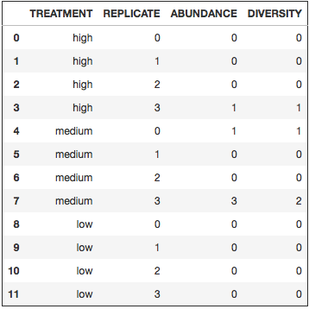
Table 1. Showcases the various treatments, replicates, abundance, and diversity for the contamination of bacteria among the different door handles in Chichester.

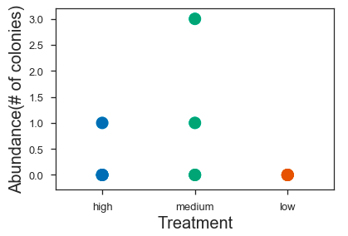

Figure 1. Represents the number of colonies for each level of contamination: high, medium, low. Each dot stands for the number of abundances for the level of contamination in the trial.

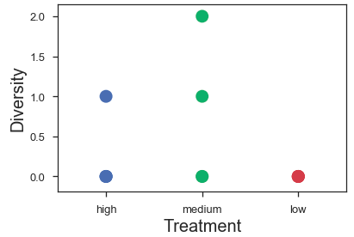
Figure 2. Represents the various species of bacteria with respect to the treatment level: high, medium, or low. Each dot stands for the number of diversities of the given treatment and trial.

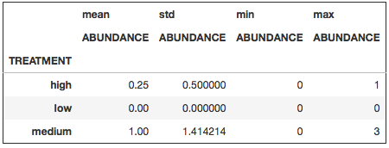
Table 2. This table represents the mean abundance number of the treatments as well as the standard variation of abundance. The std is how many deviations that given treatment falls away from the mean.

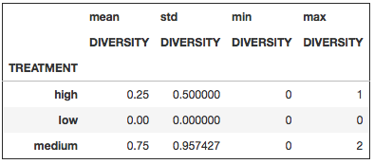
Table 3. This table represents the mean abundance number of the diversities for the various treatment levels: high, low, and medium. The std represents how far away the diversity for each treatment was from the mean.

