XYZ Middle School

Attendance Guide
Go Chiefs

Table of Contents

- Attendance in Early Grades
- Looking at the Data
- Excessive absences
- Current supports
- Protocols for Tracking Attendance
- Plan to Implement the Supports
- Sample Spreadsheet to track attendance
- Student Involvement

Attendance in the Early Grades

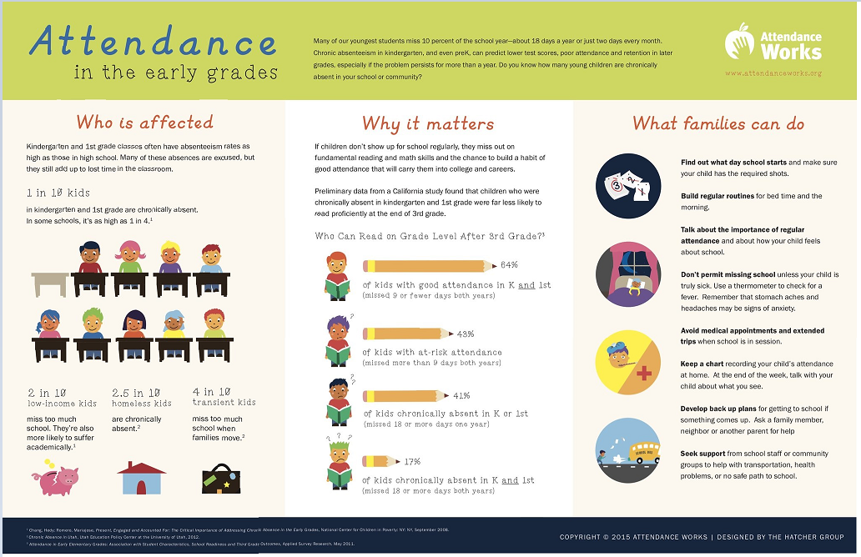

Looking at the Data

The attendance rate for XYZ Middle school was 96.4%
in the
2017-2018 sy
That is a 1.6% drop from the previous year due to there being 48 students who had excessive absences, excluding 5 for medical reasons therefore we need to put some tier1, tier 2 & tier 3 supports in place to address the absenteeism concerns from the division

Excessive Absences

Definition
All excused and unexcused absences will be included in computing excessive absences except as follows:
School-sponsored/related activities
Authorized visits of students with school personnel
Recognized religious holidays
In the high schools, students having more than twelve (12) absences from a class (excused or unexcused) within a given semester will be considered as having excessive absences. This guideline will also apply to credit courses taken at the middle school level.
In high schools with alternate day schedules (i.e. block scheduling), students having more than six (6) class absences from a class (excused or unexcused) within a given semester will be considered as having excessive absences. This guideline will also apply to credit courses at the middle school level.
In elementary and middle schools, students having more than twenty-four (24) absences for the year will be considered as having excessive absences.

Resulting Actions
When a student's absences equal two-thirds of the number for excessive absences, the school will notify the parent in writing of the number of absences and will be responsible for working with the student and the parent in developing a plan of corrective action as appropriate. Such intervention may include, but is not limited to, the following: parent conference; scheduled contact with parent; referral to the guidance counselor or school social worker; loss of privileges and/or restricted participation in school activities; referral to alternative learning program; and recommendation to the administration for other consequences.
When a student's absences are excessive, the teacher will notify the principal. The principal or his designee will advise the parent by United States mail of the appropriate following action:
In the elementary and middle schools (grades K-8), students having excessive absences will participate in a corrective action plan with intervention strategies to improve attendance. At the end of the year, on the authority of the principal, the student could be denied promotion as appropriate.
In high schools, students having excessive absences within a given semester will receive a failing grade (63/N) for that semester or the actual class grade, whichever is lower. At the middle school level, this guideline will also apply to credit courses.

Current Supports

- each Unexcused absence- the principal, or his/her designee, will make a reasonable effort to notify the parent of the pupil's absence and to obtain an explanation for the absence.
- 5th absence- Make a reasonable effort to ensure that direct contact is made with the parent/guardian by the principal or his/her designee, to obtain an explanation for the absences, and to explain to the parent/guardian the consequences of non-attendance.
- 6th unexcused absence- Within ten school days, the principal, or his/her designee, shall schedule a conference with the Student Support Team (SST),
- 7th unexcused absence- The principal, or his/her designee, shall refer the student to Juvenile Intake for an interview.

Protocols for Tracking Attendance

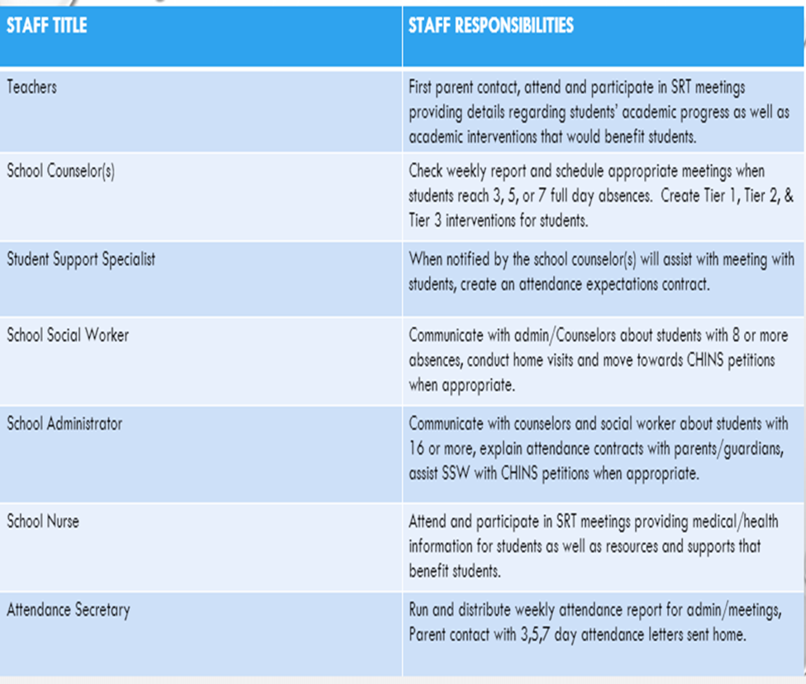

Plan to Implement the Supports

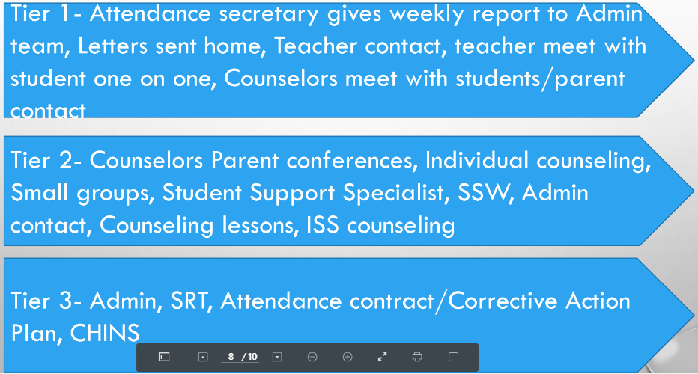

Sample Spreadsheet

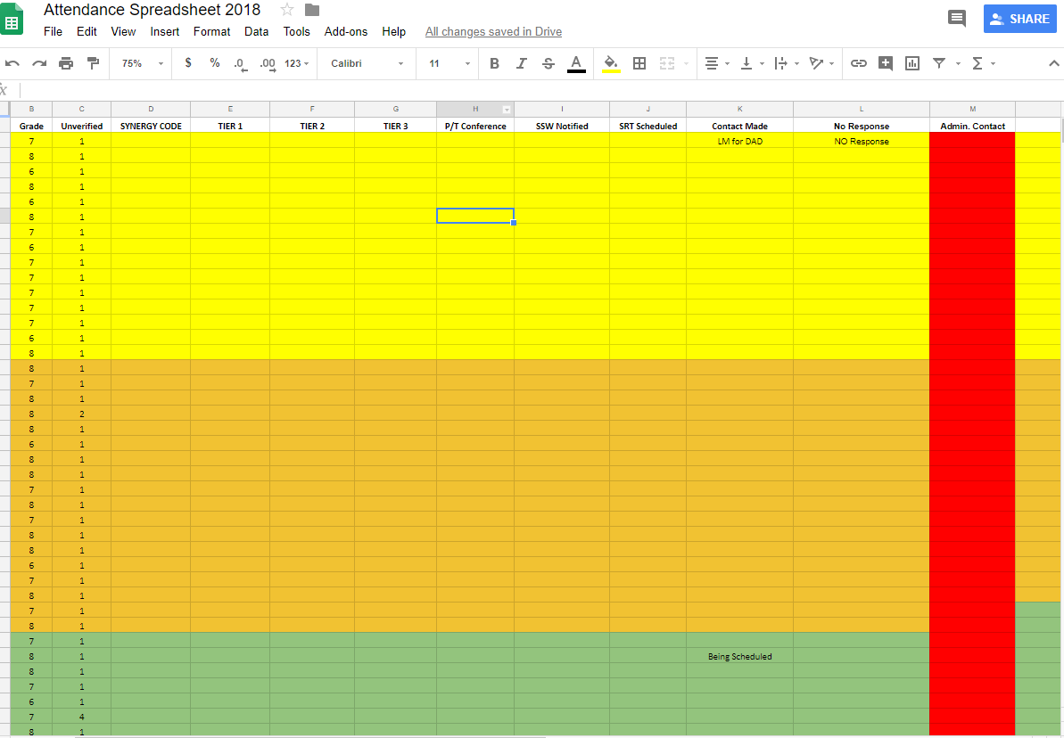

Student Involvement

Provide opportunities through:
- Clubs
- Leadership opportunities- BGR
- Committees
- Mentorship Program
- Volunteers – Helpers for school sponsored activities

