Jessica Taylor
Reader’s Guide

ABOUT THE AUTHOR

Christopher Paul Curtis, author of The Watsons Go to Birmingham, grew up in Flint, Michigan. He lived in an all-black neighborhood and the only white people that he saw were teachers that worked at his school. Curtis was a straight A student all through elementary school, but upon reaching high school he lost motivation and began to disregard academics. After Curtis graduated from high school, he began working at a factory that put together automobiles. He quickly became bored of the work that he was doing in the factory. After coming up with a system so he could rest every thirty minutes, Curtis took these breaks to write. He worked at this factory for thirteen years before he decided to take a year off to write the novel that became The Watsons Go to Birmingham. This novel won high praise, being awarded with both the Newbery Medal and the Coretta Scott King Honor. Now, Curtis lives with his wife and two kids in Windsor, Canada.

KEY PASSAGES – FAMILY RELATIONSHIPS

- “Even though she’d lived in Flint for fifteen years, she still thought cold weather could kill you in a flash. That’s why me and Joey were the warmest kids at Clark Elementary School. Momma wouldn’t let us go out on a cold winter day unless we were wearing a couple of T-shirts, a couple of sweaters, a couple of jackets, and a couple of coats, plus gigantic snow pants that hung on your shoulders by suspenders, plus socks and big, black, shiny rubber boots that closed with five metal buckles” (47).
Although Kenny is annoyed that him and Joey must dress in all this ridiculous clothing, it shows that their mother really cares about them and wants them to stay safe and germ-free. That is not to say that the other kids’ parents don’t care about them or want them to stay safe, but their Momma is showing her love in a way that she knows how. Since she is from Alabama, Momma is not used to the cold even though she has lived in Flint for over ten years. Momma is quite present in her children’s lives and she shows this by being a little overprotective about the cold weather. Although the kids are annoyed about how they must dress, they will look back at this time as a moment where their mother showed her unconditional love for them.

- “’Death row prisoner number five forty-one, you have a visitor. Please make this a short visit, ma’am, the priest will be here any minute to give the prisoner his last meal and his last cigarette. Oops! I forgot, no cigarettes for you, Five Forty-one, you’ve been banned from ever looking at matches, remember?’” (90).
This passage comes from the chapter “Every Chihuahua in America Lines Up to Take a Bite out of Byron.” Byron had gotten his hair done by Buphead, and knew that his parents would not approve of his new style. Upon his return home, his mother saw his hair and sent him to his room to wait for his father. Kenny took this opportunity to make fun of Byron, relating him to a death row inmate in this passage. The sibling rivalry is very real and relatable in this novel, and it gives readers a reminder that these characters could be real people that they know. Many siblings argue and make fun of each other, but at the end of the day they still love each other, as it will be shown in the next passage.

- “He knew this was some real embarrassing stuff so he closed the bathroom door and sat on the tub and waited for me to stop, but I couldn’t. I felt like someone had pulled a plug on me and every tear inside was rushing out, if there was a forest fire somewhere all Smokey the Bear would have to do was hold me upside down over it and the fire wouldn’t have a chance. Byron sat next to me on the floor and put my head in his lap” (199).
After the church bombing, Kenny withdraws from his family and friends and hides out behind the couch. Kenny witnessed some gruesome things in the church, and although he does not fully understand the gravity of what happened, he feels shame for crying. Byron puts his “cool dude” act aside and comforts his brother when Kenny needs it the most. Byron sat with Kenny and let him cry until he could not cry anymore, and reassures him that Kenny was not the only person who is upset. Even though siblings will always fight and bother each other, it is times of tragedy that forces families to come together and show how much they truly care for one another. By the end of the novel, readers are cheering for Byron and how he has matured in his interpersonal relationships.

DISCUSSION QUESTIONS

- How has Byron’s character changed throughout the novel? Give examples from the text.

- Do you agree with the parent’s decision to take Byron to his grandmother’s house for the summer and maybe the rest of the year? Why or why not?

- How would you feel if you were an African-American person traveling from Michigan to Alabama, like the Watsons, in the year 1963?

- What do you think about the father’s decision to buy the record player even though he knew that money would be tight? Do you think it was a worthwhile purchase?

- If you were in Kenny’s shoes when the church bombing occurred, would you have run into the church in search of your little sister? Do you consider what Kenny did brave?

- If you were going to write a sequel to this book, what topics do you think should be included? Why?

RELATED ACTIVITIES

Activity one:
If your family was going on a two-week-long trip from Michigan to Alabama, what things would you take with you? With the United States map provided, draw the route that you would take and where you would stop along the way. After you have done this, create a packing list with everything that you would need for those two weeks.

Activity two:
Go on the Internet and look up what grocery prices would be in the 1960s. Create recipes for one week of dinners for a family of five people, like the Watsons. Total the amount of money that seven dinners would cost. Then, go to the grocery store and find the ingredients for the same seven recipes. Compare the final cost of one week of dinners in 2017 and 1963. What is the difference in price?

Activity three:
Compare the animal life, the plant life, and the weather patterns that would be present on a typical December day in both Michigan and Alabama. You can do this by using the Internet or books from the library. Present your findings in a Venn Diagram.

ONE MORE ACTIVITY
HOW FAR CAN YOU TRAVEL?

This activity is focused on the diversity among different states and countries. We will be sending your favorite toy or stuffed animal to someone that you know that lives in a different state or country. The person who you will send your toy to will need to take pictures of your toy with important or well-known buildings, places, people, etc. that are in that town or city. They will also need to write journal entries with the fun things they saw and visited with your toy. They can keep the toy as long as they want, but make sure they mail it back to you with lots of fun pictures and stories!

- Think about your family members or friends that live in a different state, or even country, then you do.
- Find your favorite toy or stuffed animal.
- Put your toy in a box along with instructions for the project. Include the journal entry template (attached).
- Take your toy to the post office and wait until it returns!
- After you get your toy back, you can send it to other states or countries to get as many pictures as you would like!

SEE BELOW!
The attachments below will help your family or friend document where they have been and how much fun they have been having! When your toy gets sent back, you will get to learn about different states or countries that you might have never been to before. Like people, every state and country is different and has many unique things about it.
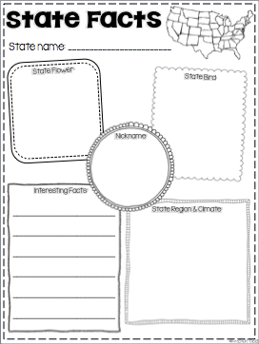

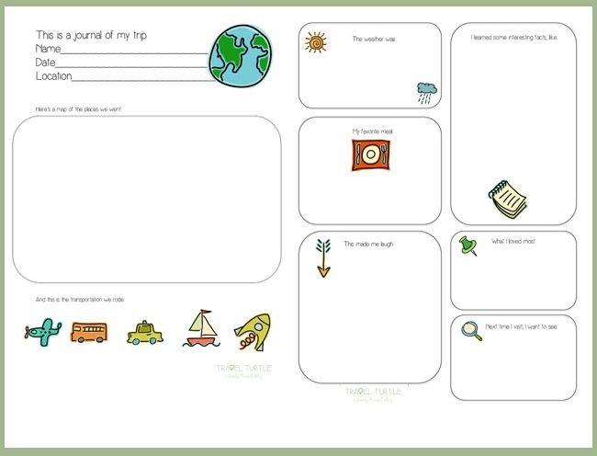

WORKS CITED

Part 1 (About the author): “A video interview with Christopher Paul Curtis.” Reading Rockets, WETA, 26 Aug. 2014, www.readingrockets.org/books/interviews/curtis.

Part 2 (Key passages): Curtis, Christopher Paul. The Watsons go to Birmingham: 1963. Yearling Book, 2013.

Part 3 (Discussion Questions): No outside sources used.

Part 4 (Related Activities): No outside sources used.

Part 5 (One More Activity): Google images for the two attached worksheets.

Google images for The Watsons Go to Birmingham picture.

