Case Study: Final Manuscript
RECR 30: Therapeutic Recreation in Mental Health
Mark D. Greenlaw
Longwood University

I have neither given nor received help on this work, nor am I aware of any infraction of the Honor Code.
Table of Contents:

Diagnosis………………………………………………………………………………………......3
Demographics……………………………………………………………………………………..3
Assessment ………………………………………………………………………………………..3
Clinical Summary ………………………………………………………………………………...4
Care Plan ………………………………………………………………………………………….4
Intervention Plan ………………………………………………………………………………….5
Plan a Group ……………………………………………………………………………...5
Facilitate a Group …………………………………………………………………………5
Progress Notes ……………………………………………………………………………6
Discharge Summary ………………………………………………………………………………6
Conclusion ………………………………………………………………………………………..7
Reference List …………………………………………………………………………………….9
Appendices …………………………………………………………………………………(10-35)
Appendix A (Biopsychosocial Assessment) …………………………………………10-21
Appendix B (Care Plan) …………………………………………………………………22
Appendix C (Intervention Plan) ……………………………………………………..23-25
Appendix D (Progress Notes) ………………………………………………………..26-33
Appendix E (Discharge Summary) …………………………………………………..34-35
Diagnosis
The patient’s name is Andrew Laeddis. He is diagnosed with Post Traumatic Stress Disorder (PTSD) and Dissociative Identity Disorder (DID). Their problem areas include physical aggression towards others and an elopement risk. The client’s reason for admission into the facility was due to the murder of his wife after she drowned their three children. (See Appendix A for more information on diagnosis).

Demographics
Andrew Laeddis is a 33-year-old Caucasian male from Boston, Massachusetts. Andrew became a widower 24 months ago when he killed his wife for murdering his children and had a psychotic breakdown. Andrew gave all the information in English which is his first and preferred language. Andrew believes himself to be a man known as “Edward Daniels” and wishes to be called as such (see Appendix A for more information). The patient was a U.S. Marshall before his admission and is very smart and in great shape. The patient currently lives on site in the Intensive Treatment Unit (ITU).

Assessment
The assessment used to diagnose the client was the Poplar Springs Integrated Assessment Part-1 Admission Counselor Assessment which is classified as a Biopsychosocial assessment used to identify problem areas in the client’s biological, social, and psychological domains. The assessment identified that the patient has assaulted patients and other orderlies and shows compulsive actions due to the client’s want to “find the man who killed his wife.” (At the time of admission, the patient had no knowledge of killing his wife and was looking for the man who did. See Appendix A for more information). The assessment helped identify the client’s past drug abuse, military trauma, violence potential, history of abuse, and psychotic tendencies.

Clinical Summary
Andrew Laeddis has been admitted into Poplar Springs ITU for PTSD and DID. Andrew is 6 feet tall and weighs roughly 170 pounds. The patient has been sedated for the past 24 months and was recently taken off medication in a “last ditch” effort to bring him back to sanity. Client is mentally unstable due to PTSD from murdering his wife after she drowned all three of their kids. Client is aggressive and goes by the name “Edward Daniels” because he cannot cope with his past and is trying to hunt down “a murderer named Andrew Laeddis” for killing his wife. Patient is very smart and does not believe anything is wrong with him. Patient has a history of aggravated assault. Before going into treatment, the patient was a recovering alcoholic.

Care Plan
Below are the patient’s listed Goals and Objectives based on Appendix B.
- Goal 1: Reduce Negative/Intrusive thoughts caused by PTSD.
- Objective 1: By the end of one month, the client will show reduced and less frequent signs of distress as judged by the CTRS.
  - Intervention: Talk therapy to get the client to open up about his traumatic experiences.
- Goal 2: Believe his true identity (Andrew Laeddis) is who he really is and stop referring to himself as Edward Daniels.
- Objective 2: At the end of two months, client will refer to themselves as the proper identity 50% of the time, as judged by the CTRS.
  - Intervention 2: Referring to the client as his given name instead of his “alter ego.”
- Goal 3: Reduce aggressive behavior towards people of authority.
- Objective 3: Throughout the duration of the session, client will work on anger management and behavior training and show consistent improvement, as judged by the CTRS.
  - Intervention 3: Mindfulness and catharsis activities.

Intervention Plan
Plan a Group: The intervention chosen was based around the concept of “Reality Orientation” for young adults aged 18-25 with DID in a group setting. With the help of a colleague and the internet, the intervention “Head’s Up! Stay Oriented in Reality” was created. (See Appendix D for more information). The purpose of this activity was to increase reality orientation and give clients an understanding of how others see them when they disconnect with reality by dissociating from their identity. The clients will also be able to experience someone dissociating and try to “re-orient” them into reality in order to find their real identity.
Facilitate a Group: The introduction to this activity was a game called “Thumb on Top” which was an activity to split the group into two smaller groups in order to make the main activity easier. Once in the smaller groups, the facilitators explained that the participants would each be given a note card with an image on it related to a location, emotion, or weather event (three rounds were implemented) and they would have to guess what their image was with the help of their groupmates.
This activity allowed the participants to step into the role of someone who mentally did not know who they were “on the outside” (or what they were portraying) and how they needed the help of others to show them what/who they were.
Progress Notes: After the implementation ended with a discussion, nine progress notes were completed for the participants (the other CTRS was responsible for five of them, four will be included in Appendix D for more information). Each participant had the same goals and outcomes for this intervention and their progress was tracked individually on their progress notes which were completed before the end of the day to keep the information as accurate as possible for the next session.

Discharge Summary
Throughout the duration of the client’s stay, the client met their goals identified in the POC. Their goals were to reduce negative/intrusive thoughts and to reduce aggressive behavior. The client did not show any signs of these actions during any of the sessions that they were present for which indicated they are showing growth. The client missed one session for an unknown reason, thus indicating they may have tried to refuse treatment. In the three sessions that the client attended, he communicated with other participants in all but one. This particular activity was an individual coloring activity (which doesn’t require much interaction), however, the client seemed to mainly focus on his work instead of communicating with the other participants. This action does not seem like poor progress but more so an observation; could the client possibly value individual activities more than group activities? The client is currently in Intensive Treatment Unit 1, however the CTRS recommends that their living arrangements to be changed to long-term care with inpatient rehabilitation based on the findings from the progress notes. One goal the client should still work on is:
- Reduce negative/intrusive thoughts caused by PTSD
Objective:
- By the end of one month, the client will show reduced and less frequent signs of distress as judged by the CTRS.
The client should continue to come to therapy groups, however the writer recommends that they focus mainly on art or athletic interventions since they seemed to thrive in those environments as judged by their outcomes in the progress notes. The client is to attend and participate in one art intervention a week for 30 minutes and progress to one hour, and the client is also to attend and participate one athletic intervention a week for 30 minutes and progress to one hour by the end of a 30-day period before being reassessed. The client is accountable for remembering when group is, however will be reminded by CTRS staff the day of. An attendance sheet will be kept at all groups for accountability of attendance.

Conclusion
Overall, I would say that I did a decent job summarizing this case on the character Andrew Laeddis from the movie Shutter Island. The biopsychosocial (BPS) could have been done with a little more detail (understandably since it was the first time I ever had to write one up) and I should have gone more in-depth with the progress notes since I have been doing them for almost three years now. I started this case study by choosing a character and watching the movie. Once doing so, I got to work with filling out the BPS and would often revisit parts of the movie to fill in gaps that I didn’t remember from the first watch. Once all of the information was filled in, the BPS was turned in to be graded. Throughout the duration of the semester, the class participated in four facilitations led by Dr. Whitely where we would write progress notes about our partner (chosen at random during the beginning of the year) and then link their behavior during the facilitation to our movie character’s attributes and problems. After the four facilitations, we had a lesson on facilitated discussion questions, or OARS; which showed us how to open up clients and validate them after sharing in a group. Finally, we paired up with another classmate who had a character with roughly the same disorder and we planned a facilitation for a small group within the class with the focus being the disorder of our movie characters. Once the facilitation was over, we had to write progress notes for our participants and then begin the final manuscript where we put the entire semesters’ work onto one big document. Two aspects of this case study that will most likely help me in my future practice would definitely have to be learning about the OARS questions and having the experience to plan a “real” facilitation for classmates and one of my professors because I am motivated off of self-efficacy and I will really look back on this experience in the future. If I could change one thing about my practice, it would have to be my time management skills. During the facilitation, we implemented three rounds of the intervention and only had half of a true debrief because we ran out of time. If we had simply cut the facilitation to two rounds, then I believe the participants would have really gotten more out of the activity due to the full debrief.

References
Bashlak, I. (2015, March 13). Hedbanz Cards. Retrieved from https://busyteacher.org/22173-hedbanz-cards.html

Guidelines for Treating Dissociative Identity Disorder in Adults, Third Revision. (n.d.). Retrieved from https://www.tandfonline.com/doi/abs/10.1080/15299732.2011.537247?journalCode=wjtd20

Appendix A
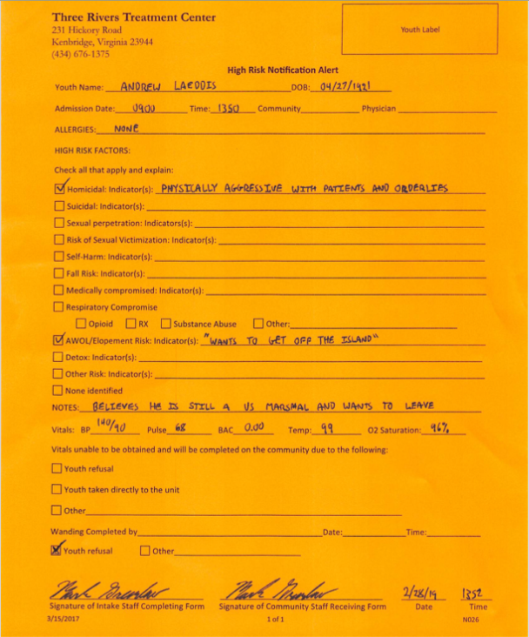

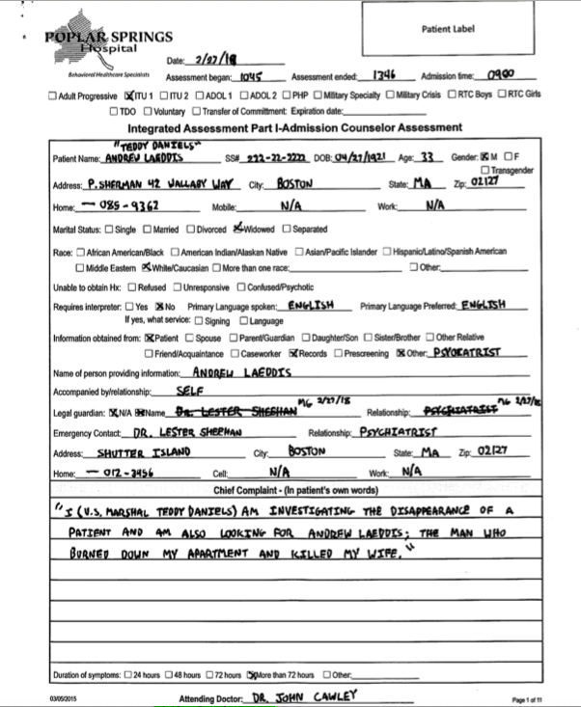

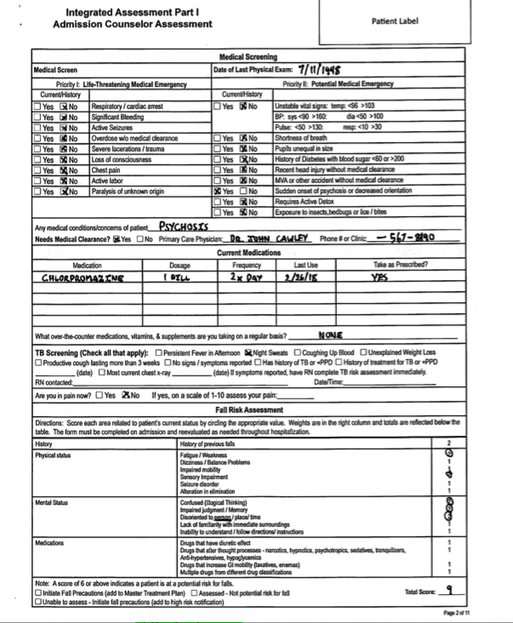
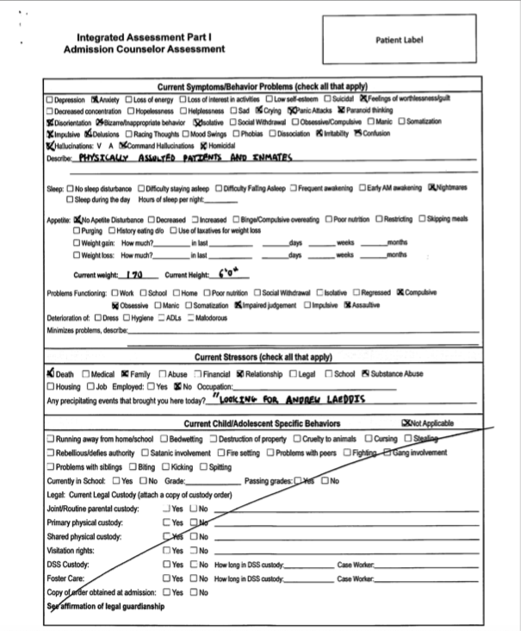
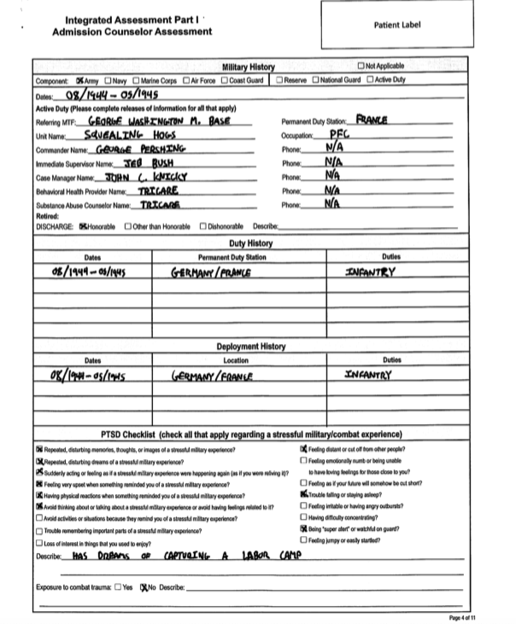
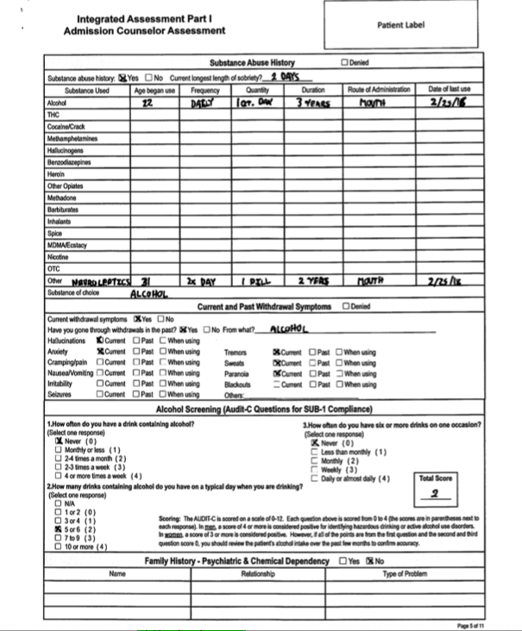
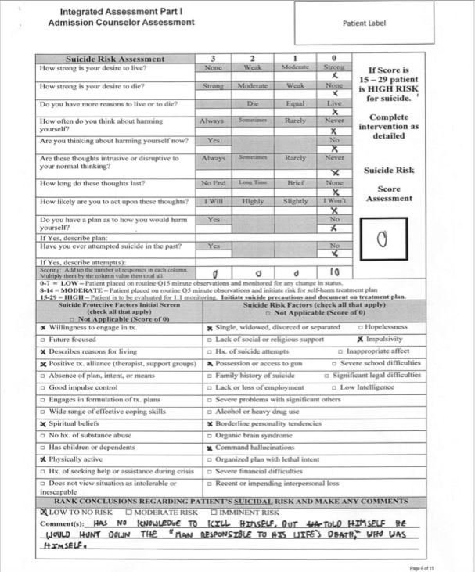
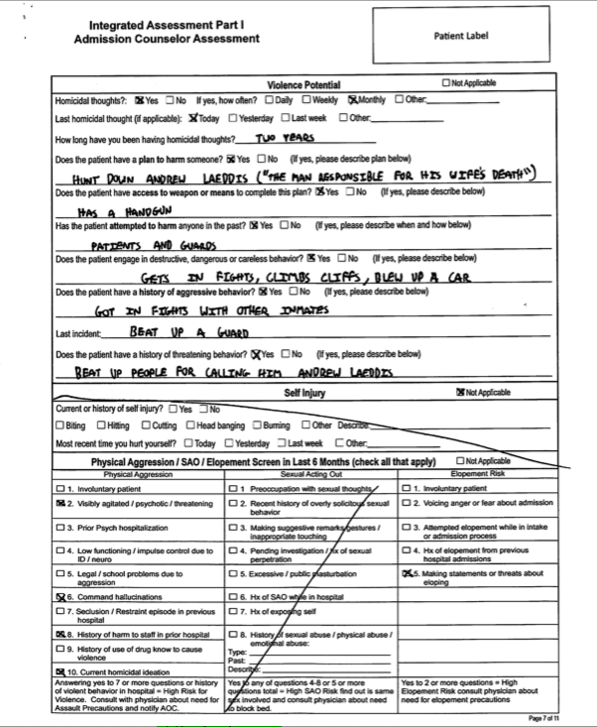
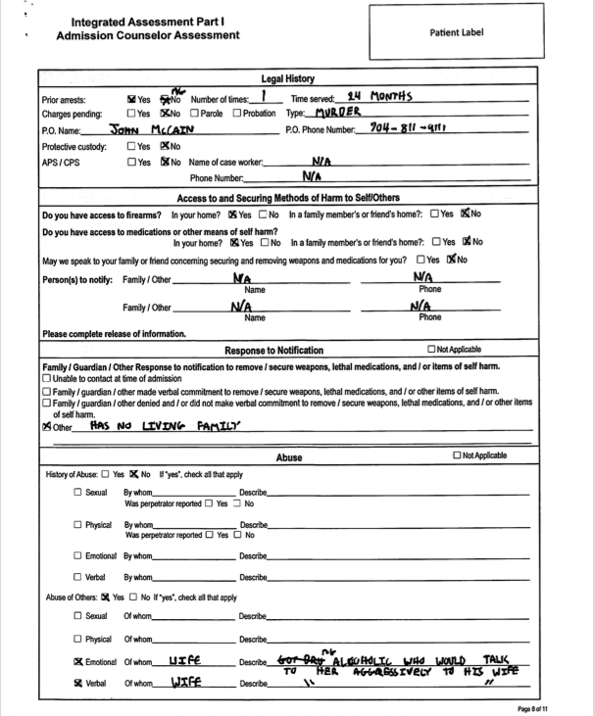
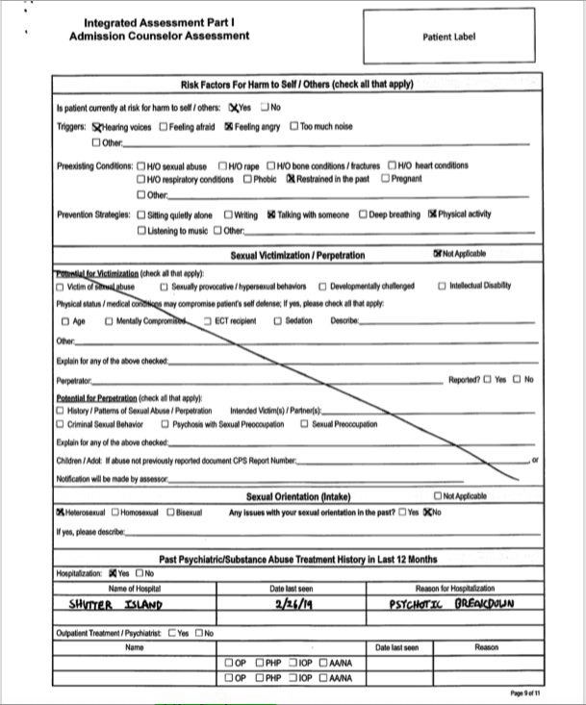
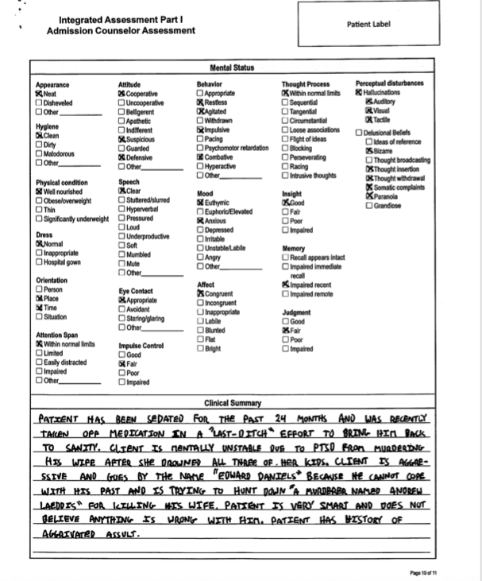
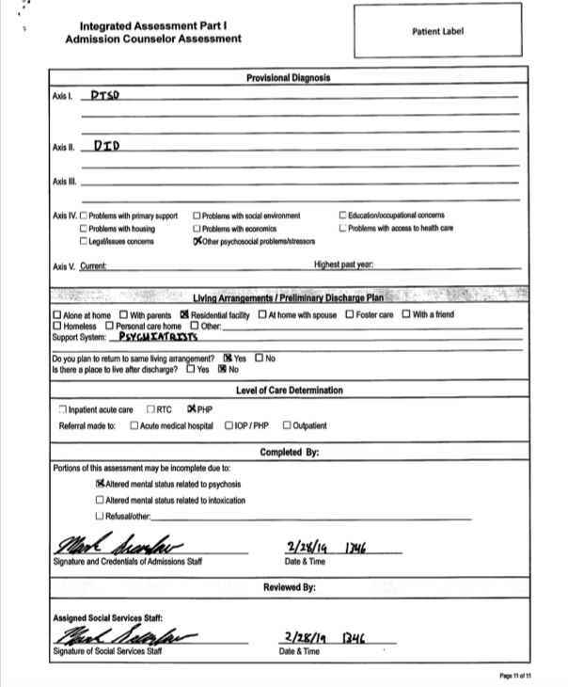

Appendix B

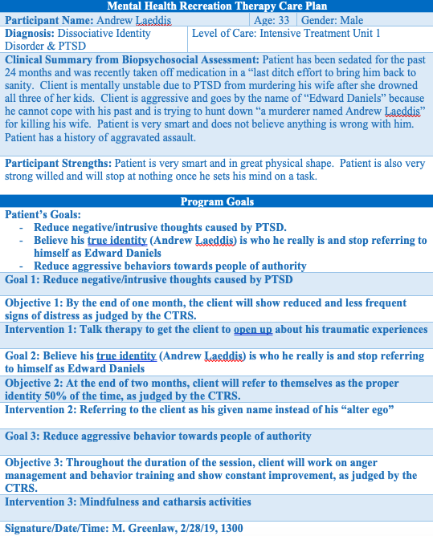
Appendix C

RECR 301 Mental Health Intervention and Facilitation Plan
Spring 2019
Brady Hinton & Mark Greenlaw
“Head’s Up! Stay Oriented in Reality” A reality orientation facilitation for young adults with Dissociative Identity Disorder
Concerns for High Risk:
High Risk Concern | Plan to Mitigate
Fall Risk | Running will not be permitted, chairs are available if clients need to sit instead of stand at any time and tables will be moved out of the way to reduce tripping hazards
Self-Harm/ harm of other participants | Make sure the participants are using the materials properly to ensure no self-harm or harm comes to any of the participants. If any actions of harm are found, the participant(s) will be removed from the activity and the supervisor will be notified immediately. Take any threats (verbal or otherwise) seriously when dealing with items that could cause harm.

Equipment Needs:
Equipment | Type (Sharp, Ligature, Contraband) | Handling
Markers (2) | Contraband | Make sure the clients do not leave until the markers are checked out. Make sure the clients only use the markers to write on paper, not themselves or others. Make sure the clients do not sniff the markers.
Notecards (30) |  | The facilitators will keep all of the topics separated and away from the clients until they are being used to reduce confusion. Once one topic is finished, all 10 notecards will be taken back and a new topic will be redistributed.
Pen (1) | Sharp | Make sure the clients use the pen only for writing and not for stabbing or writing on themselves or others. Make sure all pens in use are accounted for with all the pieces intact before dismissing the clients.
Rubber bands (23) | Ligatures | Make sure the clients only put the rubber bands around their head and not around their neck or other body parts. Make sure the rubber bands are always in sight and the clients are thoroughly instructed on why they’re given them and how to use them. If a client attempts to, makes gestures, or talks about putting the rubber band around their neck or other body parts, dismiss them from the activity and alert the supervisor immediately.

Space Needed
- In order to facilitate this activity, the facilitators need the space of one classroom.
Purpose:
The purpose/goal of this activity is to increase reality orientation and give clients an understanding of how others see them when they disconnect with reality by dissociating from their identity. The clients will also be able to experience someone dissociating and try to re-orient them into reality in order to find their real identity.
Objective:
With the help of the other participants, the clients will be able to properly identify the objects/topics on their notecards at least 2 out of 3 times, by the end of the facilitation.

Activity Implementation Instructions
Warm-up/Ice Breaker: Thumb on Top
The purpose of this activity is to separate the participants into two groups
- Facilitator will count down from 3 and the participants will grasp their hands together by interlocking fingers.
- Once done so, the facilitator will split the participants into two groups depending on if the participants’ right or left thumb were on top.
- Once split into the two separate groups, the facilitators will begin explaining the main activity.

Main Activity: Headbands
- The clients will be given 3 topics (one at a time).
- The topics are location, weather and emotion.
- The clients will begin by putting a rubber band around their forehead.
- The clients will then pick up a notecard with a picture on it face down (so the client can not tell what the image is) and they will quickly put it in-between the rubber band and their forehead so the card stays in place with the image facing outward.
- The clients will then establish who goes first in their groups and they will begin by asking one yes or no question in turn to identify the image on their notecard.
- After given an answer, the client may attempt a guess as to what is on their notecard.
- The next client in the circle will go and then the process will continue until someone gets their image correct.
- Once someone guesses correctly, the process is continued without stopping on that participant.
- The goal is to have everyone correctly guess their object/topic.
- Once everyone guesses their first card, they will all remove them from their rubber bands and (time depending) they will pick up another card from a different topic and they will play another round of the game.
- The activity will run through all three topics of discussion or until the 10-minute period is met.

Debriefing/Closing (Each facilitator must have 1 questions. Students are expected to use motivational interviewing techniques during the debrief)
Participants will form one big group circle for the Socratic debrief session
- How has this activity changed your perception of yourself after requiring someone to help you find your “identity” or the objects on your cards?
- Which topic was the most difficult for you to identify and why do you think that was?

Citations:

Bashlak, I. (2015, March 13). Hedbanz Cards. Retrieved from https://busyteacher.org/22173-hedbanz-cards.html

Guidelines for Treating Dissociative Identity Disorder in Adults, Third Revision. (n.d.). Retrieved from https://www.tandfonline.com/doi/abs/10.1080/15299732.2011.537247?journalCode=wjtd20

Appendix D

RECREATIONALTHERAPY
INTERVENTION PROGRESS NOTE
 |  |  |  |  |  |  | Patient Identifying Information
 |  |  |  |  |  |  | Patient Name
 |  |  |  |  | Lindsey Kunath
Date | 4/25/19 | Start Time | 1440 | End Time |  | 1515 |  | # of Participants | 10

REASON FOR ABSENCE
 | Refused |  | Absent, why?

GROUP TOPIC:

Reality orientation

HOW THE ACTIVITY RELATES TO TREATMENT GOALS: (What are you trying to teach?)

The purpose/goal of this activity is to increase reality orientation and give clients an understanding of how others see them when they disconnect with reality by dissociating from their identity. The clients will also be able to experience someone dissociating and try to re-orient them into reality in order to find their real identity.

STAFF INTERVENTION:
x | Provided Education | x | Facilitated Discussion | x | Encouraged Participation
x | Redirected/Set Limits |  | Not Present/No Intervention Needed

What you said to make sure the resident understood how the intervention will help them reach their
Treatment Goal? How did you assist them with using the intervention?

The facilitators made sure the clients knew the objective of the intervention and tried to keep everyone focused and on task. Once the activity was over, the facilitators then led a group discussion to help round everyone back into the main idea of the facilitation. This was done by asking specific evaluation questions to get the clients to think in-depth about everything they learned and experienced during the facilitation.

RESIDENT RESPONSE:
 | Initiates Conversation | x | Connects with Group Topic |  | Resistant/Defiant
x | Accepts Feedback from staff | x | Able to follow directions |  | Attention Seeking
x | Accepts Feedback from Peers | x | Provides positive feedback to staff/peers |  | Easily Distracted
 | Does not seem to Understand |  | Not Present/No Intervention Needed

How did they participate? What did they say?

The participant seemed to really grasp ahold of the activity and met its goal. They always gave the correct response to their image and helped their groupmates get theirs. The participant was polite and abided by all of the rules put in place by the facilitators. During the debrief, the participant gave knowledgeable feedback and provided verbal evidence that they learned from the activity through their responses.

PLAN FOR NEXT SESSION: When and how you will provide feedback on how the resident will incorporate this intervention into their daily treatment? RT will provide ongoing feedback regarding socialization skills, leisure activities, and problem solving. RT will continue to encourage resident to participate in healthy leisure activities here and during their free time once reintegrated into the community

Therapist Name (Print) | Mark Greenlaw
Therapist Signature/Credentials | Mark Greenlaw | Date | 4/25/19

RECREATIONALTHERAPY
INTERVENTION PROGRESS NOTE
 |  |  |  |  |  |  | Patient Identifying Information
 |  |  |  |  |  |  | Patient Name
 |  |  |  |  | LiAnne Harris
Date | 4/25/19 | Start Time | 1440 | End Time |  | 1515 |  | # of Participants | 10

REASON FOR ABSENCE
 | Refused |  | Absent, why?

GROUP TOPIC:

Reality orientation

HOW THE ACTIVITY RELATES TO TREATMENT GOALS: (What are you trying to teach?)

The purpose/goal of this activity is to increase reality orientation and give clients an understanding of how others see them when they disconnect with reality by dissociating from their identity. The clients will also be able to experience someone dissociating and try to re-orient them into reality in order to find their real identity.

STAFF INTERVENTION:
x | Provided Education | x | Facilitated Discussion | x | Encouraged Participation
x | Redirected/Set Limits |  | Not Present/No Intervention Needed

What you said to make sure the resident understood how the intervention will help them reach their
Treatment Goal? How did you assist them with using the intervention?

The facilitators made sure the clients knew the objective of the intervention and tried to keep everyone focused and on task. Once the activity was over, the facilitators then led a group discussion to help round everyone back into the main idea of the facilitation. This was done by asking specific evaluation questions to get the clients to think in-depth about everything they learned and experienced during the facilitation.

RESIDENT RESPONSE:
 | Initiates Conversation | x | Connects with Group Topic |  | Resistant/Defiant
x | Accepts Feedback from staff | x | Able to follow directions |  | Attention Seeking
x | Accepts Feedback from Peers | x | Provides positive feedback to staff/peers |  | Easily Distracted
 | Does not seem to Understand |  | Not Present/No Intervention Needed

How did they participate? What did they say?

The participant seemed confused and challenged by the activity based on her facial expressions and how they started out being one of the last people in their group to get their image. Once they got to the second topic however, they seemed to get into it more and got their topic right away. The participant seemed excited about the activity afterwards by their answers in the debrief and by their demeanor once they got their topic. Afterwards, they said that they “really enjoyed” the facilitation which leads the writer to believe that they got a lot out of the activity.

PLAN FOR NEXT SESSION: When and how you will provide feedback on how the resident will incorporate this intervention into their daily treatment? RT will provide ongoing feedback regarding socialization skills, leisure activities, and problem solving. RT will continue to encourage resident to participate in healthy leisure activities here and during their free time once reintegrated into the community

Therapist Name (Print) | Mark Greenlaw
Therapist Signature/Credentials | Mark Greenlaw | Date | 4/25/19

RECREATIONALTHERAPY
INTERVENTION PROGRESS NOTE
 |  |  |  |  |  |  | Patient Identifying Information
 |  |  |  |  |  |  | Patient Name
 |  |  |  |  | Sam Routzahn
Date | 4/25/19 | Start Time | 1440 | End Time |  | 1515 |  | # of Participants | 10

REASON FOR ABSENCE
 | Refused |  | Absent, why?

GROUP TOPIC:

Reality orientation

HOW THE ACTIVITY RELATES TO TREATMENT GOALS: (What are you trying to teach?)

The purpose/goal of this activity is to increase reality orientation and give clients an understanding of how others see them when they disconnect with reality by dissociating from their identity. The clients will also be able to experience someone dissociating and try to re-orient them into reality in order to find their real identity.

STAFF INTERVENTION:
x | Provided Education | x | Facilitated Discussion | x | Encouraged Participation
x | Redirected/Set Limits |  | Not Present/No Intervention Needed

What you said to make sure the resident understood how the intervention will help them reach their
Treatment Goal? How did you assist them with using the intervention?

The facilitators made sure the clients knew the objective of the intervention and tried to keep everyone focused and on task. Once the activity was over, the facilitators then led a group discussion to help round everyone back into the main idea of the facilitation. This was done by asking specific evaluation questions to get the clients to think in-depth about everything they learned and experienced during the facilitation.

RESIDENT RESPONSE:
x | Initiates Conversation | x | Connects with Group Topic |  | Resistant/Defiant
x | Accepts Feedback from staff | x | Able to follow directions |  | Attention Seeking
x | Accepts Feedback from Peers | x | Provides positive feedback to staff/peers |  | Easily Distracted
 | Does not seem to Understand |  | Not Present/No Intervention Needed

How did they participate? What did they say?

The participant picked up the activity right off the bat and was a great communicator for her groupmates. They were very descriptive with their answers but made sure to not give away the correct answer which was a benefit and not a hindrance to their group.

PLAN FOR NEXT SESSION: When and how you will provide feedback on how the resident will incorporate this intervention into their daily treatment? RT will provide ongoing feedback regarding socialization skills, leisure activities, and problem solving. RT will continue to encourage resident to participate in healthy leisure activities here and during their free time once reintegrated into the community

Therapist Name (Print) | Mark Greenlaw
Therapist Signature/Credentials | Mark Greenlaw | Date | 4/25/19

RECREATIONALTHERAPY
INTERVENTION PROGRESS NOTE
 |  |  |  |  |  |  | Patient Identifying Information
 |  |  |  |  |  |  | Patient Name
 |  |  |  |  | Kelly Mitchell
Date | 4/25/19 | Start Time | 1440 | End Time |  | 1515 |  | # of Participants | 10

REASON FOR ABSENCE
 | Refused |  | Absent, why?

GROUP TOPIC:

Reality orientation

HOW THE ACTIVITY RELATES TO TREATMENT GOALS: (What are you trying to teach?)

The purpose/goal of this activity is to increase reality orientation and give clients an understanding of how others see them when they disconnect with reality by dissociating from their identity. The clients will also be able to experience someone dissociating and try to re-orient them into reality in order to find their real identity.

STAFF INTERVENTION:
x | Provided Education | x | Facilitated Discussion | x | Encouraged Participation
x | Redirected/Set Limits |  | Not Present/No Intervention Needed

What you said to make sure the resident understood how the intervention will help them reach their
Treatment Goal? How did you assist them with using the intervention?

The facilitators made sure the clients knew the objective of the intervention and tried to keep everyone focused and on task. Once the activity was over, the facilitators then led a group discussion to help round everyone back into the main idea of the facilitation. This was done by asking specific evaluation questions to get the clients to think in-depth about everything they learned and experienced during the facilitation.

RESIDENT RESPONSE:
x | Initiates Conversation | x | Connects with Group Topic |  | Resistant/Defiant
x | Accepts Feedback from staff | x | Able to follow directions |  | Attention Seeking
x | Accepts Feedback from Peers | x | Provides positive feedback to staff/peers |  | Easily Distracted
 | Does not seem to Understand |  | Not Present/No Intervention Needed

How did they participate? What did they say?

The participant was an active communicator in their group and helped their teammates strive by giving leading answers to help the participants that struggled at times. The participant also brought up great points in the debrief such as how mindfulness is key when trying to identify with someone who is going through a DID episode.

PLAN FOR NEXT SESSION: When and how you will provide feedback on how the resident will incorporate this intervention into their daily treatment? RT will provide ongoing feedback regarding socialization skills, leisure activities, and problem solving. RT will continue to encourage resident to participate in healthy leisure activities here and during their free time once reintegrated into the community

Therapist Name (Print) | Mark Greenlaw
Therapist Signature/Credentials | Mark Greenlaw | Date | 4/25/19

Appendix E

RECR 301 Recreational Therapy Discharge Summary
Patient Name: _____Eli Rose _________________________ Evaluation Period: ________2/27 – 3/28___________
Number of RT sessions attended: ___3___ of ___4___ Level of Care: ________Acute Rehab___________________
Length of Stay: _____28 days_____
Treatment Goal(s) Addressed:
- ____Reduce negative/intrusive thoughts caused by Post Traumatic Stress Disorder ___________________________________________________________________________________________
- ____Reduce aggressive behavior towards people of authority ___________________________________________________________________________________________
Treatment Objective(s) Addressed:
- ____By the end of one month, the client will show reduced and less frequent signs of distress as judged by the CTRS. _______________________________________________________________________________________
- ____Throughout the duration of the session, client will work on anger management and behavior training and show constant improvement, as judged by the CTRS. _______________________________________________________________________________________
Discharge Summary/Treatment Outcomes:
- Throughout the duration of the client’s stay, the client met their goals identified in the POC. Their goals were to reduce negative/intrusive thoughts and to reduce aggressive behavior. The client did not show any signs of these actions during any of the sessions that they were present for which indicated they are showing growth. The client missed one session for an unknown reason, thus indicating they may have tried to refuse treatment. In the three sessions that the client attended, he communicated with other participants in all but one. This particular activity was an individual coloring activity (which doesn’t require much interaction), however, the client seemed to mainly focus on his work instead of communicating with the other participants. This action does not seem like poor progress but more so an observation; could the client possibly value individual activities more than group activities?

Aftercare Plan:
- The client is currently in ITU 1, however the CTRS recommends that their living arrangements to be changed to Long Term Care with inpatient rehab based on the findings from the progress notes. One goal the client should still work on is:
  - Reduce negative/intrusive thoughts caused by PTSD
- Objective:
  - By the end of one month, the client will show reduced and less frequent signs of distress as judged by the CTRS.
- The client should continue to come to therapy groups, however the writer recommends that they focus mainly on art or athletic interventions since they seemed to thrive in those environments as judged by their outcomes in the progress notes. The client is to attend and participate in one art intervention a week for 30 minutes and progress to one hour, and the client is also to attend and participate one athletic intervention a week for 30 minutes and progress to one hour by the end of a 30-day period before being reassessed. The client is accountable for remembering when group is, however will be reminded by CTRS staff the day of. A attendance sheet will be kept at all groups for accountability of attendance.

Emergency Coping Mechanisms:
- __If a negative action should occur and the client needs to be removed, allow them to call a friend to vent or cool off some steam before allowing them to rejoin the group as the client does well in one on one scenarios as judged by their progress over the past 28 days. ___________________________________________________

- _ If calling a friend doesn’t work, the client should go through guided breathing activities as they have said that it has worked to calm them down in the past. __________________________

- __ If guided breathing doesn’t work in cooling them off, allow the client to participate in 30 minutes of videogame play as they have stated it is their favorite activity._______________________________________
______________________________________________________________________________________________
Signature Date/Time

