Title: Sampling Math 171 & 301 Students: Presidential Approval & Ideal Temperatures

Authors: Jared Wood and Kelsey Swegle

Introduction:
The following paper is a collection of various information taken from a survey of 40 randomly selected students out of 273 students from Longwood University statistic classes. All data from each of the 40 students was put into two different tables depending on sex to have on hand. Later, several graphs were made to show the difference between each sex. The results showed that males had a tendency to favor cooler temperatures as compared to females. A 2-sample T-test was then calculated along with a hypothesis test in order to determine whether or not there was enough evidence to determine that the samples were statistically different. Though the calculations, we determined that there was not enough evidence to determine that the two samples were statistically different.

Data Collection:
The population in this study are Longwood University students of all grade status’ (freshman through senior) currently enrolled in Math 171 and Math 301 for the fall 2019 semester. There were 4 different variables collected through this survey. The variables included both categorical and quantitative groupings. Under the categorial grouping the variables included sex (not gender; as noted in the survey, sex and gender are not defined as the same thing), current class status at Longwood University, and persidential approval (approve, disapprove, or unsure). Under the quantitative grouping, the only variable included was the participant’s ideal temperature. Despite 4 variables surveyed, the only variable that will be looked at is the participant’s ideal temperature.
Random sample was obtained by using a TI-83 Plus calculator. The calculator setting randINT( was selected. This setting was filled out as the following: randINT(1, 273) and followed by the enter key. Enter was pressed until 40 numbers were listed. Each number randomly selected by the calculator was listed 1 to 40. Because there were 20 males and 20 females needed for our sample, each number selected was then labeled whether it was a male or a female depending on the given statistics. Within the 40 random numbers generated by the calculator, there were more females than males. We crossed off each female that was over 20 from the last number chosen going up until we had only 20 females. Because there were more females than males, we had to randomly select more males. The calculator had not been cleared yet, so we were able to pick off where we started. Each number randomly selected was checked to make sure it was a male. Once clarified that it was a male, the number of that student was written down. If it were female, we skipped over it and continued clicking enter until we came across a male to reach the 20 male benchmark.
This is an observational study. An observational study is defined as a study in which the researcher is observing somebody in a sample in an effort to come to a conclusion about characteristics within a population. An experiment is when the researcher changes a component within the study to look at the different responses under that change (Cengage, 2018). No variables were changed in the process of this study, therefore all conclusions were made solely based upon observation further indicating an observational study.

Data Description:
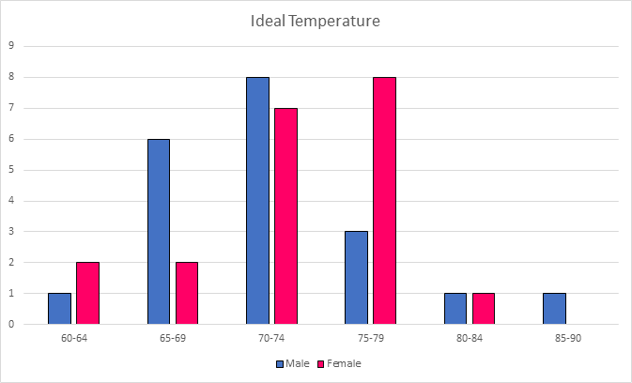
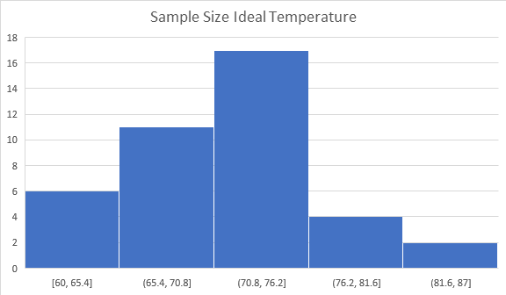
Our whole sample size of ideal temperatures

Ideal Temperature: The graph created from our SRS of ‘Ideal Temperature’ created a roughly normal curve. Although it is not perfect, both tails of our graph (for both male and female) start at a very low number, and progress to a higher number towards the center. The highest range for male students is between 70-74 degrees. For females, the highest range is 75-79 degrees. Both of which are in the exact middle of our given ranges. The data is spread evenly throughout the graph and outliers exist.

Data Analysis:
There are 3 conditions that need to be met in order to make an inference on a mean. Those three conditions are as follows:
- Random- a simple random sample was taken to obtain the data.
- Normal- n≥30 and/or approximately normal. (This condition was NOT met, however, for the sake of the assignment, testing was continued).
- Independent- each sample taken was independent of the other.
Ho:μᶠ=μᵐ
Ha:μᶠ≠μᵐ
t=$\frac{72.2-71.35}{\sqrt{\frac{{5.105^{2}{}^{}}^{}}{20}+\frac{5.575{}^{2}}{20}}}$=0.502859
Degrees of freedom=19 (20-1=19)
P-value=0.61799
Margin of error=2.899
Point estimate=72.2-71.35=0.85
Confidence level at 90% = (-2.049, 3.749)

We are 90% confident that the true difference in ideal temperatures between males and females is between -2.049 and 3.749 degrees.

The p-value is greater than the alpha level of 0.05 thus indicating that we fail to reject the null hypothesis.This causes us to believe that there is not statistically significant evidence to say the mean temperatures between males and females differ. In other words, we believe that there is statistically significant evidence to believe that the mean ideal temperature for men is equal to the mean ideal temperature for women.

Appendix:

Table 1:
Student # | Sex | Class | Presidential Approval | Ideal Temperature
272 | female | sophomore | approve | 73
67 | female | sophomore | unsure | 72
236 | female | junior | unsure | 72
104 | female | junior | approve | 75
165 | female | freshman | approve | 77
87 | female | junior | disapprove | 75
24 | female | sophomore | unsure | 73
276 | female | sophomore | approve | 78
55 | female | senior | approve | 60
110 | female | junior | unsure | 65
103 | female | freshman | approve | 77
125 | female | freshman | unsure | 75
273 | female | junior | approve | 72
177 | female | sophomore | unsure | 75
187 | female | freshman | approve | 75
221 | female | junior | disapprove | 65
153 | female | sophomore | disapprove | 80
94 | female | freshman | unsure | 65
61 | female | junior | disapprove | 70
172 | female | sophomore | approve | 70

Table 2:
Student # | Sex | Class | Presidential Approval | Ideal Temperature
175 | male | sophomore | disapprove | 75
33 | male | sophomore | unsure | 85
168 | male | freshman | unsure | 75
22 | male | freshman | disapprove | 65
5 | male | freshman | disapprove | 72
4 | male | junior | unsure | 70
193 | male | sophomore | approve | 72
194 | male | senior | approve | 69
244 | male | sophomore | unsure | 68
240 | male | junior | approve | 70
193 | male | sophomore | approve | 72
151 | male | freshman | unsure | 68
257 | male | sophomore | disapprove | 75
244 | male | sophomore | unsure | 68
35 | male | senior | disapprove | 72
129 | male | sophomore | approve | 70
64 | male | senior | approve | 60
214 | male | senior | unsure | 83
93 | male | sophomore | approve | 70
198 | male | junior | approve | 68

